Starting Your Wrecked Virtual PC
- Start your computer in S214 with the L drive, and log in as CNIT30. There is no password.
- Click Start, All Programs, VMWare, VMWare Workstation.
- In the VMWare Workstation window, from the menu bar, click View, “Go to Home Tab. Click the Open Existing VM or Team icon.
- In the Open box, click “My Computer”. Double-click the “VMs (V:)” drive to open it. Double-click the YOUR NAME VMs folder to open it. Double-click the “Your Name Wrecked Win XP Pro” folder. Double-click on the “Windows XP Professional.vmx” file. (The .vmx filename extension may not be visible.)
- The VMWare Workstation window reappears, with a tab labeled “Windows XP Professional”. In the left pane, click the blue Start this virtual machine link.
- When the virtual PC launches, click Student to log in. There is no password.

Saving a HijackThis! Short Analysis Before Cleaning
- Double-click the HijackThis executable file on the virtual desktop.
- In the Hijack This window, click the Do a system scan and save a logfile button.
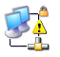
- Click anywhere in the hijackthis – Notepad window to make it active. Press Ctrl+A to select everything, and then press Ctrl+C to copy it to the clipboard.
- Open a browser and go to hijackthis.de Note: If you cannot connect to the Internet from the virtual PC, it’s because the spyware is making your network connection unreliable, as if often does. Do these steps to repair the connection:
  - Click Start, My Computer.
  - In the left pane of the My Computer window, click My Network Places.
  - In the left pane of the My Network Places window, click View Network Connections.
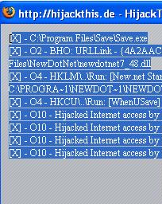
  - If you see a little yellow triangle with an exclamation point on it, as shown above and to the right on this page, right-click it and select Repair.
- Press Ctrl+V to paste the logfile into the box. Scroll to the bottom of the window and click the Analyze button.
- The next screen shows the items rated as Safe, Nasty, or Unknown as you saw in project 1. Scroll to the bottom of this page and click the Short Analysis link. A short list appears, as shown to the right on this page.

Saving a Screen Image
- Press the PrintScrn key. In the virtual machine, click Start, Programs, Accessories, Paint. In the untitled - Paint window, select Edit, Paste from the menu bar. The desktop appears in the Paint window, with only a corner of it visible.

- In the untitled - Paint window, click File, Save. Save the document in the My Pictures folder (or any other place you wish, such as a floppy disk) with the filename Your Name Proj 2a. Select a Save as type of JPEG.

Installing Windows Defender
- Windows Defender is Microsoft’s antispyware tool, and it is widely considered to be a good product.
- If you are in Science 214, use the procedure below to get Windows Defender from the server in that room. If you are working at home, you can download it from http://www.microsoft.com/athome/security/spyware/software/default.mspx
- Click Start, Run. Enter \\192.168.1.3 and click OK. If you are prompted for a name and password, enter a User name of CNIT and leave the password blank.
- An Instructor1 Machine in Sci214 window opens. Double-click the CNIT 30 folder. Drag the Windows Defender installer file to your desktop.

- Double-click the Windows Defender icon on your desktop. Run the installer, accepting all the default or recommended settings. . Validate Windows and accept the agreement when you are prompted to.
- When you see the message “Windows Defender Installation Complete”, leave the :"Check for updated definitions and run a quick scan now" box checked and click Finish.
- When the scan completes, you will see the results, like the example shown below on this page.
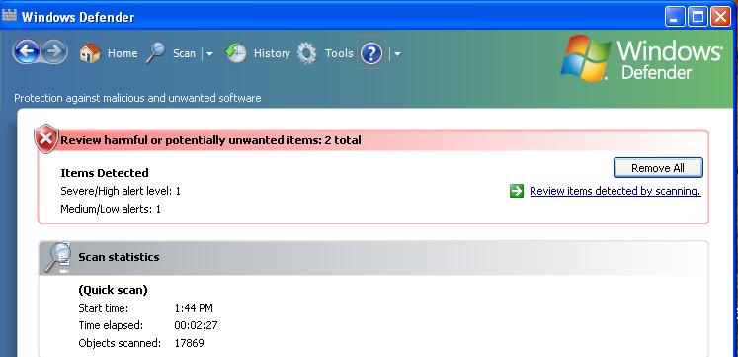

Saving a Screen Image
- Press the PrintScrn key. In the virtual machine, click Start, Programs, Accessories, Paint. In the untitled - Paint window, select Edit, Paste from the menu bar. The desktop appears in the Paint window, with only a corner of it visible.
- In the untitled - Paint window, click File, Save. Save the document in the My Pictures folder (or any other place you wish, such as a floppy disk) with the filename Your Name Proj 2b. Select a Save as type of JPEG.

Removing Spyware with Windows Defender
- In the Windows Defender box, click Remove All. If you see a box asking you to close your programs, click OK. If Windows Defender wants to restart your system, agree to that. When I ran it, Windows Defender was not able to remove all the spyware, but it did remove some of it.

Turning in your Project
- Attach both images to a single email message. Send it to: cnit.30@gmail.com with a subject line of Proj 2 From Your Name, replacing Your Name with your own first and last name. Send a Cc to yourself.

Last Modified: 6-13-07

