Starting the Host Machine
- Start your computer in S214, and log in as CNIT30. There is no password.
Starting a Your Virtual Machine
- Click Start, All Programs, VMWare, VMWare Workstation. If you see a “Tip of the day” box, click Close. If you see a “VMware Web Check” box, click Cancel.
- In the VMWare Workstation window, from the menu bar, click View, "Go to Home Tab". Click the Open Existing VM or Team icon.
- In the Open box, click “My Computer”. Double-click the “VMs (V:)” drive to open it. Double-click the YOUR NAME VMs folder to open it. Double-click the “Your Name Wrecked Win XP Pro” folder. Double-click on the “Windows XP Professional.vmx” file. (The .vmx filename extension may not be visible.)
- The VMWare Workstation window reappears, with a tab labeled “Windows XP Professional”. In the left pane, click the blue Start this virtual machine link.
- If a “Windows XP Professional – Virtual Machine” box opens with a long message about product activation, click OK.
- A “Windows XP Professional – Virtual Machine” box opens warning you that the default sound device cannot be opened. Click OK.
- If you see a message saying "A duplicate name exists on the network", click OK.
- Log in as Student with no password. You should see your virtual machine's desktop.
Using NETSTAT With No Web Pages Open
- In your virtual machine, click Start, Run. Type in CMD and press the Enter key.
- A Command Prompt window opens. Type in this command:
netstat –n
and then press the Enter key. The netstat command shows all active network connections on your machine. If you have not been using the Internet, you will see a result like the figure below on this page, with no values, just column headings. (You may see some connections anyway, because your machine is automatically connecting to Windows Update, McAfee Update, or a shared network folder.)
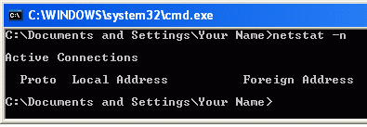
Using NETSTAT With the CCSF Web Pages Open
- Leave the Command Prompt window open. Open a Web browser and go to www.ccsf.edu. When the Web page has loaded, click in the Command Prompt window and enter the netstat -n command again, followed by the Enter key.
- Now you should see several network connections, including ones to the CCSF Web server, as shown below on this page. The lines starting with 127 are local processes on your machine talking to one another—disregard them. The number on the left, starting 192.168, is your IP Address. The value after the colon, which should be larger than 1024, is the Local Port Number. The value on the right, 147.144.1.212, is the CCSF Web Server’s IP Address. The Web server’s Port number is 80, because it is sending out normal HTTP Web pages.
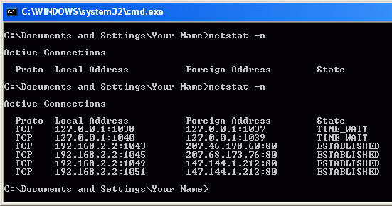

Using NETSTAT with a Secure Web Pages Open
- Leave the Command Prompt window and the CCSF Web page open. In your virtual machine, open another Web browser and go to yahoo.com. At the upper left of the Yahoo! page, click the "My Mail" button. If a "Security Alert" box pops up warning you that you are using a secure connection, click OK.
- The Yahoo! Mail sign-in page appears. Notice that this address starts https://, and that there is a padlock icon visible on the right side of your browser (the exact location varies with the browser). This is a secure page—you can be confident that you are really communicating with Yahoo, and that no one else can read the name and password you enter.
- Click in the Command Prompt window and enter the netstat –n command again. You should see connections from your machine to 208.59.201.17:443, as shown on the next page. This is Yahoo’s server, port 443, which is the port used by HTTPS. You may see a different IP address, but the port number should be 443.
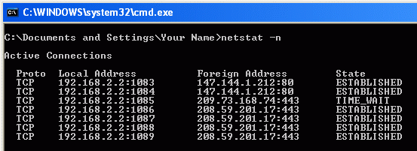

Saving a Screen Image
- Move the mouse pointer out of the VMWare Workstation window. Click on the host Windows XP's desktop.
- Press the PrintScrn key.
- In the host machine, click Start, Programs, Accessories, Paint. In the untitled - Paint window, select Edit, Paste from the menu bar. The desktop appears in the Paint window, with only a corner of it visible.
- In the untitled - Paint window, click File, Save. Save the document in the "My Pictures" folder (or any other place you wish, such as a floppy disk) with the filename Your Name Proj 3a. Select a Save as type of JPEG.
Using the Network Setup Wizard to Share Files
- Your machine is not a Web server, but it can act as a file server if you share a folder. Here’s the recommended way to do that with Windows XP.
- In your virtual machine, click Start, My Computer. In the left pane of the My Computer window, click "My Network Places".
- In the left pane of the "My Network Places" window, click the "Set up a home or small office network" link.
- At the "Welcome to the Network Setup Wizard" screen, click Next.
- At the "Before you continue…" screen, click Next.
- At the "Select a connection method" screen, accept the default selection of "This computer connects to the Internet through a residential gateway or through another computer on my network" and click Next.
- At the "Give this computer a description and a name" screen, enter a “Computer Name” as shown on the front panel of your computer with a V added to the end, so it will be something like this: S214-08V. Click Next.
- At the "Name your network" screen,. Enter a Workgroup name of SCI214 and click Next.
- At the "File and printer sharing" screen, click "Turn on file and printer sharing" and click Next.
- At the "Ready to apply network settings" screen, click Next.
- At the "Please wait" screen, wait for the animation to end. It might take a minute or longer.
- At the "You’re almost done" screen, click "Just finish the wizard. I don’t need to run the wizard on other computers" and click Next.
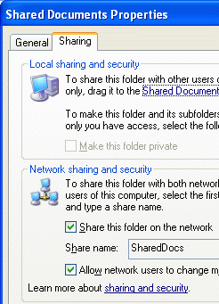
- At the "Completing the Network Setup Wizard" screen, click Finish.
- Restart your virtual machine if you are prompted to.
Sharing a Folder
- Click Start, "My Computer". Right-click the "Shared Documents" folder and select "Sharing and Security".
- In the "Shared Documents Properties" box, on the Sharing tab, ensure that the "Share this folder on the network" box is checked, as shown to the right on this page. Also ensure that the "Allow network users to change my files" box is checked. Click OK.
Finding Your IP Address
- In your virtual machine, click Start, Run. Type in CMD and press the Enter key.
- Click in the Command Prompt window, type in this command, and press the Enter key:
IPCONFIG
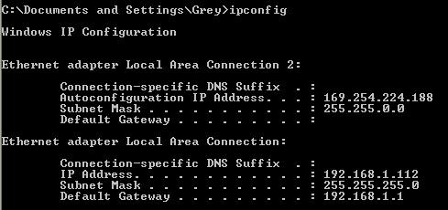
- You should see several lines of information, including your IP Address, as shown below on this page. There are two network connections, each with its own IP address. The one that is connected has an IP address starting with 192. Find that IP address and write it in the box below on this page.

Your IP Address: _______________________________________

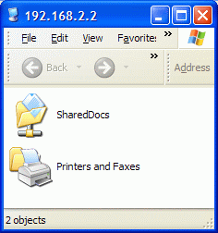
Opening the Shared Folder from the Host Operating System
- In the host operating system (NOT the virtual machine), click Start, Run. Type this line into the Run box, replacing 192.168.2.2 with the IP address you wrote down in the previous step:
\\192.168.2.2
- Press the Enter key. You should see a window open showing the shared folder on your virtual Machine, as shown to the right on this page. Double-click the SharedDocs folder to open it. This establishes a network connection between the host PC and the virtual Machine, with the virtual Machine is acting as the Server.
Using NETSTAT With a Shared Folder Open
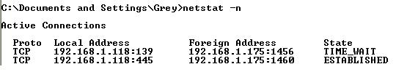
- In the virtual machine, click in the Command Prompt window and enter the netstat –n command again. You should see a connection with a "Local Address" ending in a port number of 139 and/or 445, as shown below. Ports 139 and 445 are used by the Windows file-sharing protocol. If you see no connection, it may have just timed out--repeat steps 39 and 40 to re-establish the connection.

Saving a Screen Image
- Move the mouse pointer out of the VMWare Workstation window. Click on the host Windows XP's desktop.
- Press the PrintScrn key.
- In the host machine, click Start, Programs, Accessories, Paint. In the untitled - Paint window, select Edit, Paste from the menu bar. The desktop appears in the Paint window, with only a corner of it visible.
- In the untitled - Paint window, click File, Save. Save the document in the My Pictures folder (or any other place you wish, such as a floppy disk) with the filename Your Name Proj 3b. Select a Save as type of JPEG.

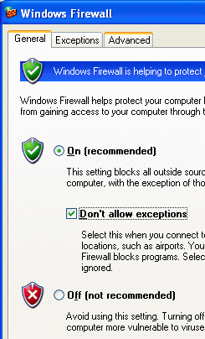
Blocking File Sharing With Windows Firewall
- In the virtual machine, click Start, "Control Panel". If you see a heading of "Pick a category" in the right pane, click the "Switch to Classic View" link in the left pane.
- Double-click "Windows Firewall". In the "Windows Firewall" box, on the General tab, check the "Don’t allow exceptions" box, as shown to the right on this page. Click the OK button.
Attempting to Open the Shared Folder from the Host Operating System
- In the host operating system (NOT the virtual Machine), click Start, Run. Type this line into the Run box, replacing 192.168.2.2 with the IP address you wrote down in the box on a previous page:
\\192.168.2.2
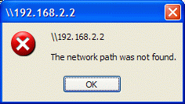
- Press the Enter key. Wait for about 45 seconds. After your computer times out, an error message appears, saying "The network path was not found", as shown to the right on this page. You cannot connect to the shared folder because the firewall is stopping you.

Saving a Screen Image
- Press the PrintScrn key.
- Click Start, "All Programs", Accessories, Paint. In the "untitled - Paint" window, select Edit, Paste from the menu bar. The desktop appears in the Paint window, with only a corner of it visible.
- In the "untitled - Paint "window, click File, Save. Save the document in the My Pictures folder (or any other place you wish, such as a floppy disk) with the filename Your Name Proj 3c.

Turning in your Project
- You should have three JPEG images, as indicated by the pointing hand symbol above. Attach all three images to a a single message addressed to: cnit.30@gmail.com with a subject line of Proj 3 From Your Name, replacing Your Name with your own first and last name. Send a Cc to yourself.
Last Modified: 6-15-07

