Start Your Ubuntu Virtual Machine
Warning! Unexpected port scans are rude, and possibly even illegal! Port scans can set off intrusion detection systems and get us all into trouble. Don’t scan other people’s servers, just scan machines you have permission to scan. The only machines you should scan in this project are machines in S214, or on your own network at home.
- Double-click the VMware Workstation icon on the desktop. In the VMware Workstation window, from the menu bar, click View, Go to Home Tab.
- On the Home tab, click the Open Existing VM or Team icon. Navigate to the V: drive, open your folder, open the Your Name Ubuntu folder, and double-click the Your Name Ubuntu.vmx file. On the left side, click the Start this virtual machine link.
- When your machine starts up, log in as with the name and password you chose in the previous project. Then press Ctrl+Alt+Enter to use your virtual machine in full-screen mode.

Examining the Package Repositories
- Ubuntu is a Debian Linux distribution, and one of the great things about Debian is that it has online repositories of applications which you can download and install easily. They are ready to go, just like updates, and they are all free!
- From the menu bar, click System, Administration, "Synaptic Package Manager". Enter your password when you are prompted to.
- Read the "Quick Introduction" box, then click the Close button.
- From the "Synaptic Package Manager" menu bar, click Settings, Repositories. A "Software Sources" box appears, as shown below. Make sure that the first four items are all checked, as shown below. These are all the repositories that contain commonly used programs. They are separated into these groups based on how open-source and free they are—they are not all supported by Ubuntu, and they are not all necessarily legal in all countries.
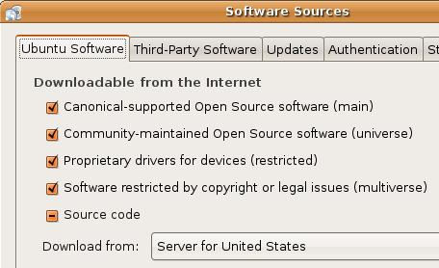
- Click the Close button. If a “Repositorieschanged” box pops up, click the Close button.
- In the "Synaptic Package Manager" box, click the Reload button. Wait while files download.
- Close the "Synaptic Package Manager" box.

Installing Nmap
- From the menu bar, click Applications, Add/Remove….
- In the upper right of this window, click in the Show: box and select "All available applications".
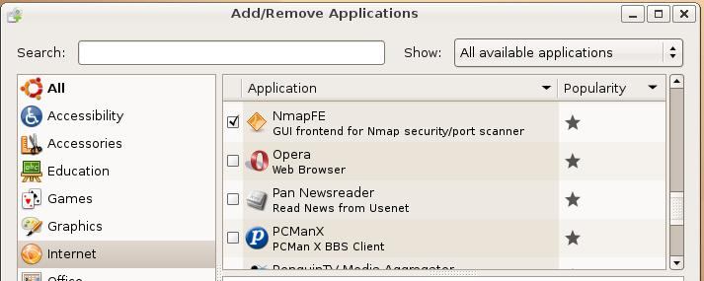
- In the left column of the "Add/remove Applications" box, click Internet. Scroll down to find NmapFE and check it, as shown below on this page. When a box pops up saying “Install community maintained software?”, click Install.

- In the "Add/remove Applications" box , click the OK button. A box pops up saying "Apply the following changes?". Click Apply. Type in your password when prompted to. Wait while software downloads and progress bars move across the screen.

Starting NmapFE as root
- From the menu bar in the upper left corner of the Ubuntu desktop, click Applications, Accessories, Terminal.
- In the Terminal window, after the $ prompt, enter this command, then press the Enter key:
sudo nmapfe
This command starts the Nmap Front End. The sudo at the start elevates your privileges to root (administrative) temporarily.
- At the Password: prompt, enter your password and press the Enter key:
Your password is required to elevate your privileges.

Starting your Windows XP Virtual Machine
- Click Start, "All Programs", VMware, "VMware Workstation. In the VMware Workstation window, from the menu bar, click View, Go to Home Tab.
- On the Home tab, click the Open Existing VM or Team icon. Navigate to the V: drive, open your folder, open the Win XP Pro for Hacking folder, and double-click the Windows XP Professional.vmx file. You should see a Windows XP Professional VM in the Powered Off state.
- In the Windows XP Professional – VMware Workstation window, on the left side, click the Start this virtual machine link.
- When your machine starts up, click the Student account to log in. There is no password, and the Student account has Administrative privileges.

Finding the IP Address of Your Windows XP Virtual Machine

IP: ____________________
- In your Windows XP virtual machine, click Start, Run. In the Run box, enter cmd and press the Enter key. In the Command Prompt window, enter the IPCONFIG command and press the Enter key. Several IP addresses appear. Find the one that starts with 192.168.1 and write it in the box to the right on this page.

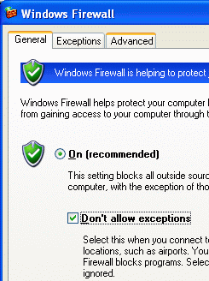
Setting Your Windows XP Virtual Machine’s Firewall to No Exceptions
- In your Windows XP virtual machine, click Start, Control Panel. If you see a heading of Pick a category in the right pane, click the Switch to Classic View link in the left pane.
- Double-click Windows Firewall. In the Windows Firewall box, on the General tab, click the On button, and also check the Don’t allow exceptions box, as shown to the right on this page. Click the OK button.

Port Scanning Your Windows XP Virtual Machine With the Firewall On – No Exceptions
- In the Nmap Front End window, enter the IP address of your Windows XP virtual machine. Click in the Scan Type box, click Connect Scan, and click the Scan button. Wait for the scan to finish—it will take about a minute.

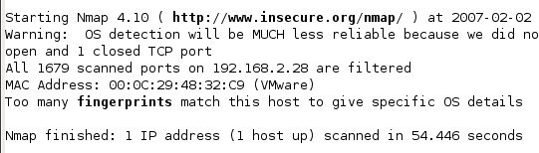
- You should get results as shown below on this page, showing All 1679 scanned ports are filtered. That’s what the firewall does—blocks all responses from all ports.

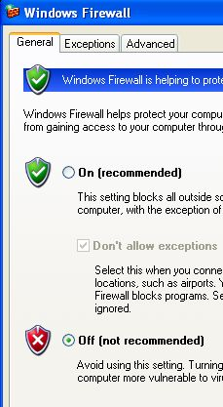
Saving a Screen Image
- Click outside the virtual machine to make the host machine’s desktop active.
- Press the PrintScrn key to copy the whole desktop to the clipboard.
- In the host machine, click Start, Programs, Accessories, Paint. In the untitled - Paint window, select Edit, Paste from the menu bar. The desktop appears in the Paint window, with only a corner of it visible.
- In the untitled - Paint window, click File, Save. Save the document in the My Pictures folder (or any other place you wish, such as a floppy disk) with the filename Your Name Proj 4xa. Select a Save as type of JPEG.

Setting Your Windows XP Virtual Machine’s Firewall to Off
- In your Windows XP virtual machine, click Start, Control Panel. If you see a heading of Pick a category in the right pane, click the Switch to Classic View link in the left pane.
- Double-click Windows Firewall. In the Windows Firewall box, on the General tab, check the Off (not recommended) box, as shown to the right on this page. Click the OK button.

Port Scanning Your Windows XP Virtual Machine With the Firewall Off
- In the Nmap Front End window, enter the IP address of your Windows XP virtual machine. Click in the Scan Type box, click Connect Scan, and click the Scan button. Wait for the scan to finish—it will take about a minute.
- You should get results as shown below on this page, showing a few open ports: 135, 139, and 445. The scan will finish much sooner, because it’s a lot faster for Nmap to collect responses from open ports than to wait for filtered ports to time out. With the firewall off, several ports respond. The OS detection is more accurate now too, because there are enough ports open to permit more tests.
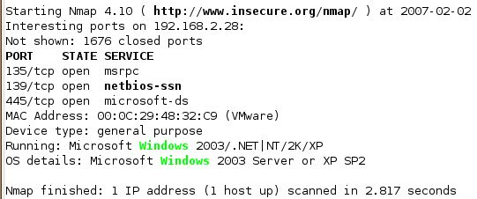

Saving a Screen Image
- Click outside the virtual machine to make the host machine’s desktop active.
- Press the PrintScrn key to copy the whole desktop to the clipboard.
- In the host machine, click Start, Programs, Accessories, Paint. In the untitled - Paint window, select Edit, Paste from the menu bar. The desktop appears in the Paint window, with only a corner of it visible.
- In the untitled - Paint window, click File, Save. Save the document in the My Pictures folder (or any other place you wish, such as a floppy disk) with the filename Your Name Proj 4xb. Select a Save as type of JPEG.

Turning in Your Project
- Email the JPEG images to me as attachments to a single email message. Send it to: cnit.30@gmail.com with a subject line of Proj 4x From Your Name, replacing Your Name with your own first and last name. Send a Cc to yourself.

Last Modified: 6-25-07

