Creating a Folder for your Ubuntu Virtual Machine
- Start your computer in S214, and log in as CNIT30. There is no password.
- Click Start, My Computer. Double-click the VMs (V:) drive to open it. Double-click the YOUR NAME VMs folder to open it.
- In the YOUR NAME VMs window, right-click the empty space and click New, Folder. Type in the folder name Ubuntu and press the Enter key.

Using VMWare Workstation to Create a New Virtual Machine
- Double-click the VMWare Workstation icon on the desktop.
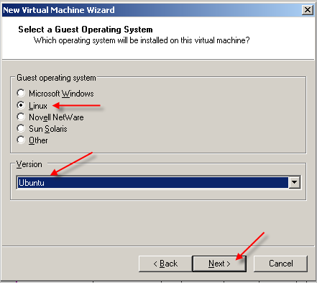
- A VMWare Workstation window opens as shown to the right on this page. Click the New Virtual Machine icon.
- At the Welcome to the New Virtual Machine Wizard screen, click Next.
- At the Select the Appropriate Configuration screen, accept the default selection of Typical and click Next.
- At the Select a Guest Operating System screen, make sure that the Linux radio button is selected and in the Version box, select Ubuntu, as shown to the right on this page. Click Next.
- At the Name the Virtual Machine screen, enter a Virtual machine name of Your Name Ubuntu. Click the Browse button to choose the drive and folder to save the VM in.
- In the Open box, click “My Computer”. Double-click the “VMs (V:)” drive to open it. Double-click the YOUR NAME VMs folder to open it. Double-click the Ubuntu folder. Click Next.
- At the Network Type screen, accept the default selection of Use Bridged Networking and click Next.
- At the Select the Appropriate Configuration screen, accept the default selection and click Next.
- At the Specify Disk Capacity screen, change the size to 7 GB. Do not check either of the boxes. Click Finish.
- You should now see a window with Your Name Ubuntu in large gray letters near the top.

Adjusting Network Settings
- The Ethernet settings on VMware Workstation are set to match the two physical network interfaces on our lab machines, so you will need to adjust network settings. This only has to be done once for each virtual machine.
- In the Windows XP Professional – Vmware Workstation window, on the left side, click the Edit virtual machine settings link.
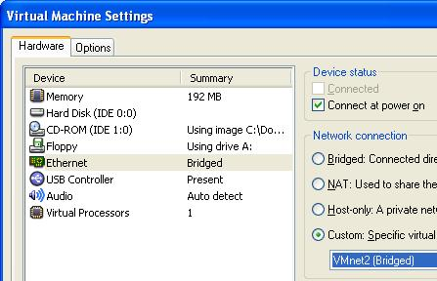
- In the Virtual Machine Settings box, on the Hardware tab, click the Ethernet item to select it. On the right side, click the Custom radio button and select VMnet2 (Bridged) as shown to the right on this page. Click the Add button.
- In the Welcome to the Add Hardware Wizard screen, click Next.
- In the Hardware Type screen, click Ethernet Adapter and click Next.
- In the Network Type screen, on the right side, click the Custom radio button and select VMnet0 (default Bridged). Click Finish.
- In the Virtual Machine Settings screen, click OK.

Starting the Virtual Machine with No Operating System
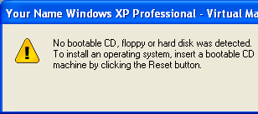
- In the Commands section in the middle of the window, click Start this virtual machine.
- A Your Name Windows XP Professional – Virtual Machine opens saying The keyboard hook timeout value …. Click OK to close the box.
- The virtual machine starts, and attempts to boot up, but there is no operating system installed, so it ends with the message shown on to the right on this page.
- Click OK to close the dialog box.

Connecting the Virtual Machine to the Ubuntu CD Image
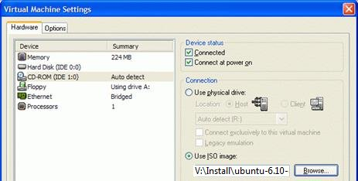
- From the Menu bar, select VM, Settings.
- In the Virtual Machine Settings box, click CD-ROM in the left pane. In the right pane, click Use ISO Image
- Click the Browse button. In the Open box, click “My Computer”. Double-click the “VMs (V:)” drive to open it. Double-click the Install folder to open it. Double-click the ubuntu-7.04-desktop-i386.iso file.
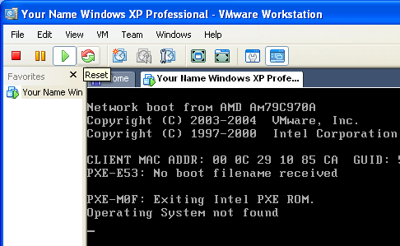
- Click OK to close the Virtual Machine Settings box
- Click the Reset button as shown to the right on this page. If a VMWare Workstation box opens asking Are you sure that you want to restart the guest operating system? click OK. In the next box, click OK.

Adjusting the BIOS Boot Order
- This next process is a little tricky. You will probably need to try it a few times to make it work, because you need to click the mouse and then press the correct key on the keyboard within 2 or 3 seconds.
- On the left side of the “Your Name Ubuntu – Vmware Workstation” window, click the blue "Start this virtual machine" link.
- If a “Your Name Ubuntu – Virtual Machine” box opens with a long message about product activation, click OK.
- A “Your Name Ubuntu – Virtual Machine” box opens warning you that the default sound device cannot be opened. Click OK.

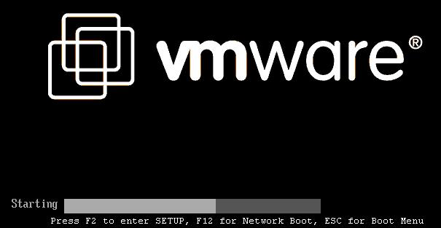
- You will see the screen shown below for just a couple of seconds, with this message at the bottom: "Press F2 to enter SETUP…". Within those few seconds, you must click the left mouse button to make the virtual machine listen to the keyboard, and press the F2 key on the upper left of your keyboard.
- If you don't do it fast enough, you will see the "Network boot"" message. If that happens, click the Reset button again to restart your virtual machine.
- When you succeed, you will see a screen titled "Phoenix BIOS Setup Utility", as shown below. Press the right-arrow key on the keyboard three times to highlight Boot. Then press the down-arrow on the keyboard twice to highlight "CD-ROM Drive". Finally, press the + key on your keyboard twice to move "CD-ROM Drive" to the top of the list, as shown in the image below.
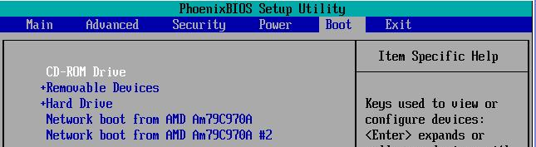

- When your screen looks like the image above, press the F10 key. A "Setup Confirmation" box appears. Press the Enter key.

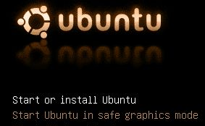
Starting Linux from the CD Image
- The virtual machine should boot from the ISO image, and show you the ubuntu starting screen shown to the right on this page.
- Press the Enter key to Start or Install Ubuntu, as shown to the right on this page.

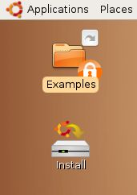
- Ubuntu will launch from the ISO file, and show a brown desktop with an Install icon on it, as shown to the right on this page.
- At this point, Ubuntu is running from the virtual CD. This “Live CD” mode is intended to let people try Linux on a Windows machine without changing the hard disk. The problem with it is that you cannot install software, save files, or customize it. Besides, we are using VMware, which protects the Windows XP host system anyway—we don’t need the Live CD feature. So we will install Ubuntu onto the virtual hard disk.

Installing Ubuntu Linux on the Virtual Hard Disk
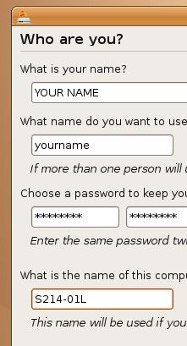
- Double-click the Install icon.
- In the first Linux install screen, labeled "Step 1 of 7" in the lower left corner, accept the default selection of English and click the Forward button.
- In"Step 2 of 7", click on the map to select Los Angeles for a time zone, and click the Forward button.
- In"Step 3 of 7", accept the default keyboard layout selection of "U.S. English" and click the Forward button.
- Step 4 of 7 is preparing the disk space. Accept the default selections of "Guided – use entire disk" and "IDE1 master (hda)" and click the Forward button.
- In"Step 5 of 7", "Migrating User Settings", don't change anything and click the Forward button.
- Step 6 of 7 is the Who are you? Screen. Type in your name and a logon name of your choice. Enter a password you can remember – I recommend P@ssw0rd. Name your computer after the station number on the front panel, adding an L (for Linux) to the end, as shown to the right on this page. Click the Forward button.
- Step 7 of 7 is the "Ready to install" screen. Click the Install button.
- Wait while Linux installs – it will take about 30 minutes. When you see an Installation Complete box, click Restart now.

Removing the Virtual CD
- Ubuntu shuts down, leaving a black screen with small blue letters at the bottom saying "please remove the disc".
- Click the lower X button in the upper right of the Ubuntu screen to shut down the virtual machine without completely closing VMware Workstation.
- You should now see a window with Your Name Ubuntu in large gray letters near the top.

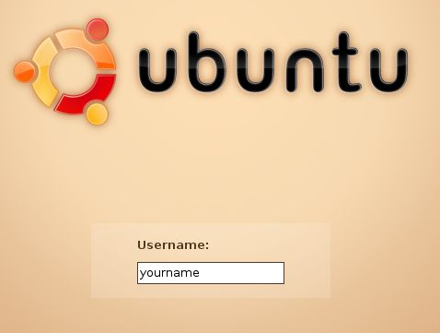
- From the Menu bar, select VM, Settings.
- In the Virtual Machine Settings box, click CD-ROM in the left pane. In the right pane, click Use physical drive.
- Click OK to close the Virtual Machine Settings box
- Click Start this virtual machine.
- You should see a GRUB LOADING message, and when Ubuntu boots up, you will see the login screen shown to the right on this page. Type in your user name and press the Enter key. Then type in your password and pres the Enter key.
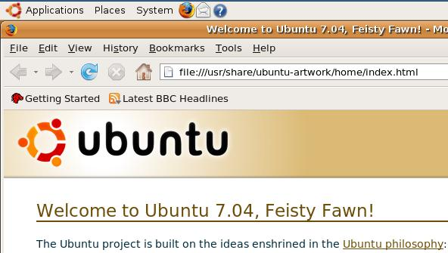
Saving the Screen Image
- From the Ubuntu menu bar, click Applications, Internet, "Firefox Web Browser". You should see the "Welcome to Ubuntu" message, as shown to the right on this page.
- Press Ctrl+Alt to release the mouse, and click on the host Windows XP desktop. Press the PrntScn key to copy whole screen to the clipboard.
- On the host Windows XP desktop, open Paint and paste in the image. Save it as a JPEG, with the filename Your Name Proj 4.

Shutting Down the Ubuntu Machi ne
- When your Ubuntu machine restarts, click System, Quit. Click the "Shut Down" button.
Turning in your Project
- Email the JPEG image to me as an attachment. Send the message to cnit.30@gmail.com with a subject line of Proj 4 From Your Name. Send a Cc to yourself.
Last modified 6-17-07

