Chapter 1: What's New in Windows Vista

Windows Vista Versions

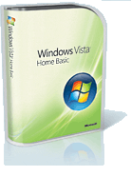
Windows Vista Home Basic

Windows Vista Home Premium

Windows Vista Business

Windows Vista Enterprise

Windows Vista Ultimate

Vista Home Basic

Entry-level successor to XP Home Edition

Includes:

Internet Explorer 7

Windows Media Player 11

Windows Mail

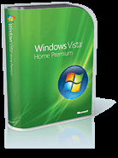
Rips and burns CDs (but not DVDs)

Does not have Aero graphics

Cannot join a corporate domain

Vista Home Premium

Includes everything in Home Basic, plus:

Aero graphics

Windows Media Center

Tablet PC support

Better Backup features

Can create and edit DVDs

Cannot join a corporate domain

Vista Business

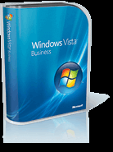
Successor to Windows XP Professional

Includes:

Joining a corporate domain

Image-based backup

Encrypting File System

Can host a Remote Desktop session

Does not include

Windows Media Center

BitLocker drive encryption

Vista Enterprise

Not for sale through retail channels

Sold to corporate customers with volume licenses

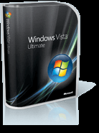
Includes everything in Vista Business, plus:

BitLocker drive encryption

Multiple-language support

Vista Ultimate

Includes everything from all other editions

Media Center

BitLocker

Also access to online premium products called Ultimate Extras

64-bit Editions

Each Vista edition comes in 32-bit and 64bit versions

Choose the version that matches your processor

Note: all device drivers must be signed for 64bit Vista

32-bit processors are limited to 4 GB of RAM

See link Ch 1e on my Web page:

Go to samsclass,info and click on CNIT 335

Foreign Editions

Windows Vista Starter Edition

Cheaper than Home Basic, sold only in emerging markets

“N” Editions

Sold in Korea and Europe

Lacks Windows Media Player and other media functionality, because of antitrust actions

See links Ch 1f, Ch 1g

Vista Interface

Control Panel ► System and Maintenance ► System

Edition

Experience Index rating

Hardware specifications

Windows activation status
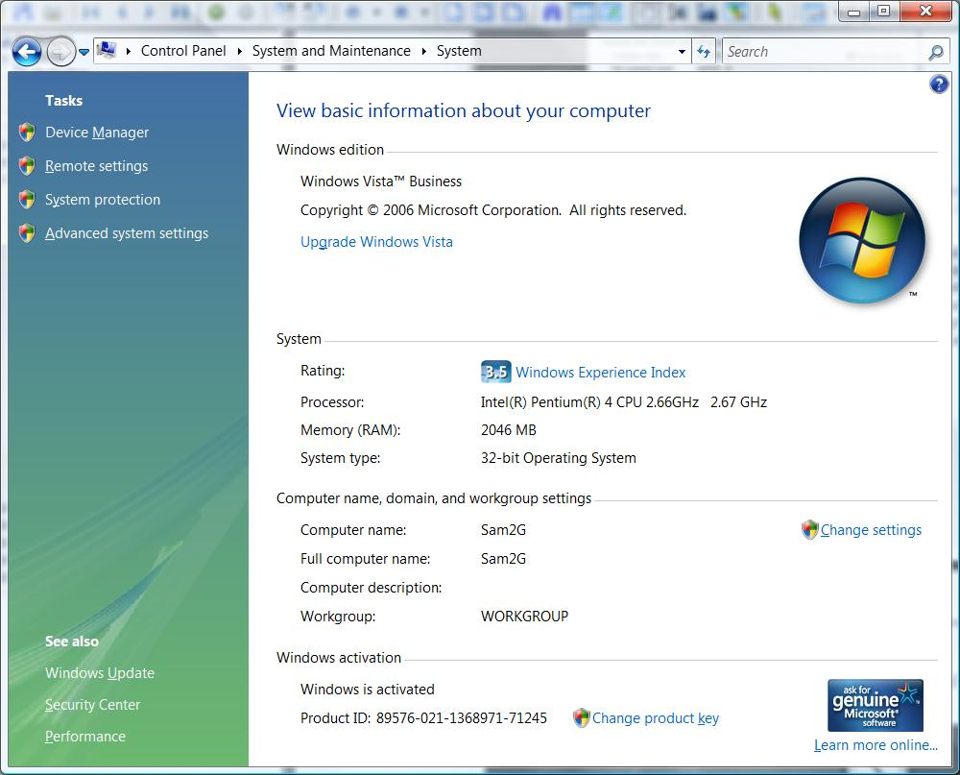

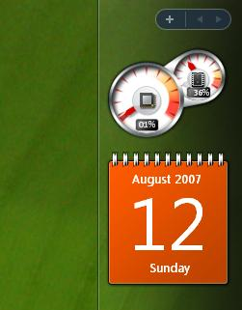
Sidebar and Gadgets

Adding and detaching gadgets from Sidebar

Closing Sidebar

Bringing gadgets to the front

Opacity settings

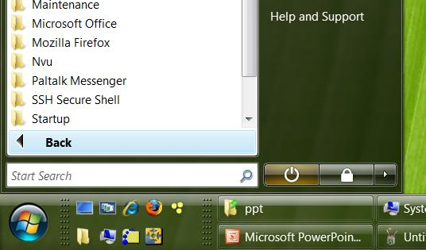

Start Button and All Programs menu

No longer expands to the right

Search box is more useful than the old “Run” box

Demonstration: search for ‘performance’

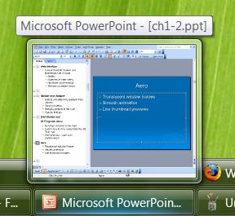

Aero User Experience

Translucent window frames

Smooth animation

Live thumbnail previews

Hover over taskbar button

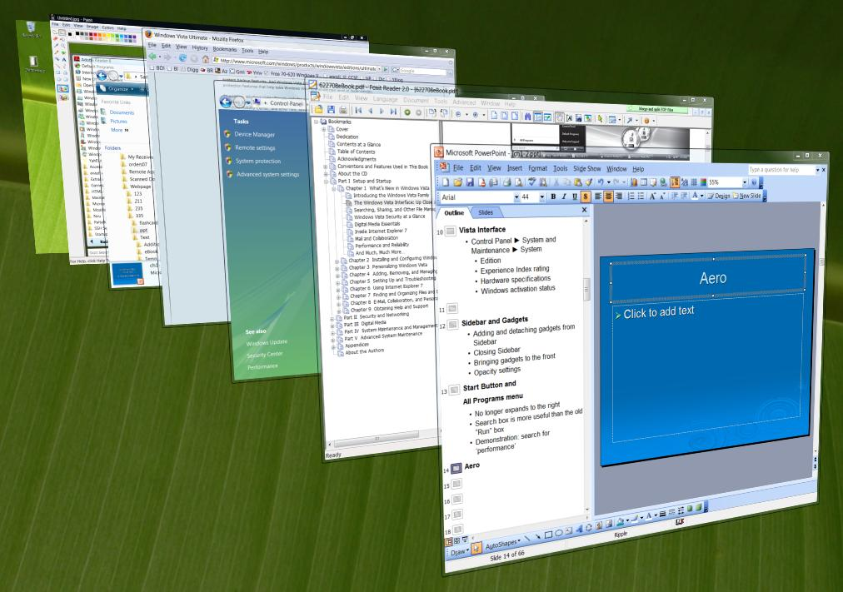
Flip 3D Task Switcher

Windows Logo key + Tab

Windows Explorer

No menus (press ALT to see them)

Breadcrumbs at the top

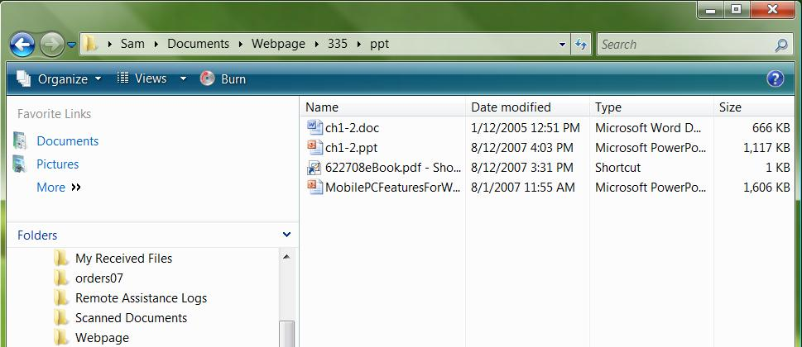
Search bar (upper right)

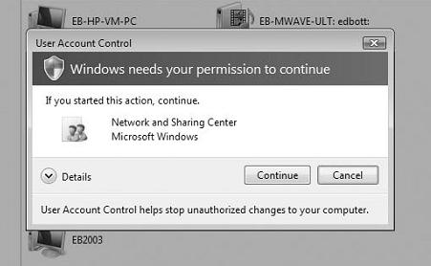
Security: Cruel Mac Video

Link Ch 1g2

Security: User Account Control

Normal users can’t do administrative tasks

Administrator accounts have two tokens: one normal, one with administrator privileges

Elevating privileges requires clicking on a User Account Control box

Security: Registry Virtualization

Some programs try to modify system registry settings

Especially old programs

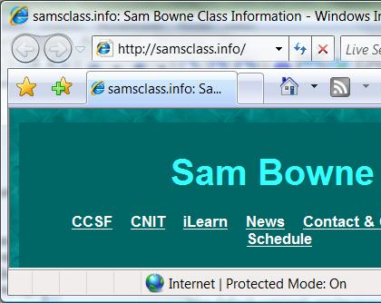
Vista makes those changes in per-user keys only

Vista lets the programs think they modified the real registry

Security: Internet Explorer 7

Protected Mode

If a browser add-on tries to change the system, that is also prevented by virtualization

Security: Windows Defender

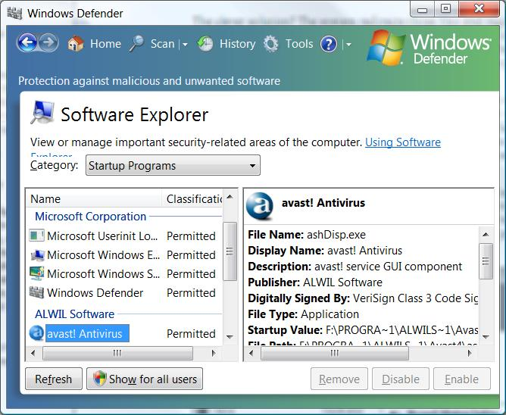
Blocks spyware

Includes “Software Explorer”

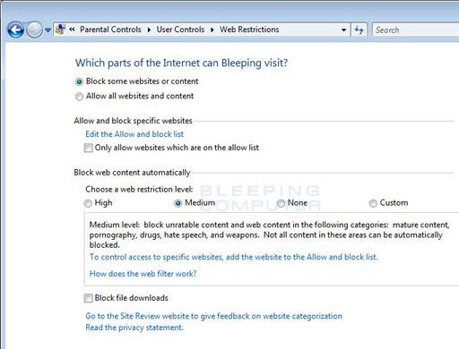

Security: Parental Controls

Limit how children use the computer

From bleepingcomputer.com

Link Ch 1i

Not in BusinessEdition

Digital Media

Windows Media Player 11

Windows Photo Gallery

Windows Movie Maker

Windows Media Center

Controls your home entertainment devices from your computer

Network and Sharing Center

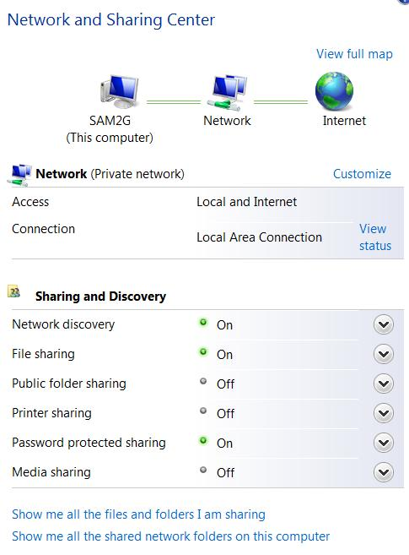
Start ► Network ► Network and Sharing Center

Precise control of networking

Vista uses both IPv6 and IPv4

Demo: use IPCONFIG

Internet Explorer 7

Tabbed browsing

RSS feeds

Protected Mode

Contact Tools

Windows Mail

Successor to Outlook Express

Windows Calendar

Windows Contacts

Windows Meeting Space

Lets you share documents, programs, and your desktop with others

Reliability and Performance Monitor

Start

Search for Performance
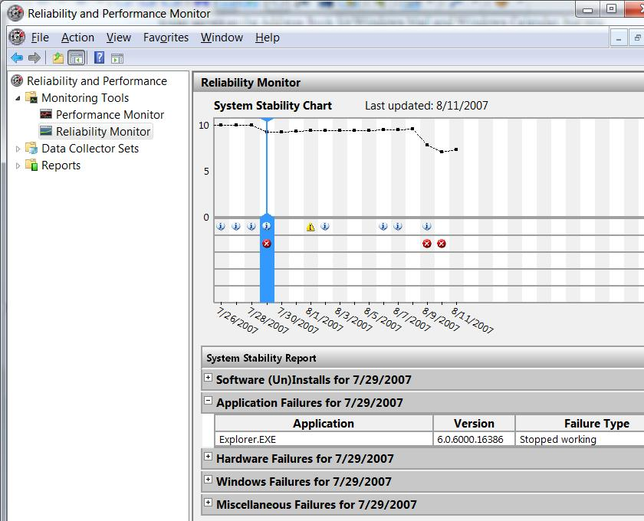

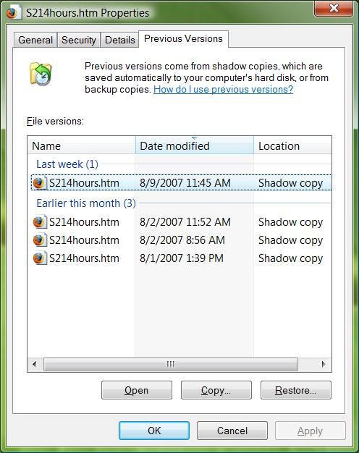
Recovering Lost Files

Backup is easier

CompletePC Backup is new for business versions

System Restore

Previous Versions

Keeps old versions of files

Ch 2: Installing and Configuring Windows Vista

Upgrade Advisor

Scans installed programs and devices and reports on Vista compatibility

Available from a link that appears when you insert a Vista install DVD

Or link Ch 2d on my Web page

Use Internet Explorer, not Firefox)

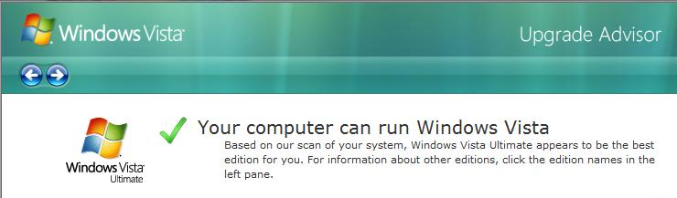

Hardware Requirements

Vista Capable (minimum, no Aero)

Processor: 800 MHz

RAM: 512 MB

Hard disk: 20 GB (15 GB free)

Graphics card: SVGA (800x600), DirectX 9

Vista Premium Ready (allows Aero)

Processor: 1 GHz

RAM: 1 GB

Hard disk: 20 GB (15 GB free)

Graphics card: DirectX 9 with WDDM, 128 MB of graphics RAM, 32 bits per pixel, Pixel Shader 2.0

Before an Upgrade

Back up your system

Turn off antivirus software

Setup Decisions

Which Windows Vista edition?

Each install DVD has all versions on it

You can only activate the the edition you paid for

You can use any edition for a free 30-day trial, which can be extended to 120 days

Setup Decisions

Clean install or Upgrade?

Clean install produces a Vista system with no added software

You must reinstall all the software you want

Upgrade preserves installed software, e-mail, and other settings

Upgraded systems are less reliable than clean installs

Setup Decisions

Which disk partition?

If you install Vista on a new partition, you can create a multiboot machine

Each time you start the computer, it asks which OS to use

In S214, this will be crucial, because many students will be sharing each machine

Clean Install

Boot from DVD

Follow the on-screen prompts, such as

Type in Product Key (skip this for a 30-day trial)

Select destination partition

You’ll do this in Project 1

Upgrading from Windows XP

Requirements:

Must be running 32-bit Windows XP with Service Pack 2

Must have a NTFS-formatted drive

Must have enough free space on the drive – typically 11 – 15 GB

Upgrade Paths

From link Ch 1b
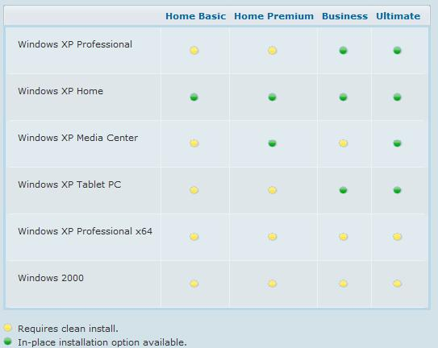

Upgrading from Windows XP

Start with Windows XP running

Insert the DVD

Follow the on-screen prompts, such as

Get updates for installation

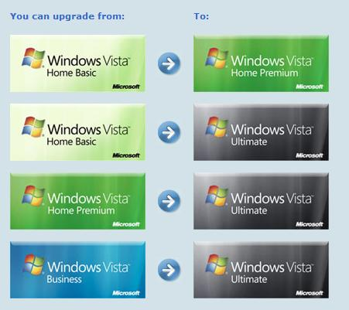
Type in Product Key (skip this for a 30-day trial)

Slower than a clean install

Vista Anytime Upgrade

Buy an upgrade license online

Insert the DVD and follow the on-screen prompts

You can’t upgrade to Business Edition

See link Ch 1c

The Vista Startup Process

No longer uses Ntldr and Boot.ini

Unless you are starting an older Windows version on a multiboot system

Power-On Self Test (POST)

BIOS passes control to the Master Boot Record (MBR)

The first sector on the boot device (usually a hard disk)

Control passes:

MBR

NTFS Boot Code

Windows Boot Manager

System BCD Store

Boot Configuration Data

Has a list of boot options

Normal Boot

Control passes to Windows Boot Loader in the Windows partition

Recovery

Control passes to Windows Boot Loader in the Windows Recovery Environment (RE)

See link Ch 2f

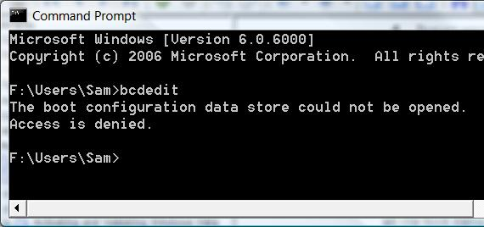
Demonstration: BCDEdit

The BCDedit command is used to control the boot options

Start, CMD, Enter

BCDEDIT

Access is denied – we need to use the Administrator Command Prompt

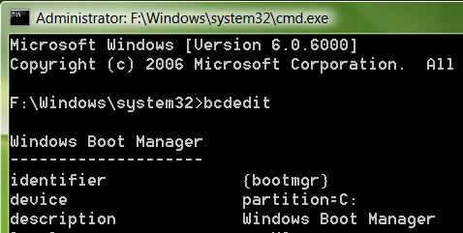
Demonstration: Administrator Command Prompt

The BCDedit command is used to control the boot options

Start, CMD, Ctrl+Shift+Enter

BCDEdit works now

Virtual Machines

Run Vista inside an application that simulates a computer

An alternative to multiboot

VMware is the older, more established product

Microsoft Virtual PC is the newer one

I had a lot of problems with Vista in virtual machines, so we will use multi-boots this semester

Warning: Data Loss in Lab S214

Don’t put anything personal or irreplaceable on those machines

Other students might accidentally erase your Vista partition at any time

If your work is lost or delayed because another student erases it, talk to your instructor about it

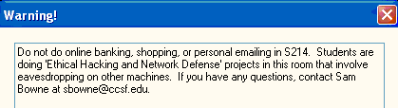
Warning: Hackers in S214

“Ethical Hacking” students are stealing passwords from the hard drives and the network in S214

Don’t use any passwords you value in there

Create a new email account to use in S214

Multiboot Disaster

If you make a multiboot machine, install operating systems in chronological order”

Win 2000 Pro, then Win XP, then Win 2003 Server, then Win Vista

If you install an older OS, it will replace the MBR with an old MBR and the newer operating systems will stop working

For the cure, see page 42 of your textbook

Activating Vista

To prevent piracy, you must activate your installation of Vista within 30 days, by

Connecting to the Microsoft activation server over the Internet, or

By calling a toll-free telephone number

If you don’t activate it, Vista will stop working

See link Ch 2g to extend the 30-day trial, up to a maximum of 120 days

Reinstalling

You can reinstall Vista on the same hardware with the same product key as many times as you wish

Microsoft uses a hardware fingerprint to identify your computer

If you make large hardware changes, like a new motherboard, you may have to call Microsoft Tech Support to reactivate Vista

Product Validation

Vista will periodically contact Microsoft to ensure that it is genuine

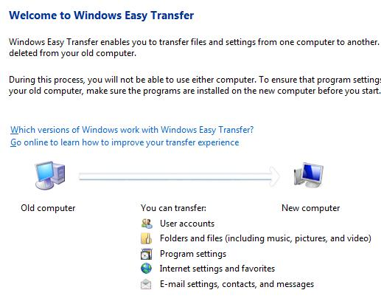
Microsoft downloads often require proof that your Windows is genuine

Windows Easy Transfer

Suppose you get a new computer, or do a clean install of Vista

Windows Easy Transfer moves your files and settings to the new Vista machine

Four Transfer Methods

Easy Transfer Cable

Available from Microsoft, uses USB ports

Network

Connect new and old computers together

Writable CDs or DVDs

Removable media

USB flash drives

External hard disks

What You Can Transfer

Files and folders

Digital media files

Email and contacts

User-specific settings

Internet settings and Favorites

Application settings

But not installed software

Last modified 8-29-07 11 am

