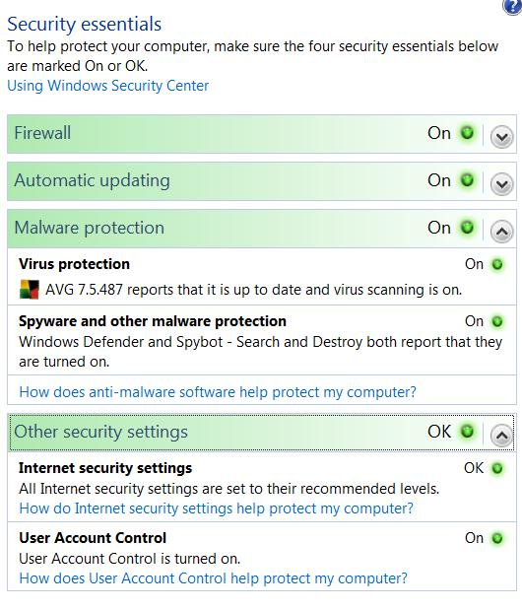
Understanding Security Threats

Essential Security Measures

Firewall

Updates

Antivirus

Antispyware

Security Center

In Control Panel

Editions

All the security software in this chapter is the same in all editions, except

Parental Controls

Only present in Home Basic, Home Premium, and Ultimate

Group Policy

Only present in Business, Enterprise, and Ultimate versions

Security Threats

Virus

Code that attaches to another program

Spreads when the infected program runs

Worm

A independent program

Usually spreads through networks, by email or instant messaging, or blogs, etc.

Spyware

Software that is installed without user’s knowledge

Records personal information

Causes ads to display

Trojan

Enables remote control of your computer

Your computer becomes part of a botnet

What’s New in Windows Vista

User Account Control (UAC)

Helps to prevents installation of software without user’s consent

Windows Firewall

Now filters outgoing traffic

Advanced configuration console is much more complex than any previous Windows Firewall

Windows Defender

Antispyware

Internet Explorer

Protected Mode

Parental Controls

Lets parents control their children’s Internet use and games

Data Redirection

Standard user accounts use virtualization to prevent changes to protected system folders and the Registry

Buffer Overrun Protection

Address Space Layout Randomization (ASLR)

Make it hard to take over computers with system calls

64-bit Vista

PatchGuard: only signed drivers are allowed

Data Encryption

BitLocker Drive Encryption

Only on Enterprise and Ultimate editions

Encrypting File System

Only fully supported on Business, Enterprise, and Ultimate editions (see link Ch 10a)

Restrictions on removable drives

USB flash drives and removable devices can be controlled with Group Policy

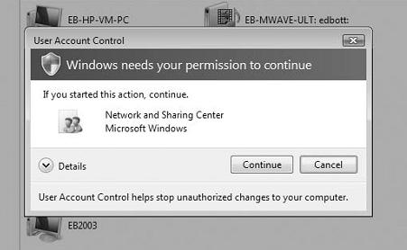
Preventing Unsafe Actions with User Account Control (UAC)

Administrator accounts have two tokens: one normal, one with administrator privileges

Elevating privileges requires clicking on a User Account Control box

What Triggers UAC Prompts

Installing and uninstalling applications

Installing device drivers

Unless they are in the Driver Store

Installing ActiveX Controls

Installing Windows Updates

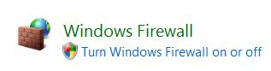
Changing settings for Windows Firewall

Changing UAC settings

Configuring Windows Update

Adding or removing user accounts

Changing a user’s account type

Configuring Parental Controls

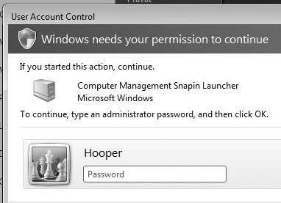
Running Task Scheduler

Restoring backed-up system files

Viewing or changing another user’s folders and files

Shield Icon

Indicates actions that will require privilege escalation

If you are logged in as a Standard User

The “credentials prompt” will ask for administrator credentials

Secure Desktop

The greyed-out desktop that forces you to respond only to the User Account Control box

Prevents other programs from running during this important process

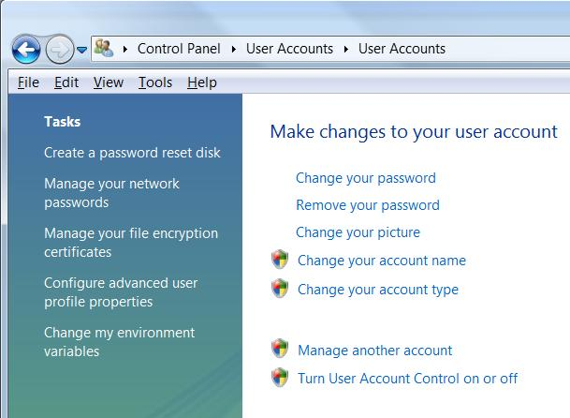
Disabling UAC

Control Panel, User Accounts, User Accounts, Turn User Account Control on or off

Puts your computer at risk

Working Around UAC Without Disabling It

Use an administrator Command Prompt window

No further elevation will be needed

Run as a standard user

Fewer elevated options will appear

Use the “Administrator” account

Disabled by default

Not affected by User Account Control by default

Using Group Policy to Customize UAC

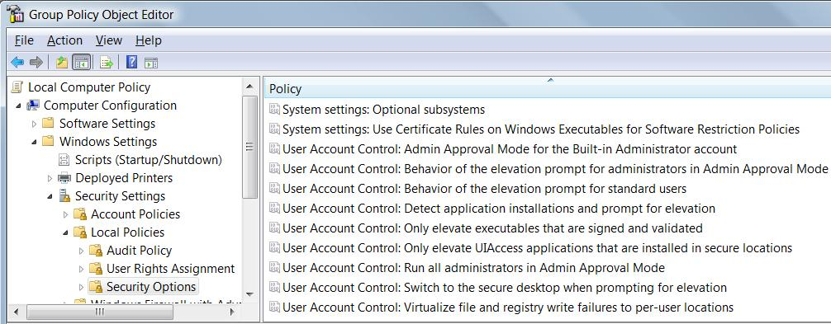
Start, GPEDIT.MSC

Monitoring Security

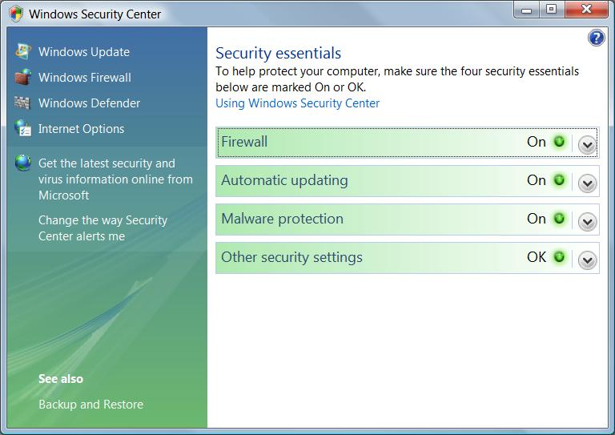
Security Center in Control Panel

Multiple Security Programs

Running two antivirus applications at the same time can freeze your computer

Two firewalls can be hard to manage, but usually doesn’t crash the machine

Two antispyware applications is commonly done and does no harm

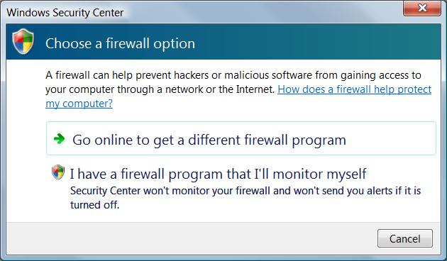

Unrecognized Software

If your security software is not recognized, you can turn off the Security Center alerts

To see this message, turn off Windows Firewall and click “Show me my available options” in the Firewall section of Security Center

Blocking Intruders with Windows Firewall

You should always run a personal firewall on your computer

Even when you work behind a corporate or home firewall

To protect you from your neighbors on the LAN

Laptops, USB flash memory sticks, etc. can bring infections inside your firewall

Windows Firewall

Filters incoming traffic only, by default

Stateful-inspection packet filtering

Remembers the requests you made recently

Allows incoming traffic only if you requested it

You can set exceptions to allow unsolicited incoming traffic

This is safer than stateless firewalls

They filter only by IP address, port, or protocol

New Windows Firewall Features

Can filter outgoing traffic

Windows Firewall With Advanced Security console allows many more settings

Exceptions can be configured for

Services

Active Directory accounts and groups, and more

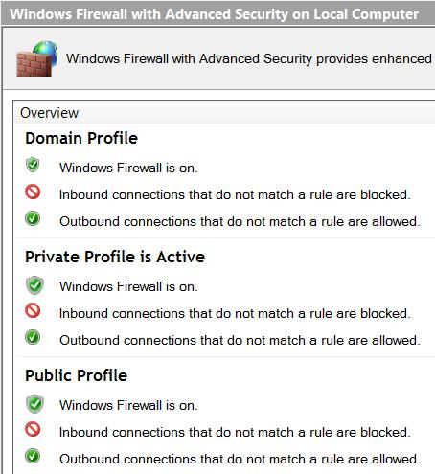
Three separate profiles

Domain, Private non-domain, or Public

Tools for Managing Windows Firewall

Windows Firewall, in Control Panel

Windows Firewall With Advanced Security

A snap-in for Microsoft Management Console (MMC)

Group Policy Object Editor

Available only in Business, Enterprise, and Ultimate editions

The Netsh utility

Command-line tool

Firewall Profiles

Domain

Your computer is joined to an Active Directory domain

Firewall settings usually controlled by settings on the Domain Controller

Private

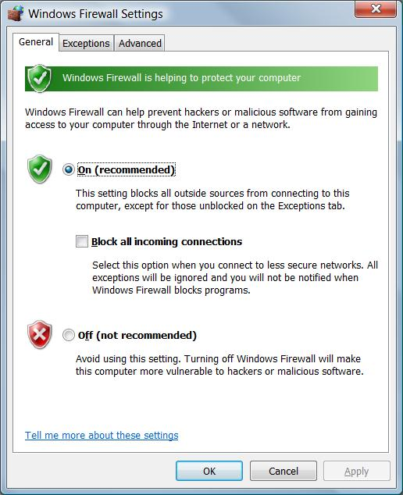
Your computer is connected to a Home or Work network in a workgroup configuration

Public

Airport, library, coffehouse, etc.

Firewall Profiles

Press Logo key

Enter "firewall"

Open "Windows Firewall with Advanced Security"

Notice that the profile you are using now is marked "Active"

Windows Firewall Settings

In Control Panel, in "Security" section, click "Allow a program through Windows Firewall"

Here you are controlling only the current profile

Demo: Turn off firewall, observe the change in "Windows Firewall with Advanced Security"

Allowing Connections Through the Firewall

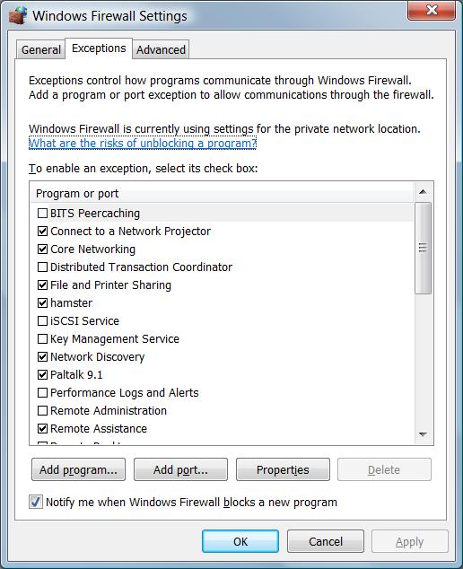
You will need exceptions any time you want your computer to act as a server

Print server

File Server

Windows Meeting Space

Games

All these functions require your computer to accept unsolicited incoming traffic

Exceptions

Checking a box here lets a program through the firewall

If the item you need is not visible, use the "Add program…" or "Add port…" buttons

Firewall Alerts

Clicking "Unblock" on this alert does the same thing as checking the box on the Exceptions tab

Windows Update

Start, All Programs, Windows Update

Updating Many Computers

If you have a network of computers at a business, automatic updates are not the best practice

It ties up your Internet connection

Not all machines get the same updates at the same time

Some updates may be harmful to your software, so you want to block them

Microsoft Update Catalog

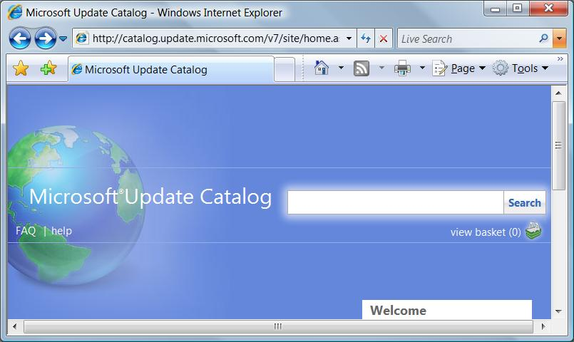
Link Ch 10b

Stand-alone installable versions of each update for Windows

Includes "all supported versions"

BUT try searching for MS04-011, no Win 2000 updates appear

See link Ch 10c

Windows Server Update Services
(WSUS)

Runs on Windows Server 2003 or 2008

Downloads updates from Microsoft

Computers get updates from the WSUS server, not Microsoft

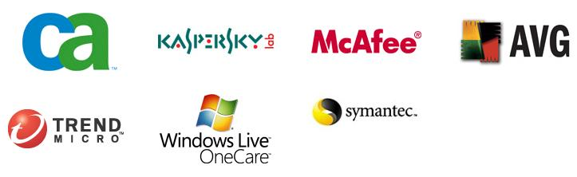
See link Ch 10d

Antivirus Software

Microsoft recommends these vendors for Vista antivirus software

For details, see link Ch 10e

For independently certified antivirus products, see link Ch 10f

Cleaning an Infected System

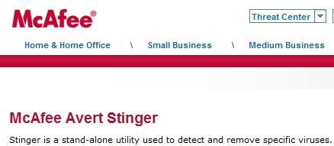
Microsoft's Malicious Software Removal Tool (MSRT)

Link Ch 10g

McAfee Stinger

Link Ch 10h

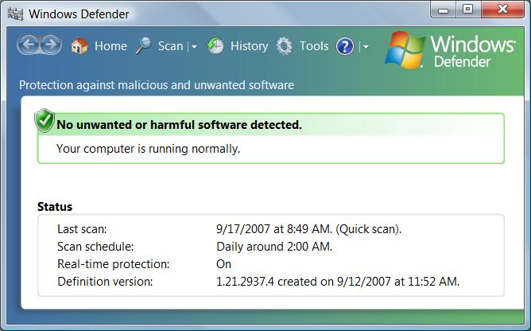
Stopping Spyware with Windows Defender

Spyware causes things like:

Unexpected new toolbars, favorites, and links in your web browser

Changes to your browser’s home page and default search provider

Numerous pop-up ads

Sudden occurrence of computer crashes or slow performance

Windows Defender

Press Logo key, type in DEF

Scans each day, by default

Real-Time Protection

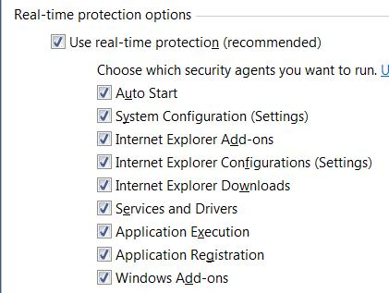
In Windows Defender, Tools, Options
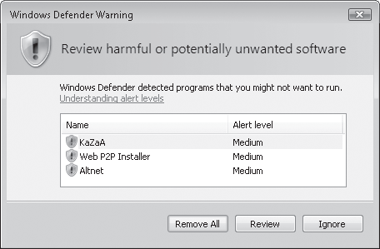

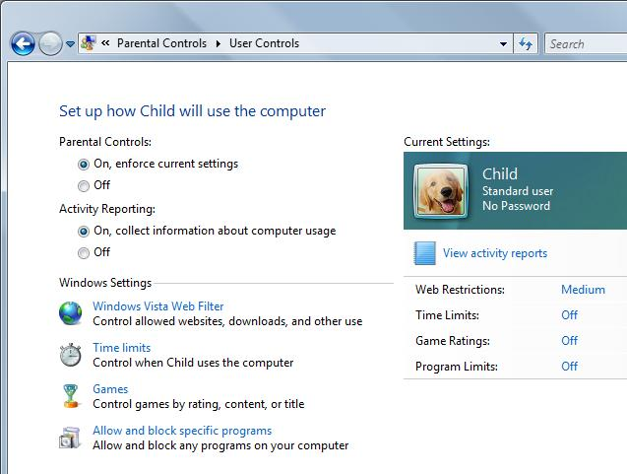

Parental Controls

Only in Home Basic, Home Premium, and Ultimate Editions

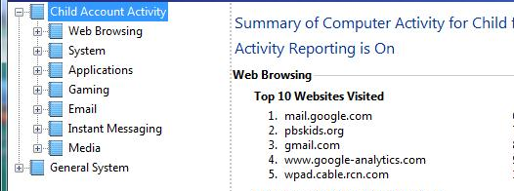

Activity Viewer

Last modified 9-18-07
3 pm

