Ch 11: User Accounts, Passwords, and Logons

Editions

Local Users and Groups is not available in the Home editions

User Accounts in Control Panel is slightly different in the business and home editions

Local Security Policy is not available in the Home editions

Introducing Windows Security

Vista uses discretionary security

Each file, printer or other object has an owner

The owner decides who can use the object

Most security features require NTFS disk format, not FAT32

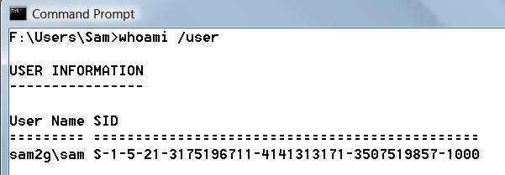
Security Identifiers (SIDs)

Each user account has a SID that uniquely identifies it

For well-known SIDs, see link Ch 11a

Tokens

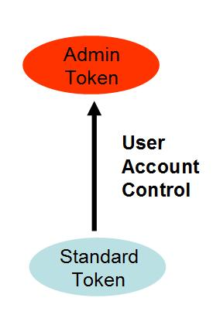
When you log on, you get a security access token

An electronic ID card

Includes your User Name, SID, and groups you belong to

Each program you launch gets a copy of your security access token

Administrators Get Two Tokens

Each time you use a printer, file, or other limited-access object

Your token is compared to the access control list

User Account Control escalates the Standard Token to the Administrator Token

Permissions and Rights

Permission

The ability to access a particular object in some defined manner

for example, to write to an NTFS file or to modify a printer queue

Right

The ability to perform a particular systemwide action, such as logging on or resetting the clock

Owners and Administrators

The owner of a resource assigns permissions

To the resource via its properties dialog box

Administrators set rights

Via the Local Security Policy console

Available only in Business, Enterprise, and Ultimate editions of Windows Vista

In the home editions, rights for various security groups are predefined and unchangeable.

Privileges

Serves as an informal term encompassing both permissions and rights

Account Types

Account Types are a convenience to describe memberships in the most frequently-user groups

Administrator accounts are in the Administrators group

Standard accounts are in the Users group

Guest accounts are in the Guests group

Tasks Only Administrators Can Perform

Create, change, and delete user accounts and groups

Install and uninstall programs

Configure automatic updating or install Windows updates manually

Install an ActiveX control

Install or remove hardware device drivers

Share folders

Set permissions

Access all files, including those in another user’s folder

Take ownership of files

Copy or move files into the %ProgramFiles% or %SystemRoot% folders

Restore backed-up system files

Grant rights to other user accounts and to themselves

Configure Parental Controls

Configure Windows Firewall

Tasks Available to Standard Users

Change the password and picture for their own user account

Use programs that have been installed on the computer

Install approved ActiveX controls

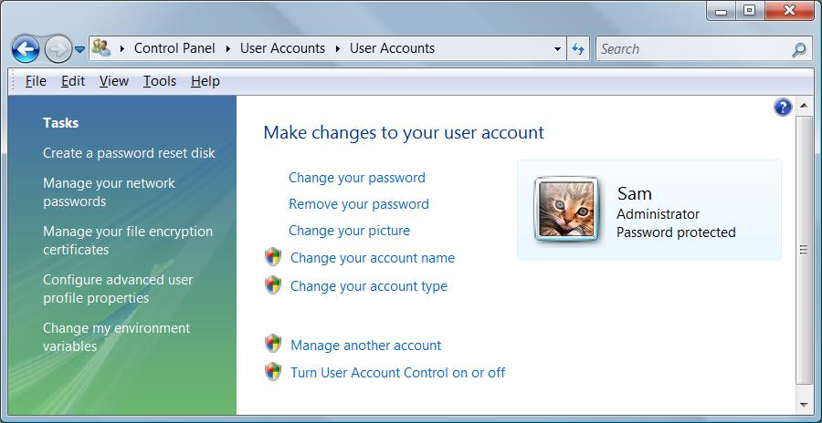
Configure a secure Wi-Fi connection

View permissions

Create, change, and delete files in their document folders and in shared document folders

Restore their own backed-up files

View the system clock and calendar, and change the time zone

Configure power options

Log on in Safe Mode

Guests

Guests have privileges similar to Standard accounts

Guests cannot create a password

Working with User Accounts

Control Panel, User Accounts, User Accounts

Or Start, and click Picture at top of Start Menu

Only shows Administrators, Users, and Guests

Other Groups

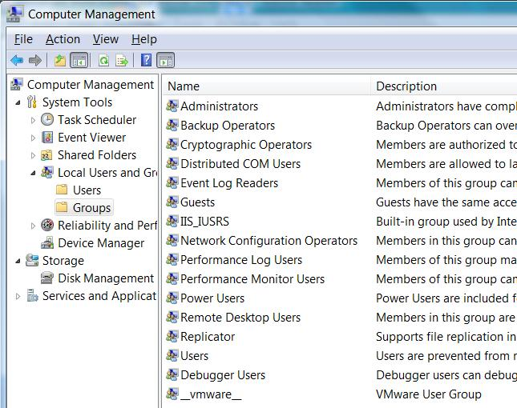
In Computer Management, in Local Users and Groups

Shows many other groups

Accounts in them won't appear in Control Panel's User Accounts

Permissions and Rights are Cumulative

If a user account belongs to more than one group

That accounts gets all the privileges from all the groups

Local Accounts and Groups vs Domain Accounts and Groups

Local Accounts are set up on each computer independently

In a Workgroup—a network without a domain

Recommended for networks with less than ten computers

Domain Accounts are set up on the domain controller

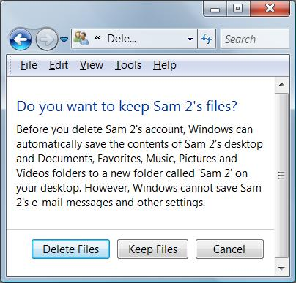
A server running Windows NT Server, Server 2000, Server 2003, or Server 2008

Working with User Accounts

Password reset disk

Network passwords

Encryption certificates

Advanced profile properties (roaming profile)

Deleting an Account

When you delete an account, you get this choice

That user's SID is gone forever

Effects of Deleting an Account

If there are files only that user has NTFS permissions to use

The Administrator can Take Ownership to gain access

If that user had encrypted files with Encrypting File System

Those files are lost forever, unless a Recovery Agent had been configured previously

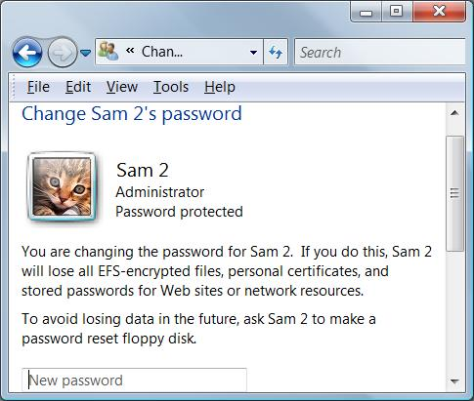
Changing a Password

Changing your own password is easy

In User Accounts

Administrators can change passwords for other accounts

EFS-encrypted files will be lost

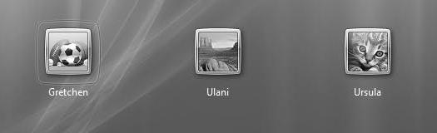

Managing the Logon Process

In a workgroup, a computer shows several login icons

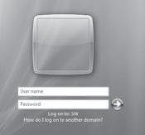

In a domain, you must first press Ctrl+Alt+Delete

Then you see one icon, with a Switch User button

Bypassing the Logon Screen

If your computer has only one account

aside from built-in accounts, such as Administrator and Guest

And if that account doesn’t have a password

Windows Vista automatically logs on as that user during startup

Logging Off, Switching Users, or Locking Your Computer

Log off

All your programs close

Switch users

Your programs continue to run

Your account is still logged on

Lock your computer

Your programs continue to run

The logon screen appears so that no one can see your desktop or use the computer

What Happened to the Administrator Account?

It's disabled by default

You can enable it in Computer Management

But it's best to just leave it disabled

Advanced Account Setup Options

User Accounts in Control Panel

At a Command Prompt, enter

control userpasswords

Advanced User Accounts

At a Command Prompt, enter

control userpasswords2
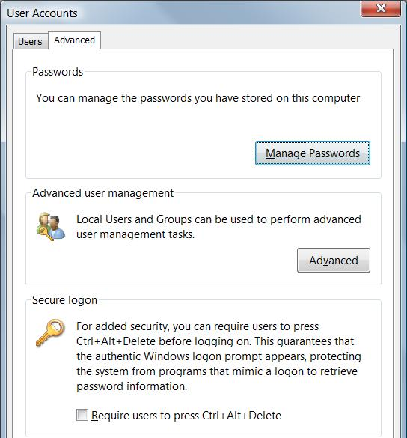
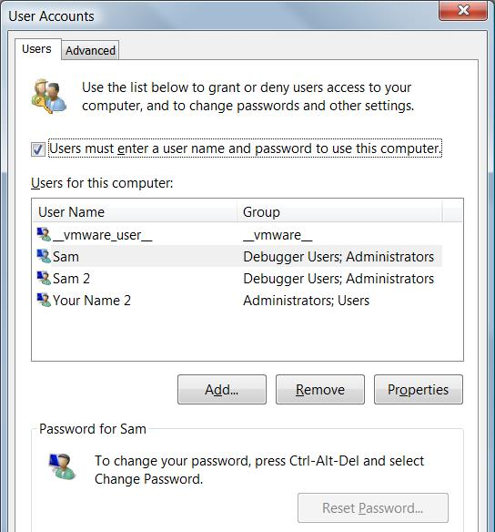

Local Users and Groups in MMC

Right-click Computer, Manage

Command-line tools

NET USER

NET LOCALGROUP

Ch 12: Setting Up a Small Network

Workgroup

This chapter is discussing a workgroup, not a domain

Recommended for 10 or fewer computers

No domain controller required

Capabilities of a Small Network

Shared storage

Shared printers

Shared internet connection

Not often used, it's usually better to use a hardware router

What’s New in Windows Vista

Next Generation TCP/IP stack

Improvements in security, performance, and convenience that are largely invisible to ordinary users

Windows Filtering Platform can filter at all levels of the TCP/IP protocol stack

Receive Window Auto-Tuning improves performance

IPv4 and IPv6 are incorporated in a single Windows driver and both enabled by default

See link Ch 12a

New Networking Features

Windows Connect Now

Simple and secure configuration of wireless access points, computers, printers, and other wireless devices

Link Layer Topology Discovery (LLTD) protocol

Used to create the network map

Plug and Play Extensions (PnP-X)

Enables discovery and configuration of network-connected devices

Using Network And Sharing Center

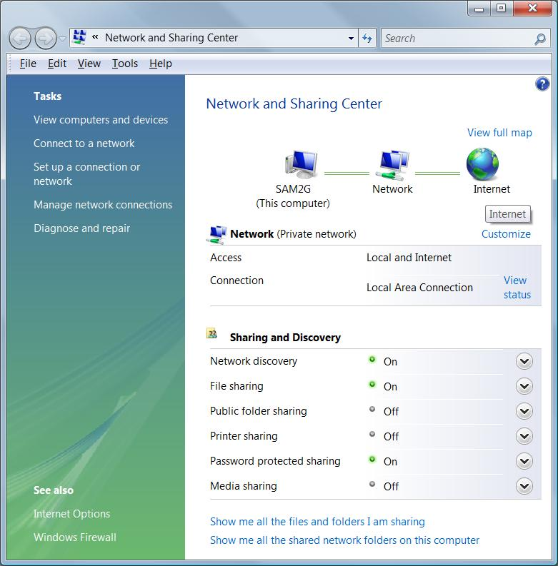
To open it:

Start, begin typing network

Control Panel, Network And Internet, Network And Sharing Center.

In the notification area, click the Network icon and then click Network And Sharing Center.

Network adapters

Each computer needs an adapter (also called a network interface card, or NIC)

Network adapters can be internal (usually installed in a PCI slot) or external (typically connected to a USB port)

Ethernet is the most popular by far

Pic from Network+ Guide to Networks, Second Edition by Tamara Dean

Hubs

A hub or switch can be used to connect the computers in an Ethernet network

To connect two computers, you can use a crossover cable and no hub

Router

You can also use a router or residential gateway, which typically adds network address translation (NAT) capabilities and security features

Wireless Network Access Point

On wireless networks, a wireless access point handles these duties

Cables

On an Ethernet network, eight-wire Category 5 patch cable with RJ-45 connectors on each end

Installing and Configuring Network Adapters

Happens automatically for Plug and Play adapters

Ethernet, Wireless, or Phone Line?

Three popular technologies, all supported by Windows Vista

Ethernet/Fast Ethernet/Gigabit Ethernet

10, 100 or 1000 Megabits per second

Wireless

IEEE 802.11b, also known as Wi-Fi -- 11 megabits per second

IEEE 802.11g or 802.1a -- 54 Mbps

IEEE 802.11n (draft) – 300 Mbps claimed

Phone Line

Uses normal phone lines, no hub or router

Home Phoneline Networking Alliance (HomePNA) -- 10 megabits per second

HomePNA 3 claims 128 megabits per second

Making Connections: Cables and Hubs

Place the hub in a central location

The segment length (distance between furthest points) should not exceed 100 meters (328.1 feet)

All the ports are the same on a hub, except the uplink port

Uplink ports are used to expand a network’s capacity by connecting two hubs

The uplink port achieves the same purpose as a crossover cable

Making Connections: Cables and Hubs

In addition to (or in place of) a hub, your network may use a router, switch, or residential gateway

Often used to share a fast Internet connection

If you plan to use Internet Connection Sharing and you have an external DSL or cable modem, you’ll need to install two network adapters in the computer with the shared Internet connection

Typical Network

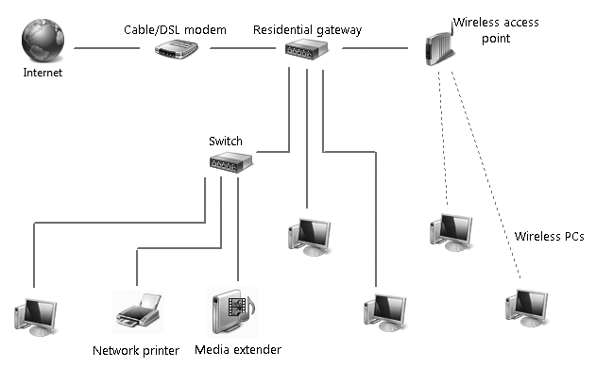

The gateway often includes the switch and the wireless access point

Understanding Security for Wireless Networks

Risks:

Theft of service

Denial of service

Overwhelming your connection with traffic

Privacy violations

Listening to traffic through your connection

Theft or destruction of data

Entering shared folders

Network takeover

Installing a Trojan to allow remote control of your systems

Wireless Security Options

Wired Equivalent Privacy (WEP)

Old and broken, has mathematical flaws

Hackers can break into a WEP network easily

Wi-Fi Protected Access (WPA)

Much safer than WEP

Uses a pre-shared key from 8 to 63 bytes long

Wi-Fi Protected Access 2 (WPA2)

Strongest protection

Open Wi-Fi Network

If you just buy Wi-Fi devices and turn them on, you get an "open" network

Completely insecure

Anyone nearby can use it

Convenient, but risky

Security at the Wi-Fi Access Point

Change the administrator password to a non-default value

Use a non-default network name (SSID)

Disable remote administration

Upgrade the firmware

Restrict access to computers with known MAC addresses

Use virtual private networks for wireless connections

RADIUS

On larger networks with one or more domain servers available

Set up a Remote Authentication Dial-In User Service (RADIUS) server

This allows the most secure option of all: 802 1x authentication

In addition, consider enabling Internet Protocol Security (IPsec)

Connecting to a Hidden Network

Some wireless networks don’t broadcast their SSID

This does not make your network more secure, because the SSID is still sent in the data packets and hackers can easily capture it

You can still connect, by entering the SSID manually (see pages 468-469 in the textbook)

Sharing an Internet Connection

To share an Internet connection safely on a small network, you have two options:

Install a router or residential gateway

The simplest and most secure method

Use Internet Connection Sharing (ICS)

Rarely done these days, nearly obsolete

Exploring the Network

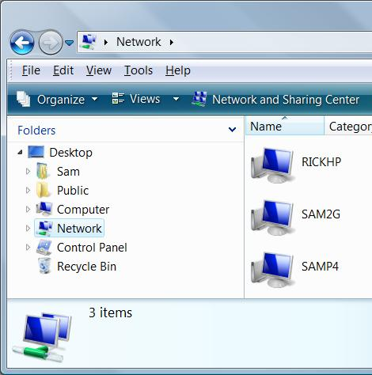
Start, Network

Location and Discovery

When you first connect to a network

You must choose a network location

If Network Discovery is turned off, you can't see other computers and shared devices

And they can't see you

Turning on Network Discovery

Start, Network

Click "Network and Sharing Center"

Turn on Network Discovery in the "Sharing and Discovery" section

Access Network Resources Without Network Discovery

Start button, then type in UNC path, starting with two back-slashes

Examples:

\\192.168.1.3

\\Server1
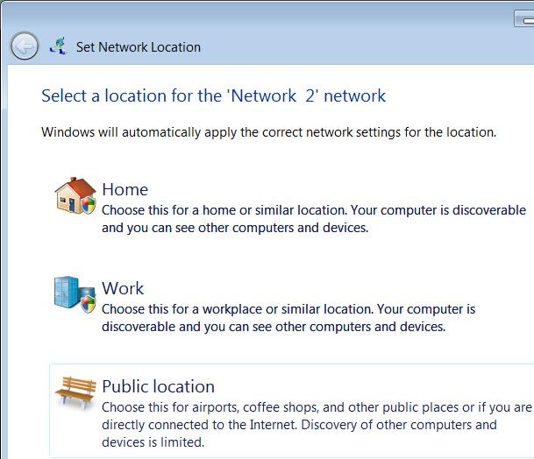

Understanding Location Types

When you first connect to a network, this box appears

Location Types

Home or Work

Have the same effect, just a different icon

A trusted network

Turns on Network Discovery

Uses the Private Windows Firewall profile

Public Location

Such as wireless hotspots in coffee shops

Turns off Network Discovery

Uses the Public Windows Firewall profile

Setting the Workgroup Name

Start, right-click Computer, Properties, "Change settings"

However, the workgroup name is unimportant in Vista

Managing Network Connections

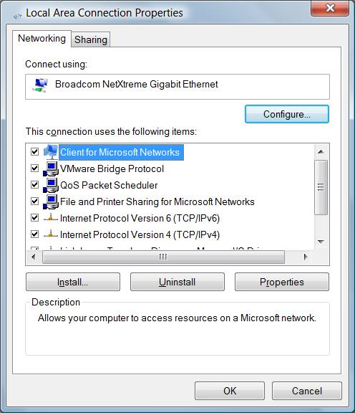
Start, Network

Click "Network and Sharing Center"

Click "Manage Network Connections"

Right-click a connection, Properties

Network Connection Components

Client For Microsoft Networks

Allows you to connect to Windows computers

QoS Packet Scheduler

Quality Of Service – will be important when we switch to Internet Protocol version 6 (IPv6)

File And Printer Sharing For Microsoft Networks

Allows your computer to be a file or print server

Internet Protocol Version 6 (TCP/IPv6)

The new Internet protocol, not widely used in the USA yet

Internet Protocol Version 4 (TCP/IPv4)

The primary Internet protocol in current use

Link-Layer Topology Discovery Mapper I/O Driver

Used to create the network map

Link-Layer Topology Discovery Responder

Also used to create the network map

IP Addresses

On a TCP/IPv4 network, every computer has a unique IP address

Four 8-bit numbers

(In decimal format, a number between 0 and 255)

Separated by periods

Example: 147.144.1.2

TCP/IP configuration has three additional settings:

Subnet Mask

Default Gateway

DNS Server

Subnet Mask, Default Gateway, DNS Server

Subnet mask

Tells the network how to distinguish between IP addresses that are part of the same network and those that belong to other networks.

Default Gateway

A computer that can send packets outside the local network

Domain Name System (DNS) Servers

Computers that translate domain names (such as www.microsoft.com) into IP addresses

Methods For Assigning IP Addresses

Dynamic Host Configuration Protocol (DHCP)

The most common method

IP configuration is set automatically by the server

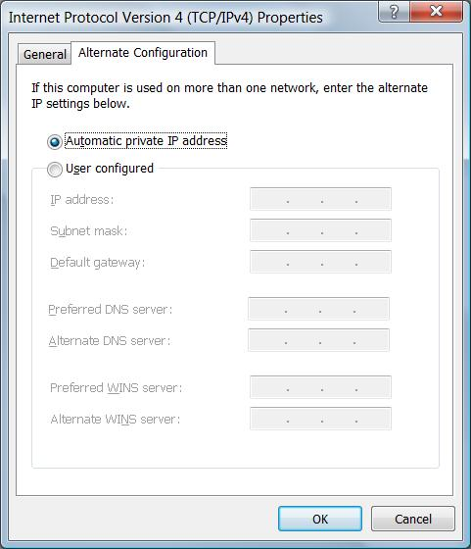
Automatic Private IP Addressing (APIPA)

If DHCP fails, the machines make up their own addresses starting with 169.254.

Static IP Addressing

Administrator must manually type in the IP address for each machine

Servers typically use static IP addresses

Requires more administrative effort and not commonly used for workstations anymore

Alternate IP Configuration

You set the address used if DHCP fails

Useful for a laptop that travels between two different LANs

Start, Network

Click "Network and Sharing Center"

Click "Manage Network Connections"

Right-click a connection, Properties

Click "Internet Protocol Version 4 (TCP/IPv4)", Properties

Public IP Addresses

Like public telephone numbers

Every computer that is directly connected to the Internet needs one

Your Internet service provider assigns you a public IP address

Dynamic IP Address

Common for dial-up connections

Each time you connect, your ISP assigns a different IP address to your computer

Static IP Address

Common for cable or DSL connections

Your IP address never changes

Private IP Addresses

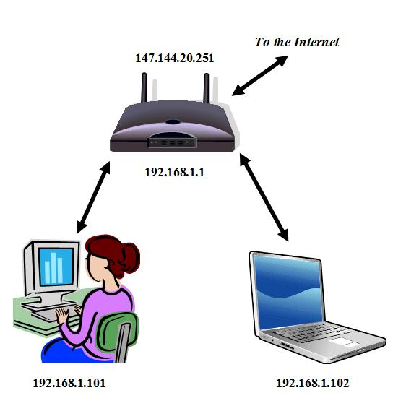
A whole network can share a single Public IP Address

Better Security

Lower Cost

Each of the computers on the local network has a Private IP Address that is not reachable from the outside world.

Router uses network address translation (NAT) to pass packets back and forth between the single public IP address and the many private IP addresses on the network

Reserved Private IP Addresses

The Internet Assigned Numbers Authority (IANA) has reserved these ranges for Private IP Addresses:

10.0.0.0 – 10.255.255.255

172.16.0.0 – 172.31.255.255

192.168.0.0 – 192.168.255.255

Understanding IPv6

IPv6 addresses are 128 bits rather than 32

The :: indicates a lot of zeroes omitted

Vista prefers IPv6 and uses IPv4 only when necessary

Which is almost all the time, in the USA

See link Ch 12b

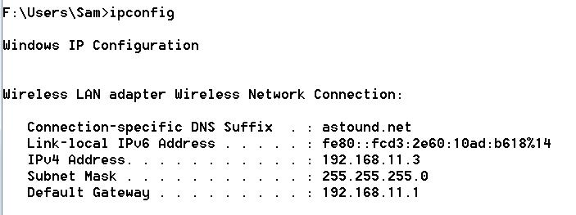

Last modified 9-25-07 7 pm

