Ch 13: Managing Shared Folders and Printers

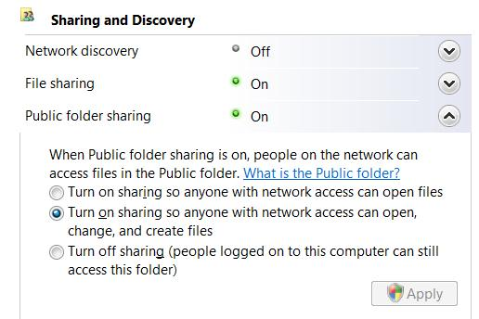
Editions

Sharing is the same in all editions

Print Management console is not available in Home Basic and Home Premium

But all its functionality is available in other tools

This Chapter Covers Workgroups Only

In this chapter, we describe resource sharing as it applies in a workgroup environment

We do not cover sharing in a domain-based environment

Public folder sharing

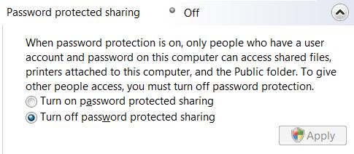
Files in the Public folder and its subfolders

Available to anyone who can log on to your computer

Use "Public folder sharing" in "Network and Sharing Center" to control network access

Password Protected Sharing

Also in "Network and Sharing Center"

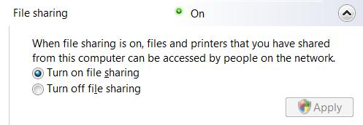
"Any Folder" Sharing

Also in "Network and Sharing Center"

Allows you to share folders or files outside the Public folder

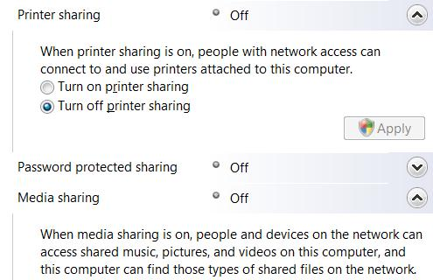
You can specify which users can access the shared data, and assign privileges

Printer and Media Sharing

Also in "Network and Sharing Center"

Simple File Sharing is Gone

Windows XP's "Simple File Sharing" is gone

The Network and Sharing center is the new technique to control sharing

Windows 9x Folder Passwords

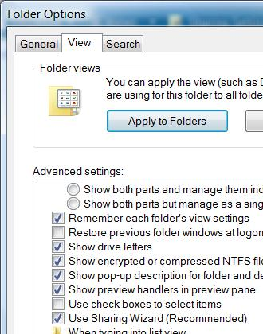
Windows 95/98/Me used share-level access control

Passwords (one for read-only access and one for full access) were assigned to each shared resource

Vista does not use that method

Configuring Your Network for Sharing

Give all computers the same workgroup name

Optional if all the computers have Vista

Set the network’s location type to Private

Turn on Network Discovery

Select sharing options

In the "Sharing And Discovery" section of "Network And Sharing Center"

Set up user accounts

The Sharing Wizard

The Sharing Wizard is enabled by default

In Folder Options, on the View tab

Open Folder Options with Start, FOL
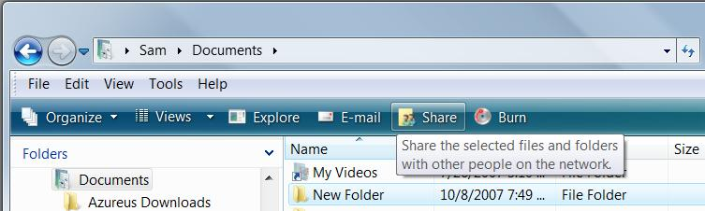

Using the Sharing Wizard

In Explorer, select the folders or files you want to share

Click the Share button

Using the Sharing Wizard

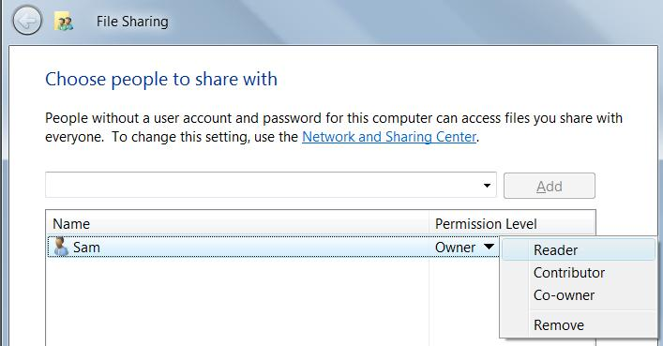
Reader has Read & Execute permission

Contributor has Modify permission for a folder

Co-owner has Full Control
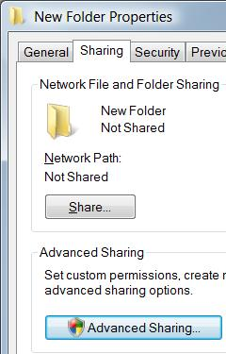

Setting Advanced Sharing Properties

Right-click a folder, Properties

Sharing tab

"Advanced Sharing"

Advanced Sharing

Limit number of users

Specify sharing permissions

Subfolders will also be shared
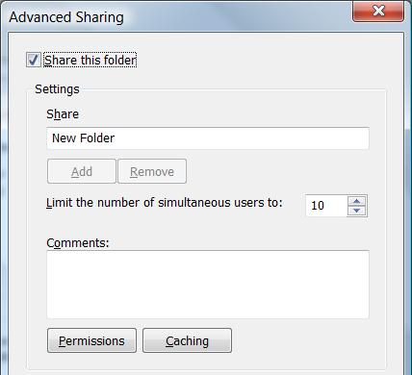
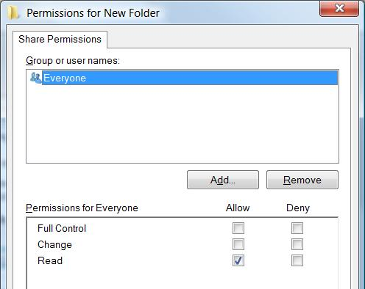

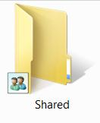
Share Permissions and NTFS Permissions Work Together

Share permissions control network access to a resource

Share permissions have no effect if you log on locally

NTFS permissions control access to a file or folder

They apply both to network and local access

Example: Sharing and NTFS Permissions

When connecting over the network

Joe has Read access

The Share permissions limit his access
Share Permissions
Joe Read

NTFS Permissions
Joe Full Control

When Joe logs on locally

Joe has Full Control access

The Share permissions don't matter

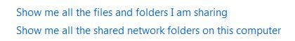
Managing Shared Folders

These two links at the bottom of Network and Sharing center make it easy to see all shared folders

The Shared Folders Snap-In

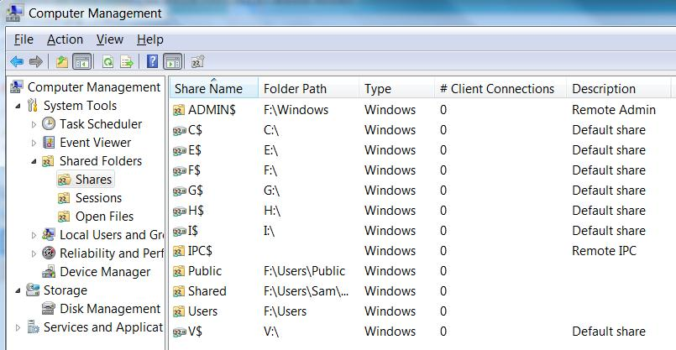
Start, right-click Computer, Manage

Administrative Shares

Created by Windows automatically

C$, D$, E$, …

Used by backup programs

ADMIN$

Used during remote administration

IPC$

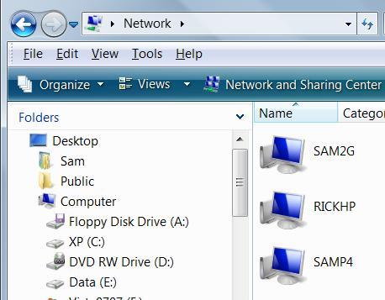
Used when viewing a remote computer's resources

PRINT$

Used for remote administration of printers

Accessing Shared Folders

Start, Network

Double-click a computer to see shares

Right-click a share to map a drive

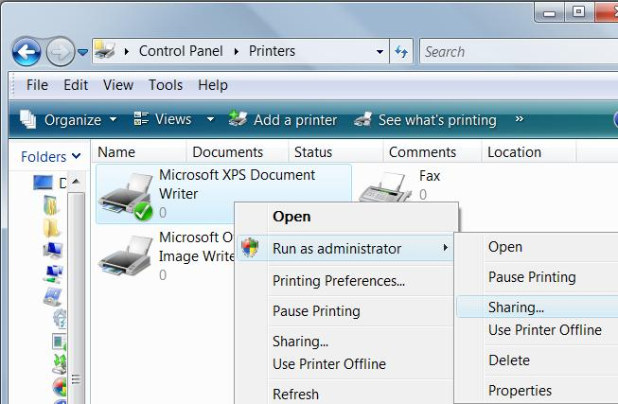

Sharing a Printer

Right-click a printer

Run as administrator

Sharing

Setting Permissions on Shared Printers

When you set up a printer, initially all users in the Everyone group have Print permission for documents they create

Provides access to the printer

Ability to manage their own documents in the print queue

And by default, members of the Administrators group also have Manage Printers and Manage Documents permission

Printer Permissions and Privileges

Print

Print documents

Control properties of owned documents

Pause, restart, and remove owned documents

Manage Printers

Share printer

Change printer properties

Remove printer

Change printer permissions

Pause and restart the printer

Manage Documents

Pause, restart, move, and remove all queued documents

Hours of Availability

The Advanced tab of the printerfs properties dialog box

Always Available and Available From

Priority and Drivers

Priority

If you create multiple printers for a single print device, documents sent to the printer with the higher Priority setting print ahead of those sent to the other printer

Driver

Shows all installed printer drivers

Spooling

Spool settings

A Spooled document is spooled to a hard disk before sending it to the printer

Spooled documents are then sent to the print device in the background

Spooling

Hold Mismatched Documents

Typically occurs when a required paper size is unavailable

Print Spooled Documents First

Saves time by printing documents that are ready first, even if they are lower-priority

Keep Printed Documents

Spooler doesn't delete documents from the queue after they print

Command-Line Utilities for Managing Shared Resources

Net Share

The Net Share command lets you view, create, modify, or delete shared resources on your computer.

Net Use

The Net Use command connects your computer to shared resources on other computers

Chapter 14 - Tweaking and Troubleshooting a Small Network

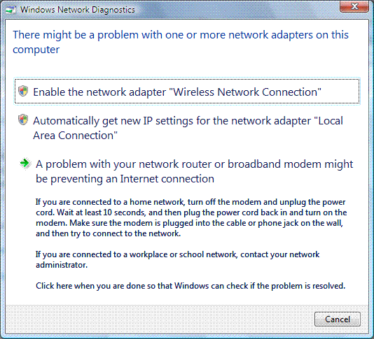
Editions

The networking features in this chapter work identically in all Vista editions

Network Diagnostics Framework (NDF)

A new Vista feature that automatically attempts to diagnose and correct network problems

Pops up boxes like this one

Link Ch 14a

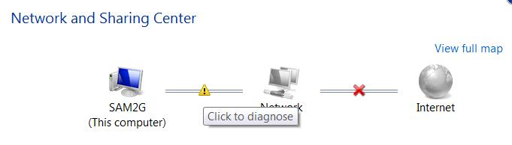

Viewing Status in Network And Sharing Center

Click the X or ! To launch Network Diagnostics

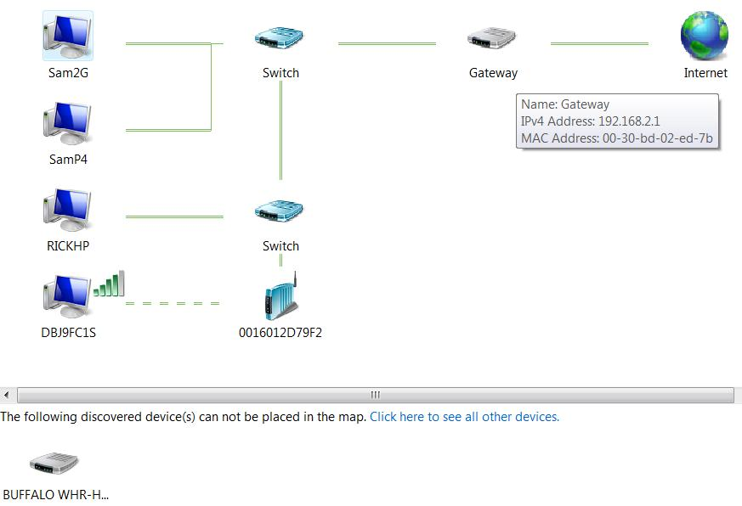

Diagnosing Problems Using Network Map

Hover over a device to see its address information

Devices in the Network Map

Devices that don't support Link Layer Topology Discovery (LLTD) appear at the bottom, including:

Win XP machines (unless you install the KB 922120 update – see link Ch 14b)

Devices that support Universal Plug and Play (UPnP) but not LLTD

Devices without network discovery turned on

Devices on a public network

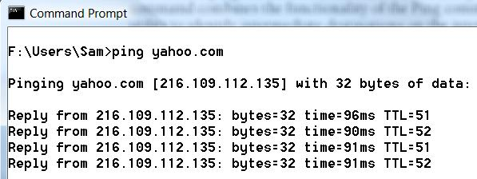
Troubleshooting TCP/IP Problems

PING an IP Address or DNS name to test connectivity

But Win XP SP2 and Vista have firewalls that block pings by default—you'll need to turn the firewalls off or allow the PINGs through first

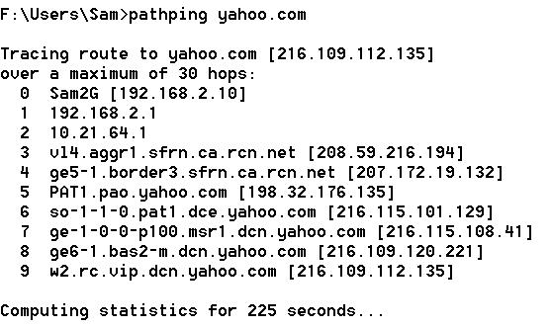
PATHPING

Finds intermediate routers

Calculates statistics

TRACERT

Sends three packets to each router on the path

Similar to PATHPING
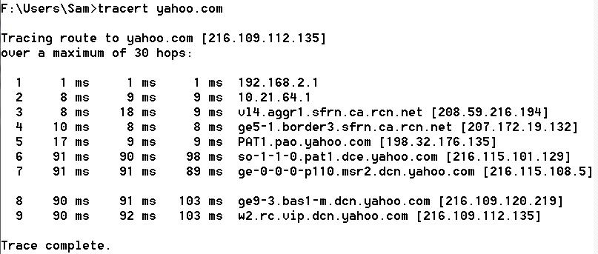

Diagnosing IP Address Problems

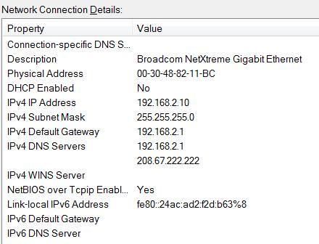
To see your IP configuration

In Network And Sharing Center, click Manage Network Connections

Double-click the icon for your connection

Click Details

Or use the IPCONFIG /ALL command at a Command Prompt

Important IP Addresses to Know

169.254.x.y

Automatic Private IP Address (APIPA)

The computer tried to use Dynamic Host Configuration Protocol (DHCP) but could not contact a DHCP Server

Make sure you are connected to the DHCP server (usually a router) and restart the machine

The IPCONFIG /RENEW command at a Command prompt works too

10.x.y.z or 192.168.x.y or 172.16.x.y to 172.31.x.y

Reserved private IP address

Normal for a computer behind a Network Address Translation (NAT) server, such as a router

But the router needs a public address on its Wide Area Network (WAN) side

You cannot connect directly to the Internet with a private address

0.0.0.0

Cable disconnected, or

IP address conflict

No networking is possible with this address

Subnet Mask

The subnet mask must be the same for all computers on your local network segment

Usually the subnet mask is one of these three

255.0.0.0

255.255.0.0

255.255.255.0

Intermediate values like 255.255.240.0 are sometimes used in large networks

Default Gateway

Traditionally uses an address ending with 1 like 192.168.0.1

All devices on a network should have the same default gateway

Unless you have a complex network with more than one router

Repairing Your TCP/IP Configuration

Automated Repair

Right-click the connection icon in Network Connections and click Diagnose

Renew your IP address

In a Command Prompt window, use

IPCONFIG /RENEW

or

IPCONFIG /RENEW6

For IPv6

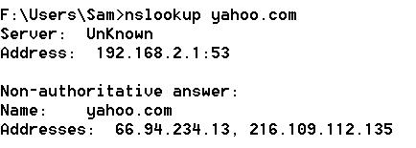
Resolving DNS Issues

Test DNS with the NSLOOKUP command

Your DNS address should be

Your router, or your ISP's DNS server

Open DNS - Free DNS Service for everyone

208.67.222.222

208.67.220.220
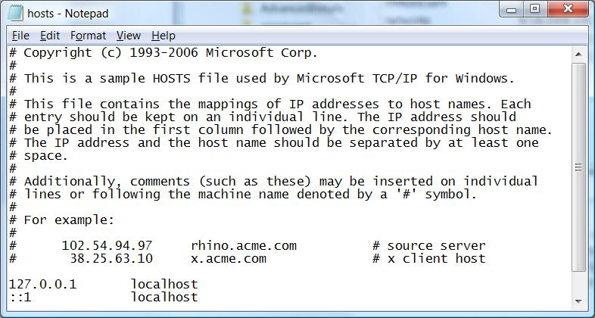

Hosts File

Malware sometimes changes the Hosts file to block websites

C:\Windows\System32\drivers\etc\hosts

DNS Cache

Windows maintains a temporary list of DNS names and IP addresses

You can clear it with this command at a Command Prompt

IPCONFIG /FLUSHDNS

Bridging Two Networks

A network bridge connects two networks together

Rarely used

Network Troubleshooting Tools

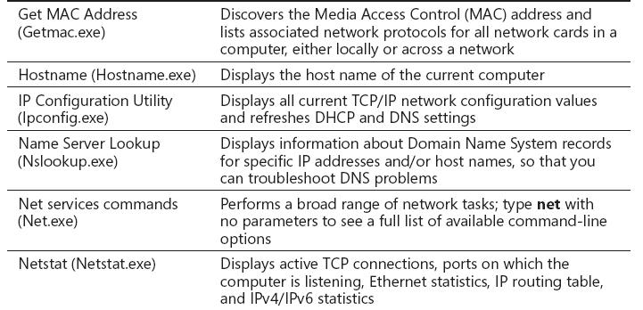

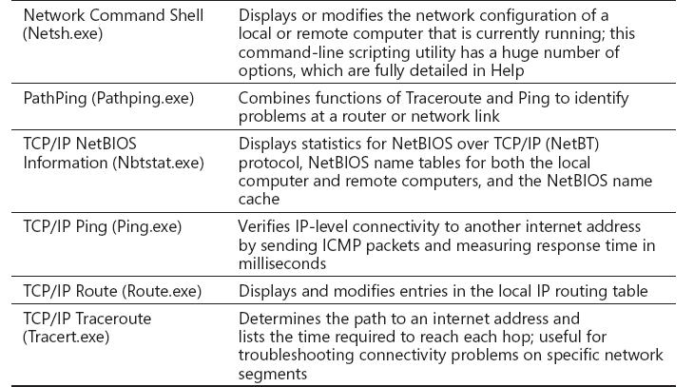

Last modified 9-25-07 7 pm

