Chapter 20 - Performing Routine Maintenance

Maintenance

Check your disks for errors.

Defragment your hard disks.

Make sure that you have enough space on your hard disk

Perform regular backups

Editions

Backup Utility in Vista Home Basic and Home Premium lacks these features:

Cannot create a Complete PC Backup

Cannot back up to a network drive

Cannot automatically schedule backups

The other things in the chapter are the same for all editions

Checking Disks for Errors

Disk errors can prevent files from opening, or cause blue-screen errors

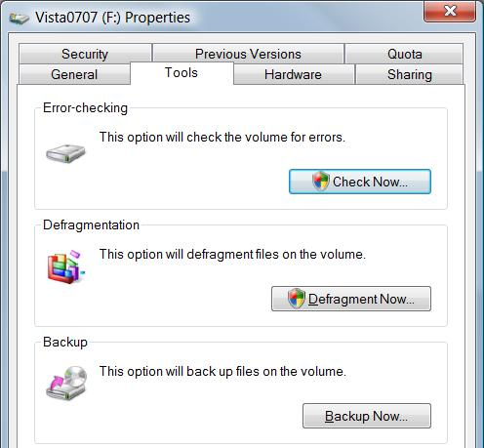
Windows can recover automatically from many disk errors, especially on drives formatted with NTFS

Windows Check Disk utility, chkdsk.exe, does a more thorough test

Two versions of this utility

Graphical version that performs basic disk-checking functions

Command-line version that provides more options

To Check for Errors

Open Computer

Right-click the drive

Properties

Tools tab

Check Now

Automatically Fix File System Errors

Equivalent to Chkdsk /F

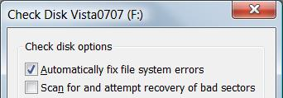
Scan For And Attempt Recovery Of Bad Sectors

Automatically repairs file system errors too, even if other box is not checked

Equivalent to Chkdsk /R

If you simply want a report of file system errors without making changes, leave both boxes unchecked

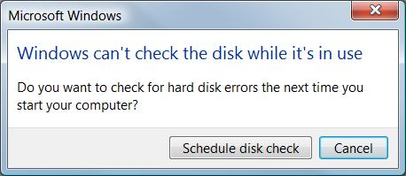
Checking System Volumes

If you selected the Automatically Fix File System Errors

On a drive with open files

The disk check occurs the next time you start Windows

It Can Take a Long Time

Once started, the Check Disk operation cannot be stopped except by pressing your computer’s power switch

On very large drives (60 GB and larger), the full disk check can takes hours or even days to complete.

Windows 9x

Check Disk runs automatically if the file system is "dirty"— data was not properly read or written

NTFS disks don’t get dirty as much as FAT32 ones

To see if your disk is dirty, use this command

chkntfs d:

See link Ch 20a

Command-line Check Disk

At an Administrator Command Prompt

Chkdsk d:

Scans disk d: in read-only mode, displaying drive status but not making any changes

Switches

/F fix any errors

/V verbose

/R Identifies bad sectors and recovers information from those sectors if possible

Chkdsk in the Windows Recovery Environment

Only two switches are available for Chkdsk in the Windows Recovery Environment

/P Performs an exhaustive check of the current disk.

/R Repairs damage on the current disk.

Defragmenting Disks for Better Performance

On a freshly formatted hard disk, Windows writes a file in contiguous clusters (in order)

Reading and writing go faster with contiguous clusters

As you delete files and save new ones, the files get fragmented

Scattered them over the hard disk into many noncontiguous pieces

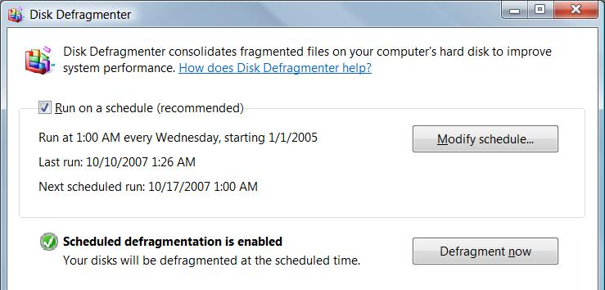
Disk Defragmenter rearranges files so that they’re stored in contiguous clusters

Automatic Defragmentaion

On the Tools tab in a drive's Properties sheet

Click "Defragment Now"

Runs once a week automatically in Vista

Third-Party Defragmenters

See link Ch 20b for a free third-party defragmenter that is claimed to be 10 times faster than Vista's built-in one

contig.exe and PowerDefragmenter

Command-Line Version Defrag

defrag d:

where d is the drive letter

switches:

-a Analyzes

-r Only consolidates file fragments below 64 MB in size (default)

-w consolidates all file fragments, regardless of size

Disk Defragmenter Limitations

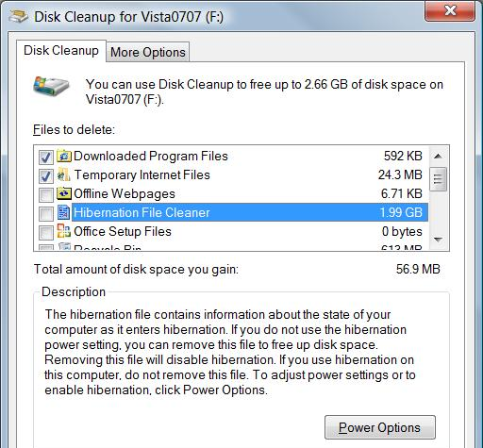
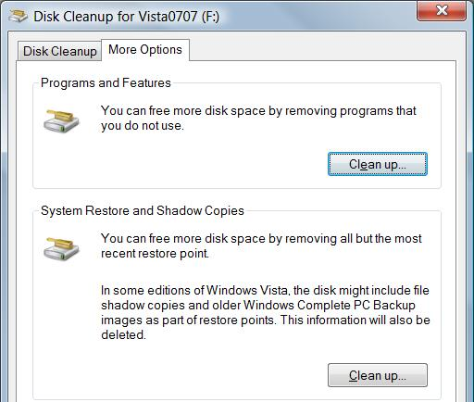
Must have at least 15 percent free for complete defragmentation

You cannot defragment a volume that has errors

First run

chkdsk d: /f

The Disk Defragmenter does not defragment files in the Recycle Bin

Empty the Recycle Bin before defragmenting

Managing Disk Space

Clear out temporary files that you no longer need

Uninstall programs you don’t need

Uninstall Windows components you don’t need

Delete documents you don’t need

On NTFS volumes, use real-time file compression

Disk Cleanup

If you click a "low disk space" warning, this tool opens automatically

To start it manually

Right-click drive icon in the Computer window, Properties, on General tab, "Disk Cleanup"

Cleanmgr.exe at a command prompt

More Disk Cleanup Options

Deleting System Restore points and backups can save space, but it's dangerous

NTFS File Compression

Compression and ZIP files can be used to save space, as we already covered in an earlier chapter

Backup

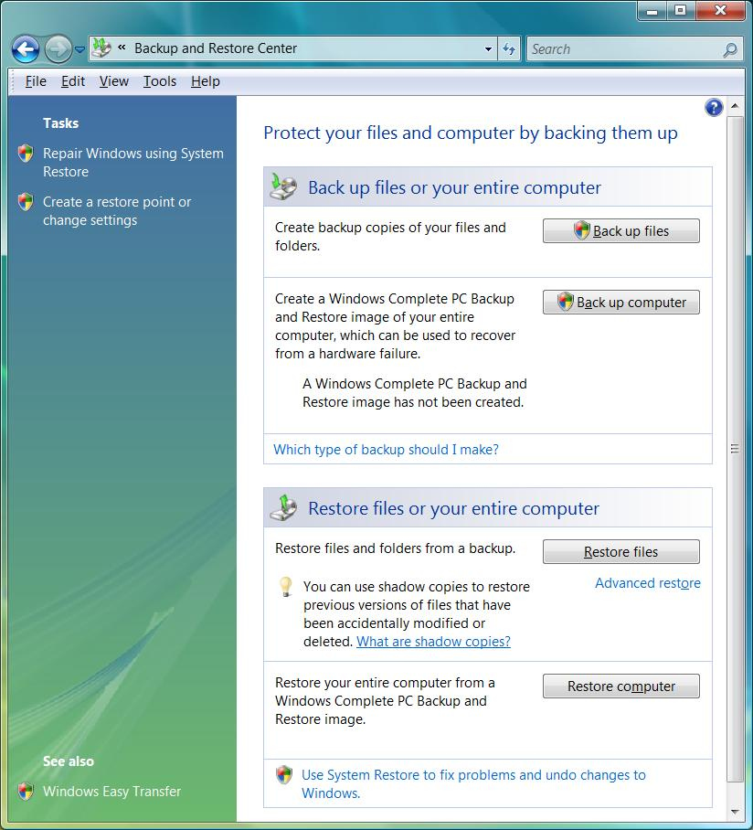
The Windows Vista Backup utility

In Control Panel

Home Editions don't offer "Complete PC Backup" option

Two Kinds of Backups

Back Up Files wizard

Backs up personal files, not programs or system files

Windows Complete PC Backup

Creates an image of your entire system drive and other drives you specify

Not available in Home Basic or Home Premium editions

Backup Status and Configuration

Another way to manage backups

Start, All Programs, Accessories, System Tools

Backup Destinations

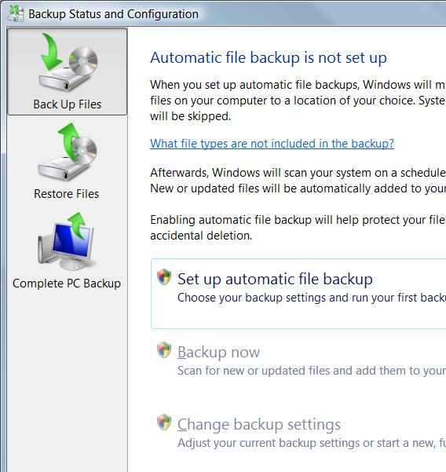
An internal hard drive

It's recommended not to use another partition on the same hard drive Vista is installed on, because a disk failure will destroy the backups

An external hard drive

USB 2.0 or IEEE 1394 (FireWire)

A shared network location

This option is not available for Complete PC backups

Not available for Vista Home Basic

Removable media, such as writable CDs or DVDs

The Backup program will prompt you to swap media as needed

Chapter 21 - Tuning Up and Monitoring Performance

Editions

All of the tools described in this chapter are available in all editions of Vista

Performance Monitoring Tools

Static snapshots

System Health Report

Windows Experience Index

Reliability Monitor

Real-time data

Windows Task Manager

Resource Overview

Performance Monitor

Performance-enhancing Technologies

SuperFetch

Adjust caching to match the way you use your computer

ReadyBoost

Uses a USB 2.0 flash memory stick or other external memory to cache

ReadyDrive

Supports hybrid hard disk drives

Containing nonvolatile flash memory (NVRAM) as well as conventional rotating disk media

Basic Strategies for Improving Performance

Ensuring that you have adequate RAM

Ensuring that you have an adequate virtual-memory configuration

Using ReadyBoost

Managing startup programs

Keeping your disks defragmented

Maintaining adequate free space on your disks

Avoiding tweaks of dubious value

Adequate RAM

“Windows Vista Capable” is 512 MB, intended for Vista Home Basic

“Windows Vista Premium Ready” is 1 GB, intended for the other editions of Vista

Double that RAM for better performance

Resource Overview

In "Reliability and Performance Monitor"

If Memory is often above 60%, you may need more RAM

A lot of hard faults also indicate a lack of RAM (frequently off the top of the graph)
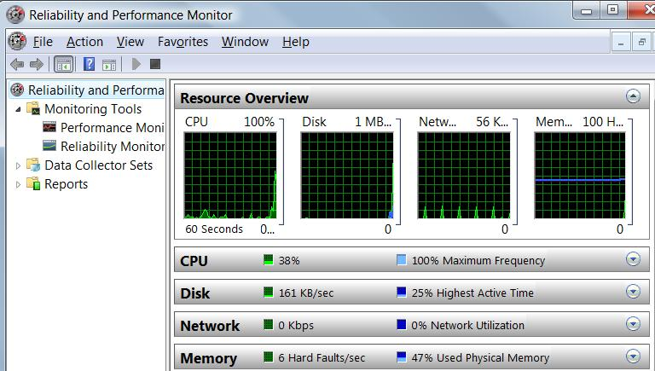

Hard Faults

A block of memory needed by the operating system has to be fetched from the page file on the hard disk

A high number of hard faults means that virtual memory is being used a lot, which slows performance drastically

Solution: get more RAM

Virtual Memory

A file on disk that is used to store data when RAM is full

Also called the "page file" or "swap file"

Starts at 1.5x the size of physical RAM

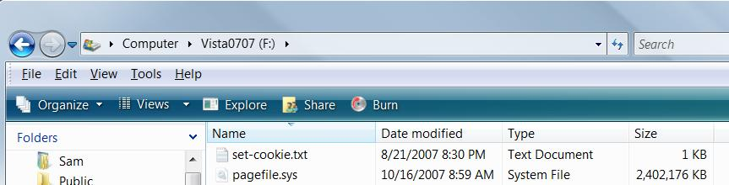
On the root of the system volume

Virtual Memory Settings

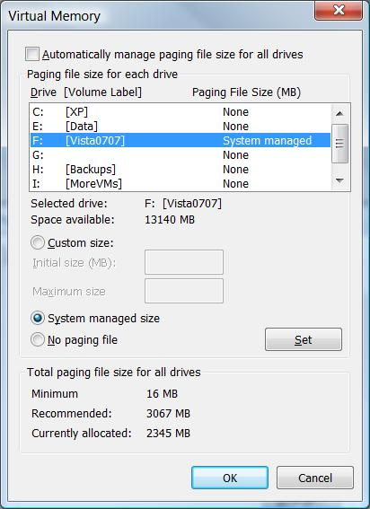
Start, right-click Computer, Properties

Advanced System Settings

In System Properties, on the Advanced tab, in the Performance section, click Settings

In Performance Options, click the Advanced tab

Click "Change"

Page File Management

If you have a second disk drive, you may get better performance by putting some page file space there

Don't bother if you have two partitions on the same physical hard drive

Leave some page file on the system drive for crash dumps

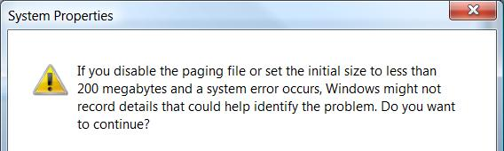

ReadyBoost

Flash memory offers lower seek times than hard disks

A USB flash memory stick can cache small files faster than a hard disk

Performance improvement seems small if you have 1 GB or more of RAM

See links Ch 21a-21d

Managing Startup Programs

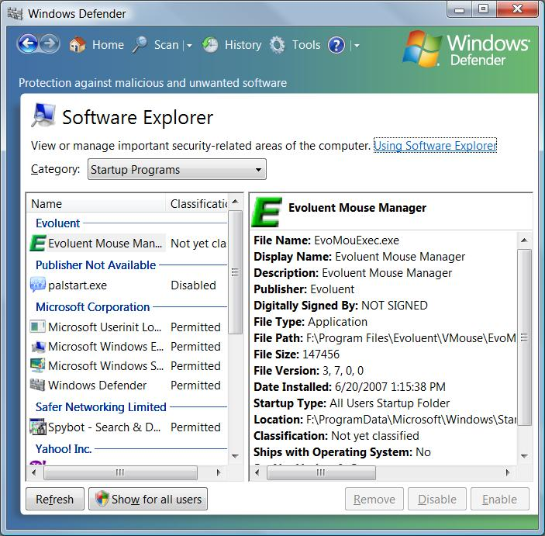
Too many startup programs slow a machine

Keeping Your Disks Defragmented

By default, Vista defragments your disk automatically each week

You shouldn't need to do anything further

Maintaining Adequate Free Space on Your Disks

Disk Cleanup can help

Page File Myths

With 1 GB or more RAM, you should eliminate the swap file

Windows wasn't designed to run without a swap file

Creating a swap file of a fixed size improves performance

This was true on 1990s-vintage hardware, but not any more

Prefetch Folder

The Prefetch folder contains an index to segments of frequently used files

This speeds up performance

Don't turn it off

It doesn't need to be manually cleared—it does that automatically

Taking Performance Snapshots

The Windows Experience Index

The System Diagnostics Report

The Reliability Monitor

Windows Experience Index

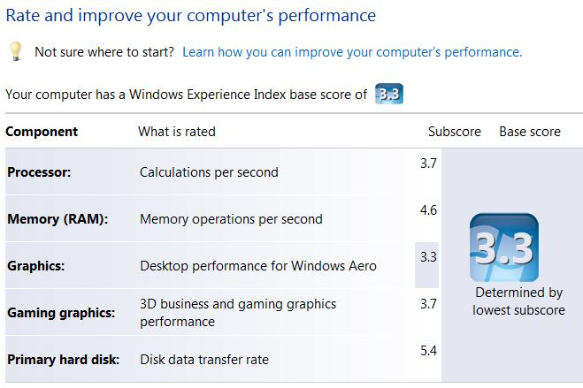
Start, right-click Computer, Properties

Windows Experience Index

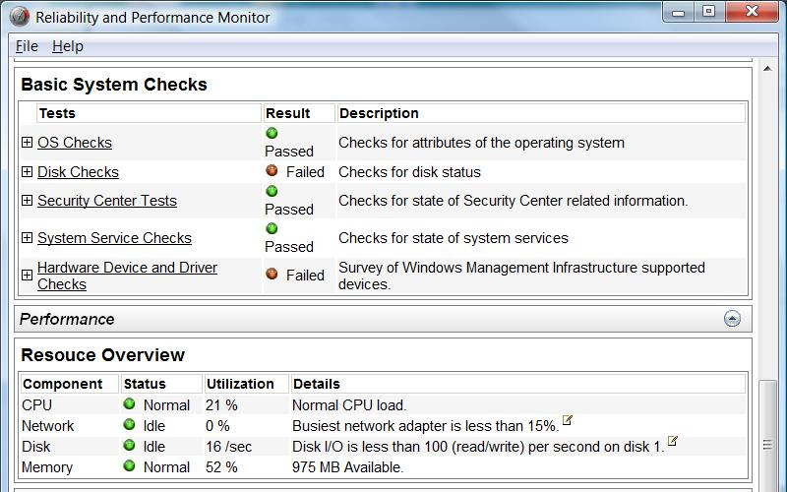

System Diagnostics Report

Logo, PERF, Performance Information and Tools, Advanced Tools, Generate a System Health Report

Monitoring Performance in Real Time

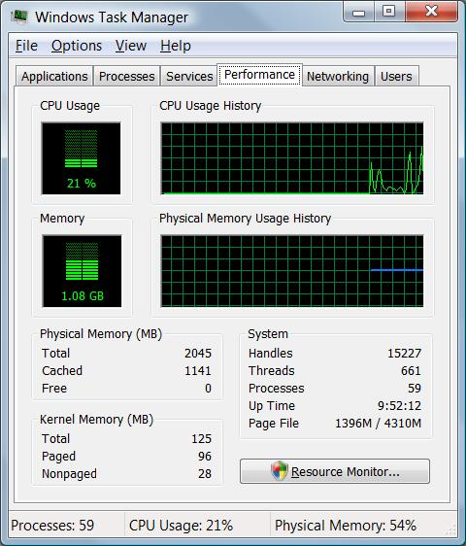
Task Manager

Resource Overview

A component of the Reliability and Performance Monitor

Performance Monitor

A component of the Reliability and Performance Monitor

Windows Task Manager

Ctrl+Shift+Esc

Performance tab shows CPU and memory usage

Options, Always on Top to control window's placement

Page File Fraction

Fraction is

(Page file currently used) /

(Physical Memory + Page File)

Processes Tab

By default, only the processes directly controlled by the user are shown

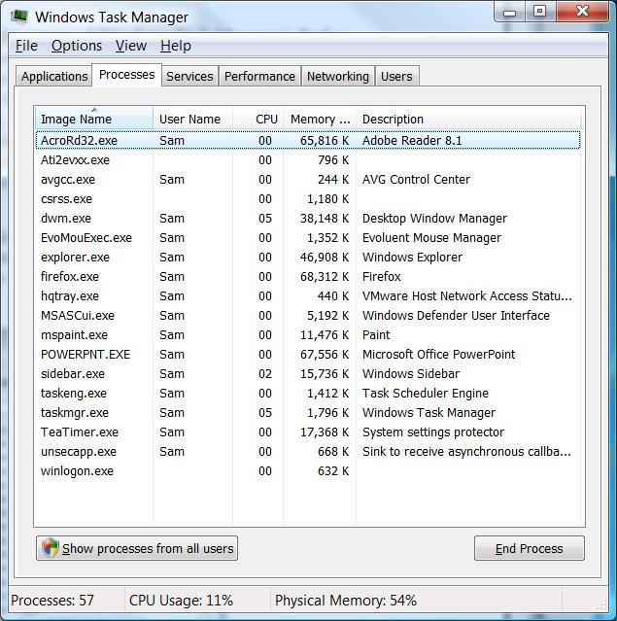
"Show processes from all users" to see them all

Process Information

For each process, Windows Task Manager shows:

Image Name (the name of the process)

PID (Process ID)

User Name (which user started the process) CPU (% currently using)

Memory (Private Working Set)

The amount of memory the process requires to perform its regular functions

Select Columns

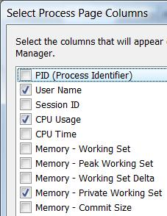
View, Select Columns to customize Task Manager

Resource Overview

Logo, REL, "Reliability and Performance Monitor"

Four graphs

Details by process below
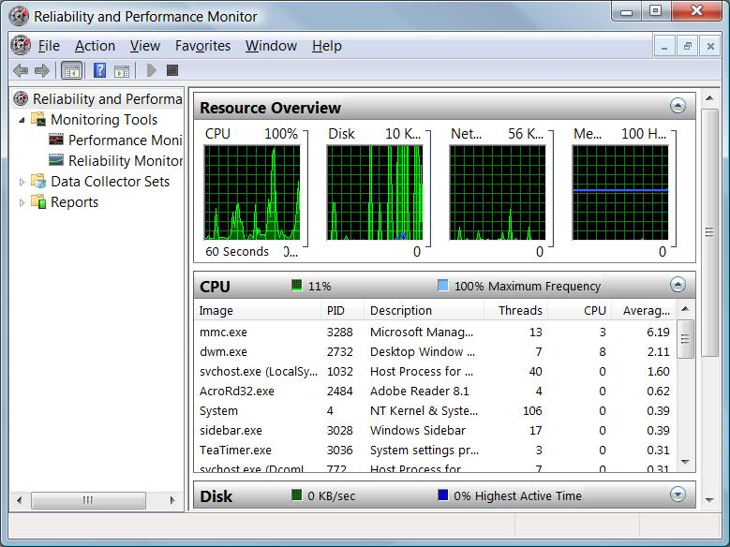

Performance Monitor

For Advanced System Analysis

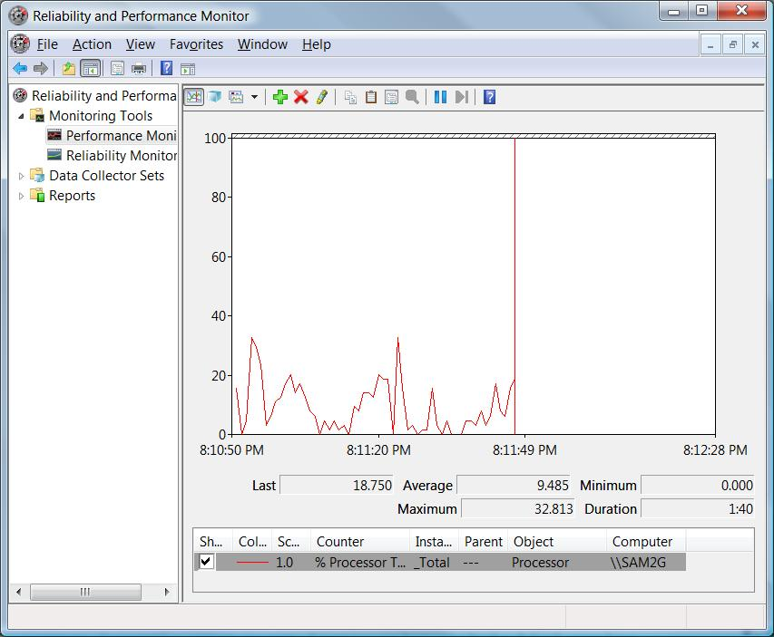

Last modified 10-17-07 11:00 am

