Chapter 22 - Monitoring System Activities with Event Viewer

Editions

Event Viewer works exactly the same way in all Windows Vista editions

Event Log Service

Records noteworthy occurrences in these log files

Application

Security

Setup

System

Forwarded Events

Event Viewer

In Computer Management

EVENTVWR from an elevated Command Prompt

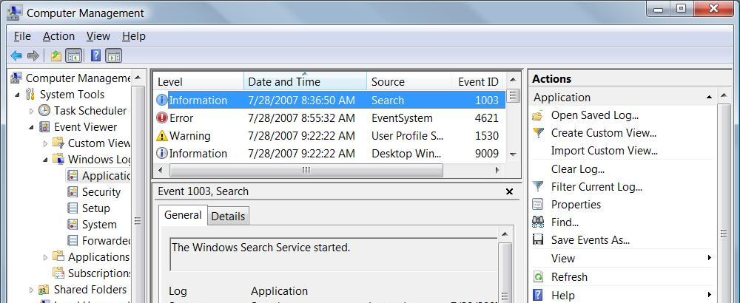
New Features

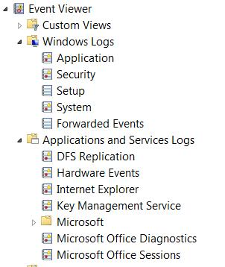
View events from multiple logs simultaneously

Create and save filtered selections as custom views

Create a task to run automatically when a particular event occurs

Create a subscription to specified events on other networked computers

Types of Events

Application

Generated by programs, selected by the developer

Security

Logon attempts

Attempts to use secured resources, such as an attempt to create, modify, or delete a file

Setup

Application installation

System

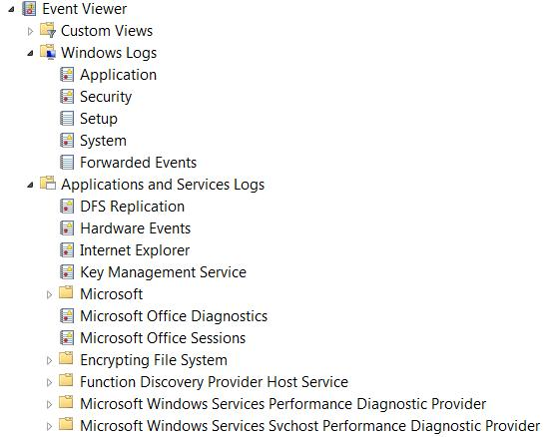
Generated by Windows itself

For example, a driver fails to load when you start Windows

Forwarded Events

Events gathered from other computers

Applications And Services

Logs for individual applications

Analytic and Debug Logs

View, Show Analytic and Debug Logs

Rarely used

Auditing Security Events

In Windows Vista Business, Enterprise, and Ultimate editions

An administrator can choose events to record

With Audit Policies (Local Policies\Audit Policy) in the Local Security Policy console (Secpol.msc)

The monitored objects must be specified in the Auditing tab in Advanced Security Settings

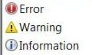
Event Levels

Error

Possible loss of data or functionality

Such as a malfunctioning network adapter

Warning

Less significant then errors

Such as a nearly full disk

Information

Other events

Such as someone using a printer

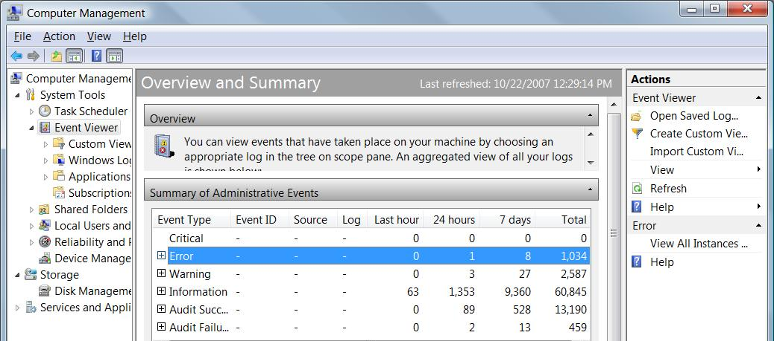
Event Logs Summary

Click Event Viewer in the left pane

For details, click an Event Type, then click "View all instances" in right pane

Viewing Individual Logs and Events

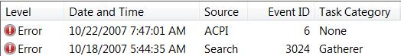
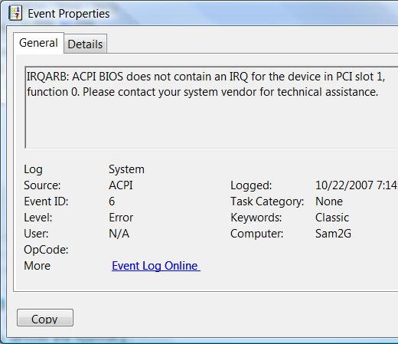
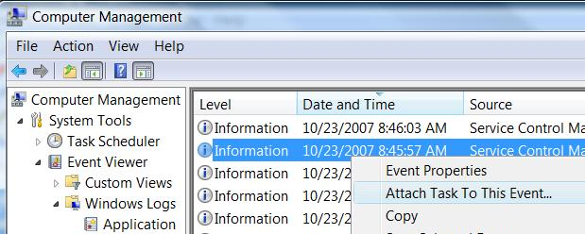
Level

Information, Warning, or Error

Date And Time

Source

The application or system component that generated the event

Event ID

A very important number to define the event

Task Category

May give further information about the event

Event Details

Double-click an event

Link at the bottom gives you Microsoft's Web info

Eventid.net gives you much better information

Creating a Task to Run When a Specific Event Occurs

Connects Task Scheduler to Events

Monitoring Other Computers’ Events with Subscriptions

One Vista computer can gather events from several other Vista computers

You have to create special user accounts on the target machines, and open a firewall exception on each machine

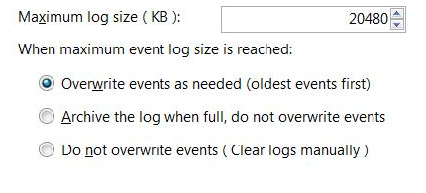
Working with Log Files

By default, logs have a limited size, and eventually overwrite old events

Adjust this behavior in a log's Properties

Chapter 23 - Troubleshooting Windows Errors

Editions

These troubleshooting techniques work exactly the same way in all Windows Vista editions

Configuring and Using Windows Error Reporting

Windows Error Reporting's new features

Can automatically transmit information about errors to Microsoft

To help them improve Windows

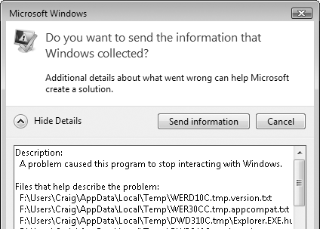
Can notify you automatically when an error occurs for which a solution is available

Maintains a history of errors on your system

Application Recovery and Restart

New functions for developers to use in applications

Responds to a crash by restarting and reopening the document you were working on

Implemented in Microsoft Office 2007

Privacy Concerns

Some of the information sent to Microsoft could contain personal information

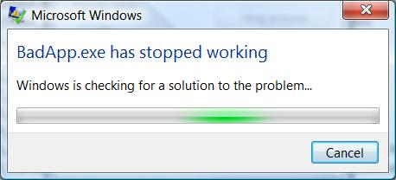
Windows Error Reporting

Windows Error Reporting gathers the basic information

Sends it to Microsoft if you have approved that

The Microsoft server tries to find a solution

The application restarts, if it can

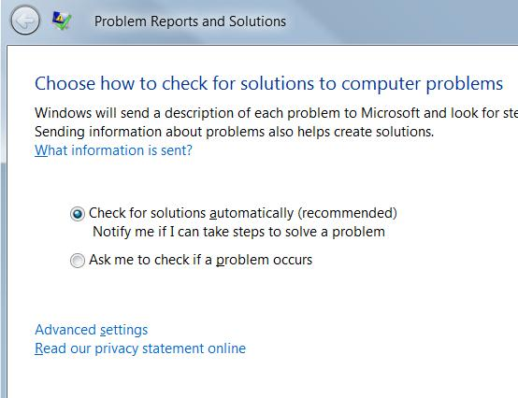

Setting Windows Error Reporting Options

Control Panel

System And Maintenance

Problem Reports And Solutions

Choose How To Check For Solutions

Advanced Error Reporting Options

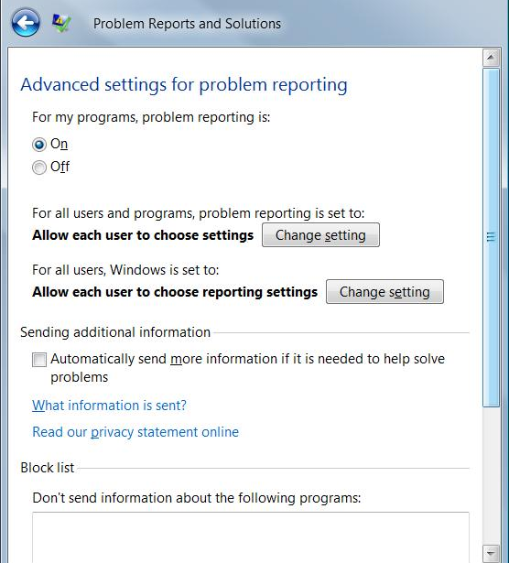
Advanced Settings

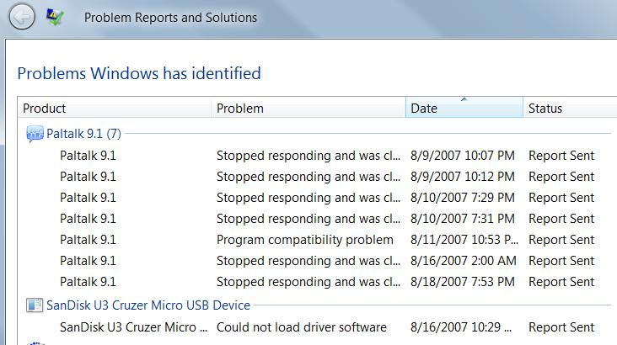
Reviewing the Problem History

Control Panel

System and Maintenance

Problem Reports and Solutions

View Problem History

Checking for Solutions

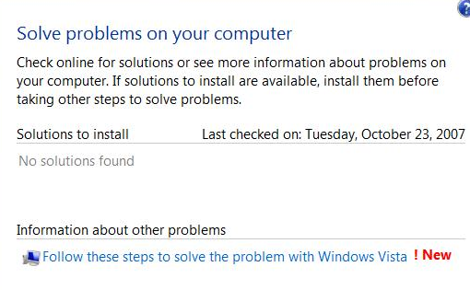
Control Panel

System And Maintenance

Problem Reports And

Solutions

Check For New Solutions

Reliability Monitor

Logo, REL
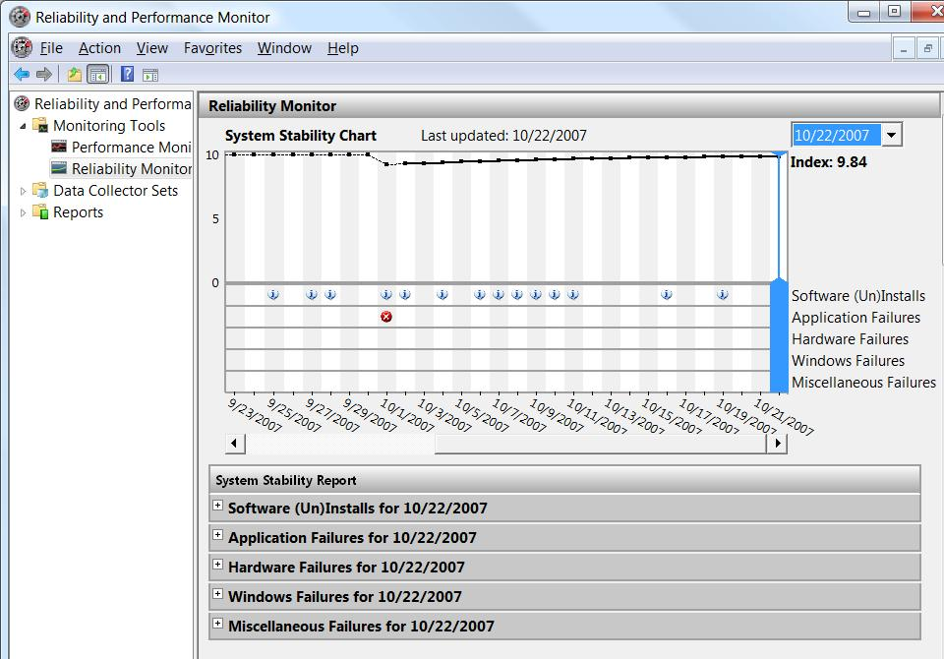

Rolling Back to a Stable State with System Restore

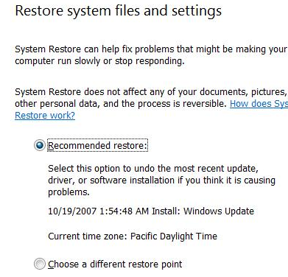
System Restore is helpful when

You install a program that conflicts with other software or drivers on your system

You install a driver that causes performance or stability problems

Your system develops performance or stability problems for no apparent reason

System Restore and Viruses

System Restore doesn't remove infections

Use antivirus software for that

After cleaning a virus, delete your System Restore points to prevent re-infection

Using System Restore

Logo, SYS

System Restore Do’s and Don’ts

Newly created user accounts may vanish

System Restore does not uninstall programs, although it does remove executable files and DLLs

Uninstalling recently installed applications before the restore is best

Changes made to your system configuration using the Windows Recovery Environment are not monitored by System Protection (System Restore)

System Restore and Safe Mode

You can restore your system to a previous configuration from Safe Mode

BUT you cannot create a new restore point in Safe Mode

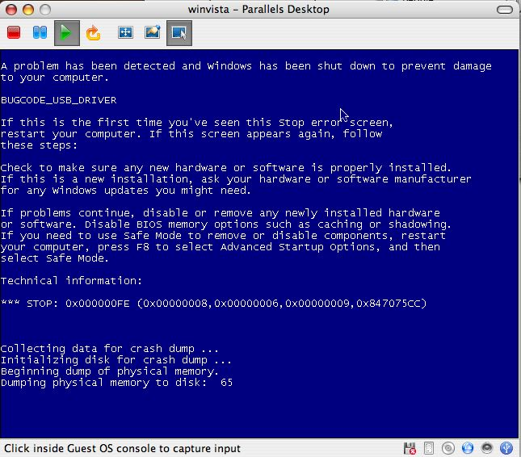
Therefore, you cannot undo a restore operation that you perform in Safe Mode

Avoid restoring in Safe Mode

Dealing with Stop Errors

Blue Screen of Death (BSOD)

Image from link Ch 23a

How Windows Handles Stop Errors

Displays a STOP error (BSOD)

Writes debugging information to the page file

When the system restarts, this information is saved as a crash dump file

By default, the system restarts
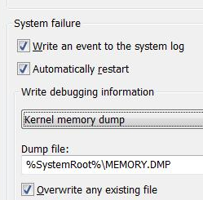

Customizing STOP Error Behavior

Start

Right-click Computer, Properties

Advanced System Settings

Advanced tab

In "Startup and Recovery" section, click Settings

How to Read a Stop Error

Symbolic error name

At the top – here it is BUGCODE_USB_DRIVER

Troubleshooting recommendations

Error number and parameters

After the word STOP

Advice for Dealing with Stop Errors

Look for a driver name

Don’t rule out hardware problems

Check your memory

Logo, MEM for Memory Diagnostics

Ask yourself, “What’s new?”

Search the Knowledge Base

Check your system BIOS for updates

Are you low on system resources?

Check RAM and disk space

Try starting in Safe Mode

If that works, it's probably a driver problem

Try an alternative driver

Even one made for a different hardware model in the same family

Last modified 10-23-07 10 pm

