Chapter 24 – Recovering From an Computer Crash

Editions

Complete PC Backup and Complete PC Restore

Are not available in Home Basic and Home Premium editions

All other troubleshooting tools described in this chapter are available in all editions
Safe Mode
Safe Mode with Networking
Safe Mode with Command Prompt

Enable Boot Logging
Enable low-resolution video (640x480)
Last Known Good Configuration (advanced)
Directory Services Restore Mode
Debugging Mode
Disable automatic restart on system failure
Disable Driver Signature Enforcement

Start Windows Normally

Recovery Tools

Advanced Boot Options

Press F8 during startup

Safe Mode

The Windows Recovery Environment (WinRE)

Boot from DVD

Replaces Windows XP's Recovery Console

Advanced Boot Options

Press F8 during startup

Windows Error Recovery

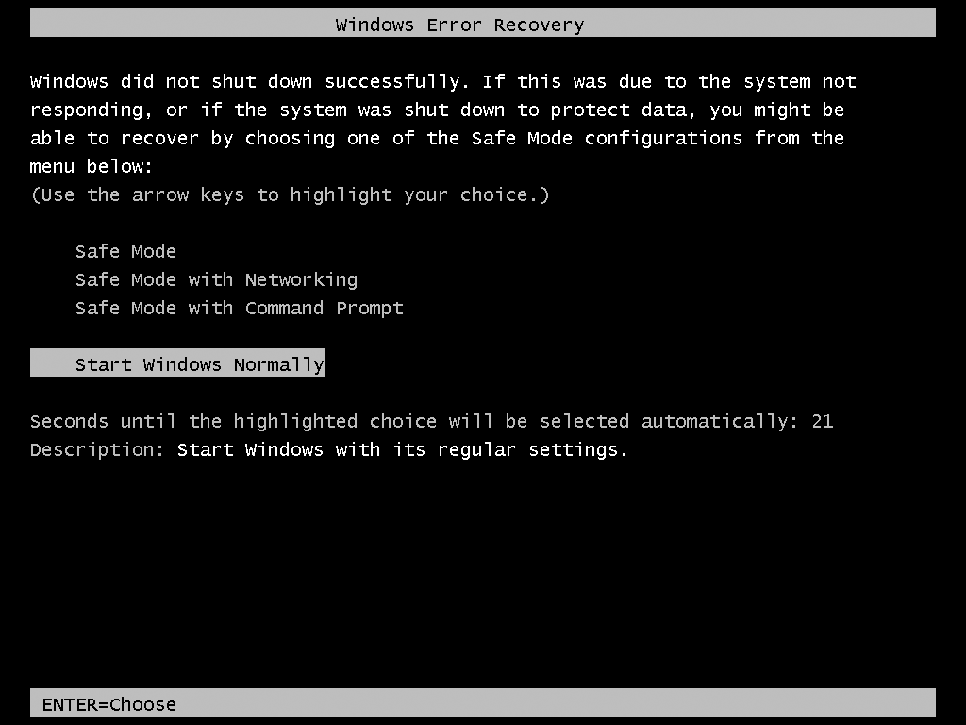
If you shut down and restart with the power switch, you see this screen

Safe Mode

Uses only those services and drivers that are absolutely required to start your system

Generic video driver at 800 x 600 resolution

USB flash drives, hard disks, keyboard, and mouse will be supported

No audio devices

No Startup folder programs

These configuration tools are available

Device Manager

System Restore

Registry Editor

Help And Support

Online help (if you use Safe Mode with Networking)

Backup and Restore Center is not available

To restore a Complete PC Backup, use the Windows Recovery Environment, not Safe Mode

Other Safe Mode Options

Safe Mode With Networking

Safe Mode plus drivers and services required to start Windows networking

Safe Mode With Command Prompt

Safe Mode with no graphics

Uses Cmd.exe only

Last Known Good Configuration

Every time Windows starts in normal mode

It makes a record of all currently installed drivers and the contents of the registry key

HKLM\SYSTEM\CurrentControlSet

Last Known Good Configuration (Advanced) restores the previous, working registry key

If you just installed a driver that makes the system hang, this is an easy fix

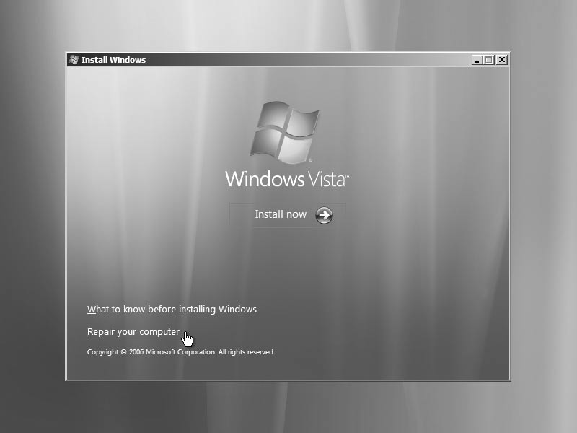
System Restore is more reliable

Other Startup Options

Enable Boot Logging

Lists the names and status of all drivers loaded

%SystemRoot%\Ntbtlog.txt

Enable Low-Resolution Video

640 x 480

Directory Services Restore Mode

Ignore it, it only applies to domain controllers

Debugging Mode

Kernel debug mode—rarely used

Disable Automatic Restart On System Failure

Stops an endless cycle of restarting

Disable Driver Signature Enforcement

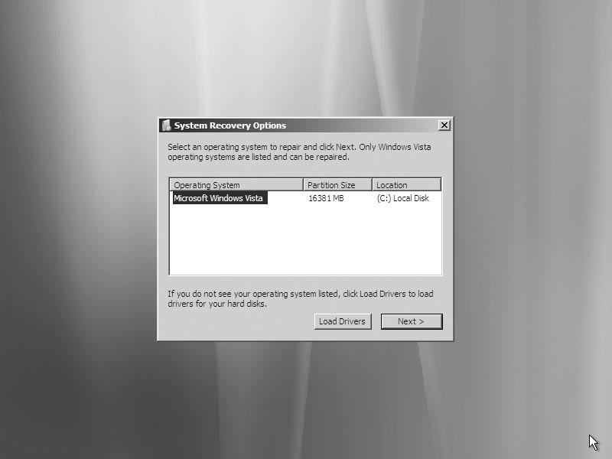
Use this option if Windows is refusing to start because of an unsigned driver

Windows Recovery Environment

Boot from Vista DVD

Select Language to Install, Time And Currency Format, and Keyboard Or Input Method, click Next

Click "Repair your computer" instead of "Install now"

Select correct operating system and click Next

If you don't have a Vista DVD, the Recovery Environment should be on a hard disk "recovery" volume

There should be a startup option to use it

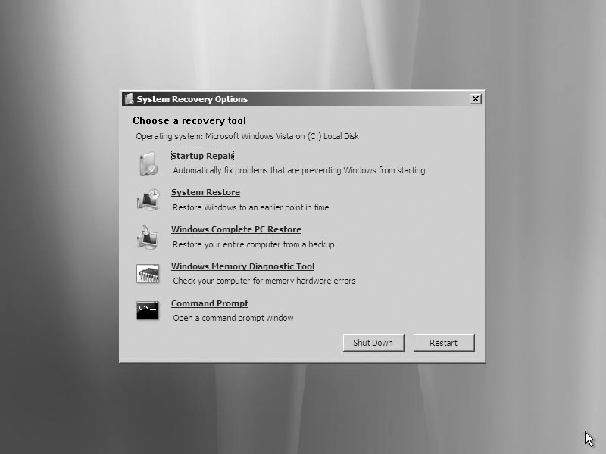

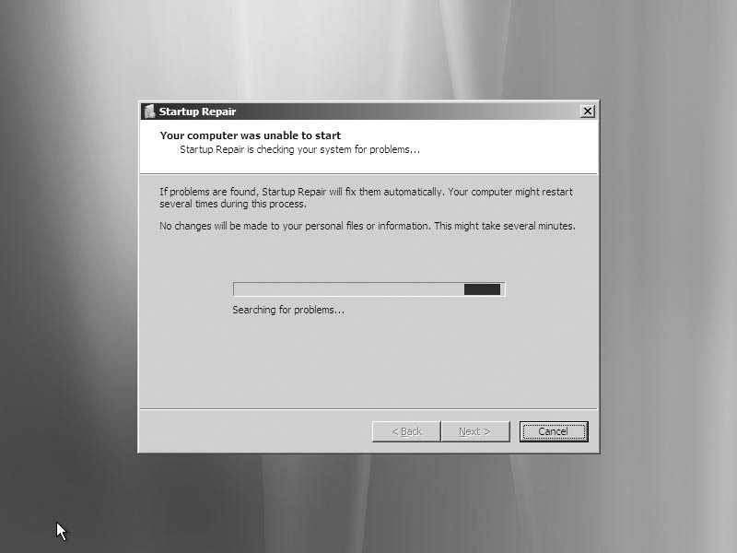
Startup Repair

Easy and automatic

Fixes boot files, including BCD (Boot Configuration Data) store

System Restore

Runs as usual, but cannot create a restore point first

So there's no way to undo a System Restore made from Windows Recovery Environment

Restoring an Image Backup With Complete PC Restore

You must have previously used Complete PC Backup to create an image backup of your system disk

Formats your disk and completely replaces it with the backup copy

You will lose recent documents on the System disk

Copy them to a USB drive with the Command Prompt first

Complete PC Restore from CDs or DVDs

Insert the last disc in the backup set before you click Windows Complete PC Restore.

If you insert the first (or any other) in a set of CDs or DVDs, the program will not find it.

Windows Memory Diagnostic Tool

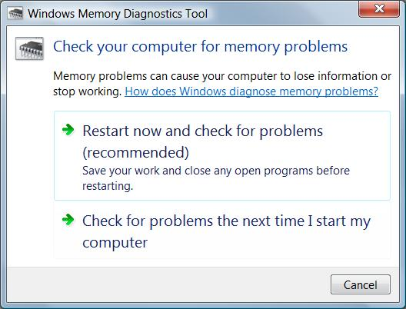
Checks your RAM

You can also run it with Vista running

Shows results at next restart

Working at the Command Prompt

The Command Prompt option

Puts you in X:\Sources (a RAM drive)

You can run all commands, including

DISKPART to manage disk partitions

Networking is not available unless you run the WPEINIT command

You run with the System account

So anyone who can boot from DVD can completely control your computer

Unless you use encryption
Chapter 25 – Managing Services

Editions

All other tools described in this chapter are available in all editions

Services

A service is a specialized program that performs a function to support other programs

Many services operate at a very low level

Interacting directly with hardware

Need to run even when no user is logged on

Run with the System account (which has elevated privileges)

Using the Services Console

A MMC snap-in

In Computer Management

Or SERVICES.MSC at a command prompt
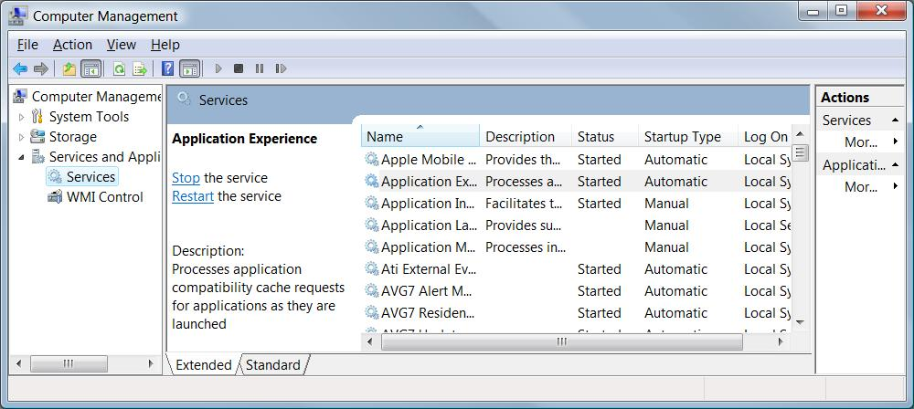

Actions on Services

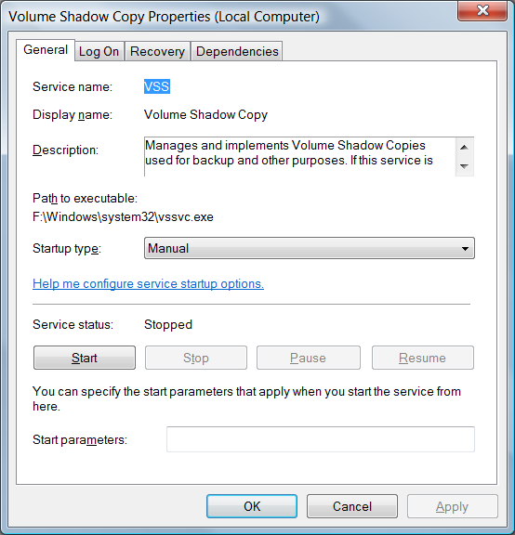
Start, stop, pause, resume, or restart

Pausing and resuming is less drastic than stopping and restarting

May avoid cancelling jobs in process

Essential services start automatically

Some others must be manually started or stopped

Usually because of an error

Service General Properties

Startup Types

Automatic (Delayed Start)

Starts shortly after the computer starts

Automatic

Starts when the computer starts

Manual

Doesn't start automatically at startup, starts when needed

Disabled

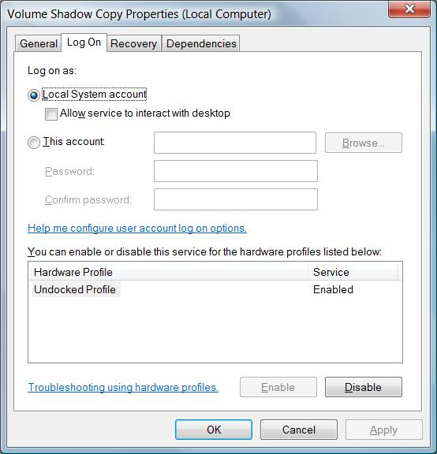
Can't be started

Service Log On Properties

The logon account must have the "Log On As A Service" right

Local Security Policy

Security Settings

Local Policies

User Rights Assignment

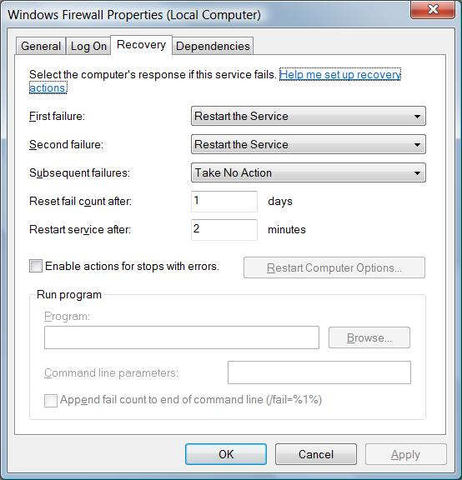
Service Recovery Properties

When it fails

Take No Action

Restart The Service

Run A Program

Restart The Computer

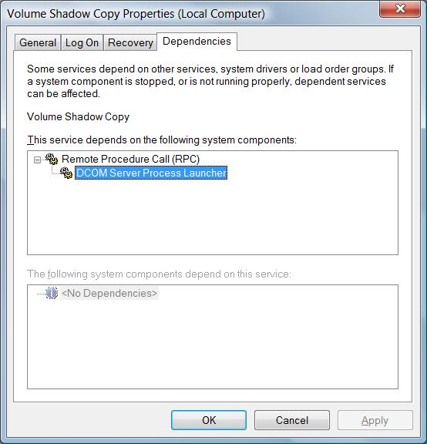

Dependencies

If you attempt to start a service that depends on other services, Windows first starts the others

If you stop a service upon which others are dependent, Windows also stops those services

Determining the Name of a Service

Each service has three names

Service name

Used in command-line and Registry

Display name

Appears in the Services console

Executable file name

Many are Svchost.exe

Managing Services from a Command Prompt

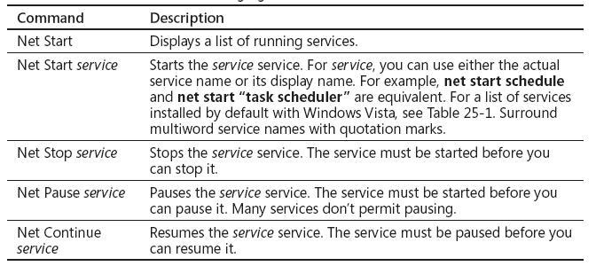

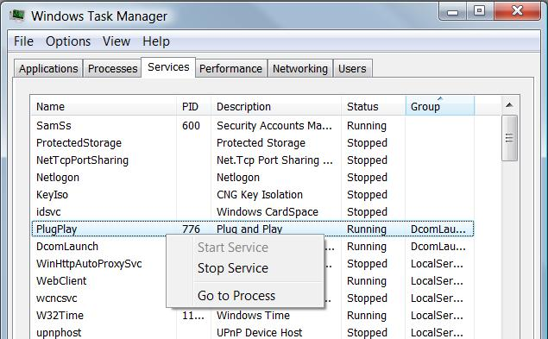

Managing Services from Task Manager

New in Vista

Chapter 26 – Editing the Registry

Editions

The structure of the registry is identical in all editions of Windows Vista

Registry Editor works exactly the same way in all editions

Group Policy is not available in the Home Editions (Home Basic and Home Premium)

Editing the Registry is Dangerous

A bad manual change can crash your system

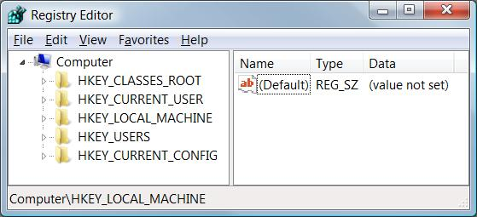
Normally you use Control Panel to update the registry to avoid such disasters

Understanding the Structure of the Registry

The registry consists of five root keys

HKey_Classes_Root

HKey_Current_User

HKey_Local_Machine

HKey_Users

HKey_Current_Config

Or HKCR, HKCU,HKLM, HKU, and HKCC

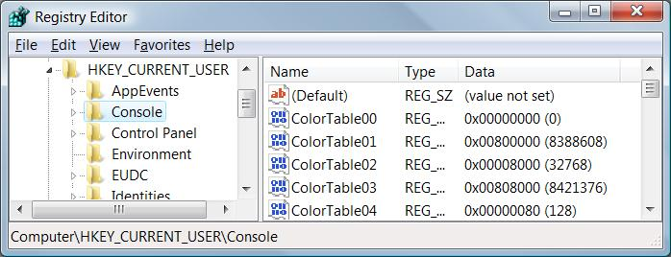
Subkeys

Root keys (sometimes called predefined keys), contain subkeys

Subkeys look like folders in Regedit

HKCU has these top-level subkeys:

AppEvents, Console, Control Panel, …

A root key and its subkeys form a path

HKCU\Console

Values

Every Subkey contains at least one value

But it may show (value not set)

The default value (often undefined)

Values have name, data type, and data

Hives

A key with all its subkeys and values is called a hive

The registry is stored on disk as several separate hive files

Hive files are read into memory when the operating system starts (or when a new user logs on)

HiveList

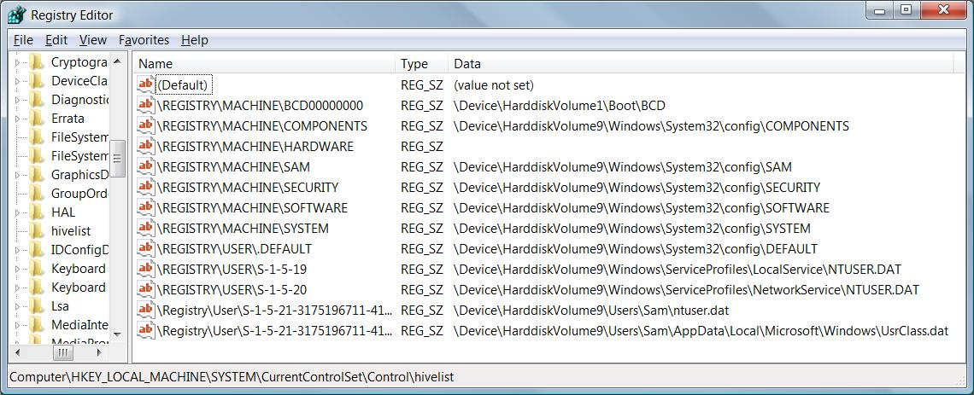
HKLM\System\CurrentControlSet\Control\HiveList

Hardware Hive

\Registry\Machine\Hardware has no associated disk file

Windows Vista creates it fresh each time you turn your system on

HKCR and HKCU

These keys are links to items contained in other root keys

HKey_Classes_Root (HKCR)

Merged from keys within HKLM\Software\Classes and HKU\sid_Classes

sid is the security identifier of the currently logged on user

HKey_Current_User (HKCU)

HKU\sid

Avoiding Registry Mishaps

Registry Editor changes the registry immediately

No Undo command


No File, Save command

Backing Up Before You Edit

Registry Editor's File, Export

Registry Hive format is recommended for backups

Because it restores the entire hive exactly

BUT if you restore it to the wrong key, it does a lot of damage

.reg Files

You can export a registry key in Registration Files format

Creates a .reg file

Can be edited in notepad

Right-click, Merge to insert values into registry
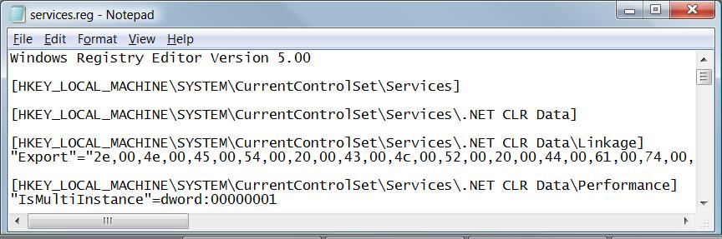

HKLM\System\CurrentControlSet

This hive is so important, Windows backs it up

To restore this hive, press F8 during bootup and use "Last Known Good Configuration"

We skipped pages 862 - 875

-

Last modified 10-31-07

