Chapter 27 – Advanced Internet Explorer 7 Security and Administration

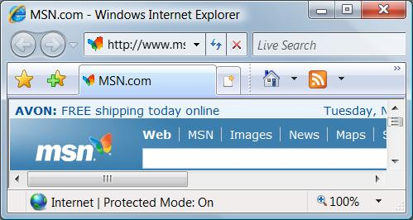
Editions

All the tools and techniques described in this chapter are available in all editions

Working with (and Around) Protected Mode

Protected Mode stops websites from

Installing programs without permission

Changing system settings

Applied to all sites except ones in the Trusted Sites zone

By default, Protected Mode is on

Low Folders

These Low folders are used by IE 7

They have the same low privilege levels as IE 7 in Protected Mode

Cache

%LocalAppData%\Microsoft\Windows\Temporary Internet Files\Low

Temp

%LocalAppData%\Temp\Low

Cookies

%AppData%\Microsoft\Windows\Cookies\Low

History

%LocalAppData%\Microsoft\Windows\History\Low

Virtual Folders

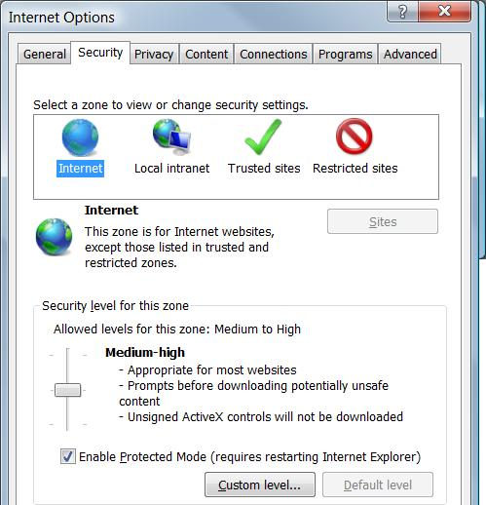
If an add-on tries to write a data file to

Program Files

Windows folders

Registry

Windows silently redirects the file write operation to a virtual equivalent

The program continues, without knowing where the file really was stored

Broker Process

When Internet Explorer needs to read those virtualized files

A broker process intercepts the operation

Shows a User Account Control dialog box before the process can continue

Disabling Protected Mode

This exposes you to risks, but may be necessary to use some websites

Tools, Internet Options, Security tab

Clear "Enable Protected Mode"

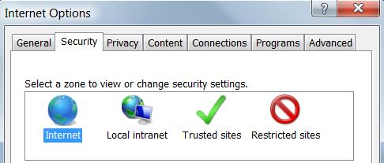
The Four Internet Security Zones

Internet

All sites that are not included in any other category

Local Intranet

Sites on your local network

Trusted Sites

(empty on a clean installation of Windows)

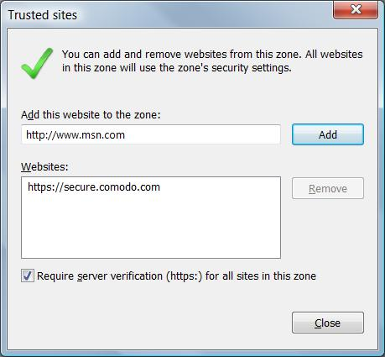
Restricted Sites

(empty on a clean installation of Windows)

Trusted Sites

"Medium" security level

Internet Explorer’s Protected Mode security is disabled

This allows some ActiveX controls to run

Adding Sites to the Trusted Zone

On the Security tab of the Internet Options dialog box. Click Trusted Sites

Click Sites

By default, sites must be secure (https)

Otherwise you don't really know if they are genuine

Restricted Sites

High security

Scripting disabled

This zone is the default for HTML-formatted e-mail you read using Microsoft Outlook or Windows Mail

Adding Sites to the Restricted Zone

On the Security tab of the Internet Options dialog box. Click Restricted Sites

Click Sites

No need for sites to be secure

Changing a Zone’s Security Settings

Use the slider to adjust the security level

Custom level for detailed settings

Protecting Yourself from Unsafe and Unwanted Software

Authenticode

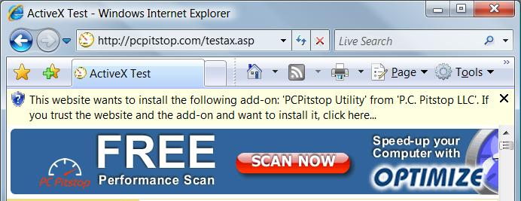
Microsoft's digital signing technology

Identifies publisher

Ensures that file has not been altered

Signed controls will prompt warnings like this:

Add-on Installer

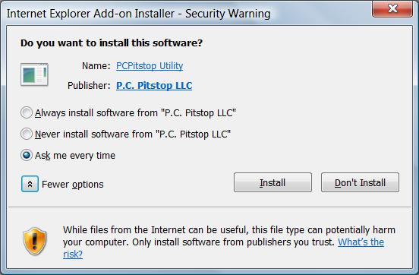
When you install an ActiveX Control, you can choose how to handle content from this publisher

Always install

Never install

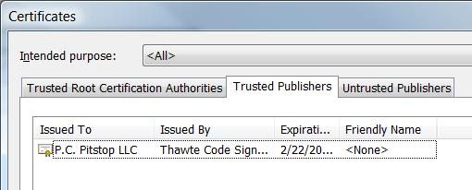

Trusted and Untrusted Publishers

Internet Options, Content tab, Publishers

Two fake Microsoft certificates appear in "Untrusted Publishers"

Blocking Potentially Unsafe Downloads

Half the failures in Windows are caused by "deceptive software"

Malicious software spread by instant messages, email, or Web pages

False error messages, offers, etc.

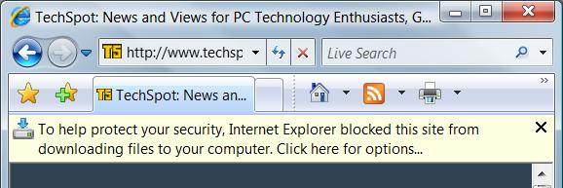
Extra software that comes with a game or file-sharing client

Spyware? Adware? What's the Difference?

Spyware gathers information about you and your browsing activities

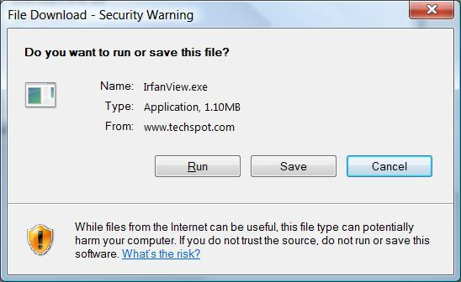
Adware displays advertisements including pop-up windows

Home-page hijackers change your default home page and browser settings

Trojan horses allow an intruder to take over a compromised computer

Use Antivirus and Antispyware software!

Downloading Executable Files

You must approve two separate Security Warnings to download a program in Internet Explorer

Running a Downloaded File

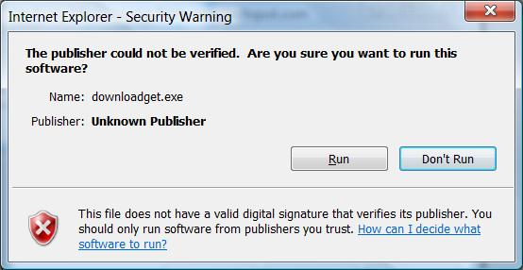
If it's not signed, you see this box too

And then, of course, you see the User Account Control dialog

How do You Know that a Program is Safe?

If a file is digitally signed, you might be comfortable trusting the publisher

If it isn't digitally signed, search for complaints about the program in Google Groups (http://groups.google.com)

Set a System Restore point before installing

Keeping ActiveX Under Control

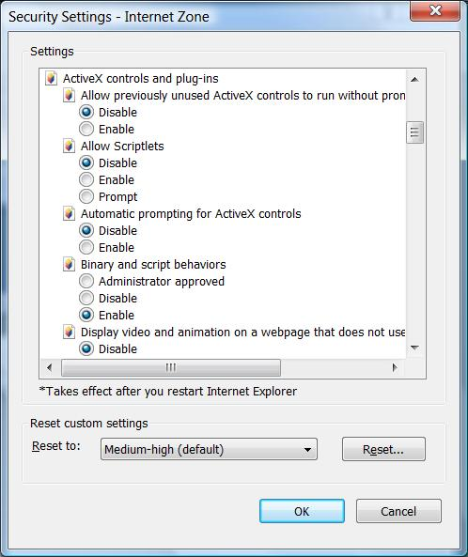
ActiveX controls are small programs that enhance the functionality of a Web site

They work only in IE, on Windows

Windows Update uses ActiveX

ActiveX controls are like executables that you run from the Start menu or a command line

They have full access to your computer's resources

ActiveX and Viruses

You cannot download an ActiveX control, scan it for viruses, and install it separately

ActiveX controls must be installed on the fly

You're protected from known viruses if you've configured your antivirus software to perform real-time scanning for hostile code

ActiveX Security Settings

Internet Options

Security tab

Internet

Custom Level

See p. 894 for a list of ActiveX security settings

Using Scripts Wisely

Scripts are small programs

Written in a scripting language such as JavaScript or VBScript

Scripts run on the client computer

See links Ch 27a, 27b

Hostile scripts can be embedded in Web pages or in HTML-formatted e-mail messages

You can disable scripts in Internet Options, the same way you control ActiveX control security

Tip: For real safe browsing, use Firefox with the Noscript extension

Browser Add-ons

Add-ons can provide New toolbars, Explorer bars, menus, buttons, extended search capabilities, manage the process of filling in forms, save bookmarks, etc.

These add-ons take the form of browser extensions, browser helper objects (BHOs), toolbars, Java applets, and ActiveX controls, and more

Add-ons can also cause crashes, pop-ups, act as Spyware, etc.

Installing, Removing, and Troubleshooting Add-ons

In IE 7, Tools, Manage Add-Ons, Enable or Disable Add-ons
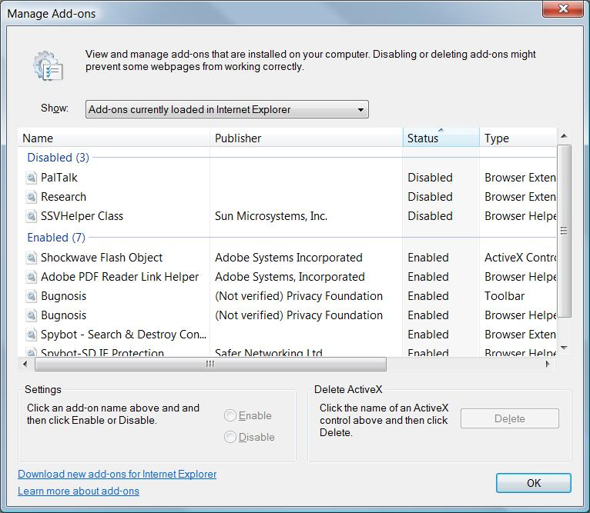

Managing Add-ons

The Manage Add-ons box does not provide an uninstallation option

You have to find the program that installed an add-on and uninstall it

Some malicious add-ons hide and do not appear in this box

Managing Cookies

A cookie is a small text file

It enables a Web site to personalize its offerings in some way

Stored in %UserProfile%\AppData\Roaming\Microsoft\Windows\Cookies

Cookies are used recording logon information, shopping preferences, etc.

Privacy Concerns

Cookies may contain information you typed into a Web page

This information can be read only by the site that created the cookie

BUT: Third-party cookies cheat and get around this rule (See link Ch 27c)

Platform for Privacy Preferences P3P

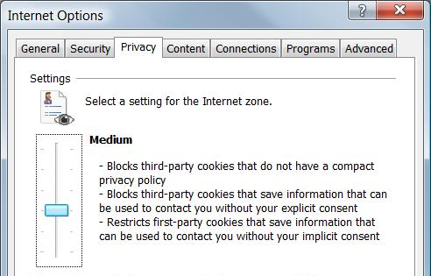
Internet Explorer 7 supports the Platform for Privacy Preferences (P3P) standard

You can choose to block certain kinds of cookies, while allowing the rest

Cookie Privacy Settings

Tools, Internet Options, Privacy tab

Block All Cookies

High

Medium High

Medium

Low

Accept All Cookies

The default setting is Medium

Viewing a Site's Privacy Report

When Internet Explorer blocks a cookie, it displays an icon on your status bar

To find out what cookie was blocked and why, double-click this icon to see

Privacy Report

Viewing a Site's Privacy Report

Click on a site in Privacy Report, click Settings to see Privacy Policy

Always Allow This Site To Use Cookies

Never Allow This Site To Use Cookies
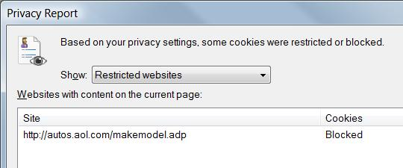

Managing Internet Explorer’s Cache and History

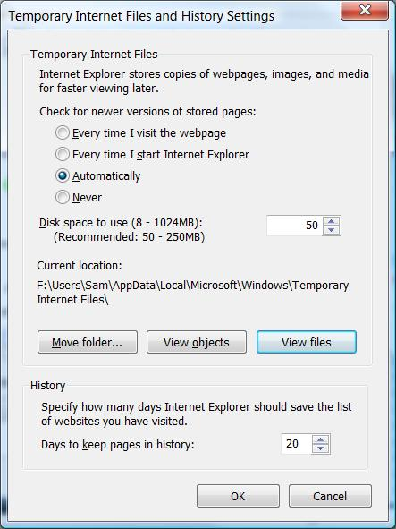
Temporary Internet files (the cache) are stored in the hidden system folder

%LocalAppData%\Microsoft\Windows\Temporary Internet Files

Changing the Size of the Cache

Tools, Internet Options, General Tab

In the Browsing History section, click Settings

You can also set how often IE checks for new versions of pages here

Shift-Refresh to force a new load

Blocking Objectionable Content

Content Advisor blocks sites that are rated outside your acceptable limits

It uses the Internet Content Rating Association (ICRA) system

Not all Internet content is rated

By default, Content Advisor blocks pages that don't have a rating

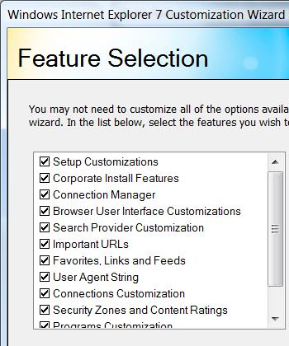

Internet Explorer Administration Kit (IEAK)

Available in several languages

Used to customize the Internet Explorer interface and control browser settings

Especially those related to security

-

Last modified 11-7-07

