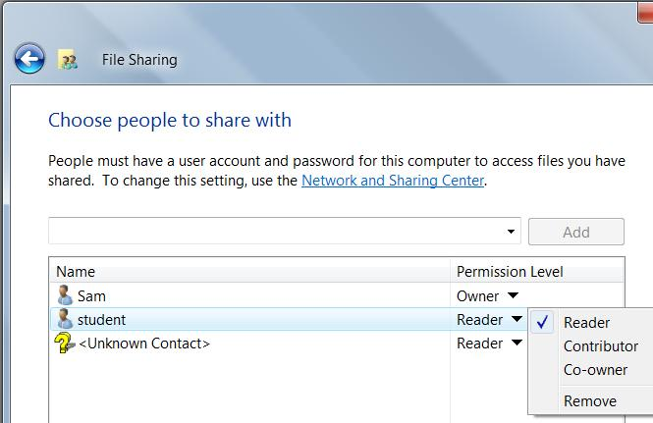
Editions

NTFS Permissions are the same in all editions of Windows Vista

Although Windows XP Home Edition concealed NTFS permissions, no version of Vista does that

Sharing Wizard

Right-click a folder or file, select Share

Select Reader, Contributor, or Co-Owner

The simplest way to share files and folders

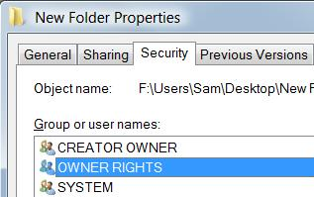
Changes to NTFS Permissions in Windows Vista

The owner of an object no longer implicitly has full control access

NOTE: This seems to be the same in Win XP in my tests

OWNER RIGHTS is a new security identifier

Vanishes when an object's owner changes—when you give or take ownership

Changes to NTFS Permissions in Windows Vista

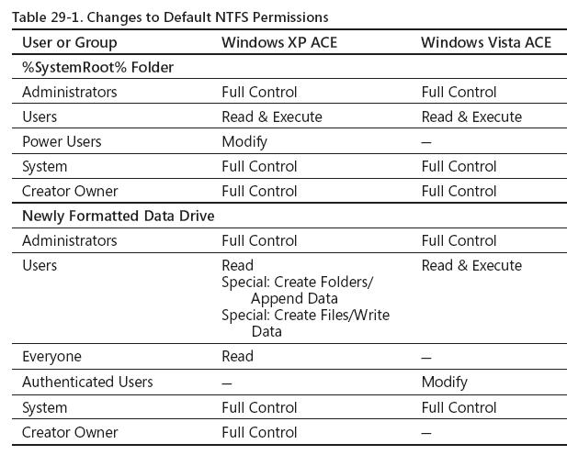
You may have to respond to a User Account Control (UAC) prompt to edit permissions

Operating system files are owned by TrustedInstaller

In previous versions of Windows, the Administrators group owned them

Controlling Access with NTFS Permissions

With NTFS permissions, you can:

Control access to any file or folder on any NTFS-formatted volume

Allow different types of access for different users or groups

Applying Advanced Security Settings

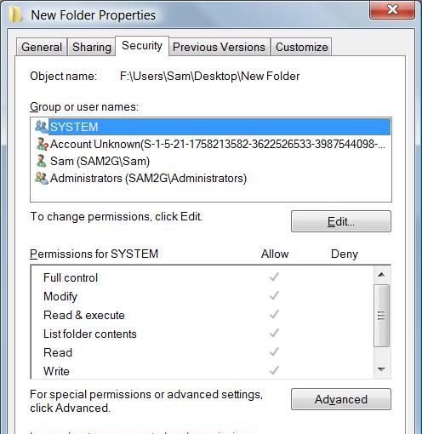
Right-click file or folder

Properties

Security tab

This is the Access Control List

Editing Permissions

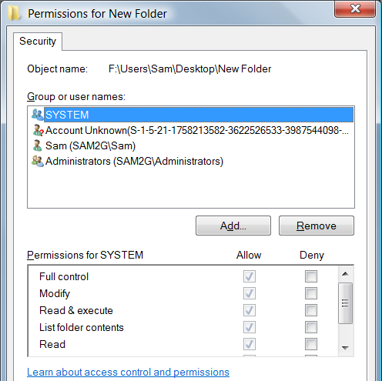
Click Edit in an object's Properties to change permissions

This click is new in Vista

Discretionary Access Control

In Windows Vista, the owner of a file or folder (typically the person who creates the file) has the right to allow or deny access to that resource

In addition, members of the Administrators group and other authorized users can grant or deny permissions

Demonstration of Ownership

Create a folder, so you are the owner

Remove all permissions except yourself

Deny yourself all access

You cannot open the folder, but you can still change the permissions because you are the owner

Be careful with the Deny box

Deny permissions take precedence over Allow permissions

It's safer to just Allow, or nor Allow, permissions

There is an exception to this rule, in which an Allow can take precedence over a Deny (see link Ch 29c)

Permissions

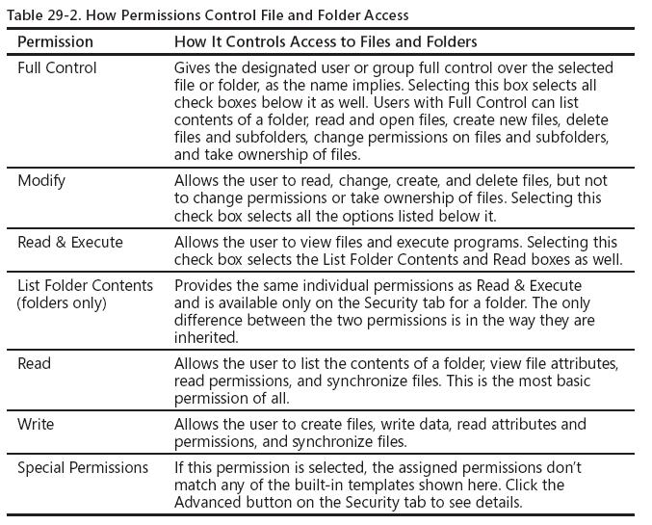
Permissions: Basic Principles

Start from the top and work down

Organize shared data files into common locations

Use groups whenever possible

Steer clear of Special permissions

Grant only the level of access that users require

If You Can't Change Permissions

The Security tab is not visible

Drive is FAT, not NTFS

Permission settings are unavailable

You are not logged on as an Administrator or the object's owner

Or the selected object is inheriting its permissions from a parent folder

Built-in Users (Special Identities)

Everyone

Doesn't include Anonymous logons

Creator Owner and Creator Group

Identifies the creator of the file or folder

Owner Rights

Identifies the current owner of the file or folder

Authenticated User

Any user who logs on with a name and password except Guest

Interactive

A user logged on locally, including users accessing the machine with Remote Desktop

Anonymous Logon

Network logons without credentials, such as connections to a Web server

Dialup

A user accessing the computer with a dial-up connection

Network

A user logged on over the network

Special Identities Example

Shared data folder

Users - Read & Execute

Users – Write

Creator Owner – Full Control

Users can create and manage their own files and folders

Users can't delete objects created by other users

Reserved Special Identities

Reserved for software and system processes

Never used by human users

Batch

Service

Local Service

Network Service

TrustedInstaller

Never adjust these permissions

C: Drive Permissions

Windows Vista applies specific permissions to these locations

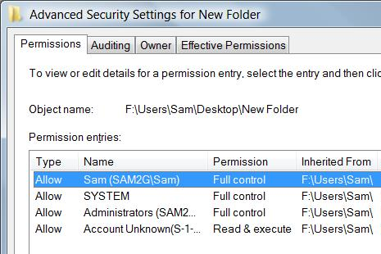
C:\ (or the root of the system drive)

C:\Windows

C:\System32

C:\Users

Subfolders of those locations

Don't change those permissions

Applying Permissions to Subfolders Through Inheritance

Files and subfolders inherit permissions from a parent folder

Right-click the folder icon, Properties, Security tab, Advanced button

To block inheritance

Click Edit

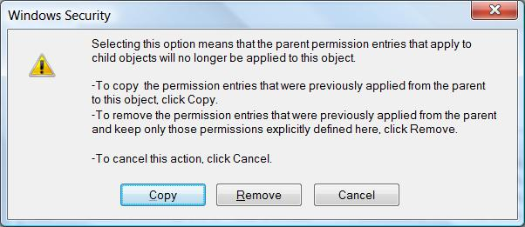
Uncheck "Include Inheritable Permissions From This Object’s Parent"

Choose Copy or Remove

Testing the Effect of Permissions

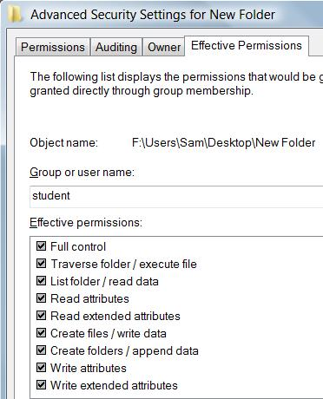
File and folder permissions can come from a variety of settings

It’s difficult to figure out exactly what each user can and can’t do

Effective Permissions combine all the NTFS permissions assigned to an individual user account and to all of the groups to which that user belongs

Effective Permissions Example

Thus, if Sue has Read & Execute permission

And is also a member of a group that has been assigned Write permissions

She has both Read & Execute and Write permissions for the folder

Effective Permissions

Right-click file or folder, Properties

Security tab, Advanced, Effective Permissions tab

Effective Permissions is Not Perfect

The effective permissions calculation does not include

Anonymous Logon

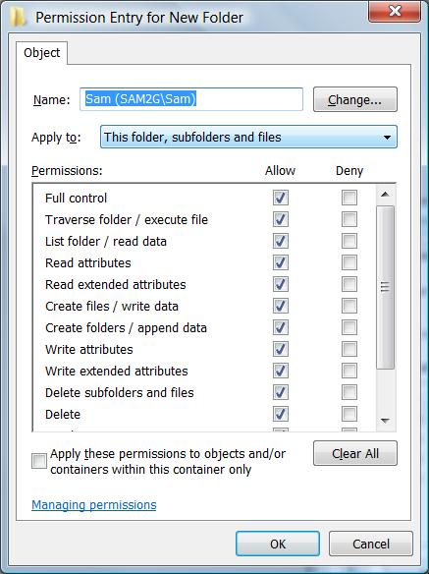
Authenticated Users group

Settings granted because a user is the Creator Owner of an object

Does not consider whether you’re logging on interactively or over a network

Don’t trust it too far

Using Special Permissions

Click Advanced on the Security tab, click Edit, select a user or group name, click Edit

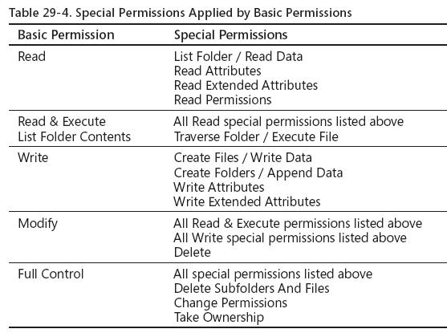
Leave Special Permissions Alone

The basic permissions like Full Control, Modify, etc. are almost always complex enough for any purpose

Don't adjust the special permissions unless you are doing something esoteric

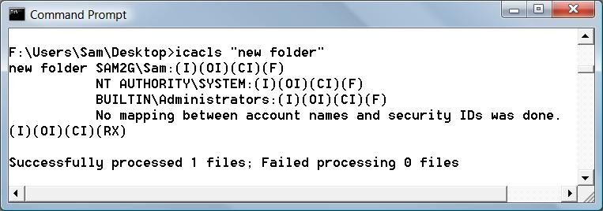

Setting Permissions from a Command Prompt

ICACLS displays and sets permissions

Permission settings: F for Full Control, M for Modify, R for Read, etc.

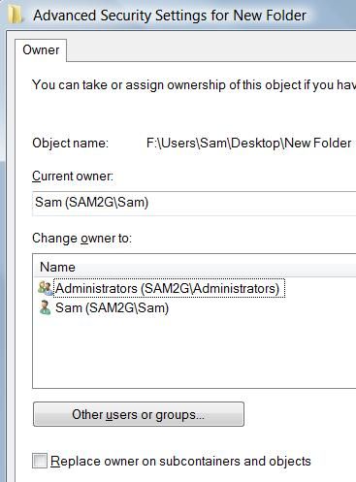
Taking or Assigning Ownership of Files and Folders

When you create a file or folder on an NTFS drive, you become its owner

Owner can allow or deny permissions

Any member of the Administrators group can take or give ownership of any file or folder

How to Take or Assign Ownership of Files and Folders

Right-click, Properties

Security tab, Advanced

Owner tab, Edit

Copying Files: Destination Folder Determines Permissions

When you copy a file or folder to an NTFS drive

The newly created folder or file takes on the permissions of the destination folder, and the original object retains its permissions

This is true regardless of whether the destination is on the same NTFS drive as the original file or on a separate NTFS drive

Moving Files

Moving Files to Another NTFS Drive: Destination Folder Determines Permissions

Moving Files to another folder on the same NTFS drive: The moved file retains its original permissions

This is because the file is not actually moved, only a pointer to it is changed

Demonstration

Make a folder, assign Deny Full Control to Network

Create two files in that folder: Inherited.txt and Explicit.txt

Break inheritance on Explicit.txt, Copy permissions

Move both folders to a new folder

Only Explicit.txt keeps its old permissions

Going from NTFS to FAT

When you copy or move a file or folder from a FAT32 drive to an NTFS drive

The newly created folder or file picks up the permissions of the destination folder

When you copy or move a file or folder from an NTFS drive to a FAT32 drive

The moved or copied folder or file in the new destination loses all NTFS permissions

Because the FAT32 file system is incapable of storing these details

-

Last modified 11-27-07

