Ch 3: Personalizing Windows Vista

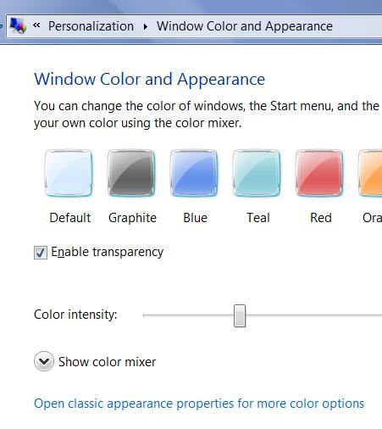
Customizing the Aero User Interface

For Aero your graphics card must have:

Windows Vista Display Driver Model (WDDM)

You can’t get Aero with Win XP drivers

DirectX 9, Pixel Shader 2.0, with 32 bits per pixel

Graphics throughput of at least 1800 MB per second at resolutions equivalent to

1280 × 1024

At least 1 GB of random access memory (RAM)

Aero Features

Transparent window frames

Live previews of icons on the taskbar

Live previews in Alt+Tab

“Flip 3D”—Windows logo key+Tab

Smoother window dragging

Interactive window controls

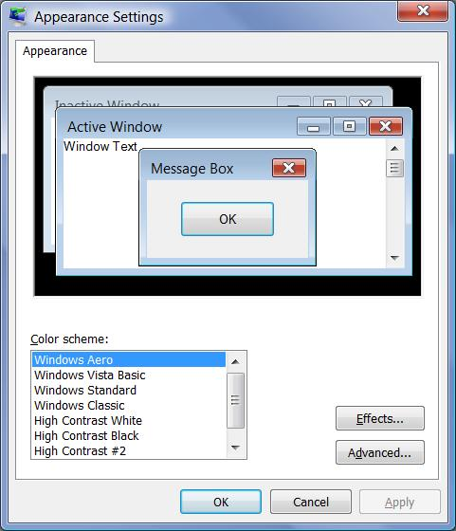
Close buttons that glow on hover

Animated window closings and openings

Windows Color and Appearance

Right-click desktop

Personalize

Window Color and Appearance

If Aero is on, you can enable transparency

Turning Aero Off

In Window Color and Appearance

Click “Open classic appearance properties for more color options”

Choose any color scheme other than Windows Aero

Adjusting Font Size

This should change font size in windows and programs too

Right-click desktop

Personalize

Adjust font size (DPI)
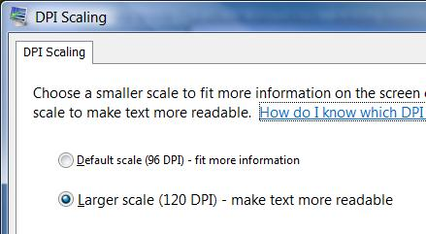

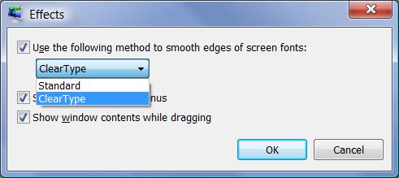
Font Smoothing

Right-click desktop

Personalize

Desktop Background

Window Color and Appearance

Click “Open classic appearance properties for more color options”

Click “Effects”

ClearType was designed for LCD displays

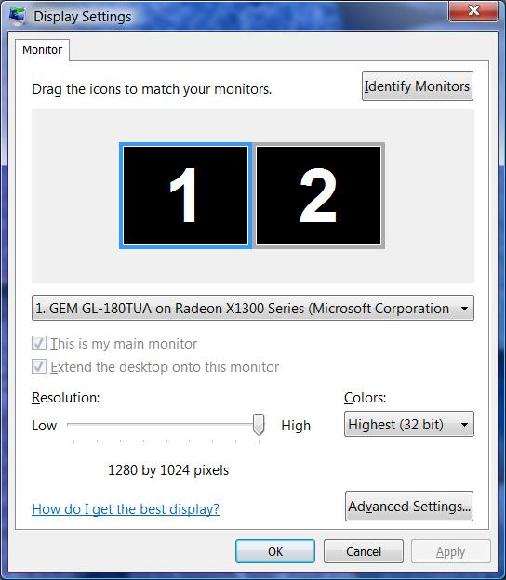
Standard may look better on CRTs

Other Customizations

Background

Screen Saver

Sounds

Mouse Pointer

Work as they did in XP

Can be saved as Themes

Screen Resolution

Right-click desktop

Personalize

Display Settings

If you have more than a single graphics card you can configure multiple monitors here

Start Menu

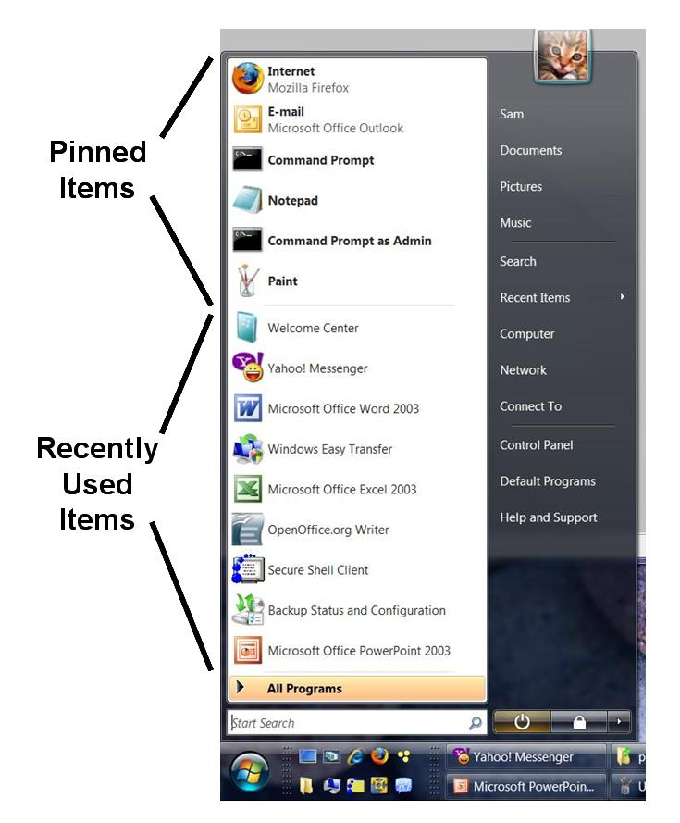
Search is new

Run is absent by default

Right-click items to pin or unpin them

Personalizing the Start Menu

Right-click Start

Properties

Can choose Start menu or Classic Start menu

Customize button to control items on the right side

Including Run

Folders that Make the Start Menu

Two folders are combined:

Personal folder

%AppData%\
Microsoft\
Windows\
Start Menu

“All Users” folder

%ProgramData%\
Microsoft\
Windows\
Start Menu

Right-click Start, “Open” or “Open All Users”

The Quick Launch Toolbar
Quick Launch

Single-click icons to launch programs

Logo-1 launches first item, etc.

Right-click taskbar to control toolbars

Demo: Add a Desktop toolbar

Customizing the Taskbar

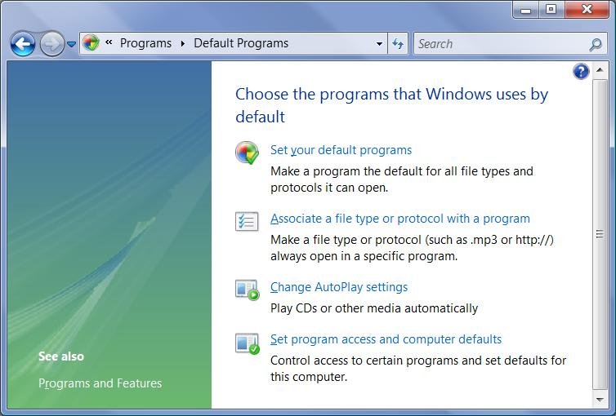
Drag taskbar to any side of the screen (unlock it first)

Make it wider or narrower

Control grouping and hiding in Taskbar Properties

Controlling the Display of Icons in the Notification Area

By default it hides inactive icons

Default Programs

Start, Default Programs

Ch 4: Adding, Removing, and Managing Programs

Add or Remove Programs is Gone

No one ever used it to add programs anyway

Programs come with installers. You just have to deal with:

User Account Control (UAC)

Compatibility issues

User Account Control (UAC)

Installers change system files and registry settings

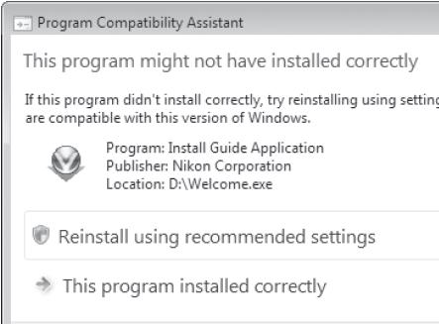
So you need to elevate privileges

Updates and uninstalls also require elevation

If the installer doesn’t automatically trigger UAC, you can right-click it and choose Run as Administrator

Compatibility Issues

"Program Compatibility Assistant" dialog boxes warn you of compatibility issues, and suggest solutions

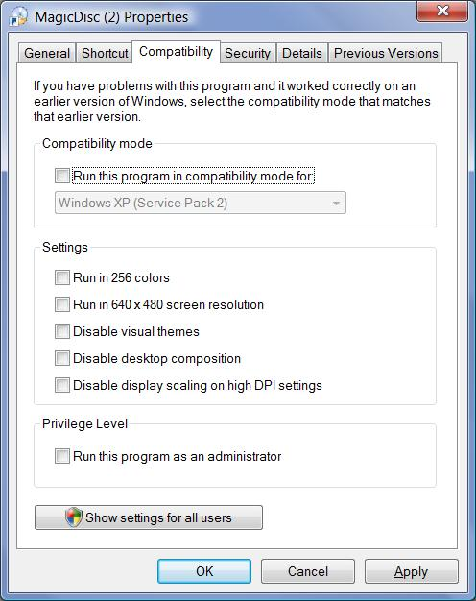

Compatibility Tab

Right-click shortcut or EXE file, Properties

MS-DOS Programs

MS-DOS programs use Autoexec.nt and Config.nt

instead of Autoexec.bat and Config.sys

Each MS-DOS program can use custom Autoexec.nt and Config.nt files, set in the program’s properties

Installing Programs on 64-bit Versions of Windows

16-bit programs won’t install

32-bit programs install into the “Program Files (x86)” folder

64-bit programs install into the “Program Files” folder

Ways to Make a Program Run at Startup

Registry keys

Run or RunOnce or Policies\Explorer\Run

Load value

RunServices or RunServicesOnce

Winlogon or BootExecute

Scheduled Tasks

Win.ini

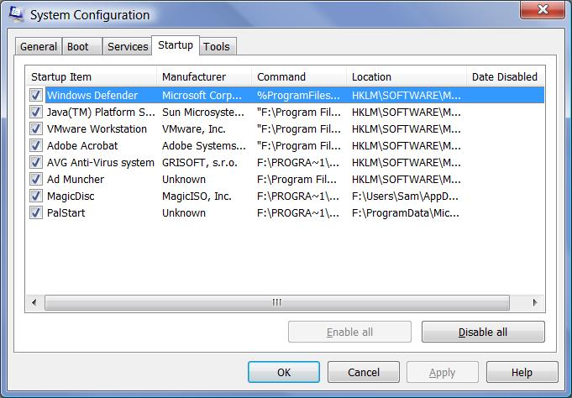
Group Policy

Shell service objects

Logon scripts

Using Msconfig to Control Startup Items

Start, MSCONFIG, Enter

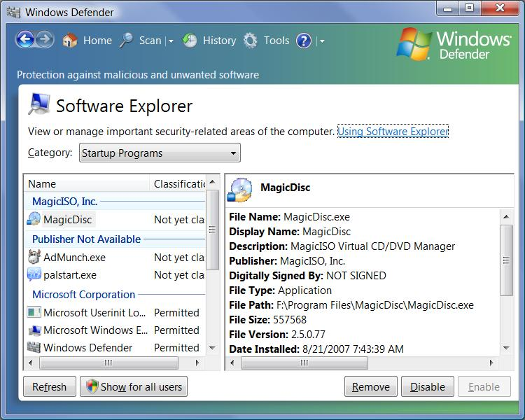

Controlling Startup Programs with Windows Defender

In Control Panel, under Programs, click Change Startup Programs

Controlling Startup Applications with Group Policy

To open the Group Policy console

Start, GPEDIT.MSC, Enter

These policies affect startup applications

Run These Programs At User Logon

Do Not Process The Run Once List

Do Not Process The Legacy Run List

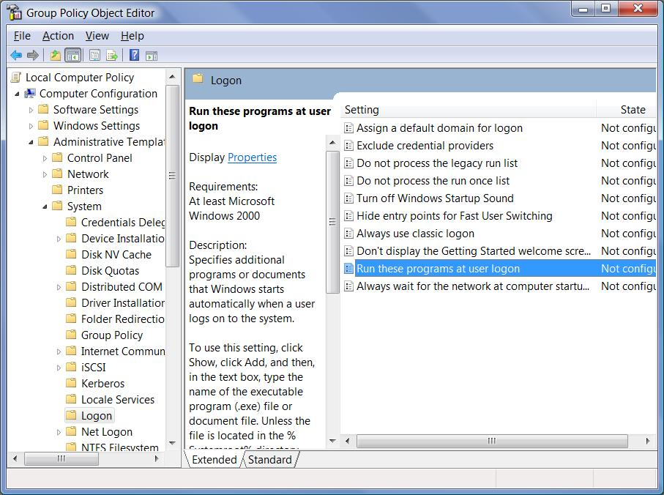
Group Policy is not available in Vista Home Basic or Vista Home Premium

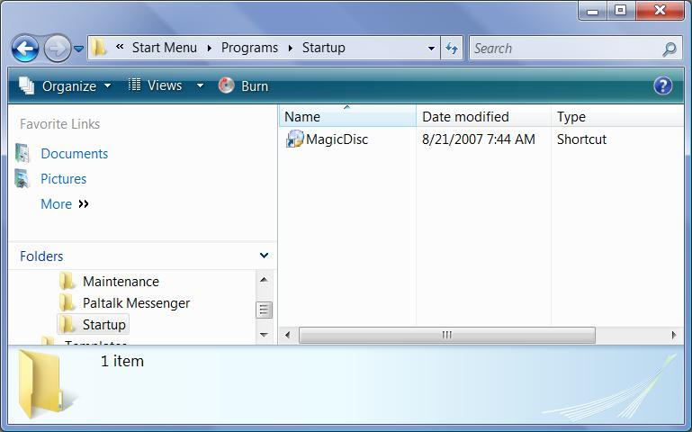
Managing Startup Programs

Right-click Start, Explore

Open Programs, and open Startup

Shortcuts placed here will execute each time you log on

Task Manager

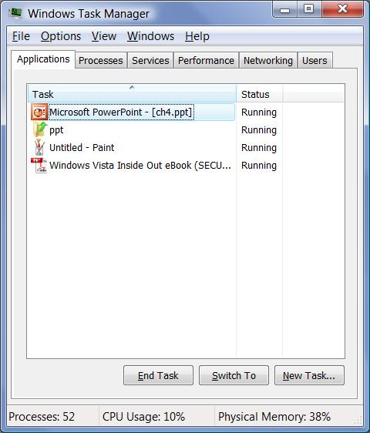
Ctrl+Shift+Escape

Task Manager Tabs

Applications

Shows running programs with status

Processes

Information about programs and services

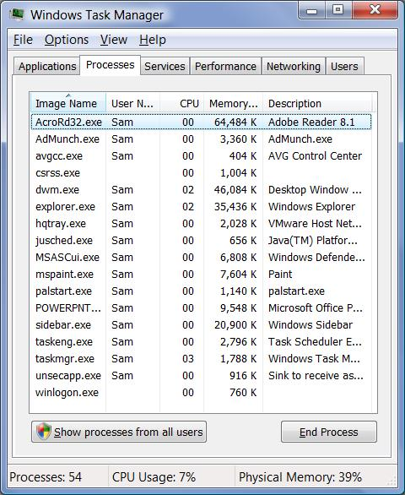
“Show processes from all users” reveals processes running under system accounts

You can shut down processes here, but it can cause loss of data or a system crash

Running a Program as an Administrator

Right-click it and choose “Run as Administrator”

Launch it from the Administrator Command Prompt

Start, type in program name, press Ctrl+Shift+Enter

Uninstalling Programs

In Control Panel, under Programs, Uninstall a Program

When Programs Fail to Uninstall Properly

Remove Registry Keys Manually

See link Ch 4a

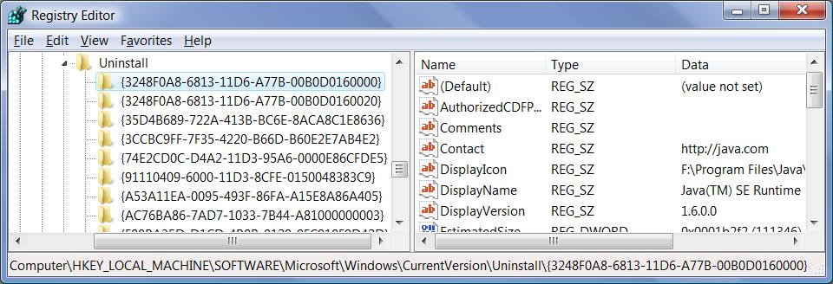

Last modified 8-29-07 11 am

