Chapter 30 – Automating Windows Vista

Editions

The Automation Tools are the same in all editions of Windows Vista

Four Ways to Automate Tasks

Task Scheduler

Easiest and simplest

Batch Programs

Carried over from MS-DOS

Windows Script Host

Can run scripts written in VBScript, JScript, and other languages

Windows PowerShell

Not included in Vista by default

A free download from Microsoft

We Only Cover Task Scheduler

The other three methods are not part of this class:

Batch Programs

Windows Script Host

Windows PowerShell

New Features in Task Scheduler

Implemented as a Microsoft Management Console (MMC) snap-in

More information about tasks

Integrated with the Event Viewer

Events can trigger tasks

More extensive triggering and scheduling options

Launch when computer is idle

Launch when a specific user logs on

Launching Task Scheduler

Control Panel, System And Maintenance, Scroll to bottom, under Administrative Tools, Schedule Tasks

Or taskschd.msc at a Command Prompt

Or Start, search for "Task Scheduler"

Task Scheduler Window

View, Customize, and then deselect Action Pane

To update, Action, Refresh
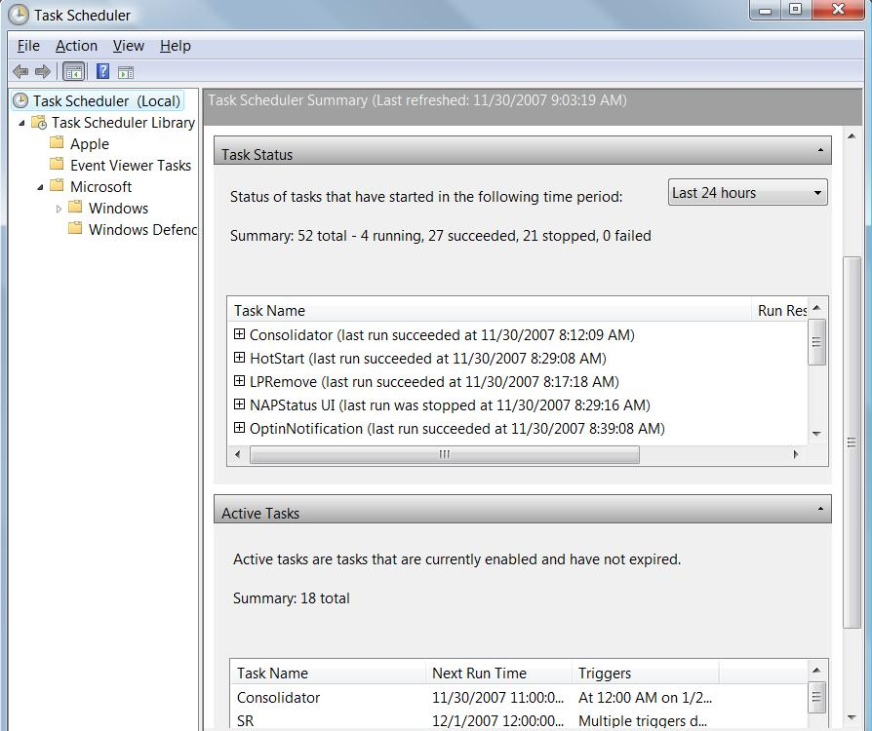

Display All Running Tasks

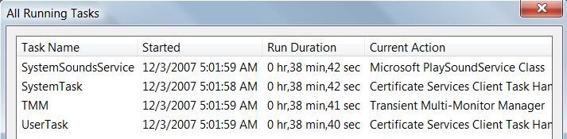
Select top node in left pane

Action, Display All Running Tasks

Task Details

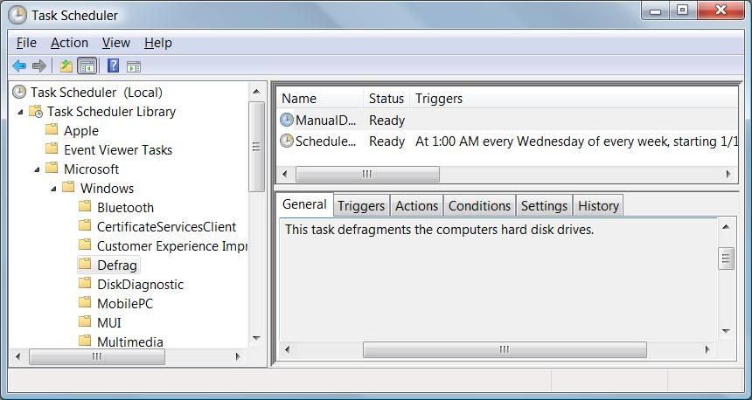
Browse to task in folder tree to see read-only details in lower pane

To modify them, right-click task name in the top pane and click Properties

Task Scheduler Terminology

Trigger

The time or the event that causes a task to run

Action

What the task does

Condition

An additional requirement that, along with the trigger, must be met for the task to run

Setting

A property that affects the behavior of a task

Demonstration: System Restore

See when Restore Points were made
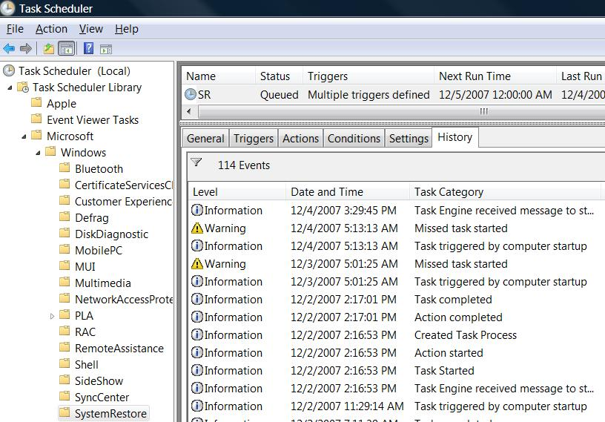

Scheduling Tasks with the Schtasks Command

Schtasks /Create

Schtasks /Change

Schtasks /Delete

Schtasks /End

Schtasks /Query

Schtasks /Run
Chapter 31 – Advanced Security Management

Topics

Windows Firewall With Advanced Security

User Rights

Auditing

Editions

Windows Firewall With Advanced Security is the same in all editions of Windows Vista

User rights are the same in all Editions

But the console for viewing and modifying them is available only in the Business, Enterprise, and Ultimate editions

Editions

Auditing is preconfigured and cannot be changed in the home editions

The other editions allow you to control exactly what you audit

Protecting a System with Windows Firewall

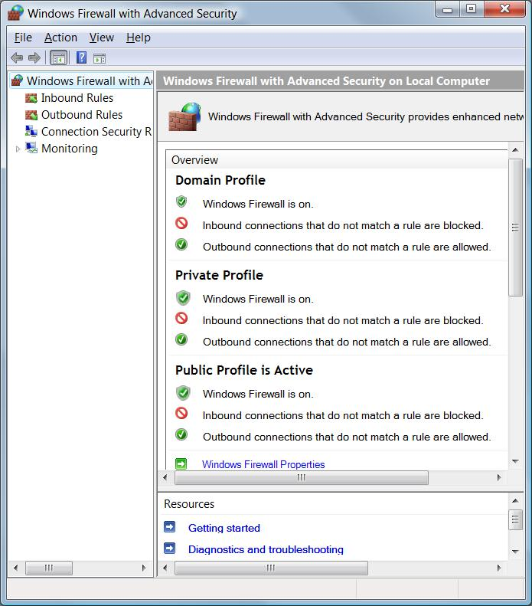
For basic control, use Windows Firewall application in Control Panel

For more advanced tasks, use:

Windows Firewall With Advanced Security, or

The Netsh command-line utility

To Open Windows Firewall with Advanced Security

Start, FIRE

or

wf.msc

at a command prompt

Viewing Active Rules and Security

A firewall rule defines how a given network packet is handled by the Windows Firewall

Exceptions in Windows Firewall comprise one of more rules

Inbound Rules

There are a lot of rules

You can make custom rules if you like (see textbook)

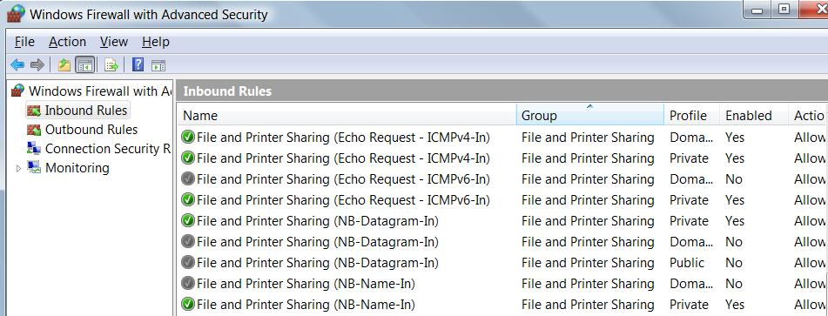

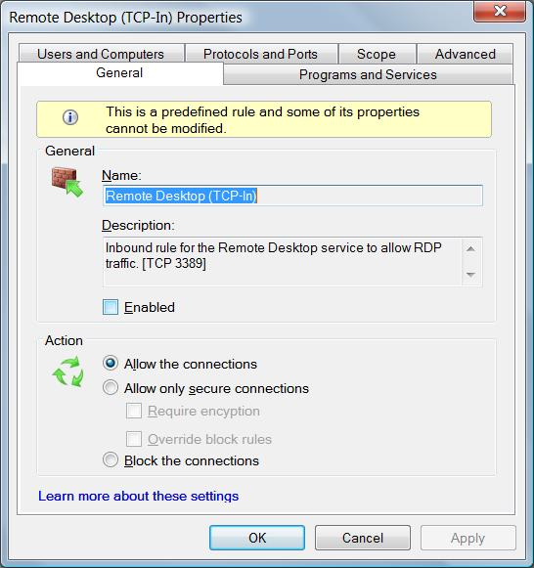
Demonstration

Restricting Remote Desktop to LAN connections

Double-click "Remote Desktop (TCP-In)

Demonstration

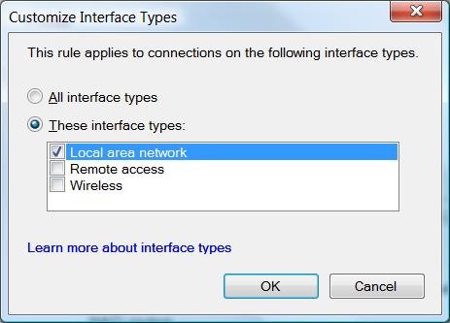
On the Advanced tab, click Customize

Select desired interface types

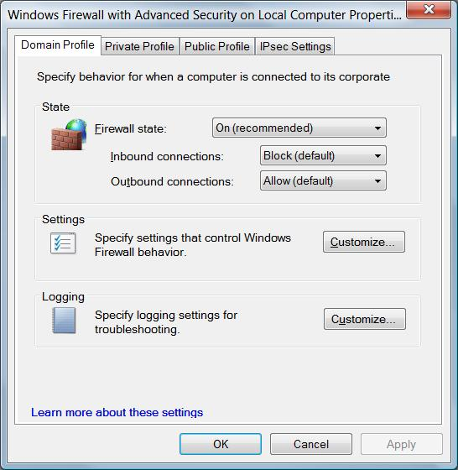

Logging Firewall Activity

Right-click the top-level folder:

Windows Firewall With Advanced Security On Local Computer

Properties

Choose the desired profile's tab

Domain, Private, or Public

Firewall Log

To view the log, you need an elevated Notepad window
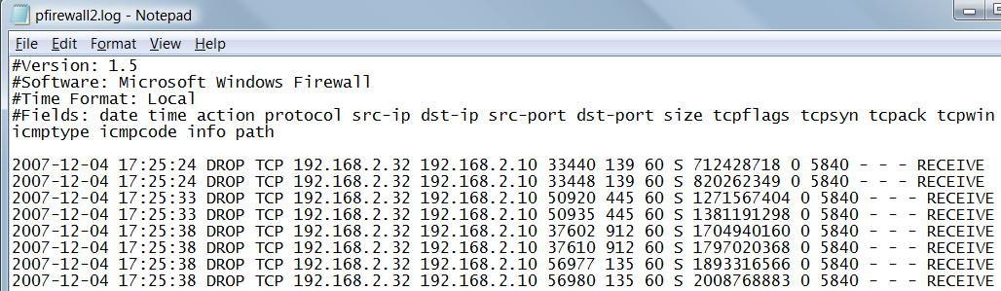

Logging Settings

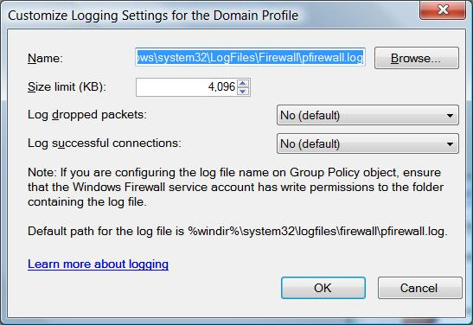
In the Logging section, click Customize

Logging successful packets is usually worthless—too much boring data

Using the Netsh Command to Manage Windows Firewall

You can enable Windows Firewall with this command:

netsh firewall set opmode enable

There are a lot of netsh commands, to use some of them, do the Server Core project

Testing Your Computer’s Network Security

To see the currently active network connections, at a Command Prompt:

netstat -a | more

You could just use netstat –a, but it would scroll off the screen

This command uses numbers instead of DNS names, and shows process IDs:

netstat -aon | more

Correlating Process IDs

Netstat shows the PID that is listening
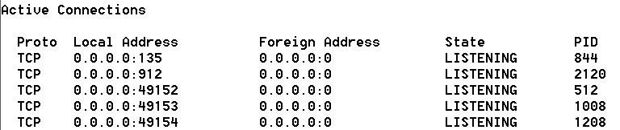

Task Manager shows the process
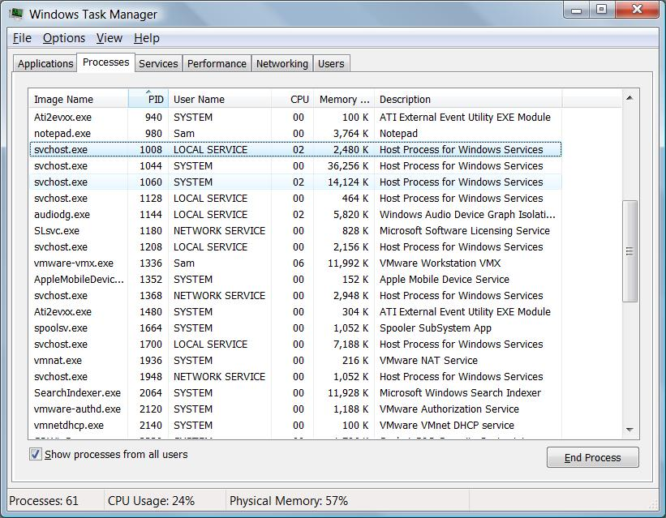

Managing User Rights

A user right is authorization to perform an operation that affects an entire computer

A permission, is authorization to perform an operation on a specific object—such as a file or a folder

Local Security Policy

Available only on Business, Enterprise, or Ultimate editions of Vista.

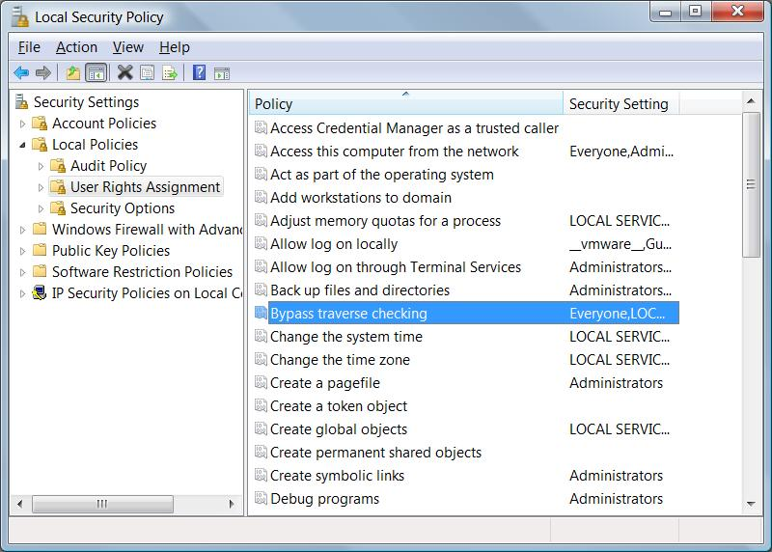
At a command prompt, type secpol.msc

Default User Rights

These User Rights are what makes an Administrator different from a User

It is not common to change them from their default settings

You could change "Bypass Traverse Checking" to prevent security problems in nested folders

Auditing Security Events

Auditing writes events into the Security Log, when

A monitored folder is accessed

Logon or Logoff

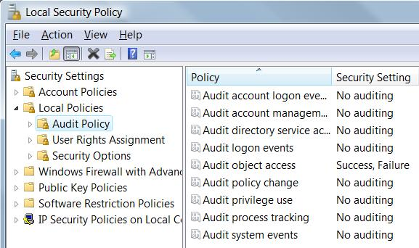
Many other possibilities

Enabling Auditing

Before any events can be written to the Security log, you must enable Auditing in Local Security Settings

Enable the desired auditing

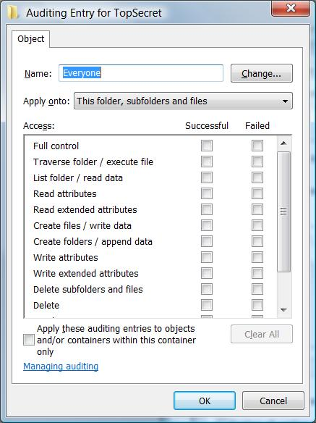
Monitoring Access to Folders and Files

Right-click file or folder, Properties, Security tab, Advanced, Auditing tab

Add, Everyone

Check events to audit

Security Events

Now you will see a LOT of events from the auditing

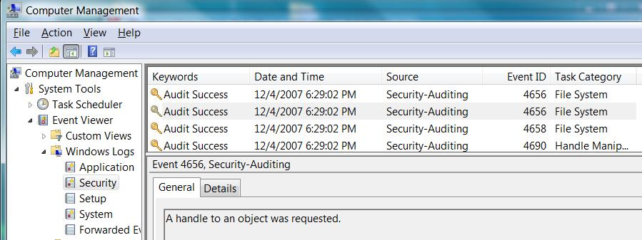

Last modified 12-4-07

