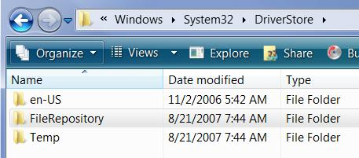
A Crash Course in Device Drivers

Each hardware device needs a driver

A compact control program

Vista has a library of drivers called the Driver Store

In C:\Windows\System32\DriverStore

Using the Driver Store

Any user can read and execute files in the Driver Store

No Administrator credentials are required

The Driver Store is created when Vista is installed

Windows Update can add drivers to it

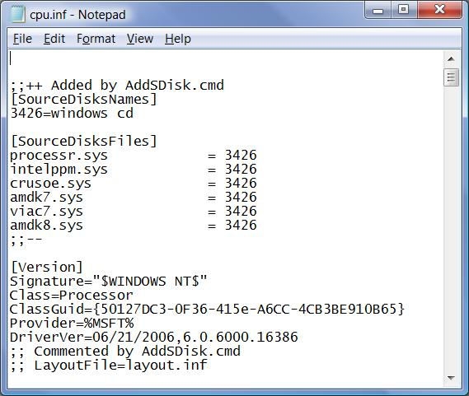
Administrators can add other drivers to the store, even ones that are not Microsoft approved or signed

INF Files

Each driver has Setup Information file (.inf)

Contains instructions Windows uses to install the driver files

Driver Store drivers have INF files in

%systemroot%\inf

Usually C:\Windows\inf
Three Types of Drivers

WHQL-Signed by Microsoft

Signed by a third party

Unsigned
Best

Worst

WHQL-Signed Drivers

Windows Logo Program

Signed by Microsoft’s Windows Hardware Quality Lab (WHQL)

Proves the driver has not been altered

Also proves the driver has been thoroughly tested so it won’t crash Windows

The most trustworthy drivers

Can be installed by any user with no warnings

Drivers Signed by a Third Party

Signed with digital certificates called “Authenticode Signatures”

Proves the driver has not been altered

Not tested by Microsoft, may cause Windows to crash

If the user has not chosen whether to trust a publisher or not yet

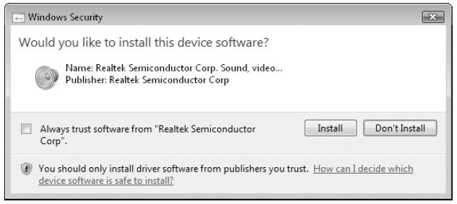
This box appears, so the user can decide whether to trust that publisher

If an Administrator has designated that publisher as trusted

The driver can be installed by any user with no prompts

If the publisher is not trusted

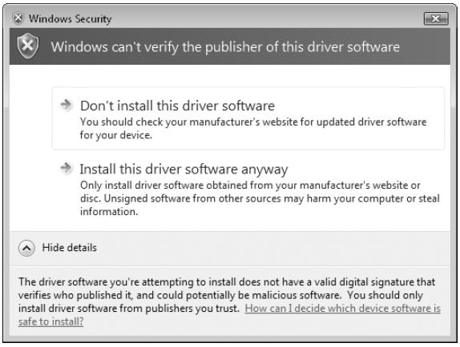
Only an Administrator can install the driver

Installation will fail silently for
non-Administrators

Unsigned Drivers

32-bit Vista will show this box asking whether to install the driver

64-bit Vista requires all drivers to be signed

Unsigned Drivers

No guarantee that the driver has not been altered

No guarantee that anyone has tested it

Driver may cause a system crash or contain a trojan

Can be installed only by Administrators

Can not be used at all on 64-bit Vista

Using Older Drivers

If no Vista driver is available

A Windows XP or Server 2003 driver will usually work

Older drivers probably will not work

Device Manager

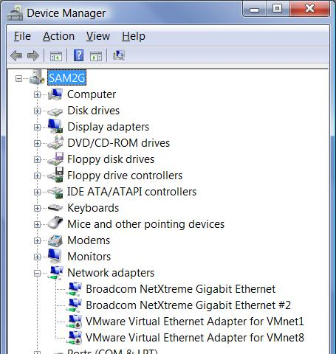
Starting point for all hardware and driver troubleshooting

To launch it:

Start, DEVMGMT.MSC, Enter

Or

Start, right-click Computer, Manage

Device Properties

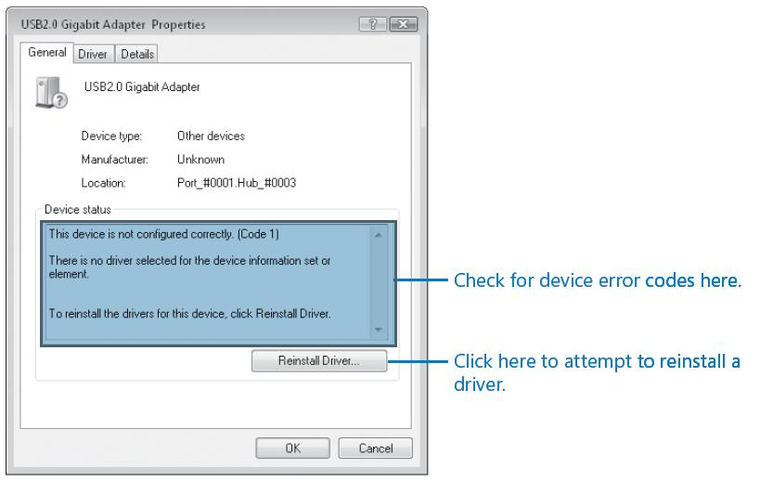
Double-click icon in Device Manager

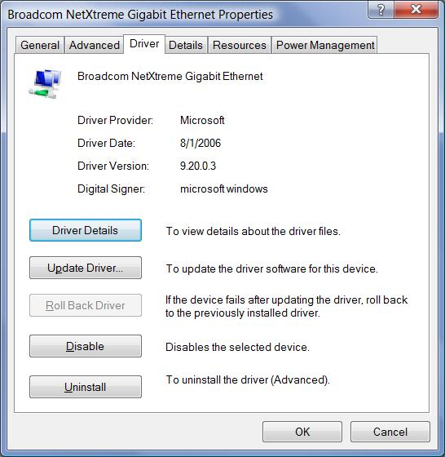

Driver Tab

Shows version, and who signed the driver

Roll back option – returns to the previous driver version

Error Icons in Device Manager

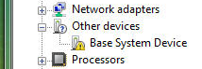
Question mark and yellow exclamation point

Indicate a missing driver or other configuration problem

Installing and Configuring a New Device

Almost all devices are Plug and Play

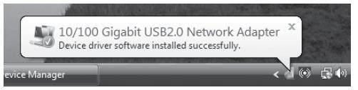
When you plug in a device

Vista looks in the Driver Store for a matching driver

Messages like this one show the Plug and Play process
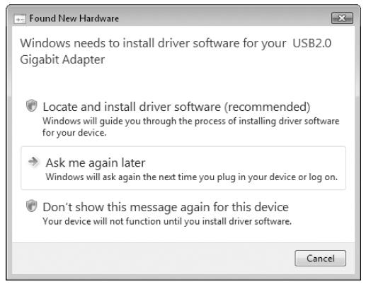

Found New Hardware Wizard

If Vista can’t find a signed driver

The Found New Hardware wizard appears

Driver Verifier

If your computer has blue-screens, lockups, or other strange behavior

Driver Verifier will thoroughly test all drivers at startup, and stop if it finds any problems

Then you can fix the problem, and turn Driver Verifier off again

To Start Driver Verifier

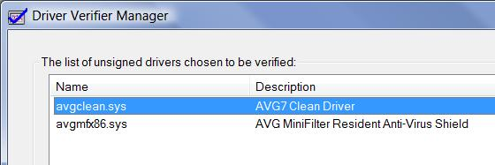
Open an Administrator Command Prompt

VERIFIER

Last modified 8-29-07 19 am

