Ch 6: Using Internet Explorer 7

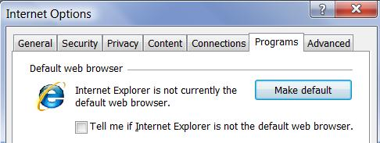
New Features in IE 7

Features that are the same on Win XP and Vista

Tabbed browsing

Instant Search box

Phishing Filter

Web feed subscriptions

Feature only found with IE7 on Vista

Protected Mode

Vista Editions

IE 7 is the same on every version of Vista, as far as anything in this chapter is concerned

Choosing a Default Web Browser

In IE: Tools, Internet Options

The default browser appears at the top of the Start Menu

If you double-click Web icons, the default browser opens

Start, Default Programs can also be used to set the default browser

Using and Personalizing Internet Explorer

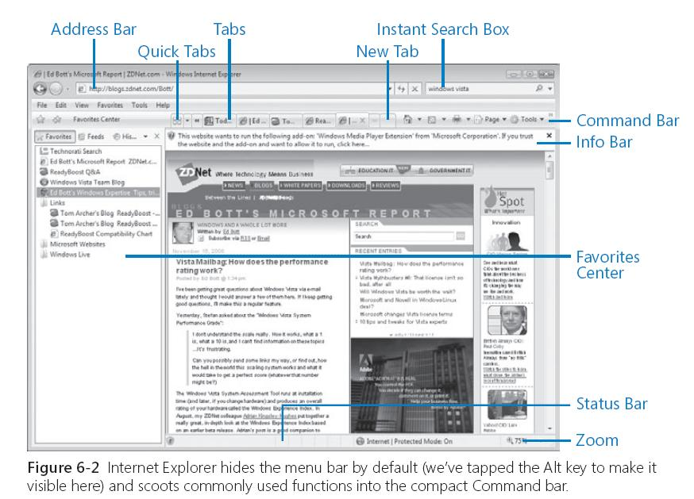

Favorites Bar

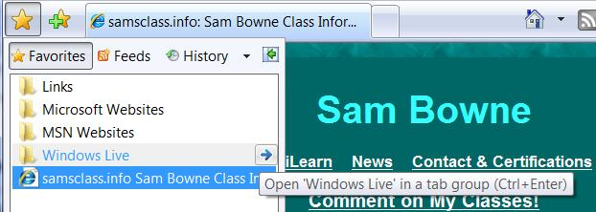
Click the star to see it

Favorites

Feeds

History

Note the “Open Tab Group” arrow

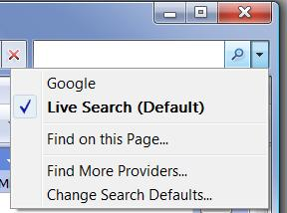

Choosing Search Providers

Click drop-down arrow to the right of the Instant Search box

Click “Find More Providers…”

Multiple Home Pages

Tools, Internet Options

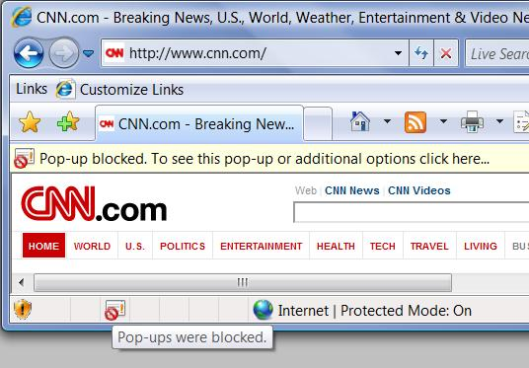

Blocking Pop-Up Windows

Information bar and the icon at the bottom both indicate when pop-ups were blocked

Ctrl+Alt+click allows pop-ups

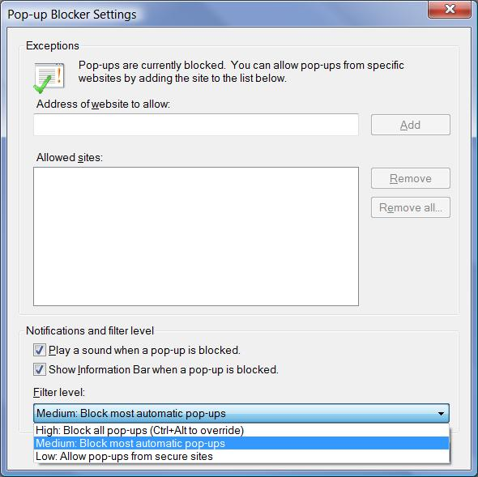
Pop-Up Blocker Settings

Tools

Pop-up Blocker

Pop-up Blocker Settings

Using (or Refusing) AutoComplete

Tools

Internet Options

Content Tab

“Settings” button in AutoComplete Section
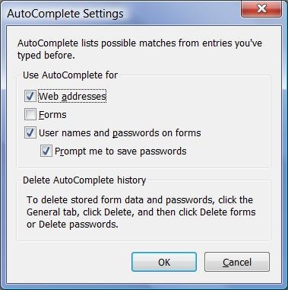

AutoComplete Password Storage

Encrypted, in the Registry

Safer than Windows XP’s storage

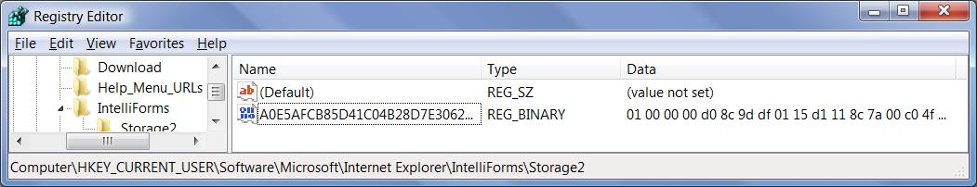

Internet Explorer Security and Privacy Options

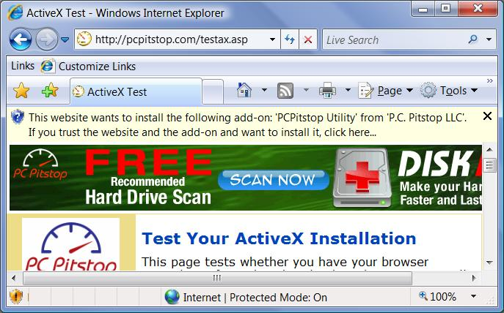
Pcpitstop.com

Check ActiveX

Warning box and Information Bar

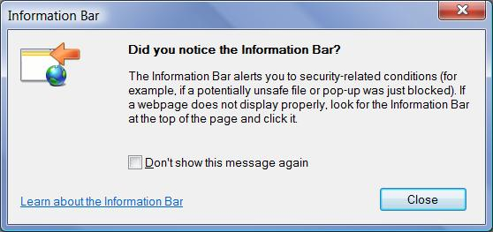

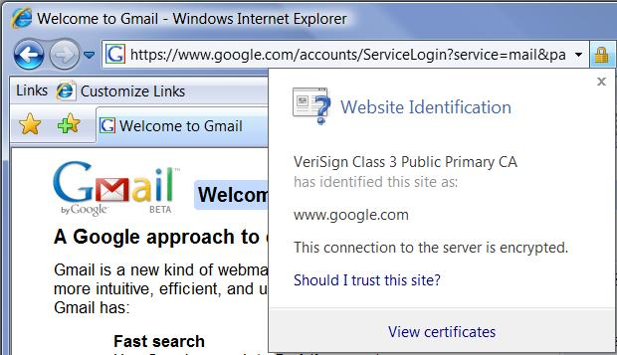

Digital Certificates

Secure sites (https) are identified by digital certificates

Click padlock to see certificate information

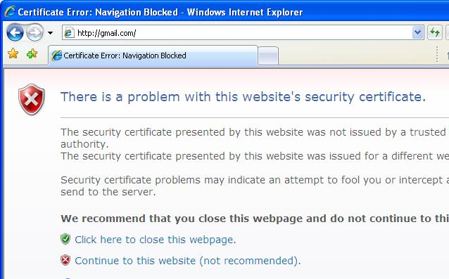

Digital Certificate Errors

Usually caused by a site’s name change, or a clock that is not set

Can be a warning of a man-in-the-middle attack

Phishing Filter

Uses heuristic checks based on page’s content

Also uses a whitelist and a blacklist

See link Ch 6a

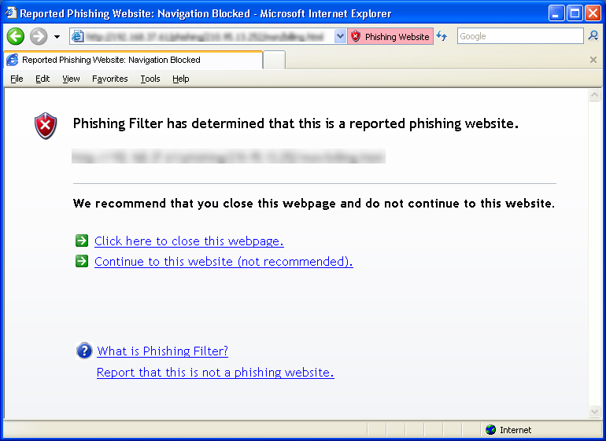



Finding, Reading, and Subscribing to RSS Feeds

Go to slashdot.org (or any page with a feed)

Click the orange Feed button
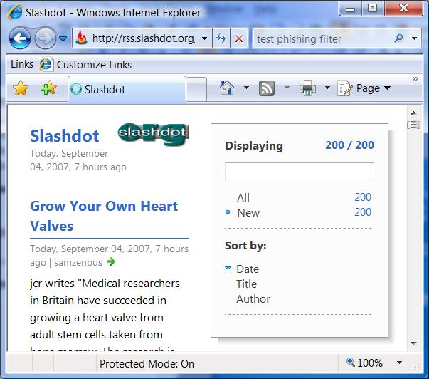

Feed Properties

Open Favorites Center

Click Feeds

Right-click a feed, Properties

Using Internet Explorer as an FTP Client

To do this, use a URL like this:

ftp://name:password@ftp.microsoft.com

But your password is sent unencrypted, so it is a very poor practice

Named FTP and Named Telnet are absurd security risks, don’t use either of them!

Use SSH Secure Shell and Secure FTP instead

Ch 7: Finding and Organizing Files and Information

New Features in Vista

Windows Explorer now has live-icon previews

Integrated search

Previous Versions

Previous Versions is not available in Vista Home Basic or Vista Home Premium

What’s What in Windows Explorer
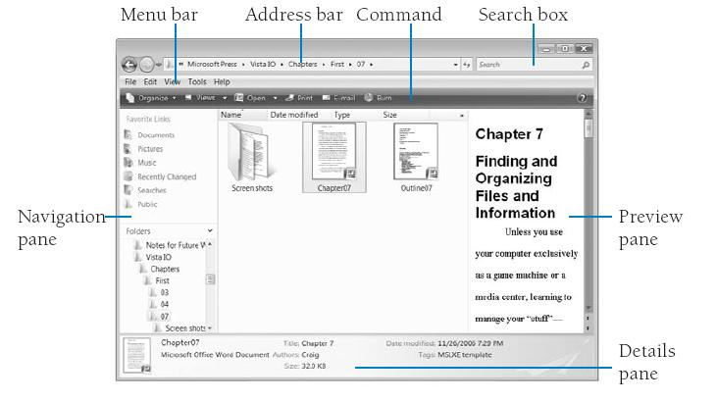

Click the right side of the Address bar to see the traditional path

Organize, Layout to control panes

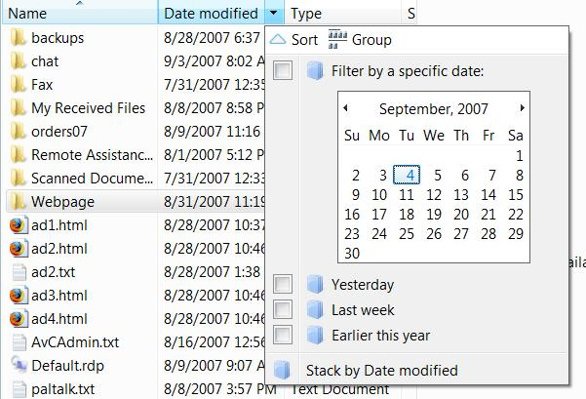
Using Headings

Click a heading to filter, sort, group, or stack

Adjusting Headings

Right-click a heading to change the visible headings

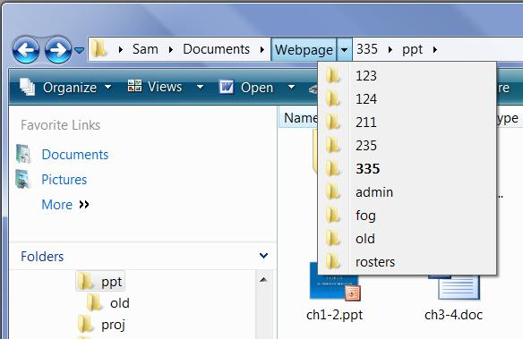
Navigating with Breadcrumbs

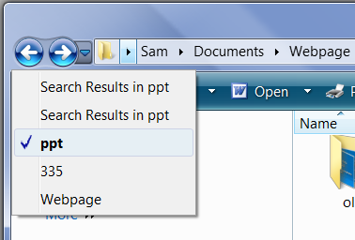

Recent Items

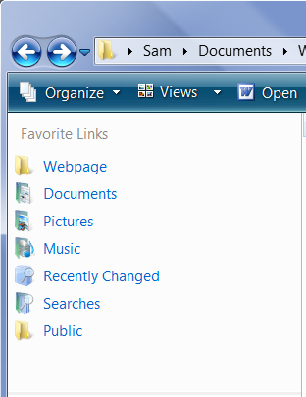

Favorite Links

Drag items to add them

Right-click to remove them

Managing User Profiles

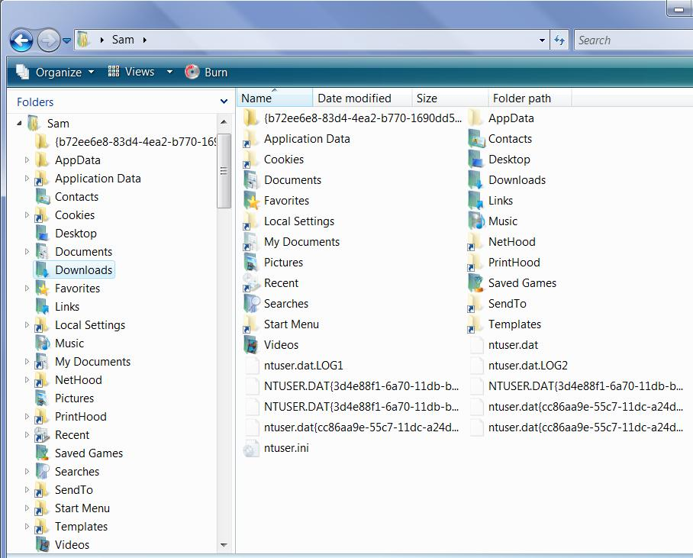

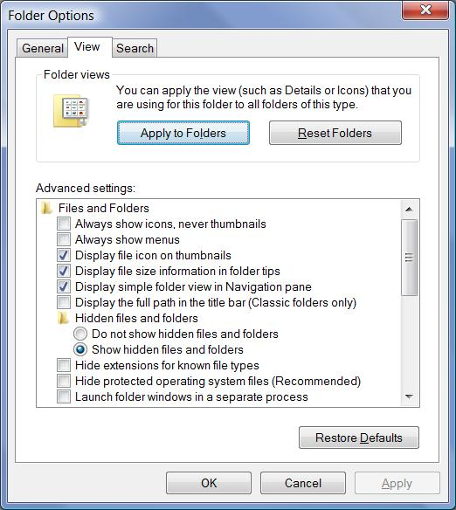
This figure includes hidden and system files

Showing Hidden and System Files

Organize, Folder and Search Options

View Tab

Check “Show hidden files and folders”

Clear “Hide protected operating system files (Recommended)”

User Profiles are Located in:

C:\Users\Username or %UserProfile%

Items in a User Profile

Ntuser.dat and other registry files

Contain the HKEY_CURRENT_USER hive

NetHood, PrintHood, and SendTo for backward compatibility with Win XP

Items in a User Profile (continued)

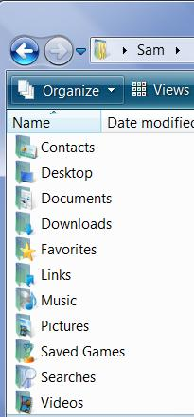
AppData

Application-specific data in three subfolders:

AppData\Roaming

Data which can be placed on a server to form a Roaming Profile

AppData\Local

Data that should not roam, like Temporary Internet Files

AppData\LocalLow

Internet Explorer Protected Mode data

Items in a User Profile

Personal Folders

The ones visible when Hidden and System files are not displayed

Favorites

Internet Explorer Favorites

Links

Shortcuts in the Favorites Links section of Windows Explorer

Items in a User Profile

Hidden Junctions that point to AppData subfolders

Application Data

Cookies

Local Settings

My Documents

NetHood

PrintHood

Recent

SendTo

StartMenu

Templates

Junctions

The Junctions, like “Application Data”, look like shortcuts but they aren’t

You can’t open them in Windows Explorer

“Everyone” is Denied Full Control

Leave them alone!

They are there to redirect data written by Windows XP legacy programs
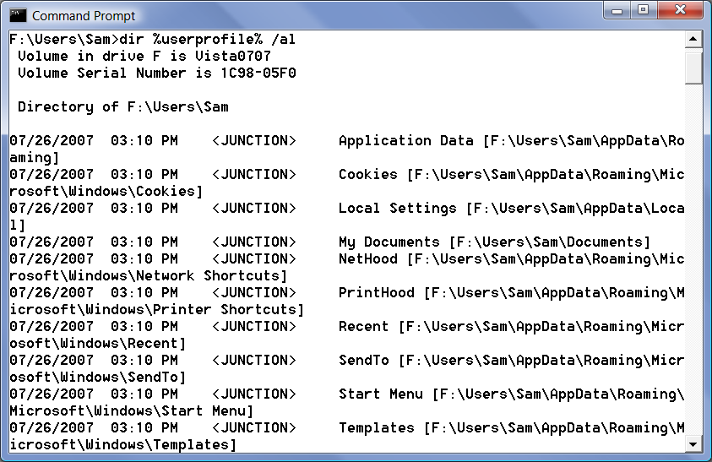

Junctions in a Command Prompt

DIR %USERPROFILE% /al

Common Profiles

Public

The Public Desktop and Start Menu are merged with the current user’s profile to create the visible Desktop and Start menu

Corresponds with “All Users” profile in Windows XP

Default

New user profiles are copies of this folder

Compatibility and Virtualization

If an application attempts to write to %ProgramFiles%

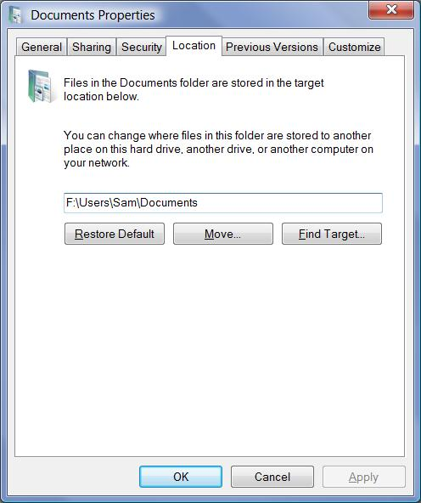
The write is redirected to %LocalAppData%\VirtualStore

Relocating Personal Data Folders

Separating the Operating System from personal data is a good idea

Simplifies backups

Easier to restore system and clean off malware

Right-click a personal folder, Properties

How to Relocate Personal Data Folders

Right-click a personal folder, Properties, Location tab
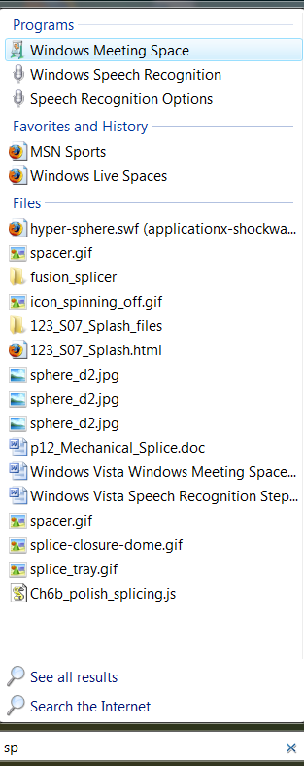

Using and Configuring Search and Indexing

Places you can Search From

Start Menu

Windows Explorer

Common dialog box

Search folder

Start Menu Search

Results are compact

“Word Wheel” – starts searching as soon as you start typing

See all results goes to a Search folder

Searching in Windows Explorer

Useful if you know what folder to search

Also a word wheel
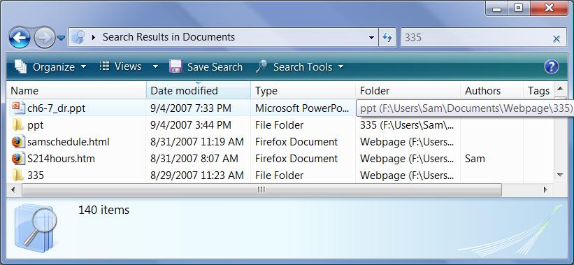

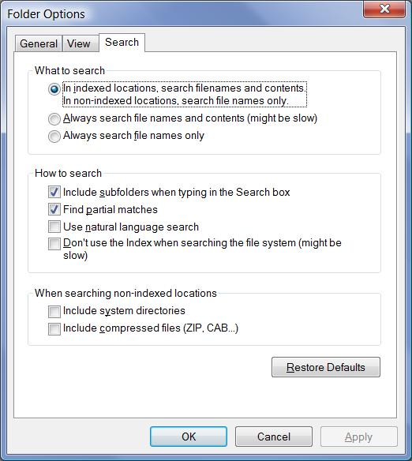
Configuring Search

Organize, Folder and Search Options

Search tab

For more details, see link Ch 7a

Search in Common Dialog Boxes

Open and Save

Search Includes File Contents

Search includes file contents for indexed folders

For files with text, like Word documets, PDF files, spreadsheets, PowerPoint files, etc.

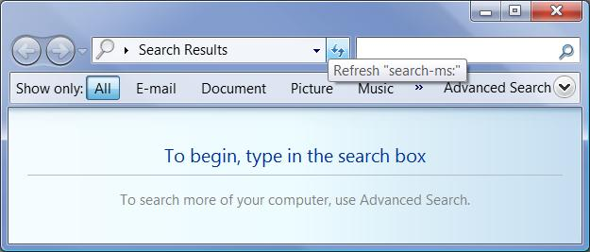

Search Folder

Start, Search

Useful to find items when you have no idea where they are

Advanced search is available here

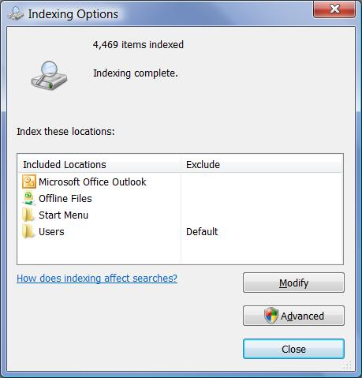

Indexing Options

In Control Panel, System and Maintenance

Restoring Files and Folders with Previous Versions

Shadow copies are created by

System Protection each day (by default)

Windows Backup when you use it

Right-click file “Restore Previous Versions”
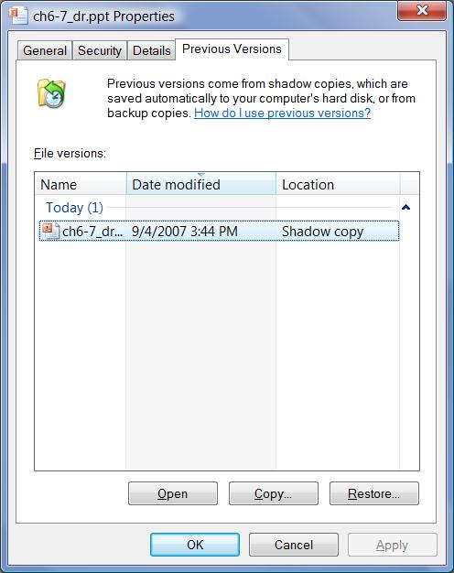

Limitations of Previous Versions

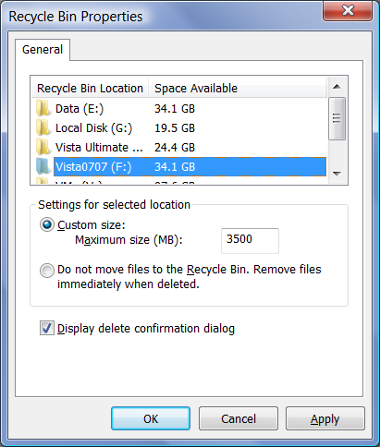
Old versions eventually are overwritten

15% of disk is reserved for shadow copies bu default

Shadow copies only record changes

Files you don’t change have no copies

If you boot to another operating system, all shadow copies are erased

Restore points are also lost!

Items that Don’t go to the Recycle Bin

Files stored on removable disks

Files stored on network drives

Files deleted from compressed (zipped) folders

Files too large to fit in the Recycle Bin

Shown: Recycle bin Properties

Configuring System Protection

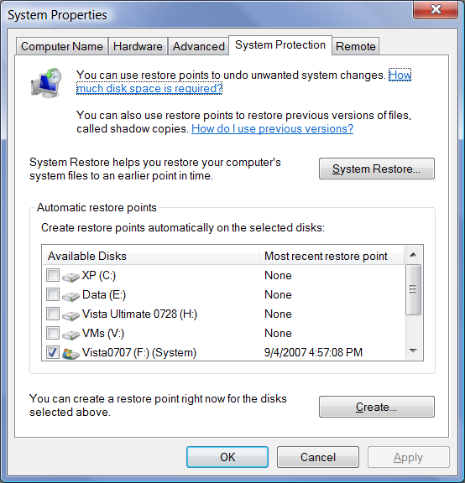
Start, Computer, Properties

System Protection

To change size of storage area, use VSSAdmin command

See link Ch 7b

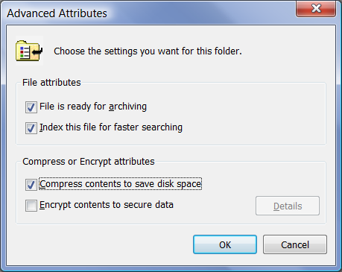
NTFS Compression

NTFS Compression makes files somewhat smaller

Very easy to use

Right-click a file, Properties, Advanced

File name turns blue

Only works on NTFS drives

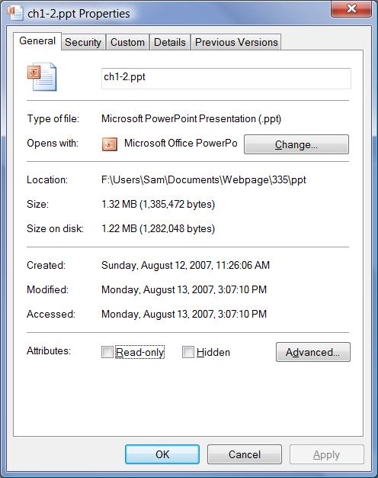

NTFS Compression Results

Not much compression – typically 10% smaller

Transparent to user – just open file normally

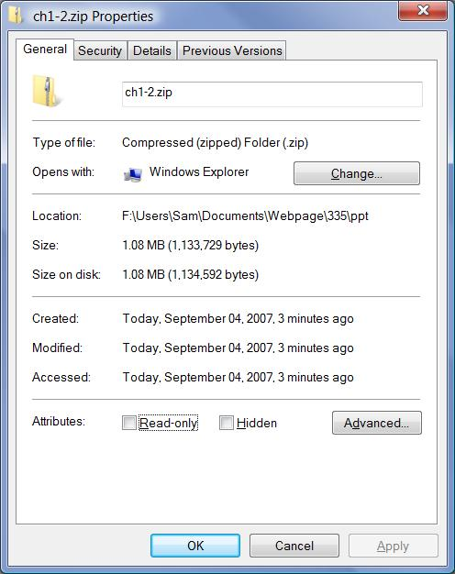

Compressed (Zipped) Folders

Right-click a file

Send To, Compressed (Zipped) folder

Same as WinZip

Can be emailed

File must be unzipped to use

More compression than NTFS compression

Last modified 9-4-07 10 pm

