Ch 8: E-Mail, Collaboration, and Personal Productivity

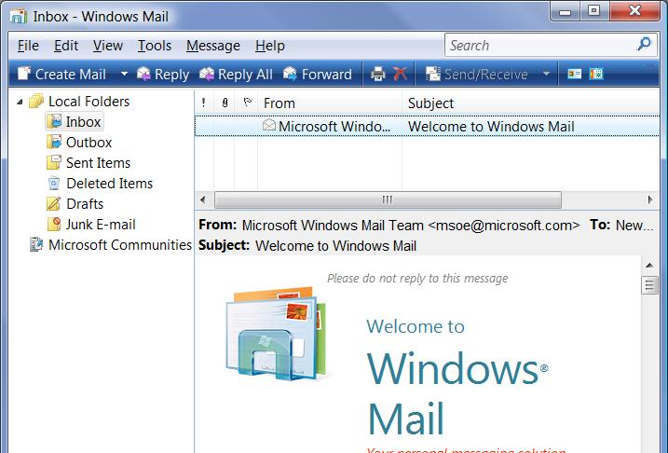
Home Basic Edition

Users of Home Basic cannot initiate a meeting in Windows Meeting Space

But they can join a meeting in progress

They can also respond to a meeting invitation

All other features in this chapter are the same for all versions

Using Windows Mail

Successor to Outlook Express

E-mail client and newsreader

Changes from Outlook Express

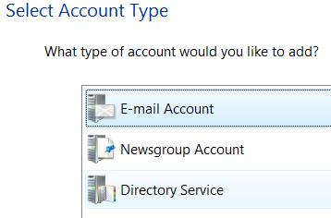
Windows Mail stores emails in individual .eml files

No more .dbx files

Search box

Contacts folder

No support for hotmail accounts

No identities feature

Creating a Mail Account

Tools, Accounts, Add

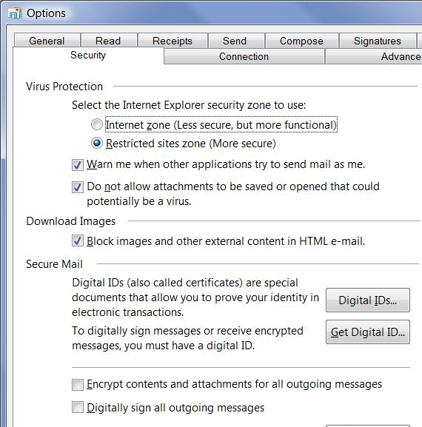
Three types of accounts:

Email

Newsgroup (USENET)

Directory Service

Allows you to look up email addresses in directories

Security Options

Tools, Options

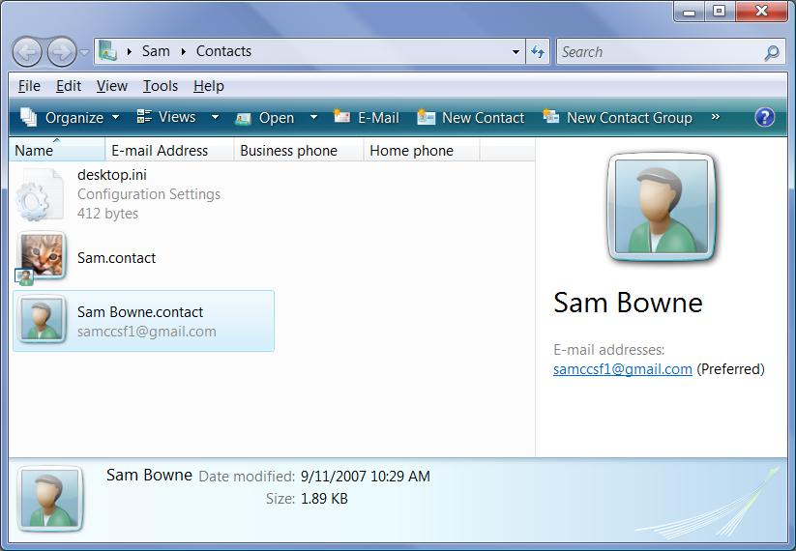
Managing Contacts

Start, “cont” to search for Windows Contacts

Contacts Folder

The Contacts folder is in a user profile, like Desktop or Documents

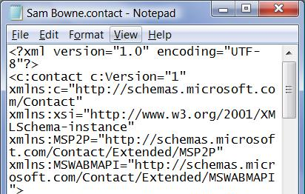

Contacts are stored in XML format

Adding Contacts

Windows Mail automatically adds anyone to whom you send a reply to Contacts

You can also add Contacts manually

You can import contacts from Windows Address Books (from Windows XP)

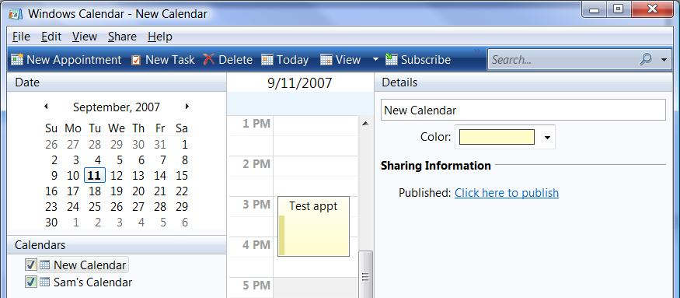

Using Windows Calendar

Schedules appointments and tasks

Share via e-mail or Web

Subscribing to Calendars

Go to link Ch 8a

Click on a calendar

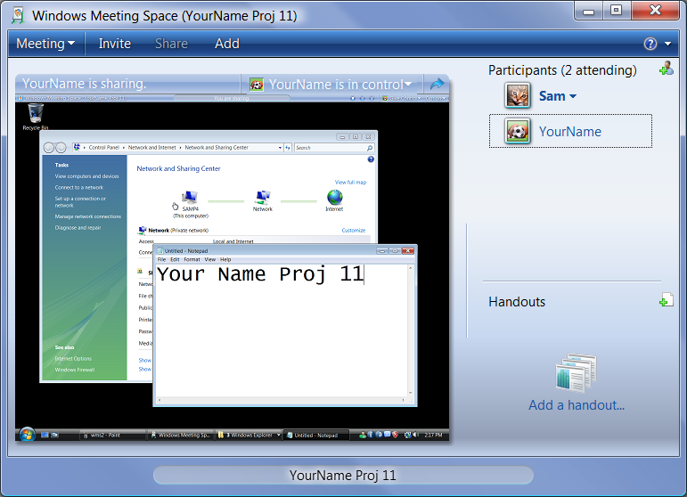

Using Windows Meeting Space

Share your desktop or a program with others on your network

Giving Control

Bar at top of screen shows that you are sharing

“Give Control” button on right lets you surrender control of your computer to another person

Ch 9: Obtaining Help and Support

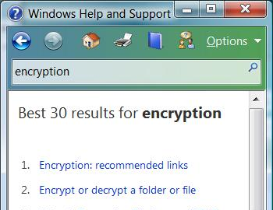
Editions

Help and Remote Assistance are the same in all editions

Help and Support

Start, Help and Support

Continually updated via the Internet

Convenient search box

No longer searches the Knowledge Base

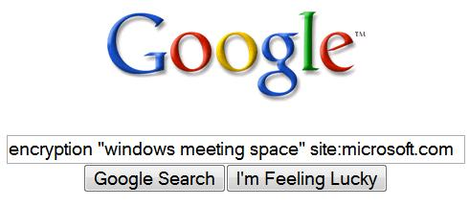
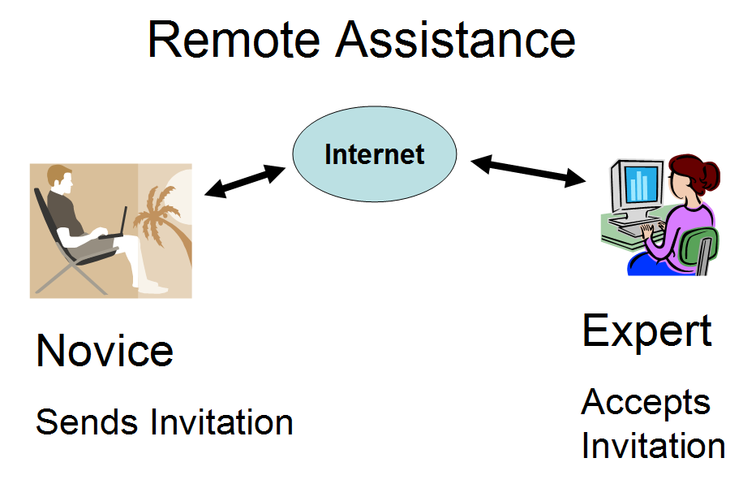
Reality

It’s not in the book, and not on the certification test

But the way to really find answers is Google with this search parameter

Site:microsoft.com

Remote Assistance

View another computer’s screen over the Internet

Control another computer (with permission) to help fix it

Remote Assistance v. Remote Desktop Connection

Remote Assistance is for fixing a computer

Both users must be at their computers

Both users must agree to allow it

You can connect to any version of Vista

Both users see the screen

Both users have complete control of the computer

Connections can be made over the Internet, even behind a router with Network Address Translation (NAT)

Remote Desktop is for using a remote computer

Can be initiated from one computer when no one is at the remote target computer

Target computer must have Vista Business, Enterprise, or Ultimate edition

The screen of the target computer is hidden, showing a logon screen

Remote users have limited rights

Remote Desktop does not work through a router (but you can use a Virtual Private Network)

Remote Assistance Connection Types

Remote Assistance can use any of these

IPv4

If both machines have public IPv4 addresses

IPv6

If the routers and switches support IPv6

UPnP NAT Addresses

If you use a UPnP router (see link Ch 9a)

NAT traversal via Teredo

A new Vista feature, encapsulates IPv6 in IPv4 UDP (see link Ch 9b)

Windows Firewall

Windows Firewall has an exception to allow Remote Assistance for private networks

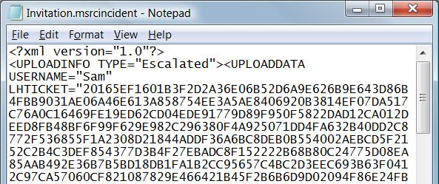
By default, Remote Assistance is blocked in

Public networks

Corporate domains

Asking for Remote Assistance

Can be done two ways:

Instant Messaging

Windows Live Messenger

Sending an invitation file, via

E-mail

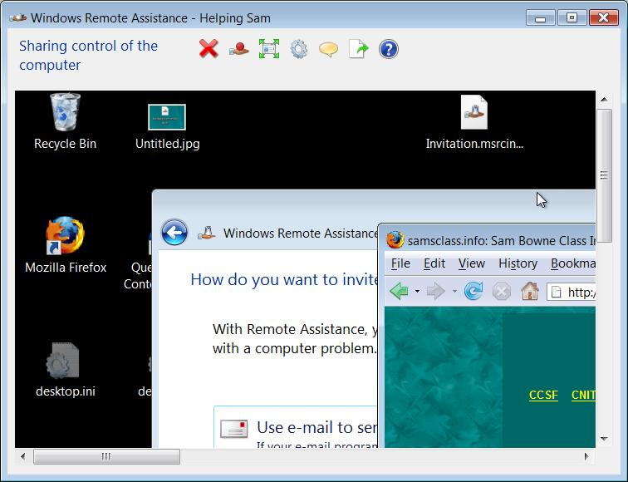
Shared folder

Physical media, such as a USB flash drive

The Invitation File

Invitation.msrcincident

An encrypted XML file

Remote Assistance

The expert can view the desktop, or even take control

Novice and expert both see the desktop

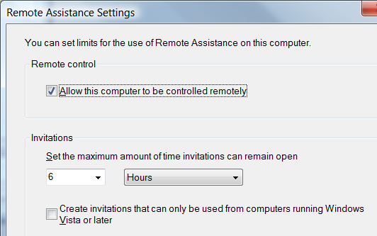

Setting Duration

Start, System

In Tasks, click Remote Settings

On Remote tab, click Advanced

Offering Assistance

With Windows Live Messenger

The expert can offer assistance

That makes it easier for the novice

Requires prior adjustment of the novice’s computer

Intended for corporate machines on a domain

That restriction makes it less of a security risk

Remote Assistance with Earlier Windows Versions

Vista’s Remote Assistance works with Windows XP and Server 2003

No voice chat

No NAT traversal or Teredo

You can’t offer assistance from a computer running an earlier version

Some invitation files are “Windows Vista Only”

Security

Password required

Novice must accept each connection

Novice must approve sharing control

Invitation files expire after 6 hours, or when the Remote Assistance session is closed

Firewall only allows Remote Assistance on private networks

Traffic is encrypted (see link Ch 9d)

Last modified 9-11-07 7 pm

