Finding Your Machine Name
Computer Name: S214-______
- Look at the front panel of your computer. There is a label just above the start button with a name starting with S214-. Write that name in the box to the right on this page.
Finding Your Product Key
- Find the Product Key on the list available in the computer lab that matches your computer name. Mark it, and use that product key. Don’t use the key from a different computer, and don’t use these keys at home or on any other machine, because they won’t activate. If you are working at home, you can get a product key from Microsoft Academic Alliance, as explained in other handouts.
Booting from the Vista x86 DVD
- Insert the Vista DVD.
- Restart your machine. When you see the message "Press any key to boot from CD or DVD", press the Enter key.
- When you see the "Install Windows" box, accept the default "Language to install","Time and currency format", and "Keyboard or input method" settings and click Next.
- In the next screen, click "Install now".
- Type in the product key you marked on the previous page. Click Next.
- Check the “I accept the license terms” box and click Next.
- Click Custom (advanced).
Choosing the Installation Partition
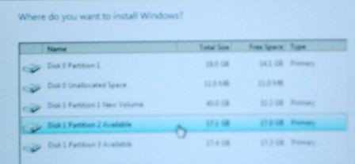
- Find a partition marked Available as shown below on this page and click on it. Note the Disk number and Partition number you chose. In the figure to the right on this page, “Disk 1 Partition 2” is selected.
- After you have clicked an available partition, click Next.
- Now wait – it will take a while to copy the files. Your computer will restart one or more times. When it restarts, don't touch the keyboard—just let it boot from the default hard disk partition.
- At the Country or Region screen, click Next.
- At the “Choose a user name and picture” page, enter Student and no password. Click any picture and click Next.
- At the “Type a computer name and choose a desktop background” page, enter the computer name you wrote in the box in step 1, click any background, and click Next.
- At the “Help protect Windows automatically” page, click “Use recommended settings”.
- At the "Review your time and date settings" screen, click Next.
- At the "Select your computer's current location" screen, click Work.
- At the "Thank you" screen, click Start.
- Now you have to wait again, while Windows checks your computer's performance.
- When that is complete, your Vista desktop will appear, showing a welcome window with "Student" in the upper left corner.

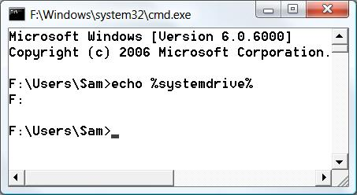
Determining the System Drive Letter
- Click Start. In the Search box, type in CMD. Press the Enter key. A Command Prompt window opens.
- Type this command into the Command Prompt window, then press the Enter key.:
ec ho %systemdrive%
The response should tell you your Vista drive letter. In the example shown to the right on this page, the drive letter is F:.

Changing the System Drive Label
- Click Start, Computer. Find your system drive in the list—it should be labeled “Available (F:)”, showing your actual drive letter instead of F:. You need to change this name, so that later students in the lab don’t see your Vista partition as Available and install Vista again on the same partition.
- Right-click your system drive icon and click Rename. Type in a new name of "Your Name Vista" and press the Enter key. In the "Access Denied" box, click Continue. In the "User account control" box, click Continue.

Creating a Personal Account for Yourself
- Sometimes students will need to use one another's computers in the lab, so it's important to leave the Student account available. Now you'll make a personal account with your name on it and a password for yourself.
- Click Start, "Control Panel". Under the "User Accounts" heading, click "Add or remove user accounts". In the "User account control" box, click Continue.
- At the "Choose the account you would like to change" screen, at the lower left, click "Create a new account".
- At the "Name the account and choose an account type" screen, type in your name for the account name. Click the Administrator radio button. Click the "Create Account" button.

Changing the Operating System Label
- Click Start. In the Search box, type in CMD. Press Shift+Ctrl+Enter. In the "User account control" box, click Continue.
- An Administrator Command Prompt window opens, as shown below on this page. Look at the title bar of this window and make sure the first word you see is Administrator. If you don't see the word "Administrator" there, you cannot use BCDedit or other administrative commands. This is a new Vista feature which is confusing at first—there are two types of command prompt windows: Standard and Administrator.
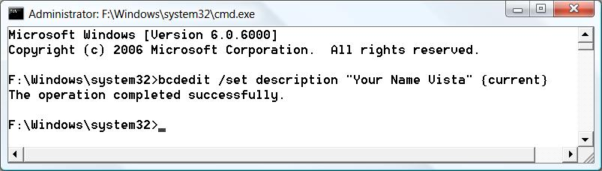

- Type this command into the Administrator Command Prompt window, then press the Enter key.:
bcdedit /set description "Your Name Vista" {current}
Replace Your Name with your own name. If you see a message saying "The boot configuration data store could not be opened. Access is denied.", you aren't in an Administrator Command Prompt window. Close the window and carefully repeat step 30 above.

Activating Windows Vista
- In the Control Panel ► System and Maintenance ► System ►.box, at the bottom, you should see a Windows Activation section. Click the message that says 14 days left to activate. Click here to activate Windows now. In the User Account Control box, click Continue.
- In the Windows Activation box, click Activate Windows online now.
- In the Windows Activation box, you should see an Activation was successful message. Click the Close button. Notice that the Windows Activation section now shows your Product ID.

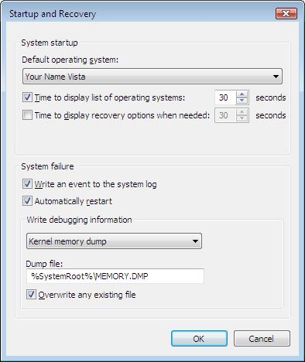
- Click Start, right-click Computer, and click Properties. In the left pane, click "Advanced system settings". In the User Account Control box, click Continue.
- On the Advanced tab, in the "Startup and Recovery" section, click the Settings button. The Default operating system box, should show "Your Name Vista", as shown to the right on this page.
- Notice the hand symbol on this page, pointing to the image. In these projects, you need to capture the images marked with the hand symbol and turn them in.

Saving the Screen Image
- Click on the "Startup and Recovery" window to make sure it is the active window.
- Hold down the Alt key and press the PrintScrn key in the upper-right portion of the keyboard. That will copy the active window to the clipboard.
- Click Start, All Programs, Accessories, Paint. In the untitled - Paint window, select Edit, Paste from the menu bar. The window image appears in the Paint window.
- In the untitled - Paint window, click File, Save. Save the document in the My Pictures folder (or any other place you wish, such as a floppy disk) with the filename Your Name Proj 1. Select a Save as type of JPEG.

Turning in your Project
- Open Internet Explorer, and use it to email the JPEG image to me as an email attachment. Send the message to: cnit.335@gmail.com with a subject line of "Proj 1 From Your Name", replacing Your Name with your own first and last name. Send a Cc to yourself.

Last Modified: 12-12-07

