Starting Your Computer
- Start your computer. Boot to your installation of Vista. Log in with your personal account.

Note to Students Working at Home
- The instructions below assume you are working in the S214 lab. If you are working at home, all you need to do is add any antivirus product and any Office product to your Vista computer. If you want to get the specific products described below, download AVG Antivirus from free.grisoft.com and OpenOffice from openoffice.org.

Getting the Installer Files from the Server
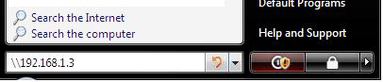
- Click the Start button (the Windows Logo button in the lower left corner). In the search box, type in \\192.168.1.3 as shown to the right on this page. Press the Enter key.
- If you are prompted to enter a login name and password, enter a name of CNIT and leave the password blank.
- In the Network ► 192.168.1.3 window, double-click cnit335.
- Drag the AVG folder to the desktop. Wait till the copy finishes.
- Drag the OpenOffice folder to the desktop. Wait till the copy finishes.

Installing AVG Antivirus
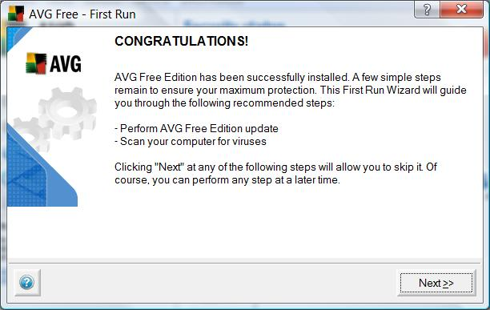
- Double-click the AVG folder on your desktop. Double click the installer file, which should have a name like this avg75free_476a1048.exe (you might have a later version). In the "Open File – Security Warning", click Run. In the "User account control" box, click Continue.
- Follow the on-screen prompts to complete the installation, using the default or recommended settings.
- After AVG is installed, it will open a box saying "CONGRATULATIONS!", as shown to the right on this page. Click Next .
- In the "AVG Free Update" box, click the "Check for updates" button.
- In the Update box, check the "Do not ask for the update source next time" box and click the Internet button. Follow the on-screen prompts to install recommended updates.
- In the "AVG Free Update" box, click the Next button.
- In the "Daily Scanning" box, clear the "Enable Scheduled Daily scan (recommended)" box and click the Next button.
- In the "Virus Scan" box, click the Next button.
- In the "AVG Free Registration" box, click the Next button.
- In the "YOUR COMPUTER IS PROTECTED!" box, click the Continue… button.
- Close the "AVG Free Edition – Test Center" window.

Opening Windows Security Center
- Click Start, "Control Panel".
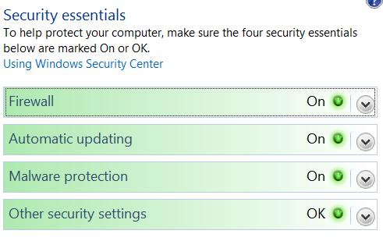
- In "Control Panel, " in the Security section, click "Check this computer’s security status". You should see all four Security Essentials items with green On buttons, as shown to the right on this page.

Saving the Screen Image
- Click on the "Windows Security Center" window to make sure it is the active window.
- Hold down the Alt key and press the PrintScrn key in the upper-right portion of the keyboard. That will copy the active window to the clipboard.
- Click Start, All Programs, Accessories, Paint. In the untitled - Paint window, select Edit, Paste from the menu bar. The window image appears in the Paint window.
- In the untitled - Paint window, click File, Save. Save the document in the My Pictures folder (or any other place you wish, such as a floppy disk) with the filename Your Name Proj 2a. Select a Save as type of JPEG.

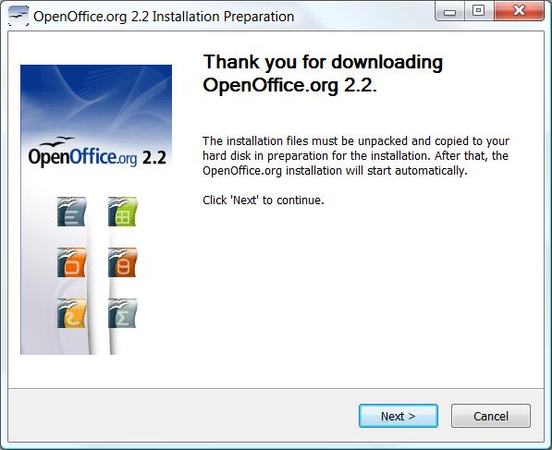
Installing OpenOffice
- Double-click the OpenOffice folder on your desktop. Double click the installer file, which should have a name like this OOo_2.2.1_Win32Intel_install_wJRE_en-US.exe (you might have a later version). In the "Open File – Security Warning", click Run. In the "User account control" box, click Allow .
- Follow the on-screen prompts to complete the installation, using the default or recommended settings.

Opening OpenOffice Writer
- Click Start, "All Programs", "OpenOffice.org 2.2", "OpenOffice.org Writer".
- In the "Welcome to OpenOffice.org 2.2" box, click Next.
- Scroll to the bottom of the license agreement and click Accept.
- At the "Provide your full name and initials below" screen, click Next.
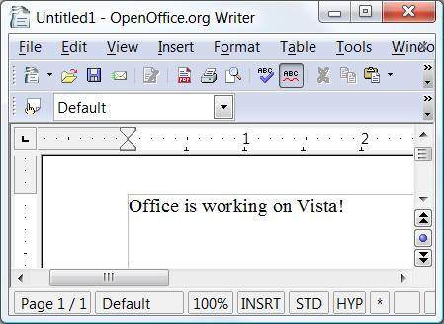
- At the "Online Update " screen, clear the "Check for updates automatically" box and click Next.
- At the " OpenOffice.org Registration" screen, click "I do not want to register" and click Finish. OpenOffice.org Writer opens, as shown to the right on this page.

Saving the Screen Image
- Click on the "OpenOffice.org Writer " window to make sure it is the active window.
- Hold down the Alt key and press the PrintScrn key in the upper-right portion of the keyboard. That will copy the active window to the clipboard.
- Click Start, All Programs, Accessories, Paint. In the untitled - Paint window, select Edit, Paste from the menu bar. The window image appears in the Paint window.
- In the untitled - Paint window, click File, Save. Save the document in the My Pictures folder (or any other place you wish, such as a floppy disk) with the filename Your Name Proj 2b. Select a Save as type of JPEG.

Turning in your Project
- Open Internet Explorer, and use it to email the JPEG images to me as attachments to one e-mail message. Send the message to: cnit.335@gmail.com with a subject line of "Proj 2 From Your Name", replacing Your Name with your own first and last name. Send a Cc to yourself.

Last Modified: 8-16-07 11 am

