Starting Your Windows 7 Machine
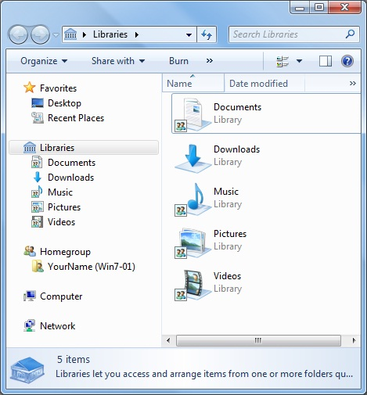
- Use Windows 7, not Vista. There are a lot of machines in S214 with Win 7 on them, and you can log in as Student with no password. If you can't, hack in with the Ultimate Boot CD, or ask your instructor to show you how to do that.
The New Windows Explorer
- Click the Start button. On the top right of the Start menu, click your logon name. Windows Explorer opens, as shown to the right on this page.
- In the left pane, notice the Libraries item. The purpose of Libraries is to bring together similar items into one place, so you don't have to search for them.
- In the Windows Explorer window, in the left pane, in the Libraries section, expand Documents.

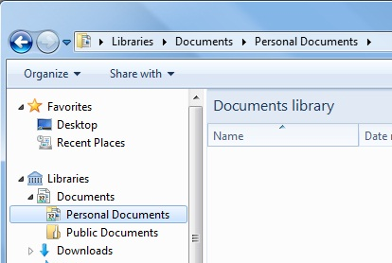
- There are two items in the Documents library: Personal Documents and Public Documents, as shown to the right on this page.
- Click Personal Documents to select it.

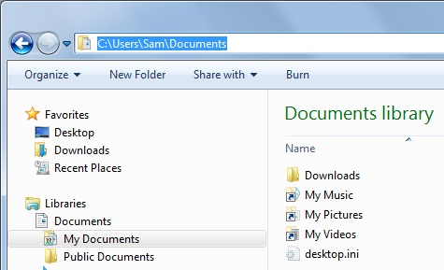
- Click in the address bar, to the right of "Personal Documents", to show the full path to this folder, as shown to the right on this page.
- In the left pane, click "Public Documents".
- Click in the address bar to see the full path to this folder. As you can see, the "Personal Documents" and "Public Documents" are not in the same folder, so placing them both in the "Documents" library is quite a change from the old-style Windows Explorer tree view.
Getting Started and User Account Control
- Press the Windows logo key, and type in GET. If necessary, use the up-arrow and down-arrow keys on the keyboard to highlight "Getting Started". Press Enter.
- In the lower portion of the "Getting Started: window, double-click "Choose when to be notified about changes to your computer".
- In the top pane of the "Getting Started: window, click "Choose your UAC prompt level".

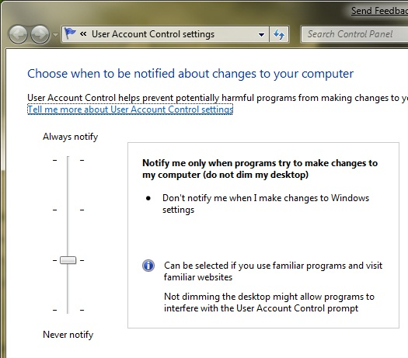
- The "User Account Control Settings" window opens, as shown to the right on this page/ Move the slider through its four positions and read about the options. This is a lot friendlier than UAC is in Vista!

Saving the Screen Image
- Press the PrintScrn key in the upper-right portion of the keyboard. That will copy the whole desktop to the clipboard.
- Press the Logo key on the keyboard. Type PAI into the Search box. When Paint is highlighted, press the Enter key.
- Click in the untitled - Paint window. Type Ctrl+V to paste the image in.
- Type Ctrl+S to save the file. Save the document in the default location of Locations ► Pictures with the filename Your Name Proj 2xa. Select a Save as type of JPEG.

Windows Gestures
- Make the Paint window an intermediate size, using approximately half the screen area.
- Point to the title bar at the top of the Paint window. Hold down the left mouse button and drag the window to the top of the screen. A frame expands, and when you release the mouse button the window maximizes.
- Point to the title bar at the top of the Paint window. Hold down the left mouse button and drag the window down an inch or so. The window restores to its original size.
- Drag the window to the right edge of the screen. It resizes to use exactly half the screen.
- Drag the window to the left edge of the screen. It resizes to use exactly half the screen. This is useful when you have two windows you want to use at the same time.

The New Calculator
- Press the Logo key on the keyboard. Type CALC into the Search box. When Calculator is highlighted, press the Enter key.
- Enter a series of calculations like this:
2 + 2 = * 14 = + 7=

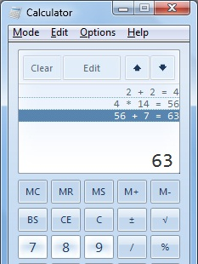
- The Calculator shows the calculations you have done in the upper pane, as shown to the right on this page. You can even click on them and edit them to correct mistakes!
- In the Calculator window, click Mode, Programmer. Type in 255. Notice that the binary equivalent of the value appears in the upper pane, as shown below on this page.

Saving the Screen Image
- Press the PrintScrn key in the upper-right portion of the keyboard. That will copy the whole desktop to the clipboard.
- Press the Logo key on the keyboard. Type PAI into the Search box. When Paint is highlighted, press the Enter key.
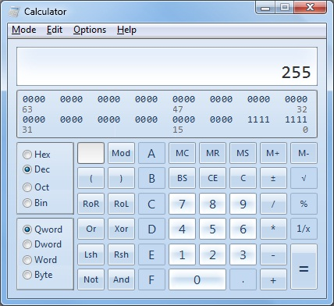
- Click in the untitled - Paint window. Type Ctrl+V to paste the image in.
- Type Ctrl+S to save the file. Save the document in the default location of Locations ► Pictures with the filename Your Name Proj 2xb. Select a Save as type of JPEG.

Turning in your Project
- Open Firefox, and use it to email the JPEG images to me as email attachments. Send the message to: cnit.335@gmail.com with a subject line of "Proj 2x From Your Name", replacing Your Name with your own first and last name. Send a Cc to yourself.

Last Modified: 1-23-09

