Starting Your Computer
- Start your computer. Boot to your installation of Vista. Log in with your personal account.

Customizing Your Profile
- Desktop Settings: Right-click the desktop and click Personalize. Click "Desktop Background". Select a background you like and click OK.
- Internet Explorer Favorites: Click Start, Internet. Go to my Web page samsclass.info and click Favorites, Add to Favorites, OK. Go to a few more pages you like and add them to your Favorites. Close Internet Explorer.

Saving Your Files and Settings with Windows Easy Transfer
- Close all windows.
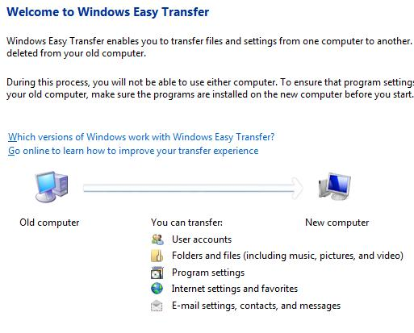
- Click Start, All Programs, Accessories, System Tools, Windows Easy Transfer. In the "User Account Control" box, click Continue.
- The "Welcome to Windows Easy Transfer" screen appears, as shown to the right on this page. Click Next.
- At the "Do you want to start a new transfer or continue one in progress?" screen, click "Start a new transfer".
- At the "Which computer are you using now?" screen, click "My old computer".
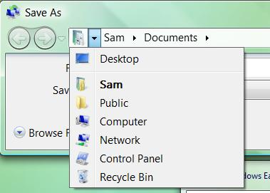
- At the "Choose how to transfer files and settings to your new computer" screen, click "Transfer directly, using a network connection".
- At the "Choose how to transfer files and settings over a network" screen, click "Copy to and from a network location".
- At the "Choose a network location" screen, click the Browse button. In the "" box, click the upper left ▼breadcrumb, as shown to the right on this page, and click Public. Accept the default file name of SaveDate.MIG and click the Save button.

- At the "Choose a network location" screen, click Next.
- At the "What do you want to transfer to your new computer?" screen, click "My user account, files, and settings only".
- At the "Review selected files and settings" screen, click Next.
- At the "Please wait until the transfer is complete" screen, wait for the progress bar to move across the box.
- At the "You're ready to transfer files and settings to your new computer" screen, click Close.

Transferring Your Settings to a New Account
- Normally you would move your settings to a different computer. But to make the project simpler, we'll just use a second user account on the same machine.
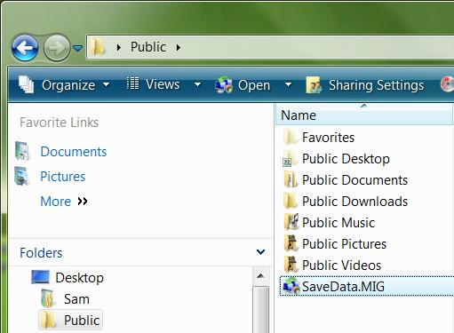
- Click Start, Computer. In the Folders list, click Public. In the right pane, double-click the SaveDate.MIG icon, as shown to the right on this page
- At the "Type a new user name or click a name in the list" screen, in the "User account on the new computer" box, type "Your Name 2". Don't use the literal words Your Name, use your own name. Click Next.
- At the "Review selected files and settings" screen, click Transfer.
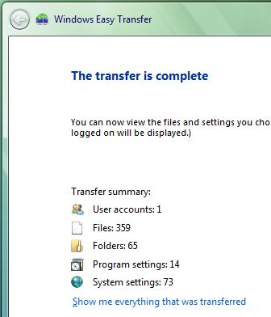
- At the "Please wait until the transfer is complete" screen, wait for the progress bar to move across the box.
- When the "The transfer is complete " screen appears, as shown to the right on this page, press the PrintScrn key in the upper-right portion of the keyboard. That will copy the whole desktop to the clipboard.
- In the "The transfer is complete " screen appears, click Close.
- A box pops up saying "You need to log off for the changes to take effect. Do you want to log off now?". Click No.

Saving the Screen Image
- Click Start, "All Programs", Accessories, Paint. In the untitled - Paint window, select Edit, Paste from the menu bar. The window image appears in the Paint window.
- In the untitled - Paint window, click File, Save. Save the document with the filename Your Name Proj 3.

Turning in your Project
- Open Internet Explorer, and use it to email the JPEG image to me as attachment to an e-mail message. Send the message to: cnit.335@gmail.com with a subject line of "Proj 3 From Your Name", replacing Your Name with your own first and last name. Send a Cc to yourself.

Observing the New Account
- Log off. Log on as Your Name 2. Note that the desktop background is the same one your chose before. Open Internet Explorer and verify that your Favorites were also transferred.
Last Modified: 8-18-07 5 am

