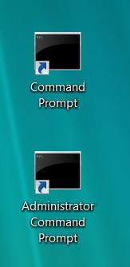
Starting Your Computer
- Start your computer. Boot to your installation of Vista. Log in with your personal account.

Creating Pinned Items for the Command Prompt
- Click Start, "All Programs", Accessories. Using the right mouse button, drag the "Command Prompt" item to the desktop and drop it there. From the context menu, select "Copy Here".
- Click Start, "All Programs", Accessories. Using the right mouse button, drag the "Command Prompt" item to the desktop and drop it there again. From the context menu, select "Copy Here". In the "Copy File" box, click "Copy, but keep both files".
- Right-click the "Command Prompt (2)" icon and click Rename. Type in a new name of "Administrator Command Prompt" and press the Enter key. You should now have two icons on your desktop as shown to the right on this page.
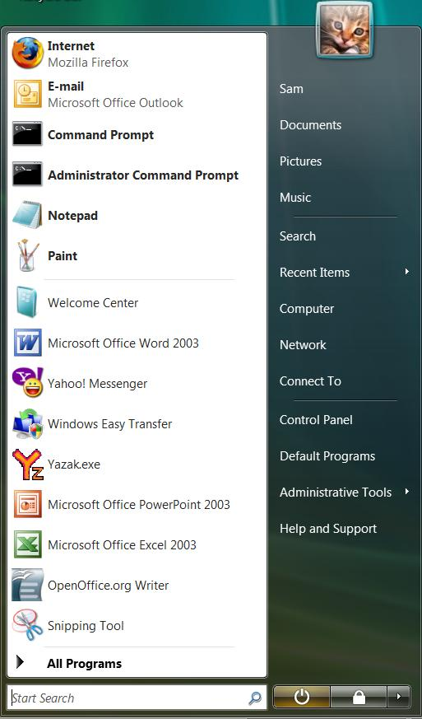
- Using the left mouse button, drag the "Command Prompt" icon from the desktop and hold it over the Start button. Wait until the Start menu appears, and then drag it up to the "Pinned Items" list at the top. Repeat the process with the "Administrator Command Prompt" icon. Your Start menu should now show the two items "Command Prompt" and "Administrator Command Prompt" at the top, as shown to the right on this page.
- Click Start. Right-click "Administrator Command Prompt" and click Properties. On the Shortcut tab, click the "Advanced..." button. In the "Advanced Properties" box, check the "Run as administrator" box. Click OK. Click OK.

Displaying Administrative Tools on the Start Menu
- Right-click the taskbar and select Properties.
- In the Taskbar and Start Menu Properties window, on the Start Menu tab, ensure that the Start menu radio button is selected rather than the Classic start menu button. Click the Customize button.

- In the Customize Start Menu window, scroll to the bottom of the list. In the "System administrative tools" section, click "Display on the All Programs menu and the Start menu".
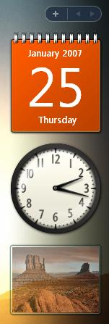
- Click OK to close the Customize Start Menu box.
- Click OK to close the Taskbar and Start Menu Properties box.

Windows Sidebar
- At the right side of your screen, you should see Windows Sidebar – a vertical darkened stripe with a clock or other gadgets on it, as shown to the right on this page. If Windows Sidebar is not visible, do these steps to turn it on:
  - Click Start. In the Search box, type "Side". At the top of the start menu, click "Windows Sidebar".
  - If Sidebar is still not visible, find the Sidebar icon in the Notification Area in the lower right portion of the desktop and right-click it. Click Open. The Sidebar should appear on the desktop.

Removing Gadgets
- Right-click the clock and select Close Gadget. Do the same with the other two gadgets.

Adding Gadgets
- Click the pale + sign at the top of the Sidebar. You should see a list of available gadgets, as shown below on this page. Double-click the CPU Meter to add it to the Sidebar. You may also add any additional gadgets you like.
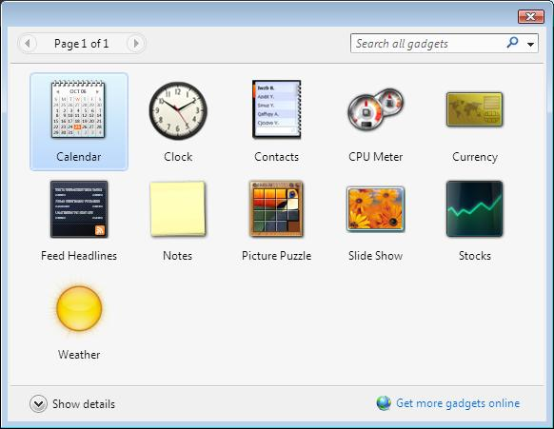

Closing the Sidebar
- The Sidebar itself wastes a lot of screen space, so we will detach the gadget we want and close Sidebar itself. Right-click the CPU Meter and select Detach from Sidebar. The CPU meter expands and moves to the left side of the screen. Right-click the sidebar (the darkened area at the right side of the screen) and click Close Sidebar.

Setting Opacity
- Drag the CPU Meter to the upper right corner of the desktop. Right-click it, point to Opacity, and click 60% or some other percentage that looks good on your background. This way you can see the CPU and RAM usage without wasting space.

Capturing an Image of the Start Menu and CPU Meter
- Click the Start button. Make sure these four items are visible, as shown below on this page:
  - "Command Prompt" at the upper left, in the Pinned Items list
  - "Administrator Command Prompt" at the upper left, in the Pinned Items list
  - "Administrative Tools" at the lower right of the Start menu
  - CPU Meter visible on the desktop
- Press the PrintScrn key in the upper-right portion of the keyboard. That will copy the whole desktop to the clipboard.
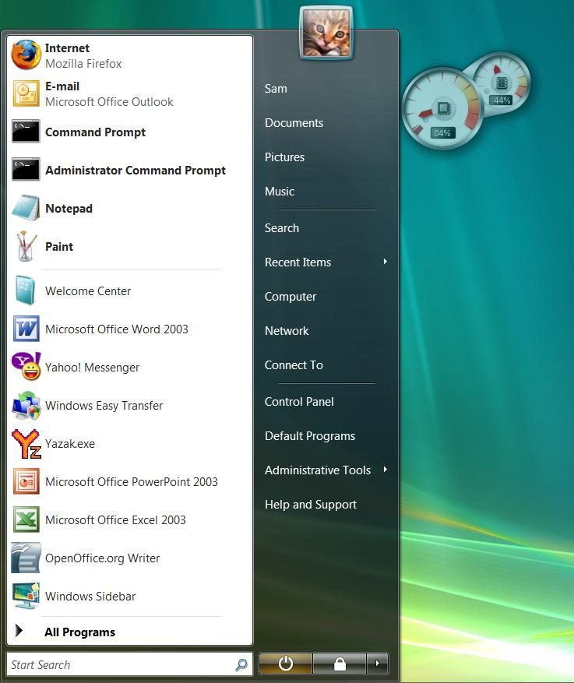
- Click Start, "All Programs", Accessories, Paint. In the untitled - Paint window, select Edit, Paste from the menu bar. The image appears in the Paint window.

- In the untitled - Paint window, click File, Save. Save the document with the filename Your Name Proj 4.
Turning in your Project
- Email the JPEG image to me as an e-mail attachment. Send the message to: cnit.335@gmail.com with a subject line of Proj 4 From Your Name, replacing Your Name with your own first and last name. Send a Cc to yourself.

Revised 7-9-08

