Starting Your Computer
- Start your computer. Boot to your installation of Vista. Log in with your personal account.

Getting the Display Driver from the Server
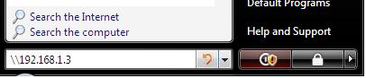
- Click the Start button (the Windows Logo button in the lower left corner). In the search box, type in \\192.168.1.3 as shown to the right on this page. Press the Enter key.
- If you are prompted to enter a login name and password, enter a name of CNIT and leave the password blank.
- In the Network ► 192.168.1.3 window, double-click cnit335.
- Drag the “Driver-GeForce6200LE” folder to the desktop. Wait till the copy finishes.

Installing the Display Driver
- Double-click the “Driver-GeForce6200LE” folder on your desktop. Double click the installer file inside, which has a name starting with 162.22_forceware. In the "User account control" box, click Continue.
- Accept the license, and follow the on-screen prompts to complete the installation, using the default or recommended settings.
- When it asks you to restart your computer, do that. Boot to your installation of Vista. Log in with your personal account.

Attempting to Use Flip 3D
- The Windows Logo key is between Ctrl and Alt on the left side of the keyboard). Hold down the Windows Logo key and press the Tab key. If Aero graphics were working, you would see a 3-D display showing the windows open on your machine, but they don’t work yet because you need to update your machine’s Windows Experience Index.

Updating Windows Experience Index
- Click Start. Right-click Computer, and click Properties. In the Control Panel ► System and Maintenance ► System window, in the middle, find the System section. The Rating: should show a value of 1.0. Click the blue "Windows Experience Index: Unrated" link.
- In the Control Panel ► System and Maintenance ► Performance Information and Tools window, on the upper right, click the "Refresh Now" button. In the "User account control" box, click Continue. Wait for a minute or two while the Aero Assessment runs. When it completes, the Rating may or may not change, but Aero should activate.

Capturing an Image of the Flip 3D Screen
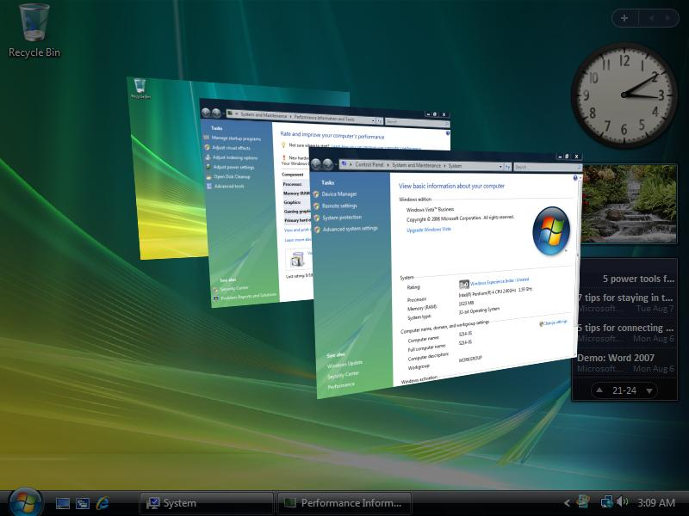
- Hold down the Windows Logo key and press the Tab key. You should see the Flip 3-D screen, as shown below on this page.

- Hold down the Windows Logo key and the Tab key, and press the PrintScrn key. That will copy the whole desktop to the clipboard.
- Click Start, "All Programs", Accessories, Paint. In the untitled - Paint window, select Edit, Paste from the menu bar. The image appears in the Paint window.
- In the untitled - Paint window, click File, Save. Save the document with the filename Your Name Proj 5a.

Viewing the User Accounts
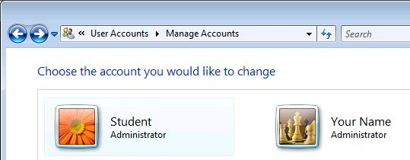
- Click Start, “Control Panel”. In the “User Accounts” section, click “Add or remove user accounts”. In the "User account control" box, click Continue.
- The Control Panel ► User Accounts ► Manage Accounts window should open, showing a Student account as shown to the right on this page.
  - If no Student account is present, click the “Create a new account” link at the bottom of the screen and follow the on-screen prompts to create one.
- In the Control Panel ► User Accounts ► Manage Accounts window should open, click the Student icon.

Capturing an Image of the Student Account
- The “Change an Account” screen should appear, as shown below on this page.
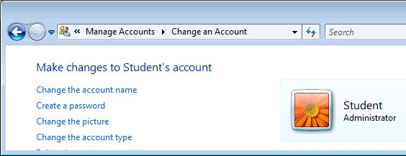

- Make sure that these three items are correct in this image:
  - The account name must be Student
  - The type of account must be Administrator (shown on the right)
  - The second item in the list on the left side must be “Create a password”, indicating that there is no password on this account.
- Press the PrintScrn key. That will copy the whole desktop to the clipboard.
- Click Start, "All Programs", Accessories, Paint. In the untitled - Paint window, select Edit, Paste from the menu bar. The image appears in the Paint window.
- In the untitled - Paint window, click File, Save. Save the document with the filename Your Name Proj 5b.
Turning in your Project
- Email the JPEG images to me as an attachments to a single e-mail message. Send the message to: cnit.335@gmail.com with a subject line of Proj 5 From Your Name, replacing Your Name with your own first and last name. Send a Cc to yourself.

Revised 8-24-07

