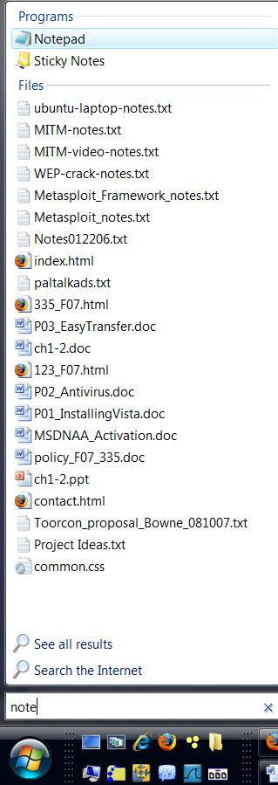
Starting Your Computer
- Start your computer. Boot to your installation of Vista. Log in with your personal account.

Launching Notepad without Using the Mouse
- Press the Windows Logo key on the bottom left of your keyboard, between the Ctrl and Alt keys. Type "note" and wait a second or two. The letters appear in the Search box, and Notepad appears at the top of the search results list, as shown to the right on this page. Press the Enter key to launch Notepad. This is a good Vista trick to learn—often the fastest way to launch an application is Logo, type the first few letters, Enter.

Creating an Annoying Startup File
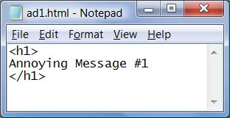
- Type in the three lines shown to the right on this page. Save the file in your Documents folder with the filename "ad1.html"—be careful not to save it with a TXT filename extension.
- Click Start, Documents. Double-click the ad1.html file. A browser window should open, showing the message, as shown below on this page. Your default browser might be Internet Explorer or some other browser—that's OK.
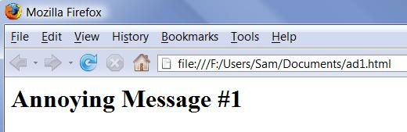

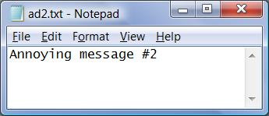

Creating Another Annoying Message
- Open Notepad, type in the text shown to the right on this page, and save the file in your Documents folder with the name ad2.txt

Setting a System Restore Point
- System Restore is extremely useful. Make a habit of setting a Restore point before doing anything dangerous to your computer, such as installing software from untrusted sources, or manually editing the Registry. That way you can easily restore the computer to its previous condition.
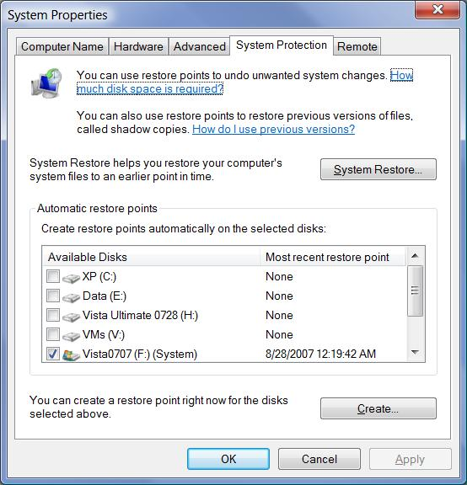
- Press the Windows Logo key on the bottom left of your keyboard, between the Ctrl and Alt keys. Type "Sys" and wait a second or two. Find System Restore near the top of the search results list, and double-click it. When the "User account control" box appears, press Alt+C on the keyboard (or click Continue).
- In the "System Restore" box, at the bottom, click "open System Protection".
- A "System Properties" box opens, as shown to the right on this page. Verify that your Vista disk is checked in the list—on my system, the Vista disk is "F:", but on yours it's probably C:. Click the Create button.
- In the "Create a restore point" box, type in a restore point description of "Your Name Before Project 6" and press the Enter key. Wait until the progress bar finishes and you see a message saying "The restore point was created successfully".
- Close all windows.

Adding a New Value to the Run Key
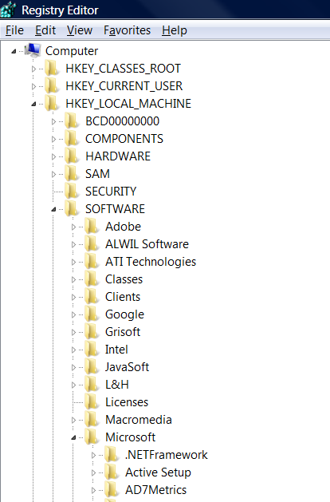
- Press the Windows Logo key on the bottom left of your keyboard, between the Ctrl and Alt keys. Type "regedit" and press the Enter key. When the "User account control" box appears, press Alt+C on the keyboard (or click Continue).
- "Registry Editor" opens. In the left pane, expand these containers, as shown to the right on this page:
HKEY_LOCAL_MACHINE
SOFTWARE
Microsoft
- Scroll down and expand these containers also:
Windows
CurrentVersion

- In the left pane, click the Run container to select it. Right-click the Run container. From the context menu, select New ► String Value, as shown below on this page.
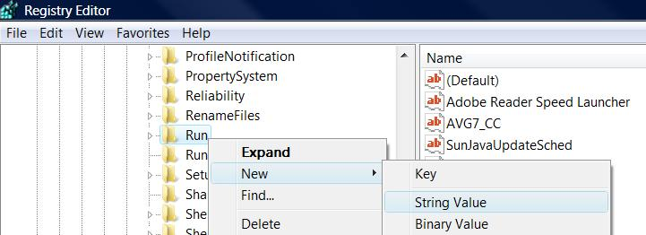

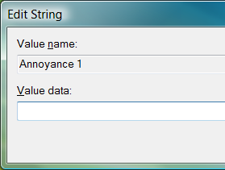
- A new value appears with its name highlighted. Type in the name "Annoyance 1" and press the Enter key. Double-click "Annoyance 1" to open the "Edit String" box, as shown to the right on this page.

Copying a Path from Windows Explorer
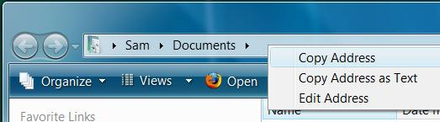
- Click Start, Documents. Right-click in the Address bar and select "Copy Address", as shown to the right on this page.

Pasting the Path into the "Edit String" box
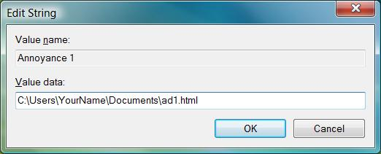
- In the "Edit String" box, right-click in the data entry box and select "Paste". The path to your Documents folder appears, which should be C:\Users\YourName\Documents.
- Type these characters at the end of the string:
\ad1.html
- The "Edit String " box should look like the example shown to the right on this page. Press the Enter key to save the value.

Launching Group Policy Object Editor
- Press the Windows Logo key on the bottom left of your keyboard. Type in the following command, and then press Enter :
gpedit.msc
- When the "User account control" box appears, press Alt+C on the keyboard (or click Continue).
- A "Group Policy Object editor" window opens, as shown on the next page of these instructions.

Adding a Startup Program in Group Policy
- In the left pane of the "Group Policy Object editor" window, in the "Computer Configuration" section, expand "Administrative Templates".
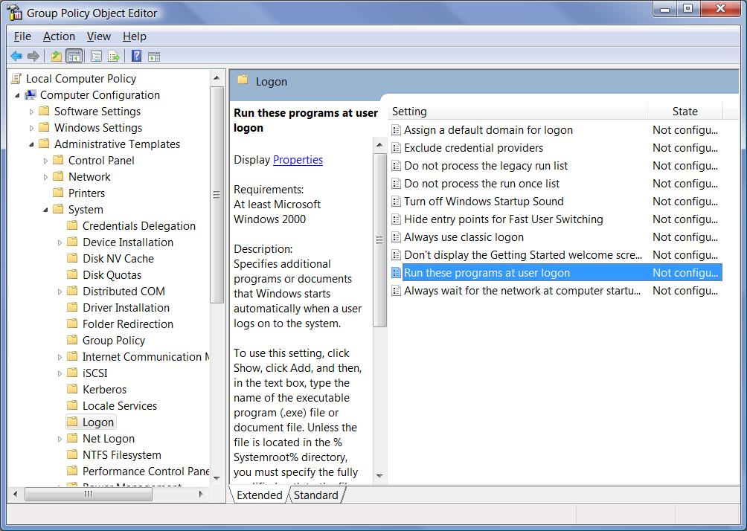
- Expand the System object, click the Logon object, and then in the right-pane, double-click "Run these programs at user logon".

- In the "Run these programs at user logon Properties" box, click Enabled, and then click Show.
- In the "Show Contents" box, click Add.

Copying a Path from Windows Explorer
- Click Start, Documents. Right-click in the Address bar and select "Copy Address".

Pasting the Path into the "Add Item" box
- In the "Add Item" box, right-click in the data entry box and select "Paste". The path to your Documents folder appears, which should be C:\Users\YourName\Documents.
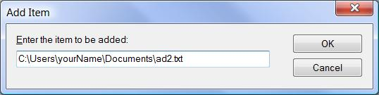
- Type these characters at the end of the string:
\ad2.txt
- The "Add Item " box should look like the example shown to the right on this page. Press the Enter key to save the item.
- In the "Show Contents" box, click OK.
- In the "Run these programs at user logon Properties" box, click OK.

Testing the Startup Items
- Close all windows and restart your computer.
- Boot to your installation of Vista. Log in with your personal account. Both "Annoying Message #1" and "Annoying Message #2" should pop up, as shown to the right on this page.

Viewing Startup Items with System Configuration
- Press the Windows Logo key on the bottom left of your keyboard. Type in the following command, and then press Enter :
msconfig
- When the "User account control" box appears, press Alt+C on the keyboard (or click Continue).
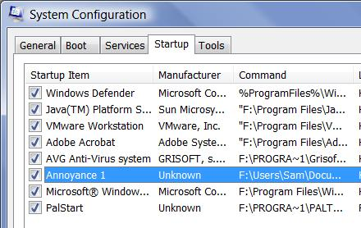
- When the "System Configuration" box opens, click the Startup tab, as shown to the right on this page. This utility lets you control startup services, but it doesn't show you all of them. As you can see, it shows "Annoyance 1" but not " Annoyance 2".

Viewing Startup Items with Software Explorer
- Press the Windows Logo key on the bottom left of your keyboard, between the Ctrl and Alt keys. Type "def" and wait a second or two. The letters appear in the Search box, and "Windows Defender" appears at the top of the search results list. Press the Enter key.
- In "Windows Defender", click Tools. In the "Tools and Settings" pane, click "Software Explorer". As shown in the image below, both the ad1.html and ad2.txt items appear here. However, the Disable button is grayed out.
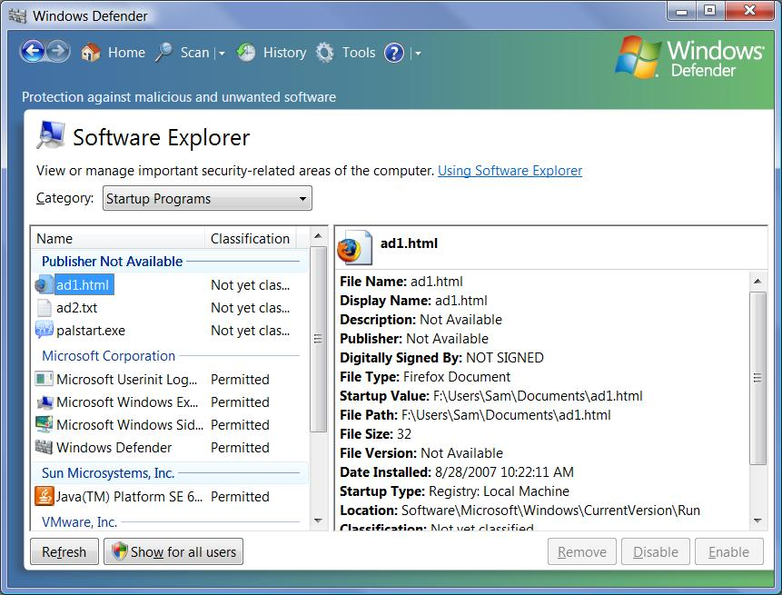

- In the bottom left of the "Software Explorer" pane, click the "Show for all users" button.
- When the "User account control" box appears, press Alt+C on the keyboard (or click Continue).
- Click ad1.html to select it. Click the Disable button. A box pops up asking "Are you sure you want to disable the application?". Click Yes.
- Click ad2.txt to select it. Click the Disable button. A box pops up asking "Are you sure you want to disable the application?". Click Yes.

Capturing an Image of Software Explorer
- Verify that both the ad1.html and ad2.txt items are classified as Disabled, as showy below on this page.
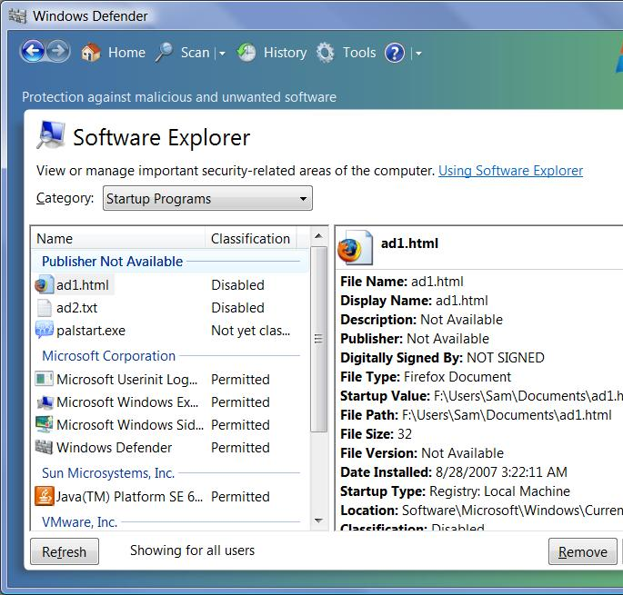
- Click in the title bar of the "Windows Defender" window to ensure that it is the active window.
- Hold down the Alt key and press the PrintScrn key in the upper-right portion of the keyboard. That will copy the active window to the clipboard.
- Click Start, "All Programs", Accessories, Paint. In the untitled - Paint window, select Edit, Paste from the menu bar. The image appears in the Paint window.

- In the untitled - Paint window, click File, Save. Save the document with the filename Your Name Proj 6a.

Testing the Startup Items
- Close all windows and restart your computer.
- Boot to your installation of Vista. Log in with your personal account. Neither annoying message should appear now, because Process Explorer disabled them.

Using System Restore to Reverse System Changes
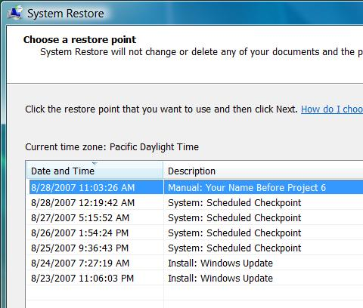
- You could use Regedit and Gpedit.msc to remove the settings you made, but it's easier and more thorough to use System Restore to return everything to normal. This will also correct any accidental extra changes you may have made to Group Policy or the Registry.
- Press the Windows Logo key on the bottom left of your keyboard, between the Ctrl and Alt keys. Type "Sys" and wait a second or two. Find System Restore near the top of the search results list, and double-click it. When the "User account control" box appears, press Alt+C on the keyboard (or click Continue).
- In the "System Restore" box, near the bottom, click "Choose a different restore point". Click Next.
- A "Choose a restore point" box opens, as shown to the right on this page. There should be an item labeled "Manual: Your Name Before Project 6".

Capturing an Image of your System Restore Point
- Click in the title bar of the "System Restore" window to ensure that it is the active window.
- Hold down the Alt key and press the PrintScrn key in the upper-right portion of the keyboard. That will copy the active window to the clipboard.
- Click Start, "All Programs", Accessories, Paint. In the untitled - Paint window, select Edit, Paste from the menu bar. The image appears in the Paint window.
- In the untitled - Paint window, click File, Save. Save the document with the filename Your Name Proj 6b.

Completing the System Restore Process
- Close all windows except the System Restore window.
- In the "Choose a restore point" box, click the " Manual: Your Name Before Project 6" item. Click Next. Click Finish.
- A box pops up saying "Once started, System Restore may not be interrupted…". Click Yes. When the System Restore is complete, your computer will restart.
Turning in your Project
- Email the JPEG images to me as an attachments to one e-mail message. Send the message to: cnit.335@gmail.com with a subject line of Proj 6 From Your Name, replacing Your Name with your own first and last name. Send a Cc to yourself.
Revised 8-28-07

