Warning!
This project may break your computer! If done correctly, it should not do any harm, but if you leave Driver Verifier turned on, a machine may show blue-screen errors at startup. If you are not comfortable doing this on your home machine, do it on the machines in S214.

Starting Your Computer
- Start your computer. Boot to your installation of Vista. Log in with your personal account.

Selecting Drivers to Verify
- Press the Windows Logo key on the bottom left of your keyboard, between the Ctrl and Alt keys. Type in this command, and then press Shift+Ctrl+Enter:
CMD
- When the "User account control" box appears, press Alt+C on the keyboard (or click Continue).
- In the Administrator Command Prompt window, type in this command, and then press Enter:
VERIFIER
- In the "Select a task" screen, accept the default selection of "Create standard settings" and click Next.
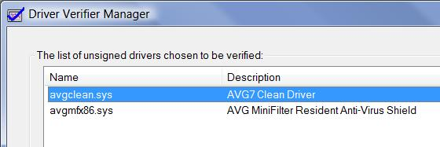
- In the "Select what drivers to verify" screen, accept the default selection of "Automatically select unsigned drivers" and click Next.
- The next screen shows the drivers to be verified. If you see any drivers in this list, click Finish. If the list is empty, click Back and make a different selection so that there are some drivers to verify.
- A box pops up saying "You must restart this computer for the changes to take effect". Click OK.

Restarting Your Computer
- Close all windows and restart your computer. Boot to your installation of Vista. One of these two things will happen:
- If your machine starts normally:
  - Skip to step 12.
- If your machine stops with a blue screen error:
  - Write down the name of the driver and the error code.
  - Restart your machine again, and press the F8 key during startup. Start the machine in Safe Mode. Then proceed to step 12.
- Log in with your personal account.

Viewing the Verified Drivers
- Press the Windows Logo key on the bottom left of your keyboard, between the Ctrl and Alt keys. Type in this command, and then press Shift+Ctrl+Enter:
CMD
- When the "User account control" box appears, press Alt+C on the keyboard (or click Continue).
- In the Administrator Command Prompt window, type in this command, and then press Enter:
VERIFIER
- In the "Select a task" screen, click "Display information about the currently verified drivers" and click Next.
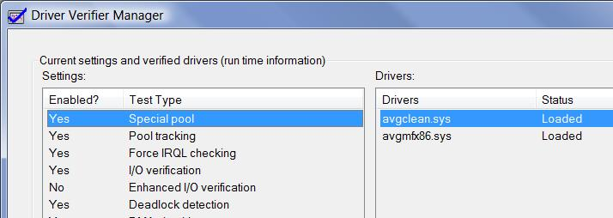
- The next screen shows information about the drivers that have been verified. You should see at least one entry in the Drivers section on the right side of this window. You may see different drivers than the ones shown in the image to the right on this page.

Capturing an Image of the Verified Drivers
- Click in the title bar of the "Driver Verifier Manager" window to ensure that it is the active window.
- Hold down the Alt key and press the PrintScrn key in the upper-right portion of the keyboard. That will copy the active window to the clipboard.
- Click Start, "All Programs", Accessories, Paint. In the untitled - Paint window, select Edit, Paste from the menu bar. The image appears in the Paint window.
- In the untitled - Paint window, click File, Save. Save the document with the filename Your Name Proj 7.

Viewing the Rest of the Verification Results
- In the "Driver Verifier Manager" window click Next.
- In the "Global counters" screen, details about the drivers tests are shown. Glance through them and click Next.
- In the "Counters specific to each of the verified drivers" screen, more details about the drivers tests are shown. Glance through them and click Finish.

Disabling Driver Verifier
- This is a very important part of the project—if you leave Driver Verifier on, it might cause blue-screen errors! It's best to turn it off when you have finished using it.
- Press the Windows Logo key on the bottom left of your keyboard, between the Ctrl and Alt keys. Type in this command, and then press Shift+Ctrl+Enter:
CMD
- When the "User account control" box appears, press Alt+C on the keyboard (or click Continue).
- In the Administrator Command Prompt window, type in this command, and then press Enter:
VERIFIER
- In the "Select a task" screen, click "Delete existing settings" and click Finish.
- A box pops up saying "This selection deletes all Driver Verifier settings and ends the program. Do you want to continue?". Click Yes.
- A box pops up saying "You must restart this computer for the changes to take effect". Click OK.

Restarting Your Computer
- Close all windows and restart your computer. Boot to your installation of Vista. Log in with your personal account.
Turning in your Project
- Email the JPEG image to me as an attachment to one e-mail message. Send the message to: cnit.335@gmail.com with a subject line of Proj 7 From Your Name, replacing Your Name with your own first and last name. Send a Cc to yourself.
Revised 9-20-07

