Starting Your Computer
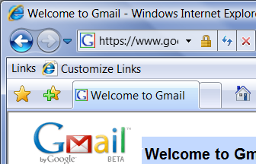
- Start your computer. Boot to your installation of Vista. Log in with your personal account.

Observing a Valid HTTPS Session
- Open Internet Explorer 7 and go to gmail.com
- You should see a padlock icon in the address bar, as shown to the right on this page. This indicates that the https page has a valid certificate. If you see any error messages at this point, try to fix the problems so you get a valid. The most likely problem is an incorrect system clock setting, as explained below.

Setting the System Clock to 2 Years Slow
- Right-click the clock in the lower right corner of the screen and select "Adjust Date/Time".
- In the "Date and Time" box, click the "Change date and time…" button. When the "User account control" box appears, press Alt+C on the keyboard (or click Continue).
- Click the left-arrow at the top of the month 24 times, to make your computer's clock 2 years slow. Click OK.
- In the "Date and Time" box, click OK.
- Open Internet Explorer 7 and go to gmail.com
- You should see an error message saying "The security certificate presented by this website has expired or is not yet valid", as shown below on this page.

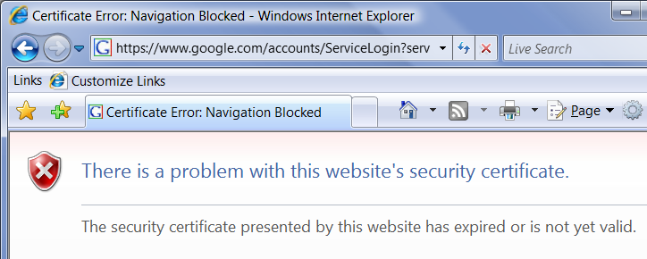

Capturing an Image of the Error Message
- Click in the title bar of the "Certificate Error: Navigation Blocked – Windows Internet Explorer" window to ensure that it is the active window.
- Hold down the Alt key and press the PrintScrn key in the upper-right portion of the keyboard. That will copy the active window to the clipboard.
- Click Start, "All Programs", Accessories, Paint. In the untitled - Paint window, select Edit, Paste from the menu bar. The image appears in the Paint window.
- In the untitled - Paint window, click File, Save. Save the document with the filename Your Name Proj 8a.

Resetting the System Clock to the Correct Time
- Right-click the clock in the lower right corner of the screen and select "Adjust Date/Time".
- In the "Date and Time" box, click the "Change date and time…" button. When the "User account control" box appears, press Alt+C on the keyboard (or click Continue).
- Adjust the date and time to the correct values. Click OK.
- In the "Date and Time" box, click OK.

Viewing a Valid Digital Certificate
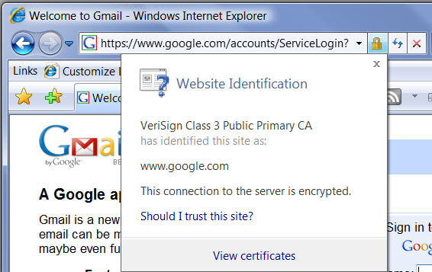
- Open Internet Explorer 7 and go to gmail.com
- You should see a padlock icon in the address bar. Click the padlock to show the "Website Identification" box, as shown to the right on this page.
- In the "Website Identification" box, click "View certificates ".
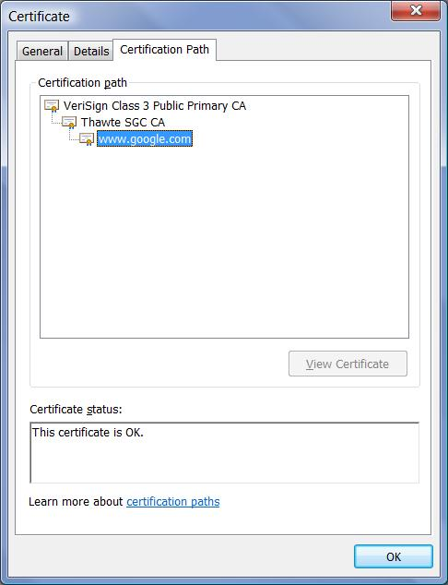
- In the "Certificate" box, click the "Certification Path" tab. You should see a "Certificate status" box at the bottom saying "This certificate is OK", as shown to the right on this page.

Capturing an Image of the Certificate
- Click in the title bar of the "Certificate" window to ensure that it is the active window.
- Hold down the Alt key and press the PrintScrn key in the upper-right portion of the keyboard. That will copy the active window to the clipboard.
- Click Start, "All Programs", Accessories, Paint. In the untitled - Paint window, select Edit, Paste from the menu bar. The image appears in the Paint window.
- In the untitled - Paint window, click File, Save. Save the document with the filename Your Name Proj 8b.
Turning in your Project
- Email the JPEG images to me as attachments to one e-mail message. Send the message to: cnit.335@gmail.com with a subject line of Proj 8 From Your Name, replacing Your Name with your own first and last name. Send a Cc to yourself.
Last changed 9-5-07

