Starting Your Computer
- Start your computer. Boot to your installation of Vista. Log in with your personal account.

Viewing Your Profile
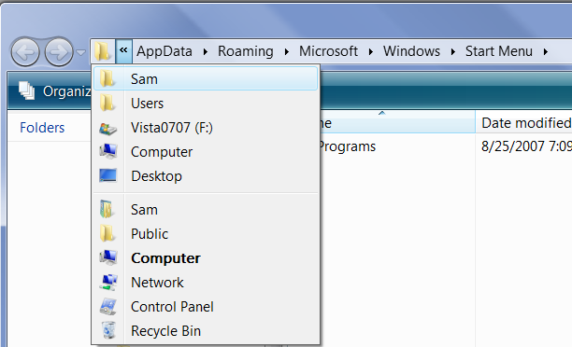
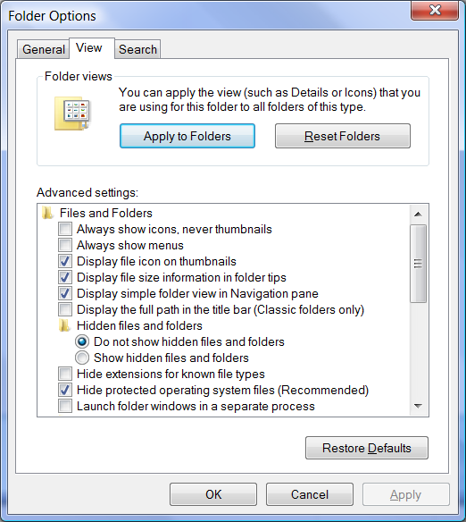
- Right-click the Start button and click Explore. On the left of the address bar, click the << symbol, as shown to the right on this page. In the drop-down list, find your name and click it.
- On the upper left of the Windows Explorer window, click the Organize button. Click "Folder and Search Options".
- In the "Folder Options " box, click the View tab.
- In the "Advanced settings" list, make sure that the "Do not show hidden files and folders" radio button is selected, and that the "Hide protected operating system files (Recommended)" box is checked, as shown to the right on this page.
- In the "Folder Options " box, click OK.

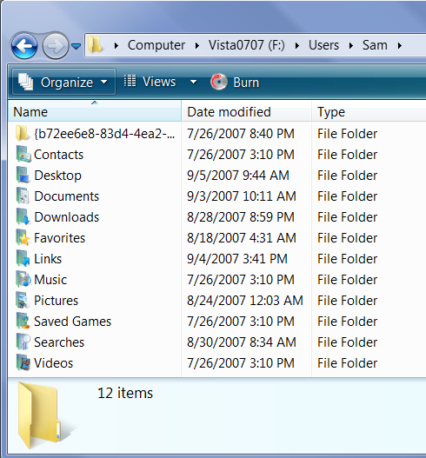
Capturing an Image of Your Profile
- Your profile folder should show your logon name in the address bar and the eleven folders "Contacts" through "Videos", as shown to the right on this page. You may have an extra folder at the top with a long name, as I did, or you may not.
- Click in the title bar of the Windows Explorer window to ensure that it is the active window.
- Hold down the Alt key and press the PrintScrn key in the upper-right portion of the keyboard. That will copy the active window to the clipboard.
- Click Start, "All Programs", Accessories, Paint. In the untitled - Paint window, select Edit, Paste from the menu bar. The image appears in the Paint window.
- In the untitled - Paint window, click File, Save. Save the document with the filename Your Name Proj 9a.

Showing Hidden and System Files and Folders
- On the upper left of the Windows Explorer window, click the Organize button. Click "Folder and Search Options".
- In the "Folder Options " box, click the View tab.
- In the "Advanced settings" list, click the"Show hidden files and folders" radio button. Click the "Hide protected operating system files (Recommended)" box to clear it. In the Warning box, click Yes. In the "Folder Options " box, click OK.

Viewing Your Profile With Hidden and System Files and Folders
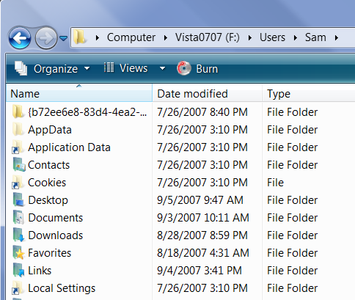
- Your profile folder should show a much longer list, including faded icons for hidden folders such as AppData, and folders with curved arrows showing Junctions like "Application Data", as shown to the right on this page. (Note that the list is much longer, and only the first few items are shown in the figure on this page.)
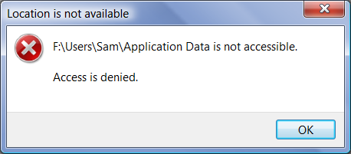
- Double-click the "Application Data" junction. A "Location is not available" error message should appear, as shown to the right on this page.

Capturing an Image of the Error Message
- Click in the title bar of the "Location is not available" box to ensure that it is the active window.
- Hold down the Alt key and press the PrintScrn key in the upper-right portion of the keyboard. That will copy the active window to the clipboard.
- Click Start, "All Programs", Accessories, Paint. In the untitled - Paint window, select Edit, Paste from the menu bar. The image appears in the Paint window.
- In the untitled - Paint window, click File, Save. Save the document with the filename Your Name Proj 9b.
Turning in your Project
- Email the JPEG images to me as attachments to one e-mail message. Send the message to: cnit.335@gmail.com with a subject line of Proj 9 From Your Name, replacing Your Name with your own first and last name. Send a Cc to yourself.
Last changed 9-5-07

