This project can be done on any version of Vista.

Choosing an Account to Use
- I wrote these instructions assuming that you will use a Gmail account. I recommend that you create a new account for this project, so your personal mail does not end up on a lab machine where other students might read it. If you have some other email service that offers POP3 access, and you don’t mind using it, you can do that. Gmail is not an essential part of this project.

Creating a GMail Account
- Open a browser and go to gmail.com
- Click the "Sign up for Gmail" link. Fill out the "Create an Account" page. When you are done, click the "I'm ready – show me my account" link.

Enable POP in your Gmail account
- You should be logged in to your Gmail account.
- Click Settings at the top of any Gmail page.
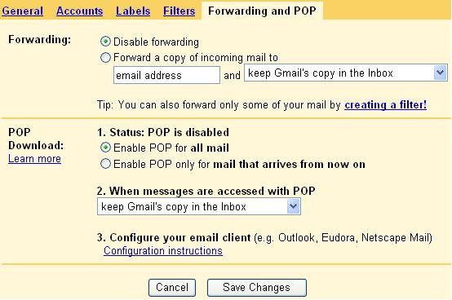
- Click "Forwarding and POP" in the orange Mail Settings box.
- Select "Enable POP for all mail, " as shown below on this page. Then click "Save Changes".

Creating a Mail Account
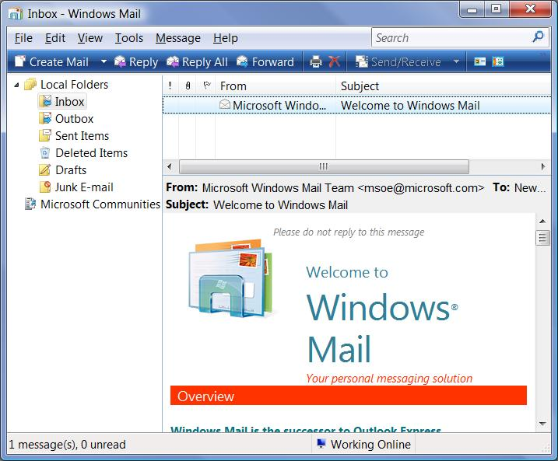
- Press the Windows logo key, next to the Ctrl key at the lower left of your keyboard. Don't touch the mouse. Type this into the Search box:
mail
- Windows Mail" should appear in the Programs list. If it's not already highlighted, press the down-arrow as needed to highlight it. Then press the Enter key. Windows Mail opens, as shown to the right on this page.
- Click Tools, Accounts from the menu bar. In the "Internet Accounts" box, click the Add button.
- In the "Select Account Type" screen, accept the default selection of "E-mail Account" and click Next.
- In the "Your Name: screen, enter your name and click Next.
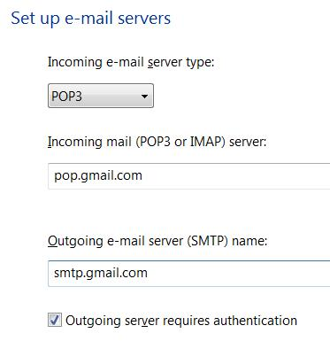
- In the "Internet E-mail Address" screen, enter your GMail address, which will look like yourid@GMail.com and click Next.
- In the "Set up e-mail servers" screen, accept the default "Incoming e-mail server type" of "POP3", as shown to the right on this page.
- In the "Incoming mail (POP3 or IMAP) server" box, enter
pop.gmail.com
- In the "Outgoing mail server (SMTP) name:" box, enter
smtp.gmail.com
- Check the "Outgoing server requires authentication" box. Your screen should look like the figure to the right on this page. Click the Next button.
- In the "Internet Mail Logon" box, enter your GMail user name and password. Leave the Remember password box checked. Note: Other students can potentially read email you access on these lab machines, so don’t read confidential email this way.
- In the "Internet Mail Logon" box, click Next.
- In the Congratulations box, check the "Do not download my e-mail at this time" box and click Finish.

Adjusting the Mail Account for GMail’s Servers
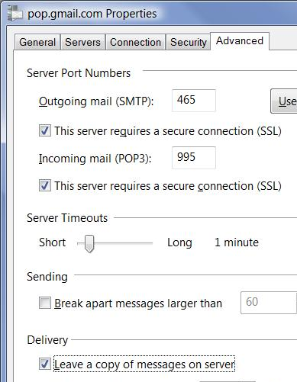
- In the "Internet Accounts" box, verify that pop.gmail.com is highlighted and click the Properties button.
- In the "pop.gmail.com Properties" box, click the Advanced tab.
- Under "Outgoing Mail (SMTP)", check "This server requires a secure connection (SSL)" box.
- In the "Outgoing mail (SMTP):" box, enter 465. This is the port number GMail uses to send mail.
- Under "Incoming mail (POP3) ", check the This server requires a secure connection (SSL)" box. The port will change to 995 – the port number GMail uses for POP3 service.
- In the Delivery section, check the "Leave a copy of messages on server" box.
- Your "pop.gmail.com Properties" box should look like the figure to the right on this page. Click OK.
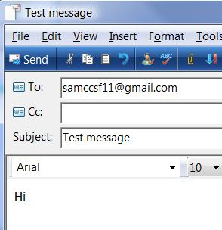
- In the Internet Accounts window, click Close.

Sending Yourself a Message
- In the "Windows Mail" window, click the "Create Mail" button. Compose an email to your GMail account, like the example shown to the right on this page, and click the Send button.
- In the "Windows Mail" window, click the "Send/Receive" button. Compose an email to your GMail account, like the example shown to the right on this page, and click the Send button.
- In the toolbar at the top of the "Windows Mail" window, click the Send/Recv button.
- If a "Windows Mail" box pops up, warning you that the mail has been moved to the Junk e-mail folder, click Close.
- You should see the test message you sent yourself appear in the Inbox, as shown at the top of the next page of these instructions. If the test message doesn't appear, return to Gmail settings and on the "Forwarding and POP" tab, click "Enable POP for all mail (even mail that's already been downloaded)" and then click "Save Changes". Then In the toolbar at the top of the "Windows Mail" window, click the Send/Recv button.

Capturing an Image of the Received Message
- Make sure that your Inbox contains a message you sent, not just the automatic "Welcome to Windows Mail" message.
- Click in the title bar of the "Windows Mail" window to ensure that it is the active window.
- Hold down the Alt key and press the PrintScrn key in the upper-right portion of the keyboard. That will copy the active window to the clipboard.
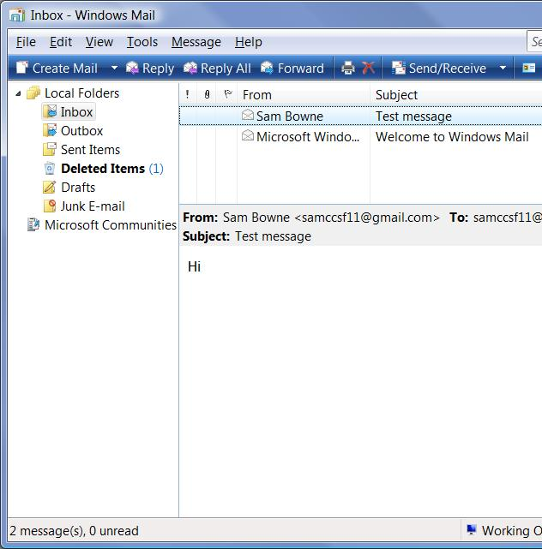
- Click Start, "All Programs", Accessories, Paint. In the untitled - Paint window, select Edit, Paste from the menu bar. The image appears in the Paint window.
- In the untitled - Paint window, click File, Save. Save the document with the filename Your Name Proj 10.

Turning in your Project
- Email the JPEG image to me as an attachment to an e-mail message. Send the message to: cnit.335@gmail.com with a subject line of CNIT 335 Proj 10 From Your Name, replacing Your Name with your own first and last name. Send a Cc to yourself.

Last modified 9-11-06

