This project can be done on any version of Vista except Home Basic. But you will need two Vista computers connected to the same network. I call them computerA and computer B below. Start both machines and log in with different accounts on each one.

Starting Windows Meeting Space: Do this on both Computer A and Computer B
- Press the Windows logo key, next to the Ctrl key at the lower left of your keyboard. Don't touch the mouse. Type this into the Search box:
mee
- "Windows Meeting Space" should appear in the Programs list. If it's not already highlighted, press the down-arrow as needed to highlight it. Then press the Enter key. A "Windows Meeting Space Setup" box opens, as shown below on this page.
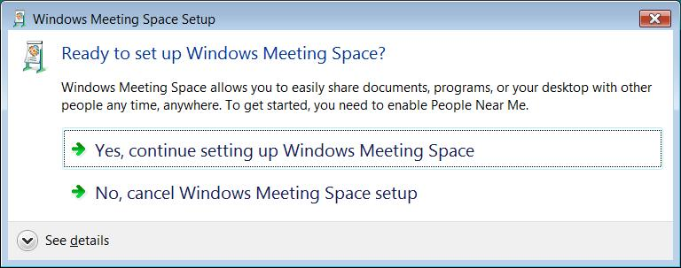

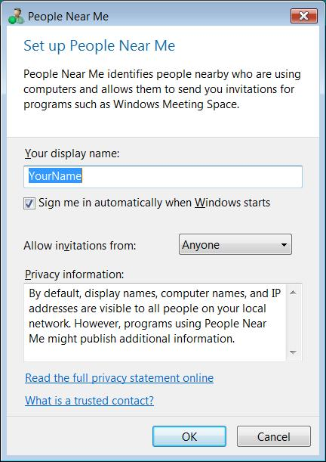
- Click "Yes, continue setting up Windows Meeting Space".
- If a "User account control" box appears, press Alt+C on the key board (or click Continue).
- A "People Near Me" box appears, as shown to the right on this page. Accept the default selections and click OK.

Starting a Meeting Space: Do this on Computer A
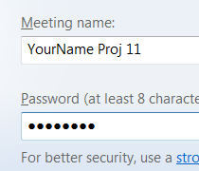
- In the large blue shaded "Windows Meeting Space" box, click "Start a new meeting".
- Enter a Meeting Name of "Your Name Proj 11" and put in a password of password
- In the "Windows Meeting Space" box, as shown to the right on this page, click the right-arrow button.

Joining a Meeting: Do this on Computer B
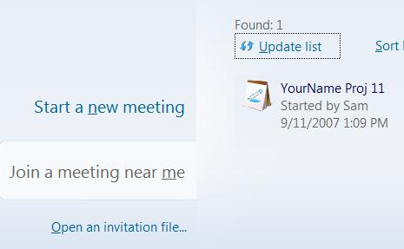
- Go to the other computer. You should see the meeting in the "Join a meeting near me" list, as shown to the right on this page. Click "Your Name Proj 11".
- A message appears saying "A password is required". Type in password and press the Enter key.
- The "Windows Meeting Space" box should now show two participants attending, in the upper right corner, as shown to the right on this page.

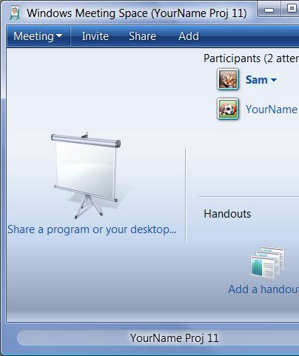
Sharing the Desktop: Do this on Computer B
- In the "Windows Meeting Space" box, click "Share a program or your desktop…".
- A "Windows Meeting Space" box pops up saying "Do you want other people to see your desktop?". Click OK.
- If a "Start a shared session" box appears, click "Desktop" and click Share.
- Press the Windows logo key, next to the Ctrl key at the lower left of your keyboard. Don't touch the mouse. Type this into the Search box:
not
- "Notepad" should appear in the Programs list. If it's not already highlighted, press the down-arrow as needed to highlight it. Then press the Enter key. Notepad opens.
- From the Notepad menu bar, click Format, Font. Change the font size to 36 and click OK. Type in these words:
Your Name Proj 11

Capturing an Image of the Shared Desktop: Do this on Computer A
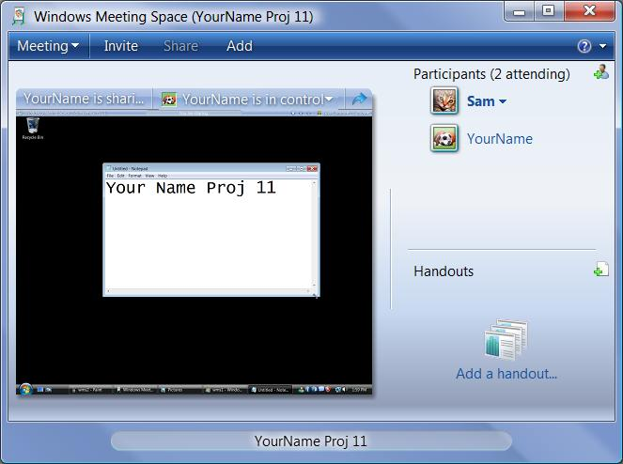
- Return to computer A. It should show a shrunken version of the Notepad window inside the "Windows Meeting Space" box, as shown to the right on this page.
- Click in the title bar of the "Windows Meeting Space " window to ensure that it is the active window.

- Hold down the Alt key and press the PrintScrn key in the upper-right portion of the keyboard. That will copy the active window to the clipboard.
- Click Start, "All Programs", Accessories, Paint. In the untitled - Paint window, select Edit, Paste from the menu bar. The image appears in the Paint window.
- In the untitled - Paint window, click File, Save. Save the document with the filename Your Name Proj 11.

Giving Control: Do this on Computer B
- In the upper right of your desktop, find the "Give Control" button, as shown to the right on this page. Click it, and click the name you logged in to station A with.

Using Control: Do this on Computer A
- Return to computer A. Try controlling the desktop shown inside the "Windows Meeting Space " window—notice that it's slow and jerky compared with direct control.

Turning in your Project
- Email the JPEG image to me as an attachment to an e-mail message. Send the message to: cnit.335@gmail.com with a subject line of CNIT 335 Proj 11 From Your Name, replacing Your Name with your own first and last name. Send a Cc to yourself.

Last modified 12-12-07

