This project can be done on any version of Vista except Home Basic. But you will need two Vista computers connected to the same network. I call them computer A and computer B below. Start both machines and log in with different accounts on each one.

Starting Remote Assistance: Do This on Computer A
- Press the Windows logo key, next to the Ctrl key at the lower left of your keyboard. Don't touch the mouse. Type this into the Search box:
rem
- "Windows Remote Assistance" should appear in the Programs list. If it's not already highlighted, press the down-arrow as needed to highlight it. Then press the Enter key.
- A "Windows remote Assistance" box opens. Click "Invite someone you trust to help you".
- The next screen asks "How do you want to invite someone to help you?". Click "Save this invitation as a file".
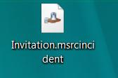
- The next screen says "Save this invitation as a file". Accept the default path and file name, which will create an Invitation.msrcincident file on your desktop. Enter a password of P@ssw0rd in both boxes and click the Finish button.
- Minimize all windows. Look on your desktop and find the Invitation.msrcincident file, as shown to the right on this page. That's the invitation file.

Transferring the Invitation File to Computer B
- Transfer the file to computer B any way you like. For example, you could copy it to a floppy disk or USB memory stick, or send it by email.

Accepting the Invitation: Do This on Computer B
- Double-click the Invitation.msrcincident file. A box pops up asking for the password. Enter this password"
P@ssw0rd
Click OK.
- A large "Windows Remote Assistance" window opens, with a message in the top left saying "Waiting for Acceptance".

Accepting the Assistance: Do This on Computer A
- A small "Windows Remote Assistance" box appears, saying "Would you like to allow Name to connect to your computer?". Click Yes.
- The background turns to black, and the color scheme is changed to Vista Basic (No Aero).

Using Remote Assistance in View Only Mode: Use Both Computers A and B
- Computer B now shows the desktop of Computer A. Open a window on computer A and move it around, and verify that the things you do are visible on computer B.

Requesting Control: Use Computer B
- On Computer B, click the "Request Control" button.

Allowing Control: Use Computer A
- On Computer A, a box appears asking "Would you like to allow Name to share control of your desktop?". Click Yes.

Sharing Control: Use Both Computers A and B
- On computer A, drag a window to the right. On Computer B, drag it up. If you get two people to operate both computers at the same time, both actions take effect and the window moves diagonally. This is Sharing Control.

Capturing an Image of the Remote Assistance Screen: Do this on Computer B
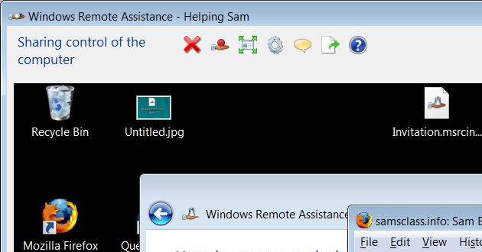
- On computer B, you should see a "Windows Remote Assistance" window with the message "Sharing control of the computer" in the upper left corner, as shown to the right on this page.

- Press the PrintScrn key in the upper-right portion of the keyboard. That will copy the whole desktop to the clipboard.
- Click Start, "All Programs", Accessories, Paint. In the untitled - Paint window, select Edit, Paste from the menu bar. The image appears in the Paint window.
- In the untitled - Paint window, click File, Save. Save the document with the filename Your Name Proj 12.

Turning in your Project
- Email the JPEG image to me as an attachment to an e-mail message. Send the message to: cnit.335@gmail.com with a subject line of CNIT 335 Proj 11 From Your Name, replacing Your Name with your own first and last name. If two people worked together on the project, send one email with both names in the subject line. Send a Cc to yourself.
Last modified 12-12-07

