Requirements
You need a computer with Windows Home Basic, Home Premium, or Ultimate edition for this project. Vista Business does not include Parental Controls. If you don't have one of those editions, do "Project X2: Installing Windows Vista Ultimate" first.
Starting Your Machine in Vista Ultimate
- Restart the machine and boot to Vista Ultimate. If it does not automatically log in, log in with the Student account, or any account in the Administrators group.
Creating the Child Account
- Click Start, "Control Panel". In "Control Panel", in the "User Accounts and Family Safety" section, click "Add or remove user accounts". In the "User Account Control" box, click Continue.
- In the "User Accounts ► Manage Accounts" box, click "Create a new account".
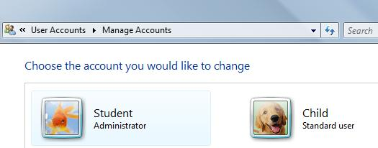
- In the "User Accounts ► Manage Accounts ► Create New Account" box, enter a name of Child. Leave the account type at its default selection of "Standard user" and click the "Create Account" button.
- The "User Accounts ► Manage Accounts" box should show the Child account, as shown to the right on this page.
Creating a Password
- In the "User Accounts ► Manage Accounts" box, click the Student icon.
- In the "User Accounts ► Manage Accounts ► Change an Account" box, click "Create a password".
- In the "Change an Account ► Create Password" box, type in P@ssw0rd into both boxes and click the "Create password" button.
- If there are any other administrator accounts, use the same process to add passwords to each of them.
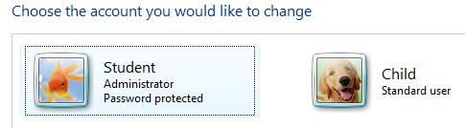
- The "User Accounts ► Manage Accounts" box should now show that the Student account is "Password protected", as shown to the right on this page.
Configuring Parental Controls
- Click Start, "Control Panel". In "Control Panel", in the "User Accounts and Family Safety" section, click "Set up parental controls for any user". In the "User Account Control" box, click Continue.
- In the "User Accounts and Family Safety ► Parental Controls" box, click the Child icon.
- In the "Parental Controls ► User Controls" box, click the "On, enforce current settings" button, as shown below on this page.
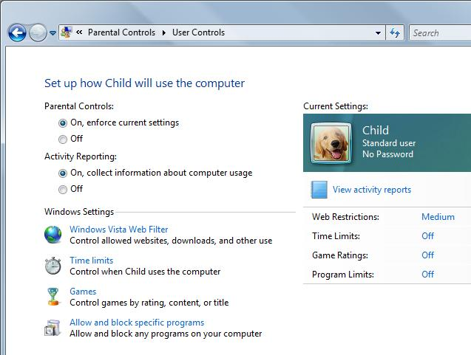
Blocking Web Content
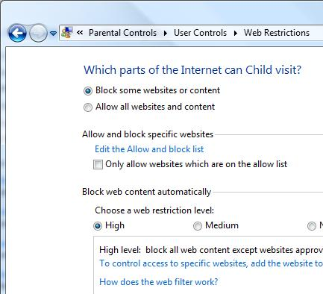
- In the "Parental Controls ► User Controls" box, click "Windows Vista Web Filter".
- In the "Parental Controls ► User Controls ► Web Restrictions" box, in the "" section, click a web restriction level of High, as shown to the right on this page. Click the OK button.
Restart and Log in as Child
- Restart your machine. Don't just log off—a complete restart is needed to start the Parental Controls monitoring service. Boot to Vista Ultimate and log in as Child.
Surfing the Web
- Open Internet Explorer and try going to these websites:
  - yahoo.com
  - cnn.com
  - www.ccsf.edu
  - pbskids.org
Only the last one is allowed. This is what surfing the Web is like with High restriction.
- Open Firefox and try going to these websites:
  - yahoo.com
  - cnn.com
  - www.ccsf.edu
  - pbskids.org
You should see the same results—Parental Controls affect all browsers, not just Internet Explorer.
Allowing a Website
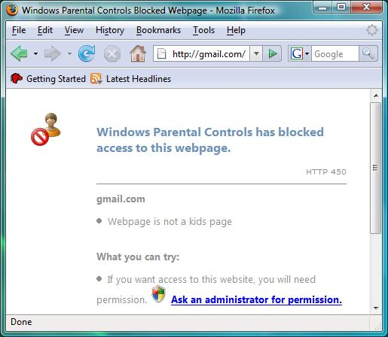
- In Firefox, type this into t e address bar, and then press Enter:
gmail.com
- The web page is blocked, as shown to the right on this page. Click the "Ask an administrator for permission" link.
- In the "External Protocol Request" box, click the "Launch application" button.
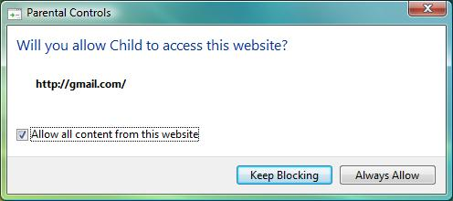
- In the "User Account Control" box, enter your password of P@ssw0rd and click the OK button.
- In the "Parental Controls" box, check the "Allow all content from this website" box, as shown to the right on this page, and click the "Always Allow" button.
- In the "Windows Parental Controls" box, click the OK button.
- Click in the Firefox window to make it active. Press the F5 key to refresh it.
- This gets you to the next page, named mail.google.com. It is blocked again. Repeat the process above again to allow this page.

Sending and Receiving Email
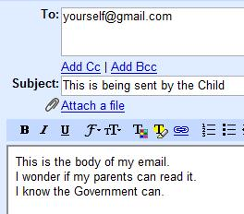
- You should now be able to log in to a Gmail account. If you don't have a Gmail account, you can use another web-based email account, but you will have to allow it past the Parental Controls the same way.
- Compose a message to yourself as shown to the right on this page.
- Send the message. Wait for it to appear in your Inbox.
- Open the message and read it.
- Close all windows and log off.
Log in as Student
- Log in as Student, or any other Administrator account. The password should be P@ssw0rd
Viewing Activity Reports
- Click Start, "Control Panel". In "Control Panel", in the "User Accounts and Family Safety" section, click "Set up parental controls for any user". In the "User Account Control" box, click Continue.
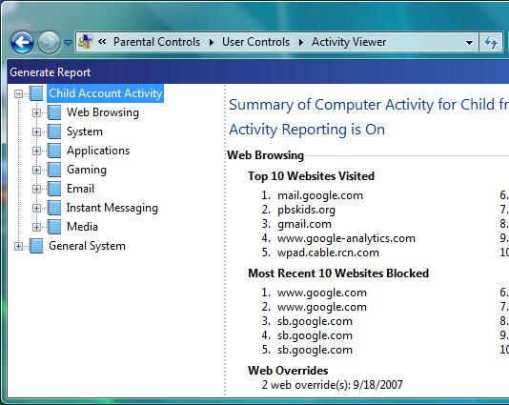
- In the "User Accounts and Family Safety ► Parental Controls" box, click the Child icon.
- In the "Parental Controls ► User Controls" box, click "View activity reports".
- You should see a "Summary of Computer Activity for Child" window, as shown to the right on this page, showing the websites you visited.

Saving the Screen Image
- Press the PrintScrn key in the upper-right portion of the keyboard. That will copy the whole desktop to the clipboard.
- Click Start, All Programs, Accessories, Paint. In the untitled - Paint window, select Edit, Paste from the menu bar. The window image appears in the Paint window.
- In the untitled - Paint window, click File, Save. Save the document in the My Pictures folder (or any other place you wish, such as a floppy disk) with the filename Your Name Proj 13. Select a Save as type of JPEG.

Checking the Email Activity
- Scroll to the bottom of the "Summary of Computer Activity for Child" window, and find the Email section. No record is kept of Gmail, apparently because it does not support Parental Controls. That would appear to limit the value of this feature.

Turning in your Project
- Open Firefox, and use it to email the JPEG image to me as an attachment to an email message. Send the message to: cnit.335@gmail.com with a subject line of "Proj 13 From Your Name", replacing Your Name with your own first and last name. Send a Cc to yourself.

Last Modified 7-9-08

