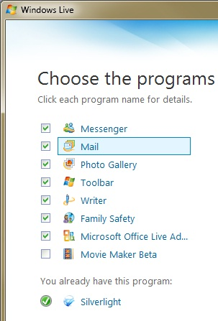
This project was written for Windows 7 Beta.
Installing Windows Live Software
- You may already have installed the Windows Live tools in a previous project. If you haven't done that, do these steps:
- In Firefox, go to this address.

download.live.com/wlmail
- Click the Download button. Save the wlsetup-web.exe file on your desktop.
- On your desktop, double-click the wlsetup-web.exe file.
- Install the software with the default options. This will add several programs to your Windows 7 machine, as shown to the right on this page.
Starting Windows Family Safety
- Press the Windows logo key. Type FAM into the search box.
- "Windows Live Family Safety" should appear in the Programs list. If it's not already highlighted, press the down-arrow as needed to highlight it. Then press the Enter key.
- Log in with your Windows Live account. If you don't have one, click the "Sign up" link to get one.
- The "Windows Live Family Safety Filter" box appears, with the filter set to On in the upper left corner, as shown below on this page.
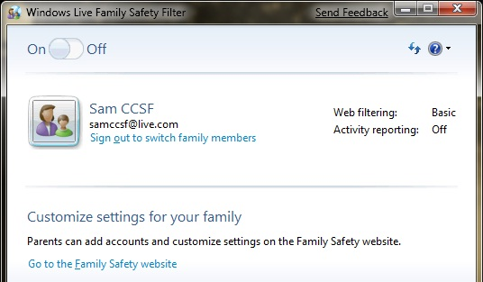
Creating the Child Account
- In the "Windows Live Family Safety Filter" box, click "Go to the Family Safety website".
- A Web page opens, titled "Windows Live". Enter your password when you are prompted to.
- The "Family Safety" page opens. Click "Add child".
- A box pops up titled "Family Safety – Windows Live". Click the "Create child ID" box.
- Fill in the form with a child ID. I recommend just adding "child" to the parent ID for this project, but you can use any name you like.
- In the upper left of the browser window, click "Family Safety" to return to the "Family Summary" screen, as shown below on this page.
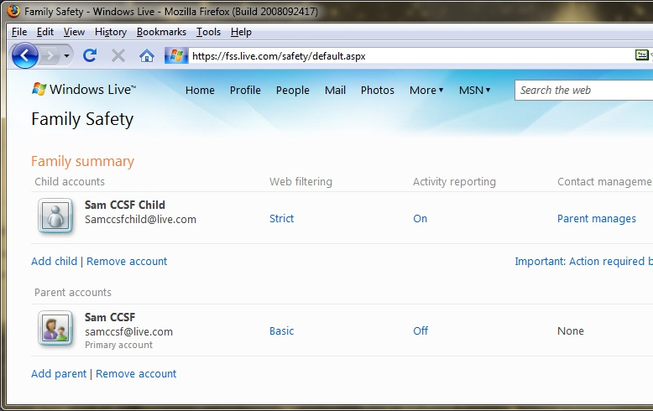

- In the "Child accounts" section, click the link saying "Important: Action required…". A box pops up explaining how to activate the Family Safety Filter.
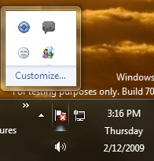
Activating the Family Safety Filter
- On the lower right of your desktop, in the Notification Area, click the "Family Safety" icon, as shown to the right on this page. You may need to click the upward-pointing triangle to reveal it.

Family Safety Icon
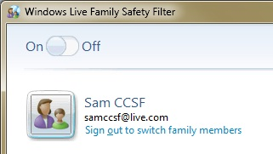
Signing in with the Child Account
- The "Windows Live Family Safety Filter" box opens, as shown to the right on this page. Click "Sign out to switch family members".
- Sign in with the Child account. Now you are subject to "Strict" Web filtering.
Browsing the Web
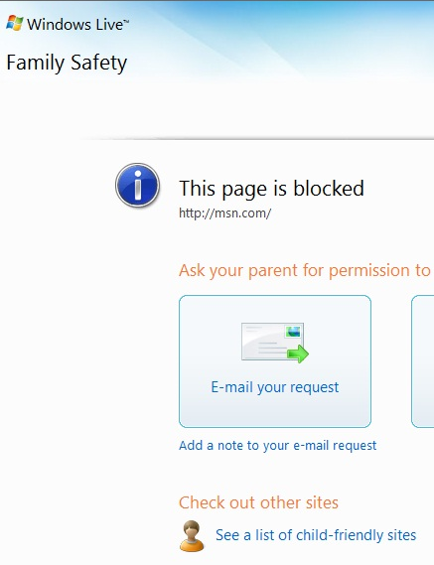
- Open Internet Explorer and go to msn.com
- A message appears saying "This page is blocked", as shown to the right on this page.
- Open Firefox and go to msn.com
- The same message appears, saying "This page is blocked". The filter affects all browsers on the computer.
Allowing a Website
- In the Internet Explorer window, click the "Ask in person" button.
- In the "Parent website approval" box, enter your password and click Approve.
- In Internet Explorer, type msn.com into the address bar and press Enter. The page opens now, with a lot of ads and images missing.
Signing in as the Parent
- In the "Windows Live Family Safety Filter" box, click "Sign out to switch family members".
- Sign in with your original account, which is the Parent.
Viewing an Activity Report
- In the "Windows Live Family Safety Filter" box, click "Go to the Family Safety website".
- In the Family Safety webpage, in the "Child accounts" section, in the "Activity reporting" column, click the blue On.
- The "Activity reporting" page opens, showing the Web addresses used by the Child, as shown to on the next page of these instructions.

Saving the Screen Image
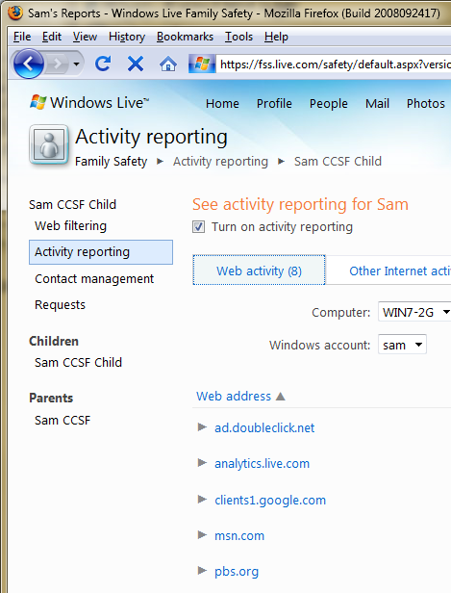
- Press the PrintScrn key in the upper-right portion of the keyboard. That will copy the whole desktop to the clipboard.
- Press the Windows logo key. Type PAINT into the Search box. When Paint is highlighted in the Search list, press the Enter key.
- Click in the untitled - Paint window. Then press Ctrl+V on the keyboard. The captured screen image appears in the Paint window.
- Click the Save icon in the Paint window (it looks like a tiny blue floppy disk). Save the document with the filename Your Name Proj 13x.

Turning in your Project
- Send the image as an Email attachment to: cnit.335@gmail.com with a subject line of "Proj 13x From Your Name", replacing Your Name with your own first and last name. Send a Cc to yourself.

Removing Family Safety
- Unless you are actually sharing this machine with children, you probably want to remove Family Safety, with the steps below.
- Click Start, "Control Panel", "Uninstall a Program".
- In the "Uninstall or change a program" box, double-click "Windows Live Essentials".
- In the "Uninstall or repair your Windows Live programs" box, accept the default selection of Uninstall and click Continue.
- In the "Select the programs you want to uninstall" box, check "Family Safety" and click Continue.
- In the "Done" box, click Close.

Last Modified 2-15-09

