Requirements
You will need a machine with Windows 7 Beta and a USB flash drive,. BitLocker To Go is not available in the Vista.
Starting Your Windows 7 Machine
- Start the machine and boot to Windows7. Log in with any account that has Administrator privileges, such as the Student account. If a password is required, try P@ssw0rd
Checking Windows Activation Status
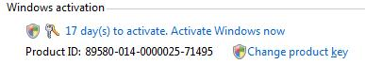
- Click Start, right-click Computer, and click Properties. Scroll to the bottom of the System window to see your Windows activation status, as shown to the right on this page. See how many days you have left to activate Windows.
If You Have More Than Seven Days Left, Skip to the Next Section
- Don’t do this step unless your activation is about to expire! You can only rearm the trial period three times, so if you do it when it’s not necessary, you could cause the installation to expire before the semester ends. However, if you have seven days or fewer left to activate Windows, do this:
  - Press the Logo key, type in CMD and press Shift+Ctrl+Enter. In the "User account control" box, click Continue.
  - Type in this command, and press the Enter key:
slmgr.vbs -rearm
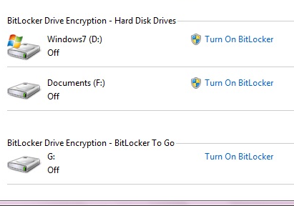
  - Restart your machine. Check the Windows activation status again—you should now have 30 days left to activate.
Starting BitLocker
- Press the Logo key, and type in
BIT
When “BitLocker Drive Encryption” is highlighted, press Enter.
- Insert a USB flash drive. When it appears in the “BitLocker Drive Encryption” window, as shown to the right on this page, click “Turn on BitLocker”.

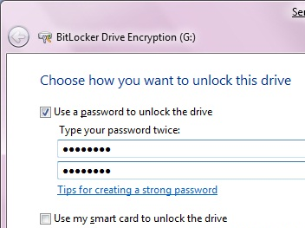
- In the “Choose how you want to unlock this dive” box, check “Use a password to unlock this device”, as shown to the right on this page. Enter a password of P@ssw0rd in both fields and click Next.
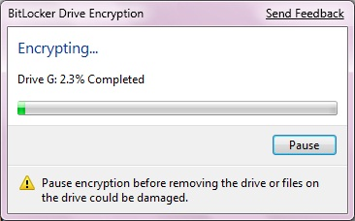
- In the next box, click “Start encrypting”. Save the key in the default location of Documents with the default name, which is just a long string of letters and numbers. Then click Next.
- You will see a progress bar moving, as shown to the right on this page.

Saving the Screen Image
- Press the PrintScrn key in the upper-right portion of the keyboard. That will copy the whole desktop to the clipboard.
- Click Start, All Programs, Accessories, Paint. In the untitled - Paint window, select Edit, Paste from the menu bar. The window image appears in the Paint window.
- In the untitled - Paint window, click File, Save. Save the document with the filename Your Name Proj 16xa. Select a Save as type of JPEG.

Viewing the Recovery Key File
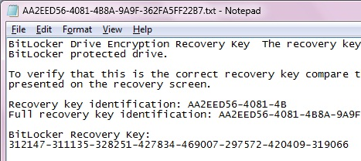
- Open the Documents folder. Double-click the recovery key file—its filename is a long string of letters and numbers. You should see the Recovery key, as shown to the right on this page.

Saving the Screen Image
- Press the PrintScrn key in the upper-right portion of the keyboard. That will copy the whole desktop to the clipboard.
- Click Start, All Programs, Accessories, Paint. In the untitled - Paint window, select Edit, Paste from the menu bar. The window image appears in the Paint window.
- In the untitled - Paint window, click File, Save. Save the document with the filename Your Name Proj 16xb. Select a Save as type of JPEG.

Turning in your Project
- Email the JPEG images to me as attachments to a single email message. Send the message to: cnit.335@gmail.com with a subject line of "Proj 16x From Your Name", replacing Your Name with your own first and last name. Send a Cc to yourself.

Let the Encryption Process Finish
- If you are using a borrowed USB memory stick in the S214 lab, please let the encryption process finish.

Last Modified 2-19-09

