Starting Your Computer
- Start your computer. Boot to your installation of Vista. Log in with your personal account.

Choosing a Backup Partition
- Click Start, Computer. Look for a partition named Backups. If there isn't one named Backups, or that partition is full, find one named Available and rename it to Backups. Remember the drive letter of the partition you are using for backups.

Creating Three Test Files
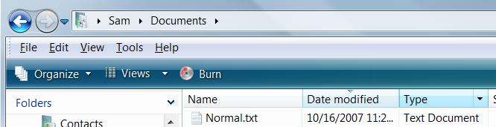
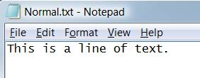
- Click Start, Documents. Right click a blank portion of the Documents window and click New, Text Document. A new document appears, with its name highlighted, showing New Text Document. Type in a name of Normal and press the Enter key. You should now have a file named Normal.txt as shown to the right on this page.
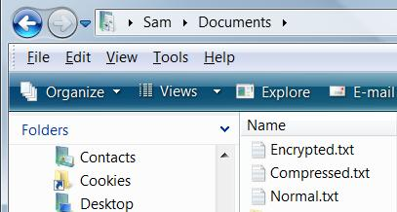
- Double-click the Normal.txt icon to open the file in Notepad. Type in a line of text, as shown to the right on this page. Press Ctrl+S to save the file. Press Alt+F, and then press X, to close the file.
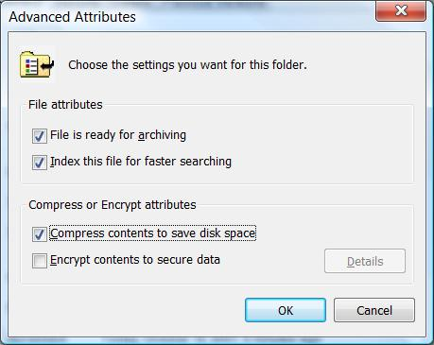
- Use the same process to create two more text files named Compressed.txt and Encrypted.txt. Type some text into each file, just to make sure they are not empty. Your Documents window should now contain three files as shown to the right on this page.

Compressing a File
- Right click the Compressed.txt file's icon and click Properties. In the "Compressed.txt Properties" box, on the General tab, click the Advanced button.
- In the "Advanced Attributes" box, check the "Compress contents to save disk space" box, as shown to the right on this page. Click OK.
- In the "Compressed.txt Properties" box, click OK.

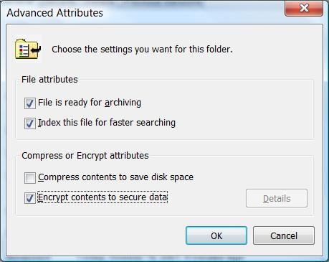
Encrypting a File
- Right click the Encrypted.txt file's icon and click Properties. In the "Encrypted.txt Properties" box, on the General tab, click the Advanced button.
- In the "Advanced Attributes" box, check the "Encrypt contents to secure data" box, as shown to the right on this page. Click OK.
- In the "Encrypted.txt Properties" box, click OK.
- In the "Encryption Warning" box, select "Encrypt the file only" and click OK.

Saving a Screen Image
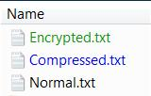
- The Documents window should now show three files, with these font colors, as shown to the right on this page:
  - Encrypted in GREEN
  - Compressed in BLUE
  - Normal in Black
- Press the PrintScrn key in the upper-right portion of the keyboard. That will copy the whole desktop to the clipboard.
- Click Start, "All Programs", Accessories, Paint. In the untitled - Paint window, select Edit, Paste from the menu bar. The image appears in the Paint window.
- In the untitled - Paint window, click File, Save. Save the document with the filename Your Name Proj 19a.

Backing Up Files and Folders
- Press the Logo key, and type in BACK
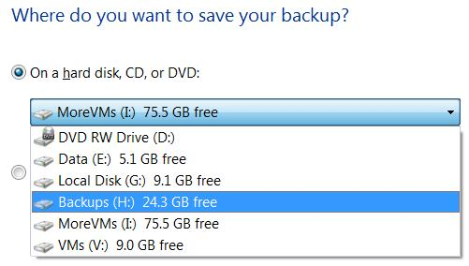
- When the Search finds "Backup and Restore Center", use the down-arrow as needed to highlight it and press the Enter key.
- In the "Backup and Restore Center" window, click "Back Up Files". In the "User Account Control" box, press Alt+C or click Continue.
- In the box titled "Where do you want to save your backup?", select your Backups drive, as shown to the right on this page. Click Next.

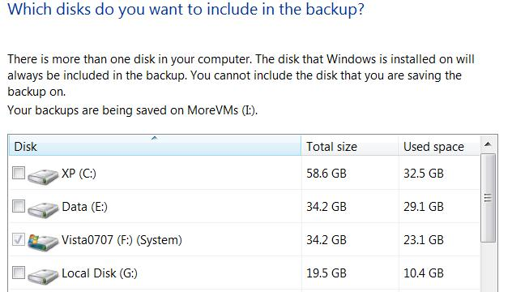
- In the box titled "Which disks do you want to include in the backup?", clear all the check marks except the one next to your Vista drive (System), as shown to the right on this page. Click Next.
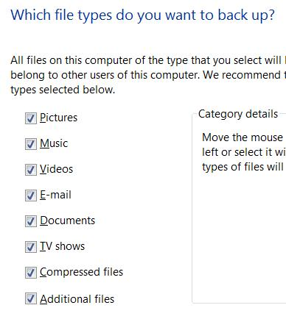

- In the box titled "Which file types do you want to back up?", ensure that all boxes are checked, as shown to the right on this page. Click Next
- In the box titled "How often do you want to create a backup?", accept the default selections and click "Save settings and start backup".
- You will see a progress indicator during the backup. You may continue to use your computer normally during the backup. When the backup completes, you will see the message shown below on this page. It took about 23 minutes on my system.
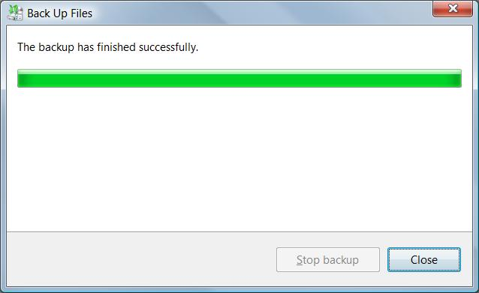

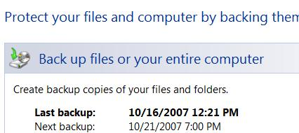

- "Backup and Restore Center" should now show the date and time of the "Last backup:", as shown to the right on this page.

Deleting the Test Files
- Click Start, Documents. Click the Normal.txt file to select it. Hold down the Shift key and press the Delete key. In the "Delete File" box, click Yes.
- Repeat the process to delete the Encrypted.txt and Compressed.txt files.

Restoring the Test Files
- Press the Logo key, and type in BACK
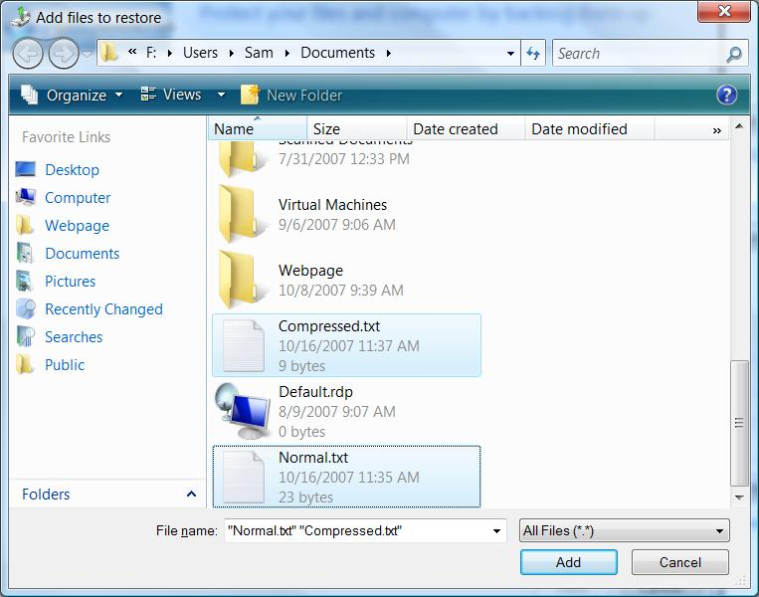
- When the Search finds "Backup and Restore Center", use the down-arrow as needed to highlight it and press the Enter key.
- In the "Backup and Restore Center" window, in the "Restore files or your entire computer" section, click "Restore Files".
- In the box titled "What do you want to restore?", accept the default selection of "Files from the latest backup" and click Next.
- In the box titled "Select the files and folders to restore?", click the "Add files…" button.
- An "Add files to restore" window opens, as shown to the right on this page. Find the Compressed.txt file and click it once to select it. Hold down the Ctrl key and click the Normal.txt file once to select it also. Notice that the Encrypted.txt file is not here—the Backup Wizard doesn't back up encrypted files!
Capturing an Image of the "Add files to restore" Window
- Press the PrintScrn key to copy the whole desktop to the clipboard.
- Click Start, "All Programs", Accessories, Paint. In the untitled - Paint window, select Edit, Paste from the menu bar. The image appears in the Paint window.
- In the untitled - Paint window, click File, Save. Save the document with the filename Your Name Proj 19b.

Completing the Restore Process
- In the "Add files to restore" window, click the Add button.
- In the box titled "Select the files and folders to restore", click Next.
- In the box titled "Where do you want to save the restored files", click "Start restore".
- In the box titled "Successfully restored files", click Finish.
- Look in the Documents window—the Compressed.txt and Normal.txt files are back now, but the Encrypted.txt file is gone forever.
Turning in your Project
- Email the JPEG images to me as attachments to one e-mail message. Send the message to: cnit.335@gmail.com with a subject line of Proj 19 From Your Name, replacing Your Name with your own first and last name. Send a Cc to yourself.

Last changed 10-16-07

