Starting Your Computer
- Start your computer. Boot to your installation of Vista. Log in with your personal account.

Stopping the Server Service
- Click Start. In the Search box, type in CMD and then press Shift+Ctrl+Enter. In the "User Account Control" box, press Alt+C or click Continue.
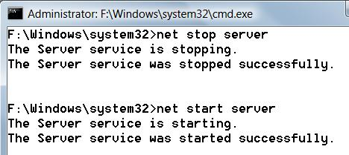
- In the Administrator Command Prompt window, type in this command, and press the Enter key:
net stop server
- In the Administrator Command Prompt window, type in this command, and press the Enter key:
net start server
These commands stop the Server service briefly, as shown above on this page. This will prevent your computer from hosting shared files or printers for a few seconds, which doesn't accomplish anything. But it creates a couple of events in the Event log to look at.

Opening Event Viewer
- Click Start. Right click Computer and click Manage. In the "User Account Control" box, press Alt+C or click Continue.
- In the left pane of "Computer Management", expand "Event Viewer" and expand "Windows Logs".
- In the left pane of "Computer Management", click System. Wait until the central pane populates with events. Right-click the "Date and Time" header and click "Sort events by this column", as shown below on this page. Wait until the sorting completes. If the most recent events are not at the top, repeat the sorting process again.
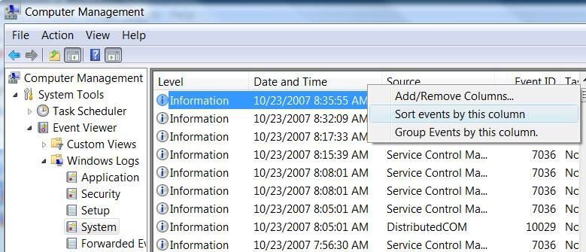

Finding Event 7036
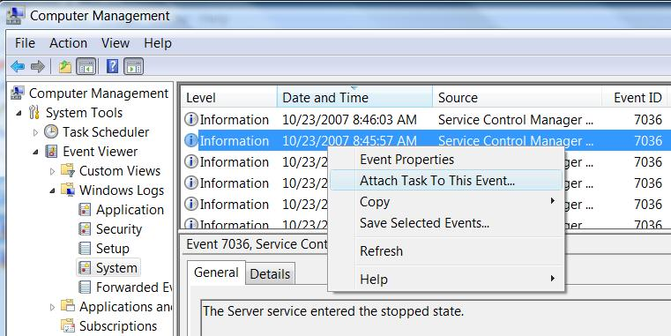
- In the central pane of "Computer Management", you should see two (or more) events from a Source of "Service Control Manager Eventlog Provider" with an Event ID of 7036, as shown below on this page.

Attaching a Task to Event 7036
- Click on the line showing an Event 7036 to see its details in the lower pane. Find the event with a description of "The Server service entered the stopped state" as shown above on this page. Right-click that event and click "Attach Task To This Event…".
- The "Create Basic Task Wizard" window opens.
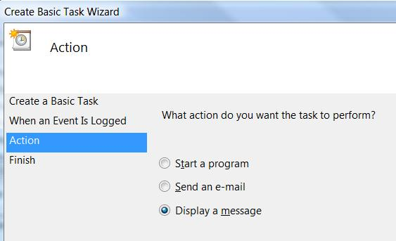
- In the "Create a Basic Task" page, accept the default name of "System_Service Control Manager_7036" and click Next.
- In the "When a Specific Event Is Logged" page, accept the default selections (you can't change anything here anyway), and click Next.
- In the "Action" page, click "Display a message", as shown to the right on this page, and click Next.
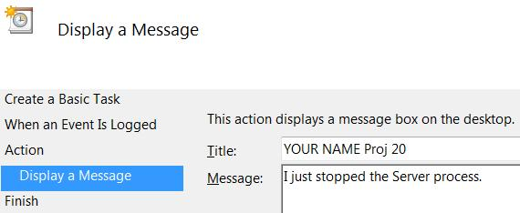
- In the "Display a Message" page, enter a title and message as shown to the right on this page, and click Next. Replace YOUR NAME with your own name.
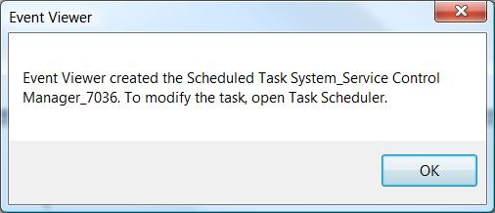
- In the "Summary" page, click Finish.
- An "Event Viewer" box pops up, as shown to the right on this page. Click OK.

Stopping the Server Service Again
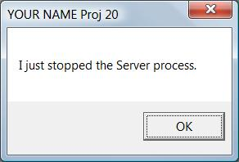
- Click Start. In the Search box, type in CMD and then press Shift+Ctrl+Enter. In the "User Account Control" box, press Alt+C or click Continue.
- In the Administrator Command Prompt window, type in this command, and press the Enter key:
net stop server

Saving a Screen Image
- You should see a box titled "YOUR NAME Proj 20" pop up, as shown to the right on this page.
- Press the PrintScrn key in the upper-right portion of the keyboard. That will copy the whole desktop to the clipboard.
- Click Start, "All Programs", Accessories, Paint. In the untitled - Paint window, select Edit, Paste from the menu bar. The image appears in the Paint window.
- In the untitled - Paint window, click File, Save. Save the document with the filename Your Name Proj 20.

Deleting the Scheduled Task
- This message can get annoying. So now that you've captured the screen image, delete it.
- Press the Logo key, and type in SCH
- When the Search finds "Task Scheduler", use the down-arrow as needed to highlight it and press the Enter key. In the "User Account Control" box, press Alt+C or click Continue.
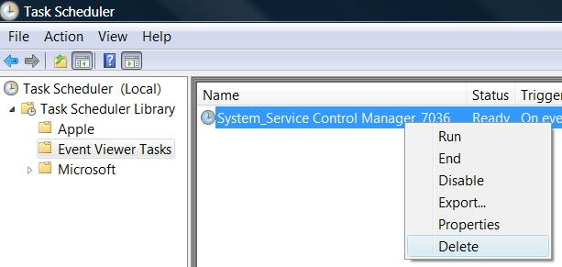
- In "Task Scheduler", in the left pane, expand "Task Scheduler Library". Click "Event Viewer Tasks". You should see an event in the right pane with a Name of "System_Service Control Manager_7036", as shown to the right on this page.
- Right click the "System_Service Control Manager_7036" line and click Delete. When a box pops up asking "Do you really want to delete this task?", click Yes. Close Task Scheduler.
Turning in your Project
- Email the JPEG image to me as an email attachment. Send the message to: cnit.335@gmail.com with a subject line of Proj 20 From Your Name, replacing Your Name with your own first and last name. Send a Cc to yourself.

Last changed 10-23-07

