Choosing a Computer to Use
- It would be best to do this on your own Vista computer, if you have one, so you can fix a real problem it has. But if you prefer to use the lab, log onto any Vista machine with any account that has Administrator privileges.

Opening Event Viewer
- Click Start. Right click Computer and click Manage. In the "User Account Control" box, press Alt+C or click Continue.
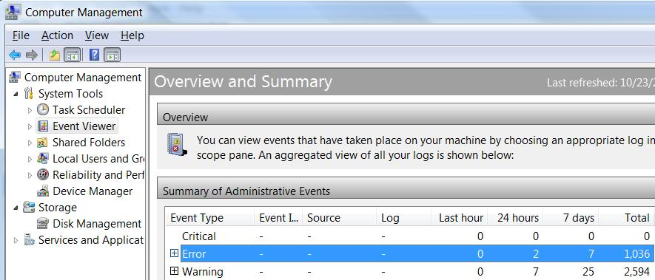
- In the left pane of "Computer Management", click "Event Viewer" to select it. Wait until you see the "Overview and Summary" as shown below on this page.

Selecting an Event to Research
- Unless you are extremely fortunate, your machine will have some Error events. As you can see above, mine has 1,036 Errors. (If you really have zero Errors, research a Warning event instead.)
- Click the Error line. In the right pane, click "View All Instances". Find an Error event that seems interesting and double-click it.

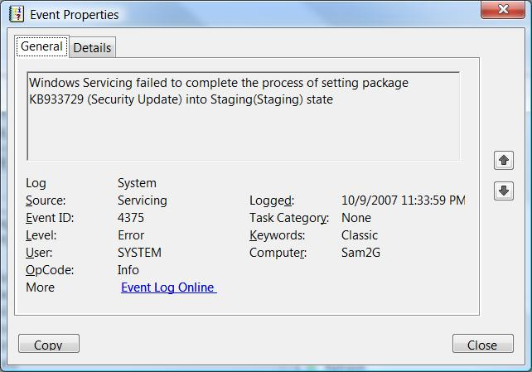
- An "Event Properties" box opens, as shown to the right on this page. Read the details. Find the Event ID number and the Source and write them in the box below.

Event ID: ______________

Source: ______________

Saving a Screen Image
- Make sure the "Event Properties" box is the active window.
- Press Alt+PrintScrn to copy the active window to the clipboard.
- Click Start, "All Programs", Accessories, Paint. In the untitled - Paint window, select Edit, Paste from the menu bar. The image appears in the Paint window.
- In the untitled - Paint window, click File, Save. Save the document with the filename Your Name Proj 21a.
When you need to understand error codes better, there are many ways to learn more: clicking the link in the Event Properties, Eventid.net, and Google.com – search by the Event ID number.

Using Microsoft Help to Learn about Events
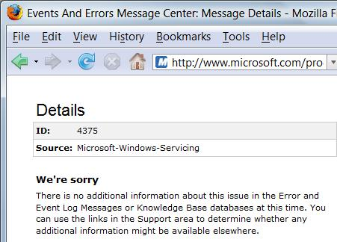
- Click the blue "Event Log Online" link in the Event Properties window. An "Event Viewer" box opens, saying "Event Viewer will send the following information across the Internet. Is this OK? " Click Yes.
- A Microsoft Web page opens, offering you the guidance Microsoft has for you. It is usually worthless, as shown to the right on this page. If it has any information, read it and learn as much as you can about your event.

Saving a Screen Image
- Make sure the "Events and Errors Message Center" is the active window.
- Press Alt+PrintScrn to copy the active window to the clipboard.
- Click Start, "All Programs", Accessories, Paint. In the untitled - Paint window, select Edit, Paste from the menu bar. The image appears in the Paint window.
- In the untitled - Paint window, click File, Save. Save the document with the filename Your Name Proj 21b.

Using Eventid.net
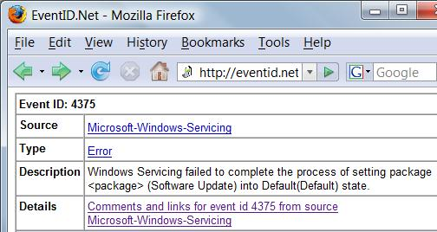
- Open a browser and go to eventid.net. Enter your Event ID in the Event ID box and click the GO button.
- You should see a page with some information about your event, as shown to the right on this page. Make sure you are looking at events with the correct Source. Click the blue link in the Details section to see comments about this event that other users of Eventid.net have posted.

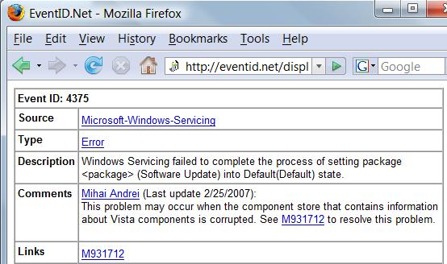
- You should see a page with Comments about your event, as shown to the right on this page.

Saving a Screen Image
- Make sure EventID.Net is the active window.
- Press Alt+PrintScrn to copy the active window to the clipboard.
- Click Start, "All Programs", Accessories, Paint. In the untitled - Paint window, select Edit, Paste from the menu bar. The image appears in the Paint window.
- In the untitled - Paint window, click File, Save. Save the document with the filename Your Name Proj 21c.

Describe The Problem And Solution In Your Own Words
- Based on what you have read, compose a description of the problem and how to solve it, in your own words. If you did not get any help from the sources above, try typing the Event ID into Google.

Turning in your Project
- Email the JPEG images to me as attachments to one e-mail message. Put your description of the problem and how to solve it, in your own words in the body of the email message. Send the message to: cnit.335@gmail.com with a subject line of CNIT 235 Proj 21 From Your Name, replacing Your Name with your own first and last name. Send a Cc to yourself.

Last modified 10-23-07

