Choosing a Computer to Use
- This project should be safe enough to do on any Vista computer. BadApp will fail in harmless ways, and should do no harm to your machine. But if you are not comfortable using your own Vista machine, or you don't have one, use the lab.
- Log onto any Vista machine with any account that has Administrator privileges.

Downloading BadApp.exe
- Open a browser and go to samsclass.info
- Click the CNIT 335 link. Click the Projects link. Scroll down to Project 22.
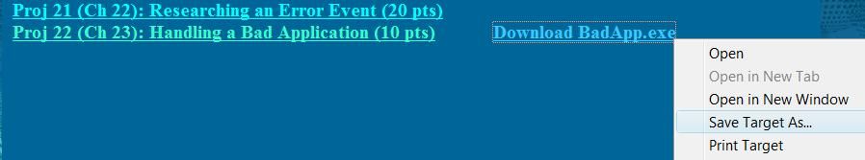
- Right click the "Download BadApp.exe" link and select "Save Target As…", as shown below on this page.

- Save the BadApp.exe file on your desktop.

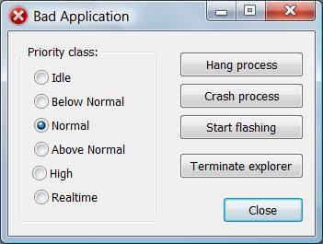
Creating a Hung Process
- On your desktop, double-click BadApp.exe.
- In the "Bad Application" box, accept the default Priority class selection of Normal, as shown to the right on this page. Click the "Hang process" button.
- Try to drag the "Bad Application" box to the side. It won't move, and the title bar changes to "Bad Application *Not Resp…" to indicate that the process has hung.

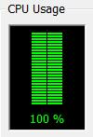
Opening Task Manager
- Press Ctrl+Shift+Esc. Task Manager opens.
- Click the Performance tab—your CPU should be pegged at 100%, as shown to the right on this page.
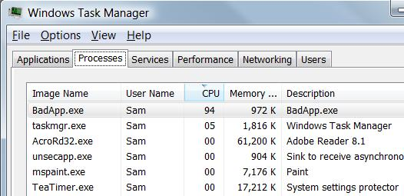
- In Task Manager, click the Processes tab. Click the CPU column header to sort by CPU and put the process with the highest CPU (BadApp.exe) at the top, as shown to the right on this page.

Saving a Screen Image
- Make sure "Windows Task Manager" is the active window.
- Press Alt+PrintScrn to copy the active window to the clipboard.
- Click Start, "All Programs", Accessories, Paint. In the untitled - Paint window, select Edit, Paste from the menu bar. The image appears in the Paint window.
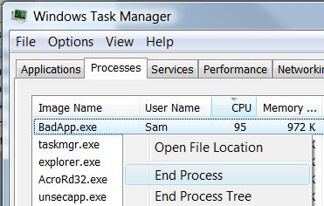
- In the untitled - Paint window, click File, Save. Save the document with the filename Your Name Proj 22a.

Terminating the Hung Process
- In Task Manager, right-click the BadApp.exe process and click End Process, as shown to the right on this page.
- A box pops up asking "Do you want to end this process?" Click the "End process" button.
- Click the Performance tab—your CPU should have returned to some reasonable value below 100%, as shown to the right on this page.
- Close Task Manager.

Creating a Crashed Process
- On your desktop, double-click BadApp.exe.
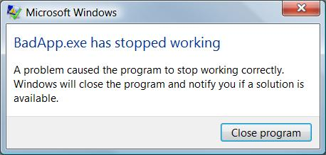
- In the "Bad Application" box, accept the default Priority class selection of Normal. Click the "Crash process" button.
- A box pops up, with a progress bar. When it completes, after a few seconds, it shows the message "BadApp.exe has stopped working", as shown to the right on this page.

Terminating the Crashed Process
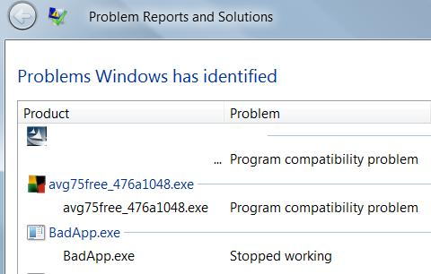
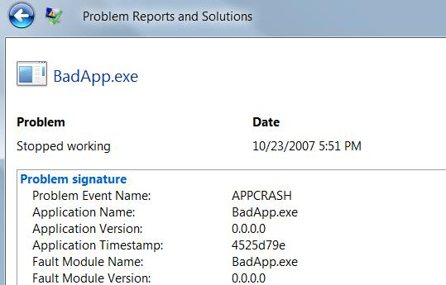
- In the "BadApp.exe has stopped working" box, click the "Close Program" button.

Checking Problem History
- Click Start, "Control Panel". Click "System And Maintenance".
- Under the heading "Problem Reports and Solutions", click "View Problem history".
- There should be an entry showing that BadApp.exe "Stopped working", as shown at the upper right on this page. Double-click the words exe "Stopped working".
- You should see a page showing details about the problem, as shown to the right on this page. It should show a "Problem Event Name" of APPCRASH and an "Application Name" of BadApp.exe.

Saving a Screen Image
- Press PrintScrn to copy the whole desktop to the clipboard.
- Click Start, "All Programs", Accessories, Paint. In the untitled - Paint window, select Edit, Paste from the menu bar. The image appears in the Paint window.
- In the untitled - Paint window, click File, Save. Save the document with the filename Your Name Proj 22b.

Turning in your Project
- Email the JPEG images to me as attachments to one e-mail message. Send the message to: cnit.335@gmail.com with a subject line of CNIT 235 Proj 22 From Your Name, replacing Your Name with your own first and last name. Send a Cc to yourself.

Last modified 10-23-07 6:45 pm

