Choosing a Computer to Use
- This project could be dangerous! You will lose all your System Restore points. You will also stop many services. If you do the project correctly, you will restore them all to their original state at the end, but if you make mistakes, you might leave services stopped that you need, which may cause problems on your machine. If you are not comfortable exposing your Vista machine to these risks, use the lab.
- Log onto any Vista machine (any edition) with an account that has Administrator privileges.

Creating a Restore Point on the Vista Machine
- On the Vista machine, click Start, right-click Computer, and click Properties. In the left pane, click "System Protection". In the "User Account Control" box, press Alt+C or click Continue.
- In the "System Properties" box, on the "System Protection" tab, click the Create button.
- In the "Create a restore point" box, enter a name of "Your Name - Before tweaking services" and click the Create button. Wait while the restore point is created.
- A box appears saying "The restore point was created successfully". Click OK.
- Close "System Properties".

Backing up the Services Registry Key
- As we will see, it is not wise to trust System Restore. So we will make backup of the Services Registry key manually.
- Press the Windows logo key, next to the Ctrl key at the lower left of your keyboard. Don't touch the mouse. Type this into the Search box:
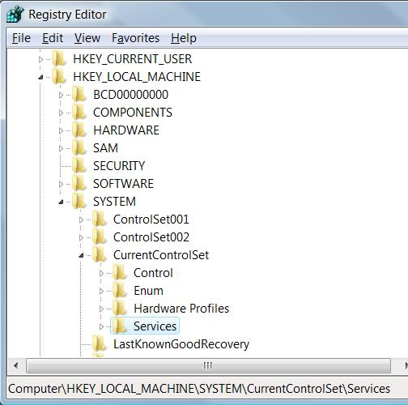
regedit
- "regedit.exe" should appear in the Programs list. If it's not already highlighted, press the down-arrow as needed to highlight it. Then press the Enter key. In the "User Account Control" box, press Alt+C or click Continue.
- In the left pane of "Registry Editor", expand these items, as shown to the right on this page:
HKEY_LOCAL_MACHINE
SYSTEM
CurrentControlSet
- In the left pane of "Registry Editor", right-click Services and click Export.
- In the "Export Registry File" box, enter a File name of "YOURNAMEServicesBackup". Accept the default "Save as type:" of "Registration Files (*.reg)" and the default location of Desktop. Click the Save button.
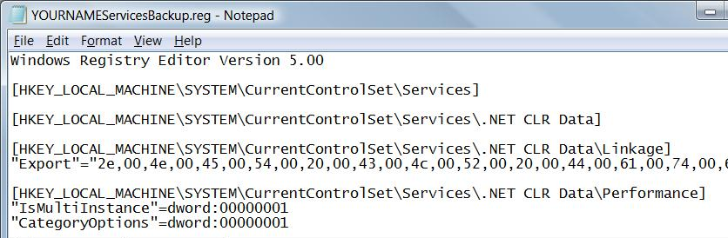
- On your desktop, right click the "YOURNAMEServicesBackup" file and click "Edit".
- You should see a list of registry items, as shown below on this page. Close Notepad.

Measuring Resource Use on Your Computer
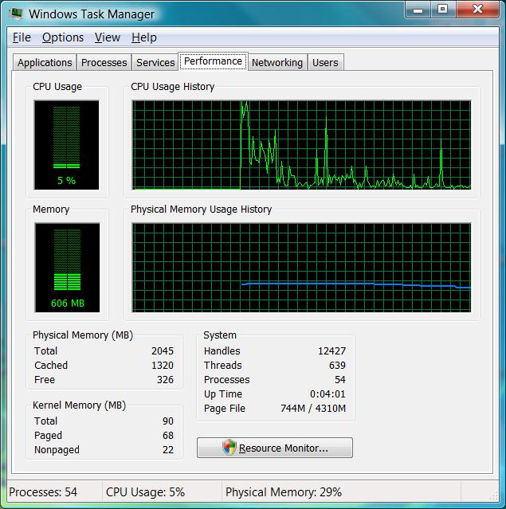
- Restart your Vista machine and log in as usual. Don't open any windows or start any programs.
- Press Ctrl+Shift+Esc. In "Windows Task Manager", click the Performance tab.
- Wait a couple of minutes for the CPU to settle down to a low value, as shown to the right on this page. This should ensure that all the startup processes are complete.

Saving a Screen Image
- Click in the title bar of the "Windows Task Manager" box to make sure it's the active window.
- Press Alt+PrintScrn to copy the active window to the clipboard.
- Click Start, "All Programs", Accessories, Paint. In the untitled - Paint window, select Edit, Paste from the menu bar. The image appears in the Paint window.
- In the untitled - Paint window, click File, Save. Save the document with the filename Your Name Proj 23a.

Recording Resource Use
- Find the amount of Memory in use shown in the green bar in the left center of the "Windows Task Manager" box, and write it in the "Normal" column in the box to the right on this page. In the example shown on the previous page, it's 606 MB.
Normal Tweaked

Memory _______________ _______________

Processes _______________ _______________
- Find the number of Processes in the lower left corner of the "Windows Task Manager" box, and write it in the "Normal" column in the box above on this page In the example shown on the previous page, it's 54.

Downloading a Process Tweak REG File
- Open a browser and go to this Web page:
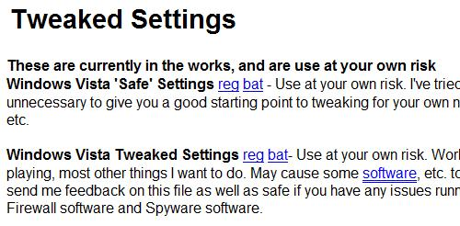
speedyvista.com/registry.html
- Under the "Tweaked Settings" header, find the "Windows Vista Tweaked Settings" item, as shown to the right on this page. Right click the reg link and click "Save Link As…".
- Save the "VistaTweaked.reg" file on your desktop.
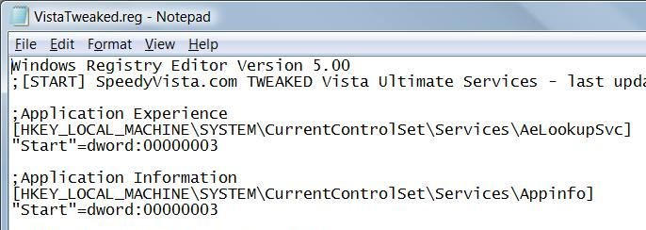
- On your desktop, right click the "VistaTweaked.reg" file and click "Edit".
- You should see a list of registry changes, as shown to the right on this page. The items like "Start"=dword:00000003" adjust the startup settings of each process. Close Notepad.

Running the Process Tweak REG File
- Right click the "VistaTweaked.reg" file and click "Merge". In the "User Account Control" box, press Alt+C or click Continue.
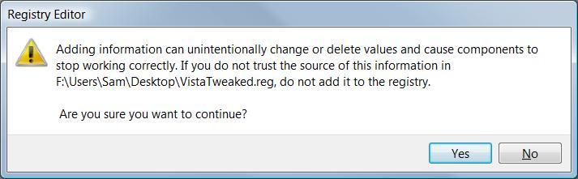
- A "Registry Editor" box appears, as shown below, warning you that you are about to change your system in potentially dangerous ways. Do you trust the person who wrote the "SpeedyVista" website? I don't see any reason to trust them. But I do trust the Restore Point we made previously—none of these changes will be permanent.

- In the "Registry Editor" box click Yes. A box opens as shown below on this page, warning you that not all the changes were made. This is normal, according to the website. It's another clue that we are not using professional software here, but let's charge ahead anyway. Click OK.
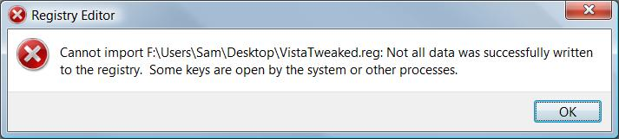

Measuring Resource Use on Your Computer
- Restart your Vista machine and log in as usual. Don't open any windows or start any programs.
- Press Ctrl+Shift+Esc. In "Windows Task Manager", click the Performance tab.
- Wait a couple of minutes for the CPU to settle down to a low value, as shown below on this page. This should ensure that all the startup processes are complete.
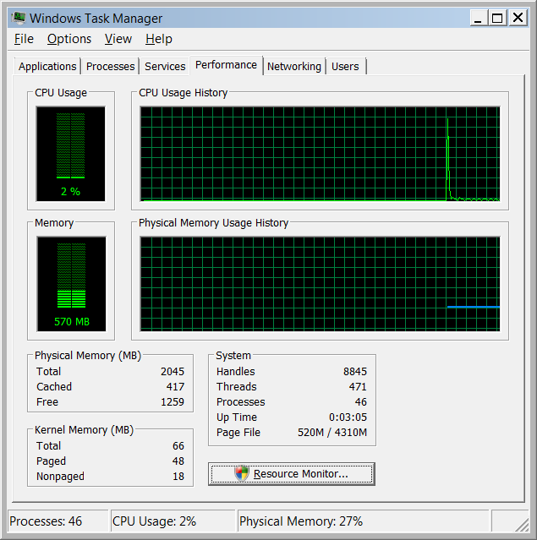

Saving a Screen Image
- Click in the title bar of the "Windows Task Manager" box to make sure it's the active window.
- Press Alt+PrintScrn to copy the active window to the clipboard.
- Click Start, "All Programs", Accessories, Paint. In the untitled - Paint window, select Edit, Paste from the menu bar. The image appears in the Paint window.
- In the untitled - Paint window, click File, Save. Save the document with the filename Your Name Proj 23b.

Recording Resource Use
- Find the amount of Memory in use shown in the green bar in the left center of the "Windows Task Manager" box, and write it in the "Normal" column in the box on a previous page.
- Find the number of Processes in the lower left corner of the "Windows Task Manager" box, and write it in the "Normal" column in the box on a previous page.
- You should see fewer processes and less memory used, and notice that the machine responds faster now. But the faster response is not without a cost—in my case, both Windows Defender and Aero Graphics stopped working!

Attempting to Restore the Machine with System Restore
- By now it seems obvious that this set of tweaks is not a good idea for us. Many parts of Vista are not working with this configuration. You could use the same process to repair all the changes the REG script made, but there's no need to—that's what System Restore is for.
- Press the Windows logo key, next to the Ctrl key at the lower left of your keyboard. Don't touch the mouse. Type this into the Search box:
rest
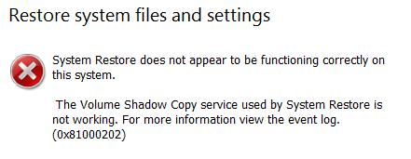
- "System Restore" should appear in the Programs list. If it's not already highlighted, press the down-arrow as needed to highlight it. Then press the Enter key. In the "User Account Control" box, press Alt+C or click Continue.
- A box opens as shown to the right on this page, saying that System Restore is not functioning. Click Cancel.

Restoring the Volume Shadow Copy Service to Manual Startup
- Click Start, right click Computer, and click Manage. In the "User Account Control" box, press Alt+C or click Continue.
- In the left pane of "Computer Management", expand "Services and Applications" and click Services.

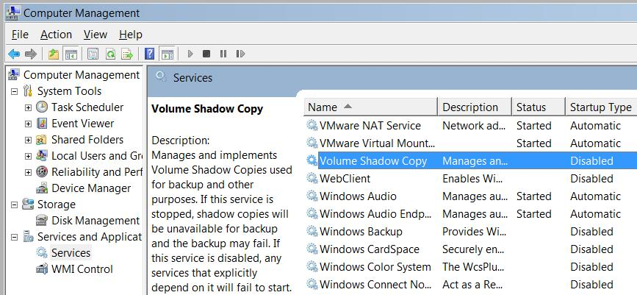
- In the right pane, scroll down to "Volume Shadow Copy", as shown below on this page.

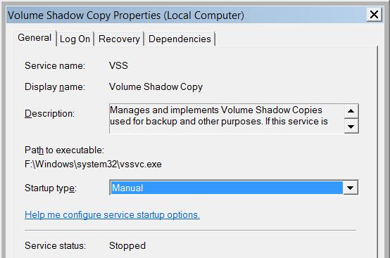
- Double-click "Volume Shadow Copy". A "Volume Shadow Copy Properties" box opens. Click the drop-down arrow in the "Startup type:" box and click Manual, as shown to the right on this page.

Saving a Screen Image
- Click in the title bar of the "Volume Shadow Copy Properties" box to make sure it's the active window.
- Press Alt+PrintScrn to copy the active window to the clipboard.
- Click Start, "All Programs", Accessories, Paint. In the untitled - Paint window, select Edit, Paste from the menu bar. The image appears in the Paint window.
- In the untitled - Paint window, click File, Save. Save the document with the filename Your Name Proj 23c.

Starting the Volume Shadow Copy Service
- In the "Volume Shadow Copy Properties" box, click OK.
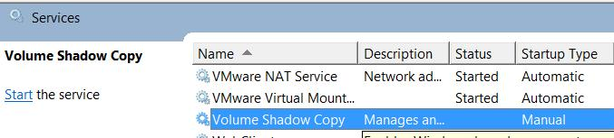
- In the right pane of "Computer Management", click "Volume Shadow Copy" to select it, as shown below on this page.
- In the right pane of "Computer Management", on the left side, click the word Start to start the "Volume Shadow Copy" service.

Attempting to Restore the Machine with System Restore
- Press the Windows logo key, next to the Ctrl key at the lower left of your keyboard. Don't touch the mouse. Type this into the Search box:
rest
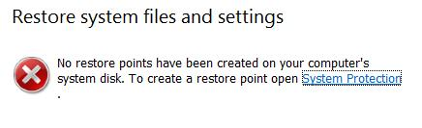
- "System Restore" should appear in the Programs list. If it's not already highlighted, press the down-arrow as needed to highlight it. Then press the Enter key. In the "User Account Control" box, press Alt+C or click Continue.
- A box opens as shown to the right on this page, saying that there are no restore points. System Restore is useless!

Restoring the Services Registry Key from Backup
- On your desktop, right click the "YOURNAMEServicesBackup" file and click "Merge". In the "User Account Control" box, press Alt+C or click Continue.
- A "Registry Editor" box appears, warning you that you are about to change your system in potentially dangerous ways. Click Yes.
- A "Registry Editor" box appears, warning you that not all the changes were made. Click OK.
- Restart your Vista machine and log in as usual. It should be back to normal now.

Turning in your Project
- Email the JPEG images to me as attachments to one e-mail message. Send the message to: cnit.335@gmail.com with a subject line of "Proj 23 From Your Name", replacing Your Name with your own first and last name. Send a Cc to yourself.

Last modified 10-31-07 11 am

