Choosing a Computer to Use
- This project could be dangerous! You will be editing the Registry, which can seriously harm your operating system if you make mistakes. If you are not comfortable exposing your Vista machine to these risks, use the lab.
- Log onto any Vista machine (any edition) with an account that has Administrator privileges.

Creating a Restore Point on the Vista Machine
- On the Vista machine, click Start, right-click Computer, and click Properties. In the left pane, click "System Protection". In the "User Account Control" box, press Alt+C or click Continue.
- In the "System Properties" box, on the "System Protection" tab, click the Create button.
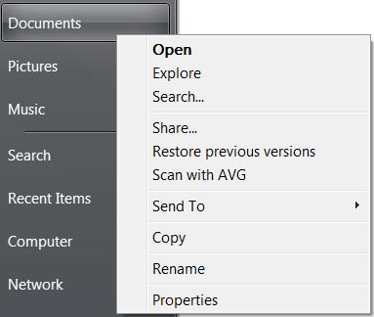
- In the "Create a restore point" box, enter a name of "Your Name - Before registry edits" and click the Create button. Wait while the restore point is created.
- A box appears saying "The restore point was created successfully". Click OK.
- Close "System Properties".

Observing Context Menu Items
- Click Start. Right click Documents. You should see a context menu, like the one shown to the right on this page. Some items may be different, depending on what software you have installed, but the "Open Command Window Here" option should not be visible.
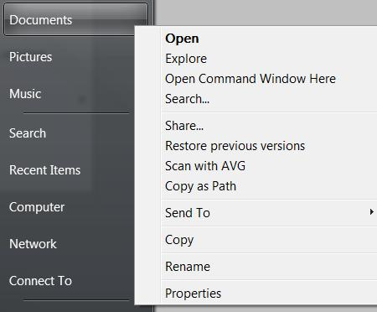

- Click Start. Hold down the Shift key and right click Documents. The "Open Command Window Here" option is now visible, as shown to the right on this page.
- This registry change will add the "Open Command Window Here" option to the normal right-click context menu.

Adding the "Command Prompt Here" Context Menu Item
- Press the Windows logo key, next to the Ctrl key at the lower left of your keyboard. Don't touch the mouse. Type this into the Search box:
regedit
- "regedit.exe" should appear in the Programs list. If it's not already highlighted, press the down-arrow as needed to highlight it. Then press the Enter key. In the "User Account Control" box, press Alt+C or click Continue.
- In the left pane of "Registry Editor", expand these items:
HKEY_CLASSES_ROOT
Folder
shell
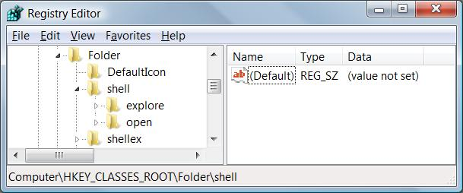
- In the left pane of "Registry Editor", look to see which subkeys exist inside the shell key. In the figure to the right on this page, there are only two subkeys: explore and option. If there is not already a subkey named "Open Command Prompt Here", do this to create one:
- In the left pane of "Registry Editor", right-click shell and click New, key. Type in the name "Open Command Prompt Here" (without the quotes) and press the Enter key. The Registry Editor window should now look like the example below on this page.
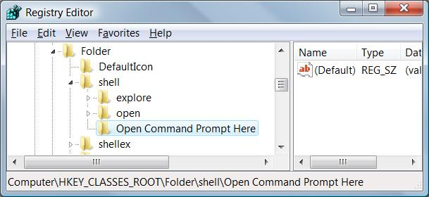

- In the left pane of "Registry Editor", right-click the "Open Command Prompt Here" key and click New, String Value. Type in a value name of command and press the Enter key.
- In the right pane of "Registry Editor", double-click command.
- In the "Edit String" box, type in this command exactly as written, and then click OK:
@="cmd.exe /k pushd %L"
- Your "Registry Editor" window should now look like the example below on this page.
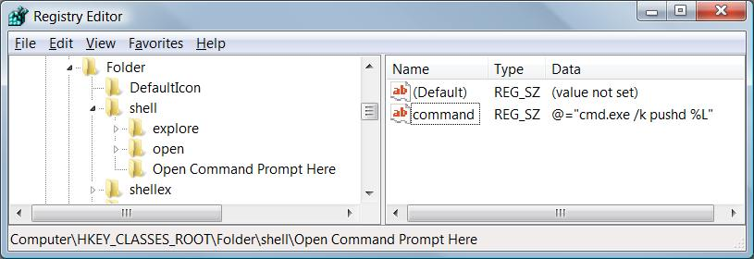

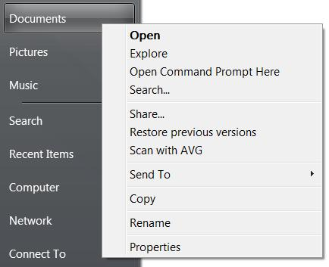
Saving a Screen Image
- Click Start. Right click Documents. You should see an "Open Command Prompt Here" item, as shown to the right on this page.
- Press PrintScrn to copy the whole desktop to the clipboard.
- Click Start, "All Programs", Accessories, Paint. In the untitled - Paint window, select Edit, Paste from the menu bar. The image appears in the Paint window.
- In the untitled - Paint window, click File, Save. Save the document with the filename Your Name Proj 24a.

Displaying the Version of Vista on the Desktop
- Press the Windows logo key, next to the Ctrl key at the lower left of your keyboard. Don't touch the mouse. Type this into the Search box:
regedit
- "regedit.exe" should appear in the Programs list. If it's not already highlighted, press the down-arrow as needed to highlight it. Then press the Enter key. In the "User Account Control" box, press Alt+C or click Continue.
- In the left pane of "Registry Editor", expand these items:
HKEY_CURRENT_USER
Control Panel
- In the left pane of "Registry Editor", click Desktop to select it. In the right pane, scroll down to find the PaintDesktopVersion item and double-click it.
- In the "Edit DWORD (32-bit) Value" box, enter a "Value data:" of 1 and click OK.
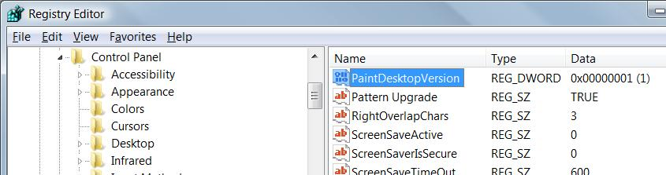
- Your "Registry Editor" window should now look like the example below on this page.

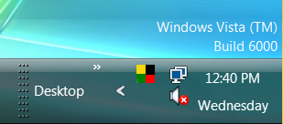
Saving a Screen Image
- Restart your machine and log in as usual. You should see a "Build 6000" message at the lower right corner of the desktop, as shown to the right on this page.
- Press PrintScrn to copy the whole desktop to the clipboard.
- Click Start, "All Programs", Accessories, Paint. In the untitled - Paint window, select Edit, Paste from the menu bar. The image appears in the Paint window.
- In the untitled - Paint window, click File, Save. Save the document with the filename Your Name Proj 24b.

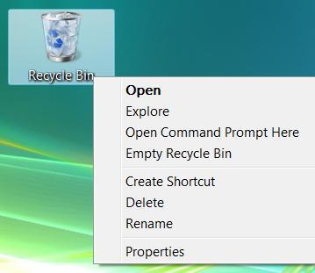
Observing the Recycle Bin Context Menu
- On the desktop, right click "Recycle Bin". Notice that there is a Delete option on this menu, as shown to the right on this page. If a user deletes the Recycle Bin, it vanishes from the desktop and is a bit hard to restore. So to prevent that, we'll just remove the Delete option.

Removing the Delete Context Menu Item
- Press the Windows logo key, next to the Ctrl key at the lower left of your keyboard. Don't touch the mouse. Type this into the Search box:
regedit
- "regedit.exe" should appear in the Programs list. If it's not already highlighted, press the down-arrow as needed to highlight it. Then press the Enter key. In the "User Account Control" box, press Alt+C or click Continue.
- In the left pane of "Registry Editor", expand these items:
HKEY_CLASSES_ROOT
CLSID
- In the left pane of "Registry Editor", scroll down and find this item:
{645FF040-5081-101B-9F08-00AA002F954E}
- In the left pane of "Registry Editor", right-click {645FF040-5081-101B-9F08-00AA002F954E} and click New, key. Type in the name Shell and press the Enter key.
- In the left pane of "Registry Editor", right-click Shell and click New, Key. Type in the name Delete and press the Enter key.
- In the right pane of "Registry Editor", double-click (Default). In the "Edit String" box, enter "Value data:" of "Your Name's indestructible Recycle Bin". Replace Your Name with your own name. Click OK.
- The Registry Editor window should now look like the example below on this page.
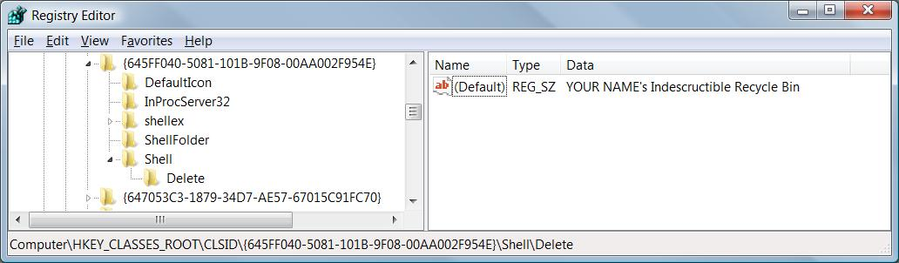

Observing the Recycle Bin Context Menu
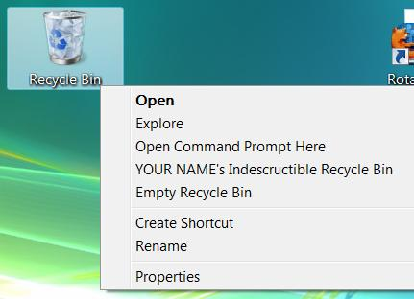
- On the desktop, right click "Recycle Bin". The Delete option is gone, and there is now an item with your name on it, as shown to the right on this page. If you click on that item (don't do it now), it just displays an error message.

Saving a Screen Image
- Make sure the Recycle Bin's context menu is visible, showing the item with your name on it.
- Press PrintScrn to copy the whole desktop to the clipboard.
- Click Start, "All Programs", Accessories, Paint. In the untitled - Paint window, select Edit, Paste from the menu bar. The image appears in the Paint window.
- In the untitled - Paint window, click File, Save. Save the document with the filename Your Name Proj 24c.

Using System Restore
- Press the Windows logo key, next to the Ctrl key at the lower left of your keyboard. Don't touch the mouse. Type this into the Search box:
rest
- "System Restore" should appear in the Programs list. If it's not already highlighted, press the down-arrow as needed to highlight it. Then press the Enter key. In the "User Account Control" box, press Alt+C or click Continue.
- In the "Restore system files and settings" box, verify that the "Recommended restore" shows "Your Name - Before registry edits". Click Next.
- In the "Confirm your restore point" box, click Finish.
- In the "System Restore" box, click Yes to restart your computer.
- Your Vista machine should be back to its normal condition:
  - No "Open Command Prompt Here" item when right-clicking a folder
  - No Build number on the desktop
  - The Delete option should be on the "Recycle Bin"context menu

Turning in your Project
- Email the JPEG images to me as attachments to one e-mail message. Send the message to: cnit.335@gmail.com with a subject line of Proj 24 From Your Name, replacing Your Name with your own first and last name. Send a Cc to yourself. Last revised 10-31-07

