Requirements
You can use any Vista machine, running any version of Vista. This project is not very dangerous, although if you do it incorrectly you might change Internet Explorer security settings to a level that makes browsing difficult. If you are not comfortable using your home machine for this project, use the lab.

Downloading the Internet Explorer Administration Kit
- Open a Web browser and go to this Web page (link Ch 27e from my Web page):
http://technet.microsoft.com/en-us/ie/bb219543.aspx
- On the right side, in the Download section, right-click the English link and select "Save target as". Save the ieak.msi file on your desktop.

Installing the Internet Explorer Administration Kit
- Double-click the ieak.msi file on your desktop.
- In the "Welcome to the Internet Explorer Administration Kit" box, click Next.
- Accept the license and click Next.
- In the "Choose License Type" box, click "Internal Distribution via a Corporate Intranet" and then click Next.
- In the "Organization Details" box, enter an Organization Name of "CNIT 335 YOUR NAME", replacing "YOUR NAME" with your own name. Click Next.
- In the "Ready to Install" box, click Install.
- In the "User Account Control" box, press Alt+C or click Continue.
- In the "Internet Explorer Administration Kit 7 Setup has successfully completed" box, click Finish.

Running the Internet Explorer Administration Kit
- Click Start, "All Programs", "Microsoft IEAK 7", "Internet Explorer Customization Wizard". In the "User Account Control" box, press Alt+C or click Continue.In the "User Account Control" box, press Alt+C or click Continue.
- In the "Welcome to the IEAK -- Corporate Version" box, click Next.
- In the "Stage 1 – Gathering Information" box, click Next.
- In the "File Locations" box, accept the default Destination folder and click Next.
- In the "Platform Selection" box, accept the default Target Platform of "Windows XP with SP2 or Vista (x86-based)" and click Next.
- In the "Language Selection" box, accept the default Target Language of "English" and click Next.
- In the "Media Selection" box, accept the default of "File" and click Next.

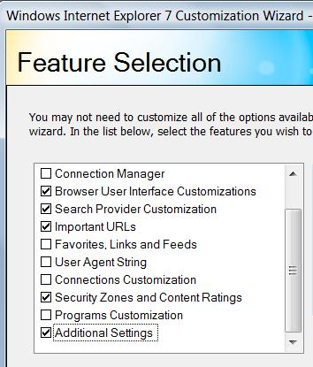
- In the "Feature Selection" box, clear all the check boxes except these five, as shown to the right on this page:
  - Browser User Interface Customizations
  - Search Provider Customization
  - Important URLs
  - Security Zones and Content Ratings
  - Additional Settings
Click Next.
- .In the "Stage 2 – Specifying Setup Parameters" box, click Next.
- A "Windows Internet Explorer Administration Wizard – Security Warning" box pops up. Click Run.
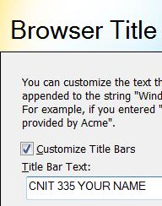
- In the "Automatic Version Synchronization" box, click the Synchronize button. Wait till the download finishes (less than 1 minute when I did it).
- Check to see if there is a second "Windows Internet Explorer Administration Wizard – Security Warning" box on your screen, possibly behind other boxes. If it's there, click Run.
- In the "Automatic Version Synchronization" box, click Next.
- .In the "Stage 4 – Customizing the Browser" box, click Next.
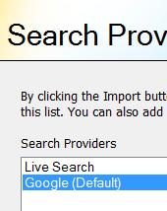
- In the "Browser Title and Toolbar Customizations" box, enter "Title Bar Text" of "CNIT 335 YOUR NAME", replacing "YOUR NAME" with your own name, as shown to the right on this page. Click Next.
- In the "Search Provider Customization" box, click the Add button.
- In the "Search Provider" box, enter a Display Name of Google and a URL of http://google.com. Click OK.
- In the "Search Provider Customization" box, ensure that Google is highlighted. Click the "Set Default" button. Google should now be marked (Default), as shown to the right on this page. Click Next.

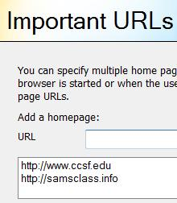
- In the "Important URLs – Home page and Support" box, click the default URL of http://go.microsoft.com/fwlink/?LinkID=69157 and click the Remove button.
- Enter a URL of http://www.ccsf.edu and click the Add button.
- Enter a URL of http://samsclass.info and click the Add button. Your screen should now resemble the example shown to the right on this page
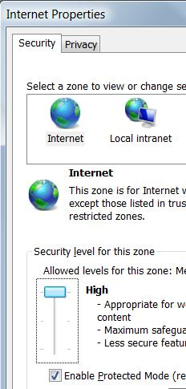
- Clear the "Retain previous Home Page (Upgrade)" box and click Next.
- In the "Welcome Page" box, check the "Disable the Internet Explorer first run page" box and click Next.
- In the "Security and Privacy Settings" box, click the "Import the current security zones and privacy settings" box. On the same line, click the "Modify Settings" button.
- An "Internet Properties" box opens. On the Security tab, in the "Select a zone to view or change security settings " box, click Internet. Move the "Security level for this zone" slider to High, as shown to the right on this page.
- Click the Privacy tab. Move the slider to High as shown below on this page. Click OK.
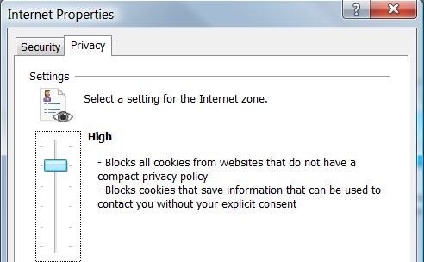

- In the "Security and Privacy Settings" box, click Next.
- In the "Additional Customizations" box, click Next.
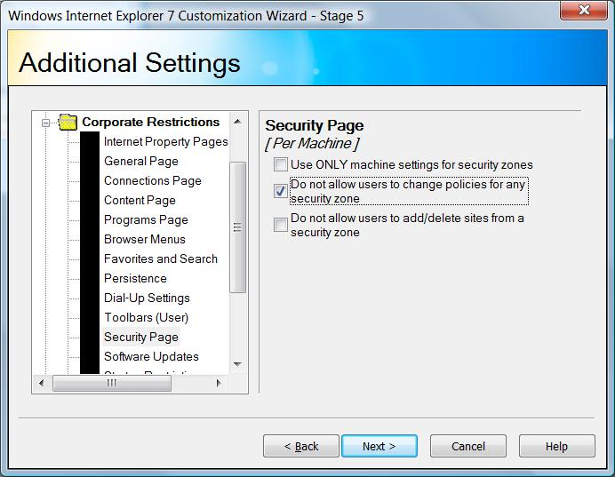
- In the "Additional Settings" box, in the left pane, expand the "Corporate Restrictions" section, and click "Security Page". In the right pane, check the "Do not allow users to change policies for any security zone" box, as shown to the right on this page. Click Next.
- In the "Wizard Complete" box, click Next. Wait while the progress bar moves.
- When the process is complete, you will see a message saying "Your package is now complete and can be found in this folder:". Write the folder down in the box to the right on this page.

Folder: ______________________________
- In the "Wizard Complete" box, click Finish.

Creating a Restore Point
- Click Start, right-click Computer, and click Properties. In the left pane, click "System Protection". In the "User Account Control" box, press Alt+C or click Continue.
- In the "System Properties" box, on the "System Protection" tab, click the Create button.
- In the "Create a restore point" box, enter a name of "Your Name - Before Proj 25" and click the Create button. Wait while the restore point is created.
- A box appears saying "The restore point was created successfully". Click OK.
- Close "System Properties".

Installing Your Customized Internet Explorer
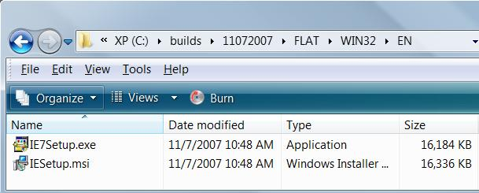
- Click Start, Computer. Navigate to the folder you wrote in the box above on this page.
- In that folder, open the FLAT folder, the WIN32 folder, and the EN folder, as shown to the right on this page.
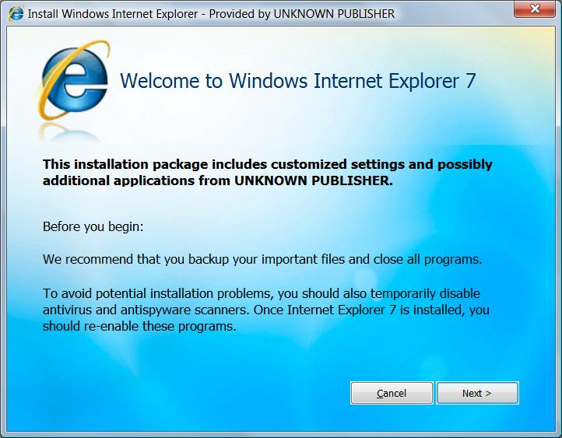
- Double-click the IESetup.msi file. In the "User Account Control" box, click Allow.
- A box titled "Install Windows Internet Explorer – Provided by UNKNOWN PUBLISHER" appears, as shown to the right on this page. Click Next.
- In the "Please read the license terms" box, click the "I Accept" button.
- In the "Internet Explorer installation is complete" box, click the "Restart Now (Recommended)" button.

Using Your Customized Internet Explorer
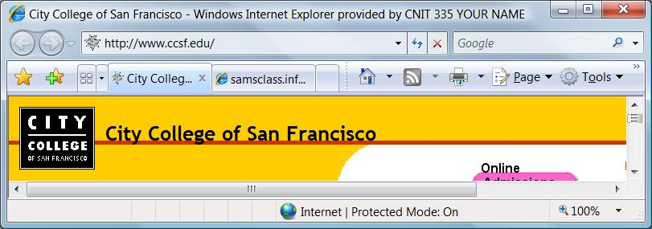
- Click Start, "All Programs", "Internet Explorer". The window title should be "City College of San Francisco – Windows Internet Explorer provided by CNIT 335 YOUR NAME", as shown below on this page. A second tab should show samsclass.info, because your customized Internet Explorer has two home pages.

Saving a Screen Image
- Make sure your name is visible in the title bar of the Internet Explorer window.
- Press PrintScrn to copy the whole desktop to the clipboard.
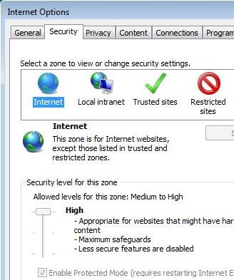
- Click Start, "All Programs", Accessories, Paint. In the untitled - Paint window, select Edit, Paste from the menu bar. The image appears in the Paint window.
- In the untitled - Paint window, click File, Save. Save the document with the filename Your Name Proj 25a.

Observing Security Settings
- In Internet Explorer, click Tools, "Internet Options". Click the Security tab. In the "Select a zone to view or change security settings" box, click Internet. Notice that the slider is grayed out, as shown to the right on this page—you cannot change security settings.

Saving a Screen Image
- Make sure the "Internet Options" box is visible, showing that the slider is grayed out.
- Press PrintScrn to copy the whole desktop to the clipboard.
- Click Start, "All Programs", Accessories, Paint. In the untitled - Paint window, select Edit, Paste from the menu bar. The image appears in the Paint window.
- In the untitled - Paint window, click File, Save. Save the document with the filename Your Name Proj 25b.

Trying to Send Email with Your Customized Internet Explorer
- Go to yahoo.com, gmail.com, or some other online email service you have an account with. Try to log in. You will probably find that you cannot—these security settings are so high that the browser cannot run the scripts and/or save the required cookies. This may be the way some companies want their browsers set up, but it's not much use for us in this class.

Using System Restore
- Press the Windows logo key, next to the Ctrl key at the lower left of your keyboard. Don't touch the mouse. Type this into the Search box:
rest
- "System Restore" should appear in the Programs list. If it's not already highlighted, press the down-arrow as needed to highlight it. Then press the Enter key. In the "User Account Control" box, press Alt+C or click Continue.
- In the "Restore system files and settings" box, verify that the "Recommended restore" shows "Your Name - Before Proj 25". Click Next.
- In the "Confirm your restore point" box, click Finish.
- In the "System Restore" box, click Yes to restart your computer.
- Your Vista machine should be back to its normal condition. Open Internet Explorer and log in to your email to verify that.

Turning in your Project
- Email the JPEG images to me as attachments to one e-mail message. Send the message to: cnit.335@gmail.com with a subject line of Proj 25 From Your Name, replacing Your Name with your own first and last name. Send a Cc to yourself.

Last revised 11-8-07

