Requirements
You can use a machine running any version of Vista. But you will be shrinking and extending partitions on your hard disk, and if you do it wrong you may lose all your data! If you are not comfortable using your home machine for this project, use the lab.

Finding a Vista Partition
- Click Start. Right click Computer and click Manage. In the "User Account Control" box, press Alt+C or click Continue.
- In the left pane of "Computer Management", click "Disk Management".
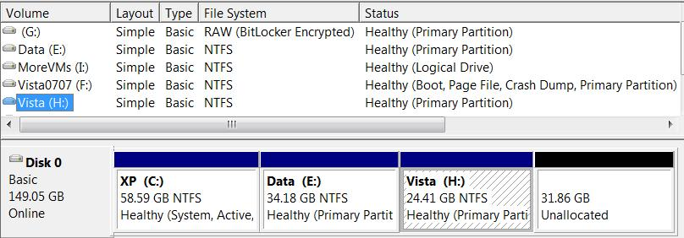
- In the lower right pane of "Computer Management", find a Vista partition to use. In the example shown below on this page, I used the Vista (H:) partition.

- Write down the size of your Vista partition in the box to the right on this page. In my example, the size was 24.41 GB.
Original Vista
Partition Size: ___________________

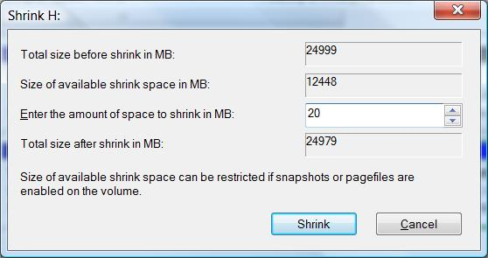
Shrinking the Vista Partition
- In the lower right pane of "Computer Management", right click your Vista partition and click "Shrink Volume".
- In the Shrink box, in the "Enter the amount of space to shrink in MB" box, type in 20, as shown to the right on this page.

- Click the Shrink button. When the process completes, the size of your Vista partition should have decreased by 0.02 GB, as shown below on this page. There should be some space marked Unallocated to the right of your Vista partition.
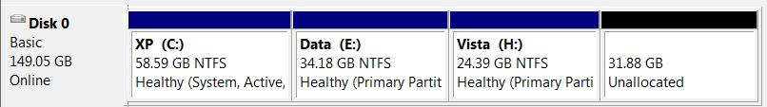

Creating a FAT Partition
- In the lower right pane of "Computer Management", to the right of your Vista partition, right click the Unallocated space and click "New Simple Volume".
- In the "Welcome to the New Simple Volume Wizard" box, click Next.
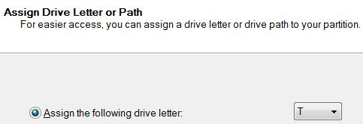
- In the "Specify Volume Size" box, enter a size of 10 MB and click Next.
- In the "Assign Drive Letter or Path" box, select a drive letter of T, as shown to the right on this page. Click Next.
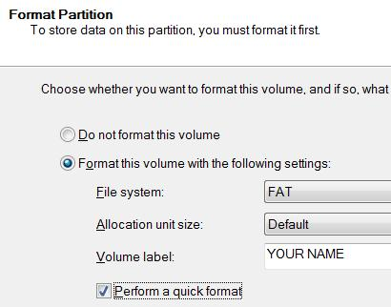
- In the "Format Partition" box, make these selections, as shown to the right on this page:
File System: FAT
Volume label: Your Name
(Replace "Your Name" with your own name.)
- Check the "Perform a quick format" box and click Next.
- In the "Completing the New Simple Volume Wizard" box, click Finish.
If you see a message saying “There is not enough space available on the disk(s) to complete this operation” you may already have the maximum number of primary partitions on this basic disk. In that case, try using a different disk with fewer partitions on it, such as Disk 0.

Observing the New Drive in the Computer Window
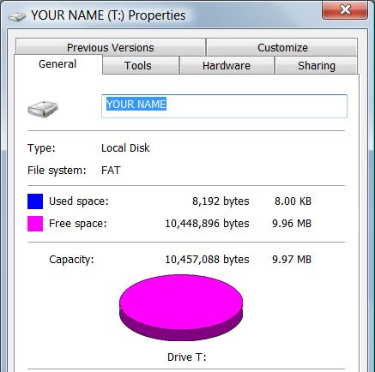
- Click Start, Computer. Right click the "YOUR NAME (T:)" volume and click Properties.
- The "YOUR NAME (T:) Properties" box appears, as shown to the right on this page.

Saving a Screen Image
- Make sure the "YOUR NAME (T:) Properties" box shows a File system of FAT and a Capacity of approximately 10 million bytes, as shown to the right on this page.
- Press PrintScrn to copy the whole desktop to the clipboard.
- Click Start, "All Programs", Accessories, Paint. In the untitled - Paint window, select Edit, Paste from the menu bar. The image appears in the Paint window.
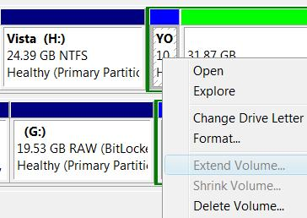
- In the untitled - Paint window, click File, Save. Save the document with the filename Your Name Proj 26a.
- Close the "YOUR NAME (T:) Properties" box.

Attempting to Extend the T: Partition
- In the lower right pane of "Computer Management", right click the "YOUR NAME (T:)" partition. Notice that the "Extend Volume" item is grayed out, as shown to the right on this page. That's because you cannot extend a FAT partition—only an NTFS partition.

Converting the T: Partition to NTFS
- Press the Windows logo key, next to the Ctrl key at the lower left of your keyboard. Type this into the Search box, and then press Shift+Ctrl+Enter:
cmd
- In the "User Account Control" box, press Alt+C or click Continue.

- In the Administrator Command Prompt window, type in this command and press Enter:
convert T: /fs:ntfs
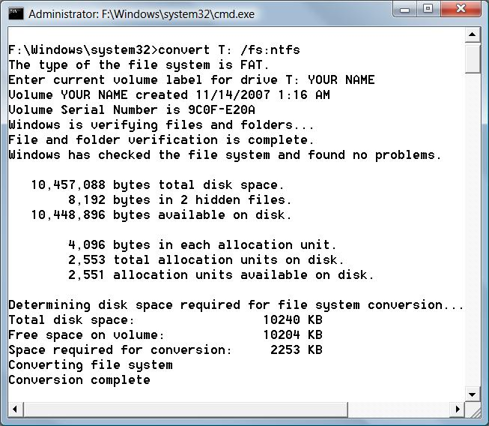
- When a prompt appears saying "Enter current volume label for drive T:", type in your name, exactly as you used it to label the T: volume, and press Enter.
- You should see several lines of text, and then the "Conversion complete" message, as shown to the right on this page.

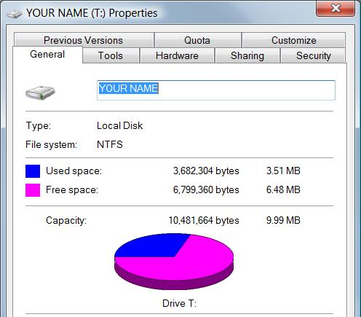

Observing the T: Drive in the Computer Window
- Click Start, Computer. Right click the "YOUR NAME (T:)" volume and click Properties.
- The "YOUR NAME (T:) Properties" box appears, as shown to the right on this page. Notice that the File system is now NTFS. Also, a lot of space is now used—for small volumes, the NTFS file system wastes more space than the FAT file system.
- Close the "YOUR NAME (T:) Properties" box.

Extending the T: Partition
- In the lower right pane of "Computer Management", right click the "YOUR NAME (T:)" partition and click "Extend Volume".
- In the "Welcome to the Extend Volume Wizard" box, click Next.
- In the "Specify Disks" box, ensure that the only disk shown in the Selected box is the same disk your T: drive is on, as shown below on this page. In the "Select the amount of space in MB" box, enter 10 and click Next.
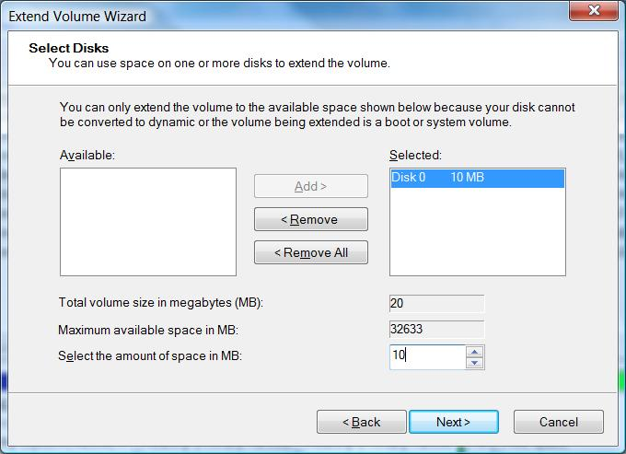

- In the "Completing the Extend Volume Wizard" box, click Finish.

.

Observing the New Drive in the Computer Window
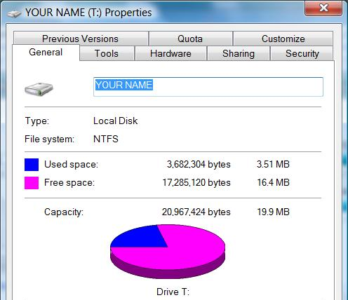
- Click Start, Computer. Right click the "YOUR NAME (T:)" volume and click Properties.
- The "YOUR NAME (T:) Properties" box appears, as shown to the right on this page.

Saving a Screen Image
- Make sure the "YOUR NAME (T:) Properties" box shows a File system of NTFS and a Capacity of approximately 20 million bytes, as shown to the right on this page.
- Press PrintScrn to copy the whole desktop to the clipboard.
- Click Start, "All Programs", Accessories, Paint. In the untitled - Paint window, select Edit, Paste from the menu bar. The image appears in the Paint window.
- In the untitled - Paint window, click File, Save. Save the document with the filename Your Name Proj 26b.

Deleting the T: Partition
- In the lower right pane of "Computer Management", right click the "YOUR NAME (T:)" partition and click "Delete Volume". Be careful that you are deleting the correct partition!
- A "Delete simple volume" box warns you that this will erase all data on the partition. Click Yes.

Turning in your Project
- Email the JPEG images to me as attachments to one e-mail message. Send the message to: cnit.335@gmail.com with a subject line of Proj 26 From Your Name, replacing Your Name with your own first and last name. Send a Cc to yourself.

Last revised 11-14-07

