Requirements
You can use a machine running any version of Vista. You must have a storage device of some sort with enough room for the backup file.

Checking to See if there is a "MoreBackups" Volume
- Click Start, Computer. Look for a volume named MoreBackups with any drive letter. If it exists, skip ahead to "Launching Backup and Restore Center" section. If it doesn't exist, continue to the "Creating a 'MoreBackups' Volume" section.

Creating a "MoreBackups" Volume
- Click Start. Right click Computer and click Manage. In the "User Account Control" box, press Alt+C or click Continue.
- In the left pane of "Computer Management", click "Disk Management".
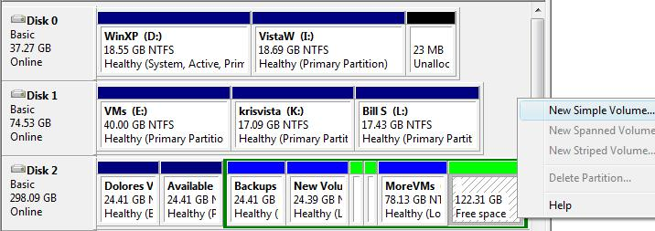
- In the lower right pane of "Computer Management", to the right of your Vista partition, right click the "Free Space" space and click "New Simple Volume", as shown below on this page.

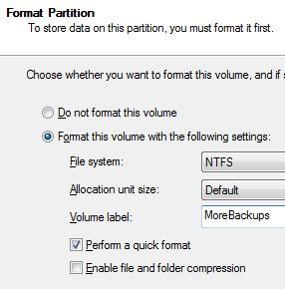
- In the "Welcome to the New Simple Volume Wizard" box, click Next.
- In the "Specify Volume Size" box, enter a size of 60000 MB and click Next.
- In the "Assign Drive Letter or Path" box, click Next.
- In the "Format Partition" box, enter a "Volume label" of MoreBackups and check the "Perform a quick format" box, as shown to the right on this page. Click Next.
- In the "Completing the New Simple Volume Wizard" box, click Finish.

Launching Backup and Restore Center
- Press the Windows logo key, next to the Ctrl key at the lower left of your keyboard. Don't touch the mouse. Type this into the Search box:
back
- "Backup and Restore Center" should appear in the Programs list. If it's not already highlighted, press the down-arrow as needed to highlight it. Then press the Enter key.
- In "Backup and Restore Center", click the "Back up computer" button, as shown below on this page. In the "User Account Control" box, press Alt+C or click Continue.
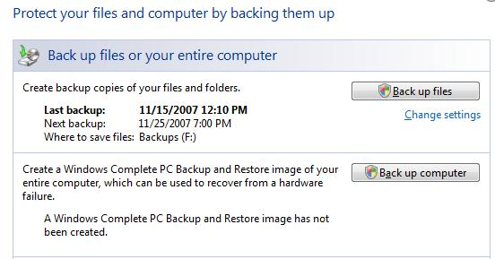

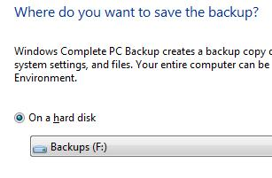

Selecting the Backup Device
- At the "Where do you want to save the backup?" screen, in the "On a hard disk" section, select the Backups volume, as shown to the right on this page. Click Next. Note that this is a poor practice—it is much better to use a removable device for a backup.

Estimating the Size of the Backup File
- In the "Which disks do you want to include in the backup?" screen, the disk to back up are already selected. If you are working in S214, both the Windows XP partition and the Vista partition are selected (scroll down to see them both, if necessary).
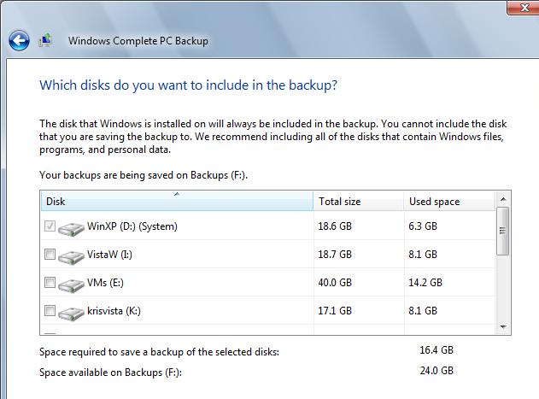
- Look at the bottom of the "Which disks do you want to include in the backup?" screen. You should see the "Space required to save a back up the selected disks" and the "Space available on Backups" numbers.

- If there is enough space available to make your backup, continue to the "Completing the Backup Process" section of these instructions. If there is not enough space, try these remedies:
- Use the MoreBackups volume instead
- Use a different computer
- Delete files other students left on the Backups or MoreBackups volumes to make more room

Completing the Backup Process
- In the "Which disks do you want to include in the backup?" screen, click Next.
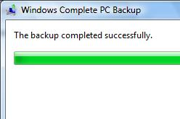
- In the "Confirm your backup settings" screen, click "Start backup". Wait until the backup process finishes—it took about 5-10 minutes when I did it.

Saving a Screen Image
- Make sure the "Windows Complete PC Backup" box is visible, showing the message "The backup completed successfully", as shown to the right on this page.
- Press PrintScrn to copy the whole desktop to the clipboard.
- Click Start, "All Programs", Accessories, Paint. In the untitled - Paint window, select Edit, Paste from the menu bar. The image appears in the Paint window.
- In the untitled - Paint window, click File, Save. Save the document with the filename Your Name Proj 27.

Turning in your Project
- Email the JPEG images to me as attachments to one e-mail message. Send the message to: cnit.335@gmail.com with a subject of "Proj 27 From Your Name", replacing Your Name with your own first and last name. Send a Cc to yourself.

Last revised 11-24-07

