Requirements
You can use a machine running any version of Vista. The system volume must be formatted with the NTFS file system, which almost all of them are.

Creating the "Your Name Shared" Folder
- Right click a blank portion of the desktop and click New, Folder. Type in a folder name of "Your Name Shared" and press the Enter key. Replace Your Name with your own name.

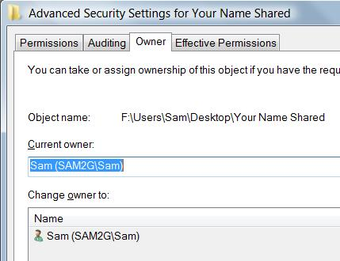
Observing the Owner of the "Your Name Shared" Folder
- Right click the "Your Name Shared" Folder and click Properties.
- In the "Your Name Shared Properties" box, on the Security tab, click Advanced.
- In the "Advanced Security Settings for Your Name Shared" box, click the Owner tab. You should see your own account name in the "Current owner:" section, as shown to the right on this page. Normally, you are the owner of an object you create.

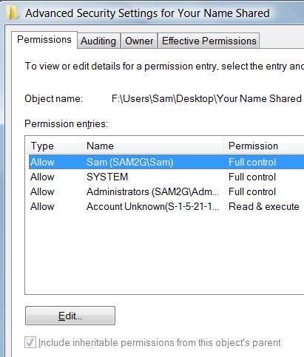
Blocking Inherited Permissions
- In the "Advanced Security Settings for Your Name Shared" box, on the Permissions tab, as shown to the right on this page, click the Edit button.
- In the new "Advanced Security Settings for Your Name Shared" box, clear the "Include inheritable permissions from this object's parent" box.
- A "Windows Security" box appears, asking you if you want to Copy or Remove permissions. Click Remove.
- In the "Advanced Security Settings for Your Name Shared" box, click OK.
- Read the "Windows Security" box warning you that no users can access this folder, and click Yes.
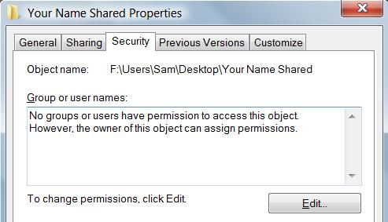
- In the "Advanced Security Settings for Your Name Shared" box, click OK.
- The "Your Name Shared Properties" box now has no entries in the "Groups or user names" section, but it has a paragraph explaining that the owner (you) can still change permissions, as shown to the right on this page.

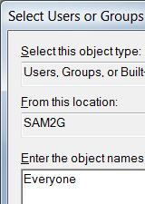
Assigning Permissions to the "Your Name Shared" Folder
- In the "Your Name Shared Properties" box, on the Security tab, click the Edit button.
- In the "Permissions for Your Name Shared" box, click the Add… button.
- In the "Select Users of Groups" box, enter Everyone, as shown to the right on this page. Click OK.

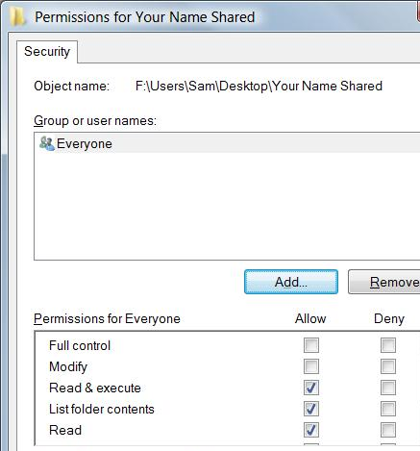
- In the "Permissions for Your Name Shared" box, you should see Everyone in the top pane, with "Read & execute", "List folder contents", and Read checked, as shown to the right on this page.
- In the "Permissions for Your Name Shared" box, click the Add… button.
- In the "Select Users of Groups" box, enter Administrators. Click OK.

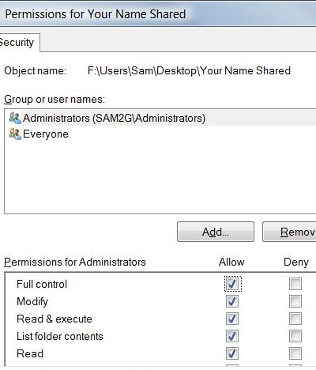
- In the "Permissions for Your Name Shared" box, click Administrators in the top pane to select it. In the lower pane, check the "Full Control" box in the Allow column. All the Allow boxes should now be checked, as shown to the right on this page.
- In the "Permissions for Your Name Shared" box, click the Add… button.
- In the "Select Users of Groups" box, enter OWNER RIGHTS. Click OK.

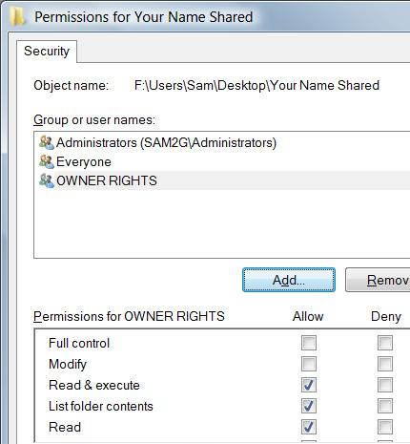
- The "Permissions for Your Name Shared" box should now show the items Administrators, Everyone, and "OWNER RIGHTS", as shown to the right on this page. Click OK.
- In the "Your Name Shared Properties", click OK.

Attempting to Create the "Test.txt" File with the Context Menu
- On your desktop, double-click "Your Name Shared" to open it.
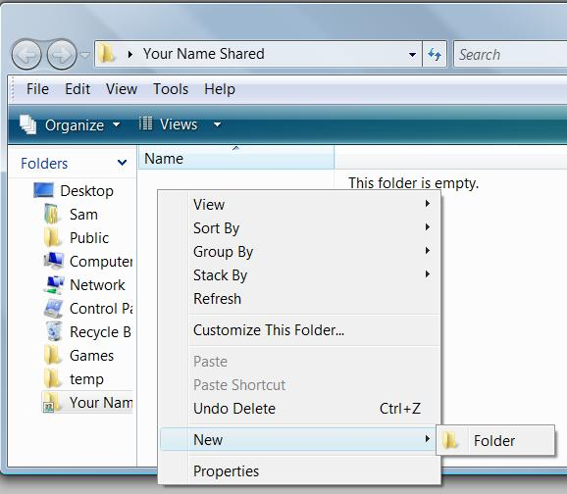
- Right-click a blank portion of the "Your Name Shared" window, and point to New. Notice that the only option available is Folder, as shown below on this page. This is unusual—normally there are other options, including New, "Text Document".

Saving a Screen Image
- Make sure the context menu is visible, showing the New submenu with only the Folder item, as shown to the right on this page.

- Press PrintScrn to copy the whole desktop to the clipboard.
- Click Start, "All Programs", Accessories, Paint. In the untitled - Paint window, select Edit, Paste from the menu bar. The image appears in the Paint window.
- In the untitled - Paint window, click File, Save. Save the document with the filename Your Name Proj 28a.

Creating a "TestFolder" Folder
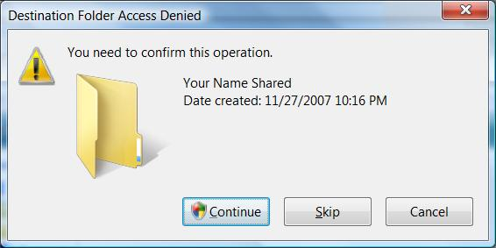
- This is a frustrating situation—you want to create a text document in the "Your Name Shared" folder, but Vista won't let you do it. To understand why, let's create a folder.
- Right-click a blank portion of the "Your Name Shared" window, point to New, and click Folder.
- A "Destination Folder Access Denied" box appears, as shown to the right on this page. This shows that the problem is User Account Control—we need to be in the Administrators group to have Full Control over that folder, but Windows Explorer runs with low privileges by default. And since only one instance of Windows Explorer can run at a time, we can't open a folder with elevated privileges. We can only elevate privileges when Vista offers us a User Account Control box like this.
- In the "Destination Folder Access Denied" box, click Continue. In the "User Account Control" box, press Alt+C or click Continue.
- A new folder appears in the "Your Name Shared" window. But we still don't have a text document in there.

Attempting to Create the "Test.txt" File with the Context Menu Again
- Right-click a blank portion of the "Your Name Shared" window, and point to New. Still, the only option is Folder. Even though we just elevated privileges long enough to create the folder, the privileges did not stay elevated, so we still cannot create a document in this folder.

Attempting to Create the "Test.txt" File with Notepad
- Perhaps we can use Notepad to create the file.
- Press the Windows logo key, next to the Ctrl key at the lower left of your keyboard. Don't touch the mouse. Type this into the Search box:
note
- Notepad should appear in the Programs list. If it's not already highlighted, press the down-arrow as needed to highlight it. Then press the Enter key.
- In the "Untitled - Notepad" window, type in a few characters. Press Ctrl+S. In the "Save As" box, navigate to your Desktop, and double-click the "Your Name Shared" folder to open it. In the " File name :" field, type in Test. Click Save.

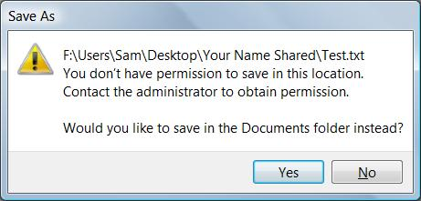
- A "Save As" box appears, as shown to the right on this page, saying that you don't have permission to save the file. It even tells you to contact the administrator—but you ARE the administrator! This is the sort of frustrating experience that provokes people to turn off User Account Control, or even to downgrade to Windows XP.
- In the "Save As" box, click No.
- In Notepad's "Save As" box, click Cancel.
- Close Notepad. Don't save changes.

Using an Elevated Notepad Window to Create the "Test.txt" File
- Press the Windows logo key, next to the Ctrl key at the lower left of your keyboard. Don't touch the mouse. Type this into the Search box, and then press Shift+Ctrl+Enter:
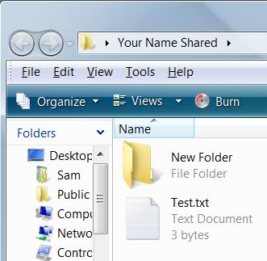
notepad.exe
- In the "User Account Control" box, press Alt+C or click Continue.
- In the "Untitled - Notepad" window, type in a few characters. Press Ctrl+S. In the "Save As" box, navigate to your Desktop, and double-click the "Your Name Shared" folder to open it. In the " File name :" field, type in Test. Click Save. The file saves normally.
- Close Notepad.
- The "Your Name Shared" window now contains a Test.txt file, as shown to the right on this page.

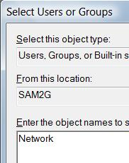
Assigning Permissions to the "Test.txt" File
- Right click the Test.txt file and click Properties.
- In the "Test.txt Properties" box, on the Security tab, click the Edit button. In the "User Account Control" box, press Alt+C or click Continue.
- In the "Permissions for Test.txt" box, click the Add… button.
- In the "Select Users of Groups" box, enter Network , as shown to the right on this page. Click OK.
- In the "Multiple Names Found" box, accept the default selection of NETWORK and click OK.
- In the "Permissions for Test.txt" box, click OK.
- In the "Test.txt Properties" box, on the Security tab, click Advanced….
- In the "Advanced Security Settings for Test.txt" box, you should see permissions for NETWORK that are <not inherited>, as shown below on this page. There are other permissions also, that were inherited from the containing folder.
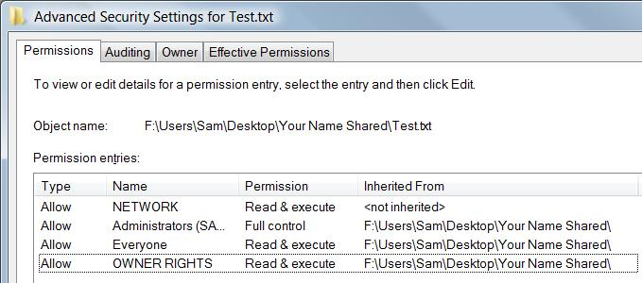

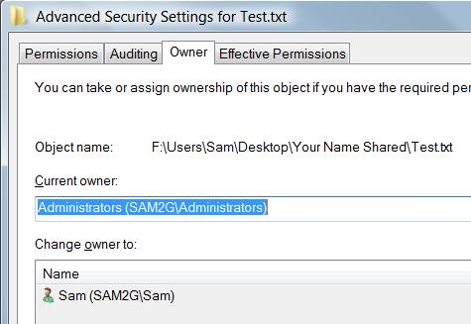
Assigning Ownership of the "Test.txt" File to Yourself
- In the "Advanced Security Settings for Test.txt" box, click the Owner tab.
- Notice that the "Current owner" of the file is Administrators. You are not the owner of a file you created! This is another bizarre consequence of User Account Control—you had to elevate privileges to create this file, so your identity changed to Administrators.
- Click the Edit button. In the "User Account Control" box, press Alt+C or click Continue.
- In the "Advanced Security Settings for Test.txt" box, in the "Change owner to:" list, click your own user name. Click OK.
- In the "Windows Security" box, click OK.
- In the "Advanced Security Settings for Test.txt" box, click OK.
- In the "Test.txt Properties" box, click OK.

Observing the OWNER RIGHTS Permissions of the "Test.txt" File
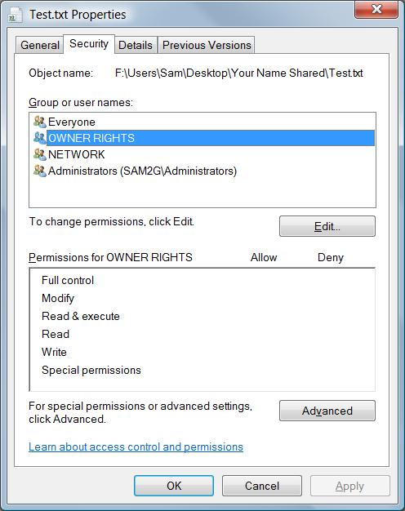
- Right click the Test.txt file and click Properties.
- In the "Test.txt Properties" box, on the Security tab, click OWNER RIGHTS to highlight it. The "Permissions for OWNER RIGHTS" section shows no check marks—the permissions all vanished when you assigned ownership.

Saving a Screen Image
- Make sure the "Test.txt Properties" box is visible, showing that there are no check marks for OWNER RIGHTS, as shown to the right on this page.
- Press PrintScrn to copy the whole desktop to the clipboard.
- Click Start, "All Programs", Accessories, Paint. In the untitled - Paint window, select Edit, Paste from the menu bar. The image appears in the Paint window.
- In the untitled - Paint window, click File, Save. Save the document with the filename Your Name Proj 28b.

Turning in your Project
- Email the JPEG images to me as attachments to one e-mail message. Send the message to: cnit.335@gmail.com with a subject of "Proj 28 From Your Name", replacing Your Name with your own first and last name. Send a Cc to yourself.

Last revised 11-28-07

