Starting Your Machine in Vista
- Restart the machine and boot to Vista. Log in as usual.
Putting the Intel NIC Driver on the VMs Drive
- Press the Windows logo key, next to the Ctrl key at the lower left of your keyboard. Don't touch the mouse. Type this into the Search box, and then press the Enter key:
\\192.168.1.3
If you are asked for a login name and password, use the name CNIT with no password. If the connection cannot be established, ensure that the "Laraine" server is turned on.
- In the Network ► 192.168.1.3 window, double-click the CNIT335 folder to open it.
- Right-click the IntelNICDriver folder and click Copy.
- Click Start, Computer.
- In the Computer ► window, double-click the VMs drive to open it.
- In the Computer ► VMs window, double-click the Install folder to open it.
- In the Computer ► VMs ► Install window, look to see if there is already a folder named "". If there is, some other student already copied the NIC driver, so you can skip to the next section: "Booting from the Longhorn DVD". If the folder is not there, right-click a blank portion of the folder and click Paste.
Putting the Clamwin and Firefox Installers on the VMs Drive
- Repeat the same process to move the two folders Clamwin and Firefox from the server to the VMs drive.
Booting from the Windows 7 DVD
- Insert the Windows 7 Pre-Beta DVD.
- Restart your machine. When you see the message "Press any key to boot from CD or DVD", press the Enter key.
- When you see the "Install Windows" box, accept the default "Language to install","Time and currency format", and "Keyboard or input method" settings and click Next.
- In the next screen, click "Install now".
- Check the “I accept the license terms” box and click Next.
- Click Custom (advanced).
Choosing the Installation Partition
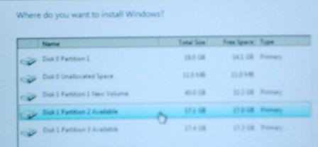
- Find a partition marked Available as shown to the right on this page and click on it. Note the Disk number and Partition number you chose. In the figure to the right on this page, “Disk 1 Partition 2” is selected.
- After you have clicked an available partition, click Next.
- Now wait – it will take a while to copy the files. Your computer will restart one or more times. When it restarts, don't touch the keyboard—just let it boot from the default hard disk partition. When I did it, it took about 10 minutes.
Setting Up Windows
- A "Set Up Windows" box appears, asking you to enter a user name and computer name. Use your own name as the user name, and name the computer WIN7-01, replacing 01 with your station number. Click Next.
- The next box asks for a password. I recommend that you use a password of P@ssw0rd. Put anything in the hint box.
- When it asks for a product key, clear the "Automatically activate Windows when I'm online" box, leave the product key blank, and click Next.
- At the "Help protect and improve Windows automatically" screen, click "Use recommended settings".
- At the "Review your time and date settings" screen, click Next.
- At the "Select your computer's current location" screen, click "Home network". This will make it possible for you to set up a homegroup later.
- If your network card operates with the default Windows 7 drivers, the "Do you want to create a homegroup?" box appears now—just click Skip for now. In S214, it won't appear, because you need to install the NIC drivers.
- Your desktop appears.
Installing the Network Adapter Driver
- Click Start, Computer. Double-click the VMs drive to open it. Double-click the Install folder to open it. Double-click the IntelNICDriver folder to open it.
- Double-click the PROVISTA32 file to start the installer. Follow the on-screen prompts to install the driver with the default selections.
Installing Clamwin Antivirus
- Click Start, Computer. Double-click the VMs drive to open it. Double-click the Install folder to open it. Double-click the Clamwin folder to open it.
- Double-click the clamwin setup file. Follow the on-screen prompts to install Clamwin antivirus with the default selections.
Installing Firefox
- Click Start, Computer. Double-click the VMs drive to open it. Double-click the Install folder to open it. Double-click the Firefox folder to open it.
- Double-click the Firefox setup file. Follow the on-screen prompts to install Firefox with the default selections.

Determining the System Drive Letter
- Click Start. In the Search box, type in CMD. Press the Enter key. A Command Prompt window opens.
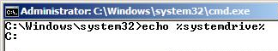
- Type this command into the Command Prompt window, then press the Enter key.:
echo %systemdrive%
The response should tell you your system drive letter. It should be C:.

Changing the System Drive Label
- Click Start, Computer. Find your system drive in the list—it should be labeled “Available (C:)”. You need to change this name, so that later students in the lab don’t see your partition as “Available” and install another OS on the same partition.
- Right-click your system drive icon and click Rename. Type in a new name of "Your Name Win 7" and press the Enter key.

Changing the Operating System Label with BCDEDIT
- Click Start. In the Search box, type in CMD. Press Shift+Ctrl+Enter. An Administrator Command Prompt window opens.
- Type this command into the Administrator Command Prompt window, then press the Enter key.:
bcdedit /set description "Your Name Win 7 Pre-Beta" {current}
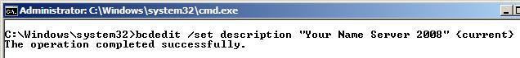
Replace Your Name with your own name. If you see a message saying "The boot configuration data store could not be opened. Access is denied.", you aren't in an Administrator Command Prompt window. Close the window and carefully repeat the "Changing the Operating System Label with BCDEDIT" steps above.

Creating a Student Account
- Click Start, "Control Panel". In the "User Accounts and Family Safety" section, click "Add or remove user accounts".
- In the "Choose the account you would like to change" screen, click "Create a new account".
- In the "Name the account and choose the account type" screen, enter a name of Student, click "Administrator", and click "Create a new account". Your screen should now look like the image below.
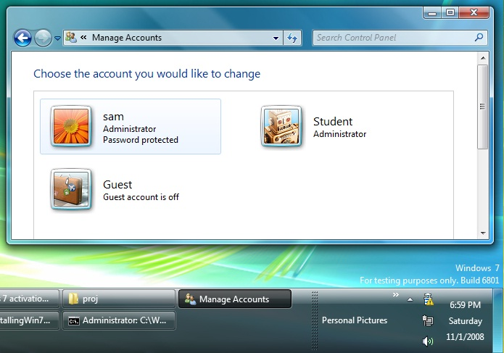

Saving the Screen Image
- Make sure the Student account is visible, showing its Administrator status, and no “Password protected” message.
- Make sure the "Windows 7" label is visible in the lower right corner of the desktop.
- Press the PrintScrn key in the upper-right portion of the keyboard. That will copy the whole desktop to the clipboard.
- Press the Logo key on the keyboard. Type PAI into the Search box. When Paint is highlighted, press the Enter key.
- Click in the untitled - Paint window. Type Ctrl+V to paste the image in.
- Type Ctrl+S to save the file. Save the document in the default location of Locations ► Pictures with the filename Your Name Proj X12. Select a Save as type of JPEG.

Turning in your Project
- Open Firefox, and use it to email the JPEG image to me as an email attachment. Send the message to: cnit.335@gmail.com with a subject line of "Proj X12 From Your Name", replacing Your Name with your own first and last name. Send a Cc to yourself.

Activating Windows
You can’t activate this version, so it will expire after 30 days. Hopefully you can extend that time with the slmgr –rearm command, but don’t do it till your 30 days are nearly over—you can only do it 3 times.
Last Modified: 11-1-08

