Background Information
The server you made in project X12 is a "Member Server"—it belongs to a Workgoup, a low-security simple network type intended for homes and small businesses. Larger networks, with more than ten machines, are usually Domains. Domains are far more secure and easier to manage, but the require a special server machine called a Domain Controller. In this project you convert your Server 2008 machine from a Workgroup machine to a Domain Controller.
Starting Your Windows 2008 Server Machine
- You must do project X12 before this project.
- Start your computer and boot to Server 2008. Log in as Administrator with the password P@ssw0rd

Calculating your IP Address
- Look on the front panel of your machine. You will find a label indicating the station number, which will look like S214-01. Find the last two digits, which will probably be something different than 01. Write those last two digits in the box to the right on this page, so they become the last two digits of your IP address. For example, S214-01 has an IP address of 192.168.1.201.

Static IP: 192.168.1.2____

Assigning a Static IP Address to the Server
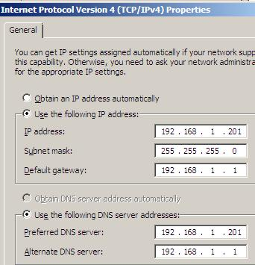
- Click Start, right-click Network, and click Properties. In "Network and Sharing Center", on the left side, click "Manage Network Connections".
- In "Network Connections", right-click "Local Area Connection" and click Properties.
- In " Local Area Connection Properties", click "Internet Protocol Version 4 (TCP/IPv4)". Click the Properties button.
- In the "Internet Protocol Version 4 (TCP/IPv4) Properties" box, fill in the numbers as shown to the right on this page. Replace the "IP Address" and the "Preferred DNS Server" with the "Static IP" you wrote in the box above on this page. Click OK. Click Close.
- Close the "Network Connections" window.
- Close the "Network and Sharing Center" window.

Adding a Server Role: Active Directory Domain Services
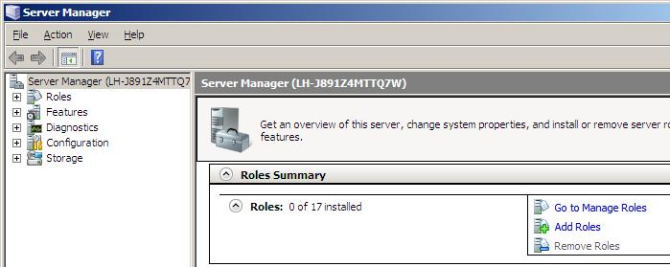
- "Server Manager" should have opened automatically, as shown below on this page. If it is not open, click Start and then click "Server Manager".
- In the right pane of the "Server Manager" window, in the "Roles Summary" section, click "Add Roles".

- On the "Before You Begin" page, review the information and then click Next.
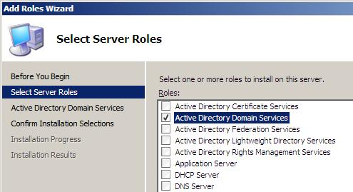
- On the "Select Server Roles" page, click the "Active Directory Domain Services" check box, as shown to the right on this page, and then click Next.
- On the "Active Directory Domain Services" page, click Next.
- On the "Confirm Installation Selections" page, click Install.
- On the "Installation Results" page, click Close.

Finding your Domain Name
- Look on the front panel of your machine. You will find a label indicating the station number, which will look like S214-01. Find the last two digits, which will probably be something different than 01. Write those last two digits in the box to the right on this page, so they become part of the domain name. For example, S214-01 has a domain name of S21401ccsf.com

Domain Name: S214____ccsf.com

Promoting your Machine to a Domain Controller
- Click Start, Run. Type in this command, and then press the Enter key:
DCPROMO
- On the "Welcome to the Active Directory Domain Services Installation Wizard" page, click Next.
- On the "Choose a Deployment Configuration" page, click"Create a new domain in a new forest", and then click Next.
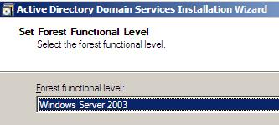
- On the"Name the Forest Root Domain" page, type the Domain Name you wrote in the box above, and then click Next.
- On the "Set Forest Functional Level" page, select "Windows Server 2003", as shown to the right on this page, and then click Next.
- On the "Set Domain Functional Level" page, select "Windows Server 2003" and then click Next.
- On the "Additional Domain Controller Options" page, click Next.
- A box pops up saying "A delegation for this DNS Server will not be created…" Click Yes.
- On the "Location for Database, Log Files, and SYSVOL" page, accept the default locations and click Next.
- On the "Directory Services Restore Mode Administrator Password" page, type P@ssw0rd in both boxes and click Next.
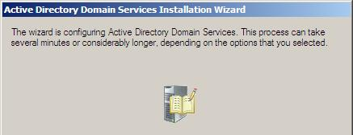
- On the Summary page, review your selections. Click Next.
- A box appears showing the stages of the installation, as shown to the right on this page.

- When you see the "Completing the Active Directory Domain Services Installation Wizard " screen, click Finish.
- A box appears saying "Windows must be restarted…". Click "Restart Now".
- Wait while your computer restarts. It will take several minutes. The logon screen will look different than it used to.
- When it restarts, log in with the user name Administrator and a password of P@ssw0rd
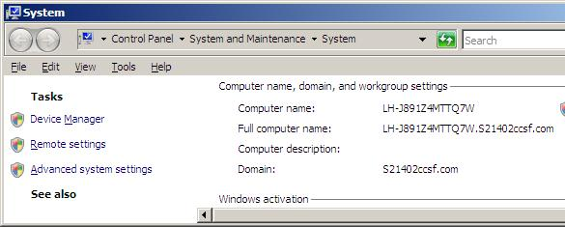
- Click Start, right-click Computer, and click Properties. In the "Computer name, domain, and workgroup settings" section, the Domain: entry should show your domain name, as you wrote it in a box on a previous page of these instructions, as shown below on this page.

Saving the Screen Image
- Press the PrintScrn key in the upper-right portion of the keyboard. That will copy the whole desktop to the clipboard.
- Click Start, All Programs, Accessories, Paint. In the untitled - Paint window, select Edit, Paste from the menu bar. The window image appears in the Paint window.
- In the untitled - Paint window, click File, Save. Save the document in the My Pictures folder (or any other place you wish, such as a floppy disk) with the filename Your Name Proj X13 Select a Save as type of JPEG.

Turning in your Project
- Open Internet Explorer, and use it to email the JPEG image to me as an email attachment. Send the message to: cnit.335@gmail.com with a subject line of "Proj X13 From Your Name", replacing Your Name with your own first and last name. Send a Cc to yourself.

Last Modified: 9-14-07 6 pm

