Starting Your Windows 7 Machine
- Restart the machine and boot to Windows 7. If you don’t have a Windows 7 machine, look for one to use in the lab, or do Project X15: Installing Windows 7 first. Log in as usual.
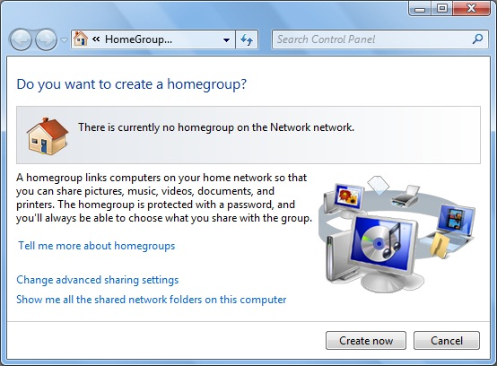
Setting up a HomeGroup
- Press the Windows logo key, and type in HOME. If necessary, use the up-arrow and down-arrow keys on the keyboard to highlight "Set up sharing with a homegroup". Press Enter.
- In the "Do you want to create a homegroup?" page, as shown to the right on this page, click the "Create now" button.
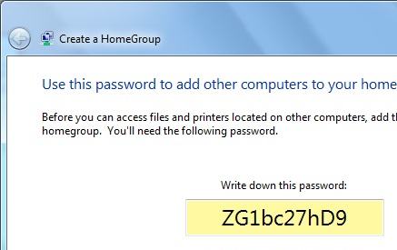
- In the "Create a HomeGroup" page, check all the boxes and click the "Create now" button.
- In the "Use this password to add other computers to your homegroup" page, a password appears. Write the password in the box below on this page
- Then click the Finish button.
Joining a HomeGroup
- If possible, go to another Windows 7 computer on the same network.
HomeGroup
Password: ______________________________
- On the other computer, press the Windows logo key, and type in HOME. If necessary, use the up-arrow and down-arrow keys on the keyboard to highlight "Set up sharing with a homegroup". Press Enter.
- In the "Do you want to join a homegroup" page, ensure that the homegroup you created appears on the list and click the "Join now" button.
- In the "Join a HomeGroup" page, check all the boxes and click the "Join now" button.
- In the "Type your homegroup password" page, type the password you wrote in the box on a previous page of these instructions. Then click the "Join now" button.
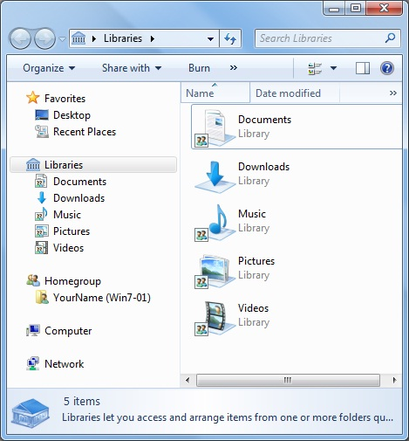
- In the "You have joined the homegroup" page, click the Finish button.
Viewing Your HomeGroup
- On your original computer, click the Start button. On the top right of the Start menu, click your logon name. Windows Explorer opens, as shown to the right on this page.
- In the left pane, notice the Homegroup item. This shows the computers in your homegroup. You can click on them to open the shared folders on them.
Libraries
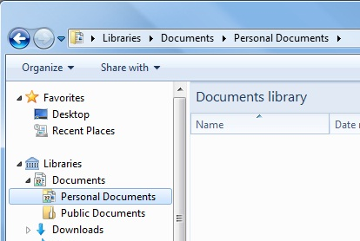
- The purpose of Libraries is to bring together similar items into one place, so you don't have to search for them.
- In the Windows Explorer window, in the left pane, in the Libraries section, expand Documents.
- There are two items in the Documents library: Personal Documents and Public Documents, as shown to the right on this page.
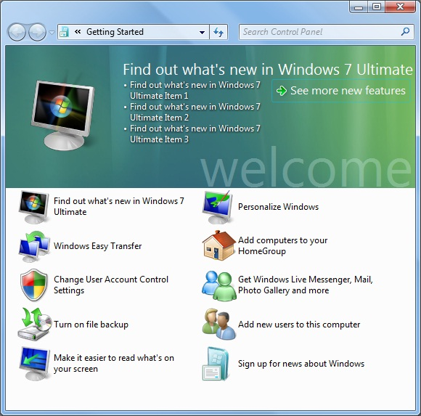
- Click Personal Documents to select it.
Getting Started and User Account Control
- Press the Windows logo key, and type in GET. If necessary, use the up-arrow and down-arrow keys on the keyboard to highlight "Getting Started". Press Enter.
- In the "Getting Started: window, click "Change User Account Control Settings".
- In the top pane of the "Getting Started: window, click "Choose your UAC prompt level".
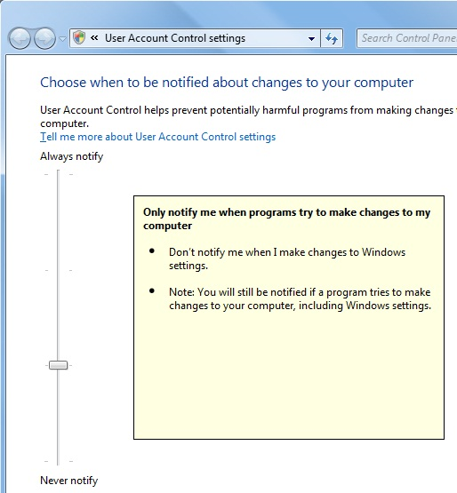
- The "User Account Control Settings" window opens, as shown to the right on this page/ Move the slider through its four positions and read about the options. This is a lot friendlier than UAC is in Vista!

Saving the Screen Image
- Press the PrintScrn key in the upper-right portion of the keyboard. That will copy the whole desktop to the clipboard.
- Press the Logo key on the keyboard. Type PAI into the Search box. When Paint is highlighted, press the Enter key.

- Click in the untitled - Paint window. Type Ctrl+V to paste the image in.
- Type Ctrl+S to save the file. Save the document in the default location of Locations ► Pictures with the filename Your Name Proj X13a. Select a Save as type of JPEG.

New Window-Dragging Effects
- Make the Paint window an intermediate size, using approximately half the screen area.
- Point to the title bar at the top of the Paint window. Hold down the left mouse button and drag the window to the top of the screen. A frame expands, and when you release the mouse button the window maximizes.
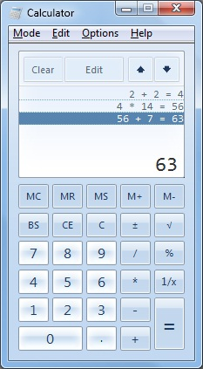
- Point to the title bar at the top of the Paint window. Hold down the left mouse button and drag the window down an inch or so. The window restores to its original size.
- Drag the window to the right edge of the screen. It resizes to use exactly half the screen.
- Drag the window to the left edge of the screen. It resizes to use exactly half the screen. This is useful when you have two windows you want to use at the same time.

The New Calculator
- Press the Logo key on the keyboard. Type CALC into the Search box. When Calculator is highlighted, press the Enter key.
- Enter a series of calculations like this:
2 + 2 = * 14 = + 7=
- The Calculator shows the calculations you have done in the upper pane, as shown to the right on this page. You can even click on them and edit them to correct mistakes!

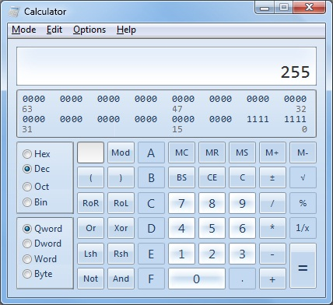
- In the Calculator window, click Mode, Programmer. Type in 255. Notice that the binary equivalent of the value appears in the upper pane, as shown to the right on this page.

Saving the Screen Image
- Press the PrintScrn key in the upper-right portion of the keyboard. That will copy the whole desktop to the clipboard.
- Press the Logo key on the keyboard. Type PAI into the Search box. When Paint is highlighted, press the Enter key.
- Click in the untitled - Paint window. Type Ctrl+V to paste the image in.
- Type Ctrl+S to save the file. Save the document in the default location of Locations ► Pictures with the filename Your Name Proj X15. Select a Save as type of JPEG.

Turning in your Project
- Open Firefox, and use it to email the JPEG images to me as email attachments. Send the message to: cnit.335@gmail.com with a subject line of "Proj X13 From Your Name", replacing Your Name with your own first and last name. Send a Cc to yourself.

Last Modified: 11-1-08

