Caution
Using a pre-beta product is already pretty risky. I hope you aren't trusting your only copy of anything you love to Windows 7 Pre-Beta. But using unauthorized hacks to activate features Microsoft regarded as so unfinished that they aren't even in the Pre-Beta is downright insane. So do this on a machine you don't mind completely hosing, like one in S214. If you don't have an extra machine to mess around on, use the machines in the S214 lab!
Starting Your Windows 7 Machine
- Restart the machine and boot to Windows 7. If you don’t have a Windows 7 machine, look for one to use in the lab, or do Project X12: Installing Windows 7 first. Log in as usual.
Backing Up System Files
- Click Start, Computer. Open the Windows 7 system drive (usually C:). If necessary, click "Show files and folders".
- In the "Computer ► C:" window, right-click an empty portion of the window, and click New, Folder. Name the folder Backups.
- Double-click the Windows folder to open it. If necessary, click "Show files and folders". Drag the folder to the left side of the desktop so it resizes to half the screen.
- Click Start, Computer. Open the Windows 7 system drive (usually C:). Drag the folder to the left side of the desktop so it resizes to half the screen. Double-click the Backups folder to open it.
- In the left window, right-click explorer and click Copy. In the right window, right-click a blank portion of the window and click Paste.
- In the left window, double-click the System32 folder to open it.
- Copy all these files to the right window:
- \Windows\System32\ieframe.dll
- \Windows\System32\powercfg.cpl.
- \Windows\System32\shell32.dll
- \Windows\System32\stobject.dll
- \Windows\System32\TabletPC.cpl
- \Windows\System32\themecpl.dll
- \Windows\System32\themeui.dll
- \Windows\System32\wisptis.exe
Downloading the Blue Badge Tool
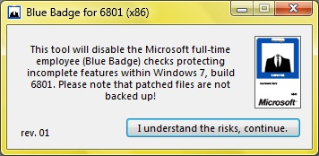
- Open a browser and go to withinwindows.com
- Read the page and get the latest version of the Blue Badge tool. When I did it, it was from Nov 9, 2008, and it was BlueBadge_rev1_x86.zip. Save the file in your Downloads folder, unzip it, and run the installer. Restart your machine when you are prompted to.
Using the New Taskbar
- Open three Firefox windows (or any other type of windows). Click the corresponding button in the Taskbar to show the Live Preview, as shown below on this page.
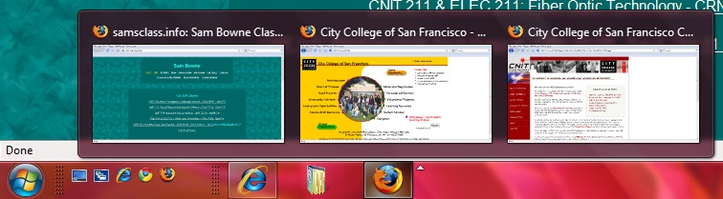

Saving the Screen Image
- Press the PrintScrn key in the upper-right portion of the keyboard. That will copy the whole desktop to the clipboard.
- Press the Logo key on the keyboard. Type PAI into the Search box. When Paint is highlighted, press the Enter key.
- Click in the untitled - Paint window. Type Ctrl+V to paste the image in.
- Type Ctrl+S to save the file. Save the document in the default location of Locations ► Pictures with the filename Your Name Proj X14. Select a Save as type of JPEG.
Using the New Themes
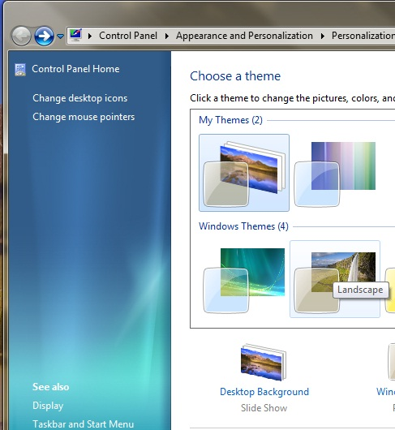
- Right-click the desktop and click Personalize. In the "Windows Themes" section, click the second Theme, named Landscape, as shown to the right on this page.
- In the lower part of the personalization window, click the icon labeled "Desktop Background".
- The "Choose your desktop background" screen opens, as shown below on this page. In the Textures and Vistas sections, check the boxes next to some or all of the pictures. In the "Change picture every" drop-down list box, select "10 seconds", as shown below on this page.
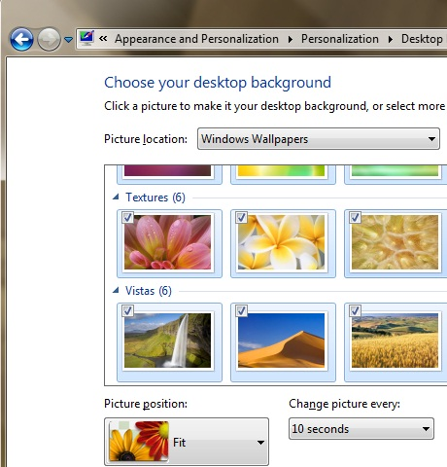
- Now the background should cycle through the pictures.

Turning in your Project
- Open Firefox, and use it to email the JPEG image to me as an email attachment. Send the message to: cnit.335@gmail.com with a subject line of "Proj X14 From Your Name", replacing Your Name with your own first and last name. Send a Cc to yourself.

Last Modified: 11-10-08

