This project can be done on any version of Vista.

First Do Project 10: Windows Mail
- You need to have Windows Mail set up with a working Email account.

Setting your Default Browser to Internet Explorer
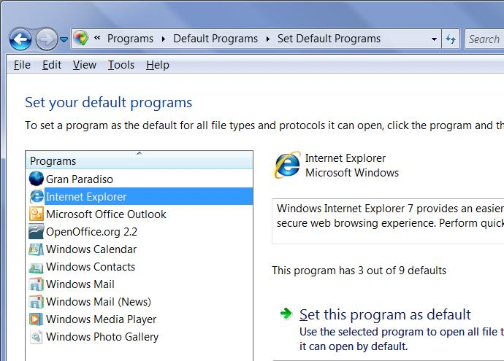
- The Comodo certificate installer requires you to use Internet Explorer. The easiest way to do that is to make it your default browser.
- Click Start, "Default Programs".
- In the "Control Panel ► Programs ► Default Programs" box, click "Set your default programs".
- In the Programs list, click "Internet Explorer". In the right pane, click "Set this program as default". Click the OK button.

Starting Windows Mail
- Press the Windows logo key, next to the Ctrl key at the lower left of your keyboard. Don't touch the mouse. Type this into the Search box:
mail
- "Windows Mail" should appear in the Programs list. If it's not already highlighted, press the down-arrow as needed to highlight it. Then press the Enter key. Windows Mail opens.

Getting a Digital ID
- Click Tools, Options from the menu bar. In the Options box, click the Security tab. In the "Secure Mail" section, click the "Get Digital ID… button.
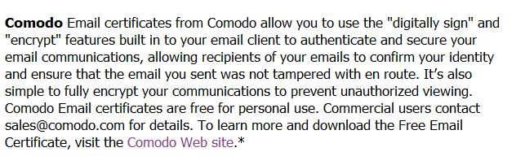
- A browser opens showing a Microsoft Office Online page, listing "Available Digital IDs for the 2007 Microsoft Office system". Scroll down to the Comodo section, as shown to the right on this page, and click the "Comodo Web Site" link.


- On next page, click the "GET YOUR FREE EMAIL CERT NOW!" button, as shown to the right on this page.
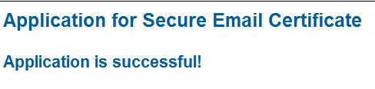
- Fill in the "Application for Secure Email Certificate" and click the "Agree & Continue" button. In the "Web Access Confirmation" box, click Yes.
- You should see the "Application is successful!" message, as shown to the right on this page. Close Internet Explorer.

Installing the Certificate
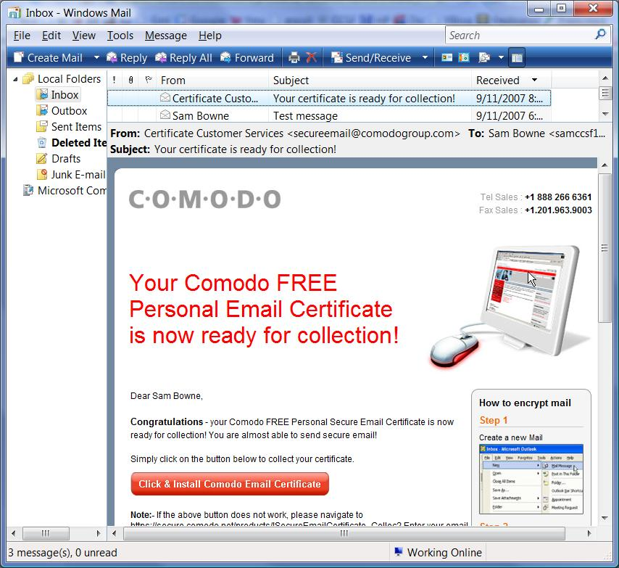
- If the Windows Mail "Options" box is open, click OK to close it.
- In the "Windows Mail" window, click the "Send/Receive" button. You should see a message with a Subject of "Your certificate is ready for collection!", as shown to the right on this page.
- In the message, click the red "Click & Install Comodo Email Certificate" button.
- Internet Explorer opens, showing a Comodo page, as shown to the right on this page. A yellow Information bar opens, saying "Internet Explorer has blocked this site from using an ActiveX control in an unsafe manner".
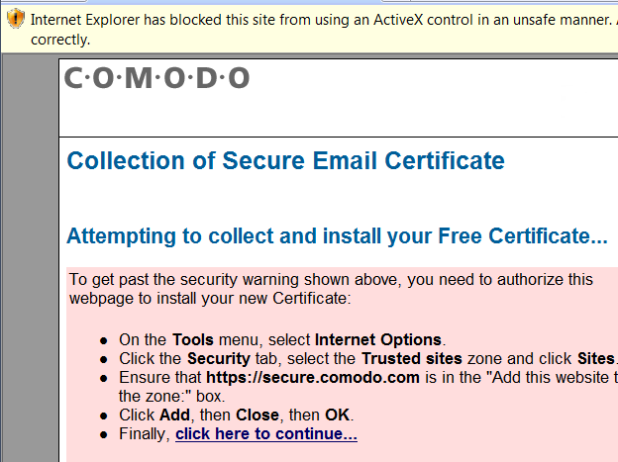
- Press and release the Alt key. Click Tools, "Internet Options".

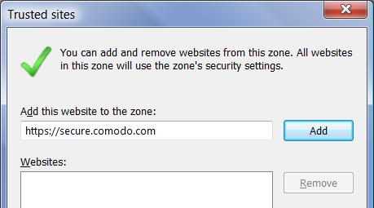
- In the "Internet Options" box, click the Security tab. In the top pane, click "Trusted sites". Click the Sites button. A "" box opens, with https://secure.comodo.com entered in the top field, as shown to the right on this page. Click the Add button. Click the Close button.
- In the "Internet Options" box, click the OK button.
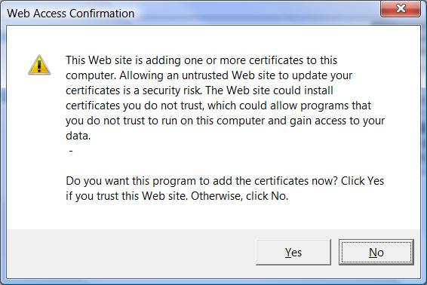
- In Internet Explorer, on the Comodo page, click the "click here to continue…" link.
- If an "Internet Explorer" box opens, saying "Internet Explorer needs to open a new window…". Click OK.
- A "Web Access Confirmation" box opens, as shown to the right on this page, informing you that you are about to add a certificate to your computer. Click Yes.
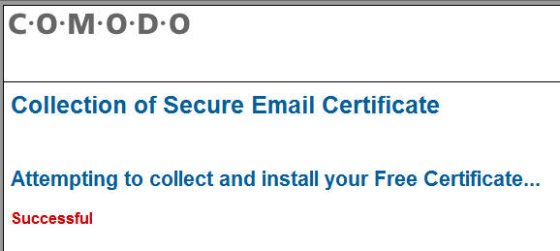
- The Comodo web page should now have the word "Successful! " in red font at the bottom, as shown to the right on this page.

Viewing the Installed Certificate in Internet Options
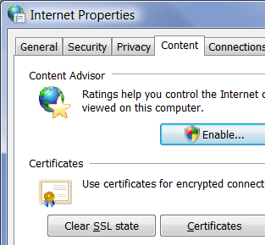
- Press the Windows logo key, next to the Ctrl key at the lower left of your keyboard. Don't touch the mouse. Type this into the Search box:
inter
- "Internet Options" should appear in the Programs list. If it's not already highlighted, press the down-arrow as needed to highlight it. Then press the Enter key. "Internet Properties" opens, as shown to the right on this page.

- In the "Internet Properties" box, click the Content tab. In the Certificates section, click the Certificates button.

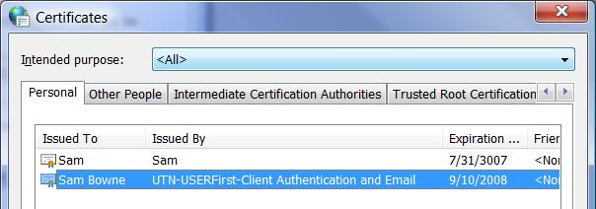
- In the Certificates box, you should see a certificate issued by "UTN-USERFirst-Client Authentication and Email", as shown to the right on this page.
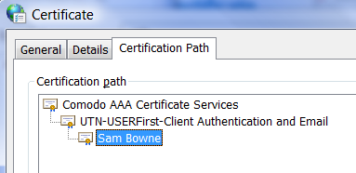
- Double-click "UTN-USERFirst-Client Authentication and Email". Click the "Certification Path" tab. You should see that the path begins with "Comodo AAA Certificate Services", as shown to the right on this page.
- In the Certificate box, click OK.
- In the Certificates box, click Close.
- In the "Internet Properties" box, click OK.

Sending Yourself an Encrypted Message
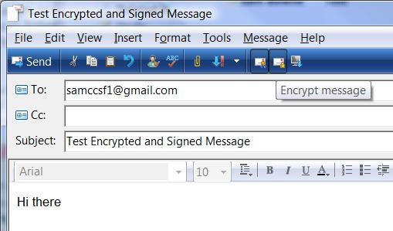
- In the "Windows Mail" window, click the "Create Mail" button. Compose an email to your GMail account, like the example shown to the right on this page. On the right side of the toolbar there are two buttons that look the same. Hover over them to see the tooltip messages. One of them says "Digitally sign message" and the other says "Encrypt message". Click them both, as shown to the right on this page, and click the Send button.
- In the "Windows Mail" window, click the "Send/Receive" button. Compose an email to your GMail account, like the example shown to the right on this page, and click the Send button.
- In the toolbar at the top of the "Windows Mail" window, click the Send/Recv button.
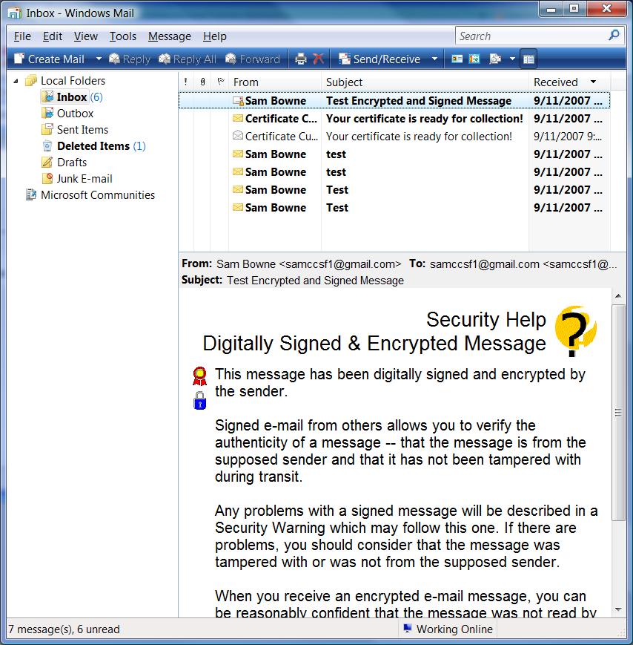
- If the test message doesn't appear, return to Gmail settings and on the "Forwarding and POP" tab, click "Enable POP for all mail (even mail that's already been downloaded)" and then click "Save Changes". Then In the toolbar at the top of the "Windows Mail" window, click the Send/Recv button.
- You should see the test message you sent yourself appear in the Inbox. The message should show "Security Help – Digitally Signed & Encrypted Message", as shown as shown to the right on this page.
- Scroll to the bottom of the message and click the Continue button.

Capturing an Image of the Received Message
- The lower-right pane of Windows Mail should show the message you sent, with the two icons shown below on this page, showing that the message is signed and encrypted.
Signed and Encrypted icons

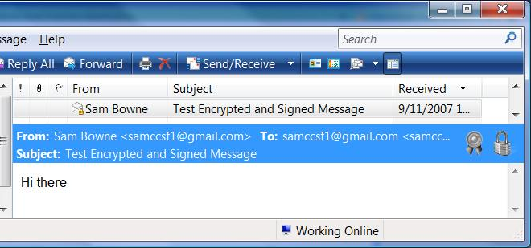

- Click in the title bar of the "Windows Mail" window to ensure that it is the active window.
- Hold down the Alt key and press the PrintScrn key in the upper-right portion of the keyboard. That will copy the active window to the clipboard.
- Click Start, "All Programs", Accessories, Paint. In the untitled - Paint window, select Edit, Paste from the menu bar. The image appears in the Paint window.
- In the untitled - Paint window, click File, Save. Save the document with the filename Your Name Proj X1.

Turning in your Project
- Email the JPEG image to me as an attachment to an e-mail message. Send the message to: cnit.335@gmail.com with a subject line of CNIT 335 Proj X1From Your Name, replacing Your Name with your own first and last name. Send a Cc to yourself.

Note: You should really back up your certificate before using it for important email. However, as far as I can determine, the free Comodo certificates cannot be backed up properly in Vista right now—the private key is set to be non-exportable. I sent an inquiry to Comodo about it, and hopefully they will have a satisfactory answer.

Last modified 9-11-07

