Starting Your Machine in Vista
- Restart the machine and boot to Vista. Log in as usual.
Putting the Intel NIC Driver on the VMs Drive
- Press the Windows logo key, next to the Ctrl key at the lower left of your keyboard. Don't touch the mouse. Type this into the Search box, and then press the Enter key:
\\192.168.1.3
If you are asked for a login name and password, use the name CNIT with no password. If the connection cannot be established, ensure that the "Laraine" server is turned on.
- In the Network ► 192.168.1.3 window, double-click the CNIT335 folder to open it.
- Right-click the IntelNICDriver folder and click Copy.
- Click Start, Computer.
- In the Computer ► window, double-click the VMs drive to open it.
- In the Computer ► VMs window, double-click the Install folder to open it.
- In the Computer ► VMs ► Install window, look to see if there is already a folder named "IntelNICDriver". If there is, some other student already copied the NIC driver, so you can skip to the next section: "Booting from the Vista DVD". If the folder is not there, right-click a blank portion of the folder and click Paste.
Putting the Clamwin and Firefox Installers on the VMs Drive
Repeat the same process to move the two folders Clamwin and Firefox from the server to the VMs drive.
Booting from the Vista x86 DVD
- Insert the Vista DVD.
- Restart your machine. When you see the message "Press any key to boot from CD or DVD", press the Enter key.
- When you see the "Install Windows" box, accept the default "Language to install","Time and currency format", and "Keyboard or input method" settings and click Next.
- In the next screen, click "Install now".
- The next screen asks for a product key. Clear the "Automatically activate Windows when I'm online" box, leave the product key blank, and click Next.
- When a box pops up asking "Do you want to enter your product key now?" box, click No.
- The next screen asks you to select the edition of Windows that you purchased. Select "Windows Vista ULTIMATE". Check the "I have selected the edition of Windows that I purchased" box and click Next.
- Check the “I accept the license terms” box and click Next.
- Click Custom (advanced).
Choosing the Installation Partition
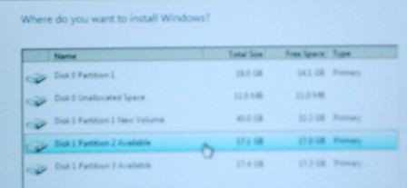
- Find a partition marked Available as shown below on this page and click on it. Note the Disk number and Partition number you chose. In the figure to the right on this page, “Disk 1 Partition 2” is selected.
- After you have clicked an available partition, click Next.
- Now wait – it will take a while to copy the files. Your computer will restart one or more times. When it restarts, don't touch the keyboard—just let it boot from the default hard disk partition.
- At the Country or Region screen, click Next.
- At the “Choose a user name and picture” page, enter Student and no password. Click any picture and click Next.
- At the “Type a computer name and choose a desktop background” page, enter the computer name you wrote in the box in step 1, click any background, and click Next.
- At the “Help protect Windows automatically” page, click “Use recommended settings”.
- At the "Review your time and date settings" screen, click Next.
- At the "Select your computer's current location" screen, click Work.
- At the "Thank you" screen, click Start.
- Now you have to wait again, while Windows checks your computer's performance.
- When that is complete, your Vista desktop will appear, showing a welcome window with "Student" in the upper left corner.
Installing the Network Adapter Driver
- Click Start, Computer. Double-click the VMs drive to open it. Double-click the Install folder to open it. Double-click the IntelNICDriver folder to open it.
- Double-click the PROVISTA32 file to start the installer. Follow the on-screen prompts to install the driver with the default selections.
Installing Clamwin Antivirus
- Click Start, Computer. Double-click the VMs drive to open it. Double-click the Install folder to open it. Double-click the Clamwin folder to open it.
- Double-click the clamwin setup file. Follow the on-screen prompts to install Clamwin antivirus with the default selections.
Installing Firefox
- Click Start, Computer. Double-click the VMs drive to open it. Double-click the Install folder to open it. Double-click the Firefox folder to open it.
- Double-click the Firefox setup file. Follow the on-screen prompts to install Firefox with the default selections.

Determining the System Drive Letter
- Click Start. In the Search box, type in CMD. Press the Enter key. A Command Prompt window opens.
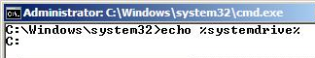
- Type this command into the Command Prompt window, then press the Enter key.:
echo %systemdrive%
The response should tell you your Vista Ultimate drive letter. It is usually C:.

Changing the System Drive Label
- Click Start, Computer. Find your system drive in the list—it should be labeled “Available (C:)”. You need to change this name, so that later students in the lab don’t see your Vista Ultimate partition as “Available” and install an operating system on the same partition.
- Right-click your system drive icon and click Rename. Type in a new name of "Your Name Vista Ultimate". Press the Enter key.

Changing the Operating System Label with BCDEDIT
- Click Start. In the Search box, type in CMD. Press Shift+Ctrl+Enter. In the "User account control" box, click Continue.
- Type this command into the Administrator Command Prompt window, then press the Enter key.:
bcdedit /set description "Vista Ultimate Your Name installed date" {current}
Replace Your Name with your own name. If you see a message saying "The boot configuration data store could not be opened. Access is denied.", you aren't in an Administrator Command Prompt window. Close the window and carefully repeat the previous step.
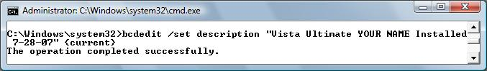

Viewing Computer Properties
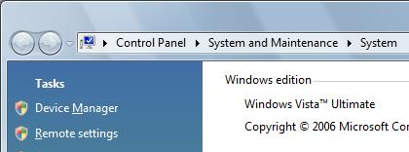
- Click Start, right-click Computer, and click Properties. The "Control Panel ► System and Maintenance ► System" box should show a "Windows edition" of "Windows Vista Ultimate", as shown to the right on this page.

Saving the Screen Image
- Press the PrintScrn key in the upper-right portion of the keyboard. That will copy the whole desktop to the clipboard.
- Click Start, All Programs, Accessories, Paint. In the untitled - Paint window, select Edit, Paste from the menu bar. The window image appears in the Paint window.
- In the untitled - Paint window, click File, Save. Save the document in the My Pictures folder (or any other place you wish, such as a floppy disk) with the filename Your Name Proj X2a. Select a Save as type of JPEG.

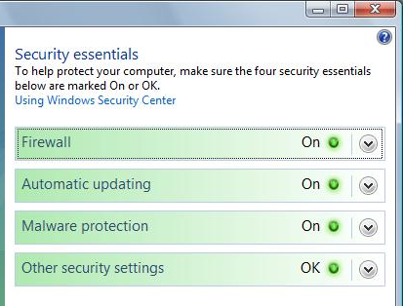
Viewing Security Center
- Click Start, "Control Panel". In "Control Panel", click Security. In "Control Panel ► Security", click "Security Center".
- The "Windows Security Center" box should show all four "Security essentials" in a satisfactory green On state, as shown to the right on this page. However, it doesn't detect Clamwin correctly, at the time of this writing, so the Malware protection does not show the green state. If that happens, just take the whole screen image with PrintScreen and turn it in—I will be able to see the Clamwin icon in the Notification Area at the lower right of the desktop, so I can tell you have the antivirus installed.

Saving the Screen Image
- Press the PrintScrn key in the upper-right portion of the keyboard. That will copy the whole desktop to the clipboard.

- Click Start, All Programs, Accessories, Paint. In the untitled - Paint window, select Edit, Paste from the menu bar. The window image appears in the Paint window.
- In the untitled - Paint window, click File, Save. Save the document in the My Pictures folder (or any other place you wish, such as a floppy disk) with the filename Your Name Proj X2b. Select a Save as type of JPEG.

Turning in your Project
- Open Firefox, and use it to email the JPEG images to me as attachments to a single email message. Send the message to: cnit.335@gmail.com with a subject line of "Proj X2 From Your Name", replacing Your Name with your own first and last name. Send a Cc to yourself.

Extending Your 30-day Trial
- The Windows Ultimate you have installed will only work for 30 days. If you want it to work longer than that, you need to extend the trial period. You can do that from an elevated command prompt with this command:
slmgr.vbs -rearm
- You can only do this three times, and you should wait until the 30-day trial period is near its end before doing it. For more details, see link Ch 2g on my Web page.

Last Modified: 7-9-08

